Name: - Atharva Manoj Kulkarni

PRN: - 2019BTEIT00076

**3.2** Write the program to show file statistics using the fstat system call.Take the file name / directory name from user including path. Print only inode no, UID, GID, FAP and File type only.

**Objectives:**

1. To learn about File system Internals.

**Theory:**

Name:

stat, fstat, lstat - get file status

Syntax:

#include <[sys/types.h](https://linux.die.net/include/sys/types.h)>

#include <[sys/stat.h](https://linux.die.net/include/sys/stat.h)>

#include <[unistd.h](https://linux.die.net/include/unistd.h)>

int stat(const char \**path*, struct stat \**buf*);

int fstat(int *fd*, struct stat \**buf*);

int lstat(const char \**path*, struct stat \**buf*);

Description:

These functions return information about a file. No permissions are required on the file itself, but-in the case of stat() and lstat() - execute (search) permission is required on all of the directories in *path* that lead to the file.

stat() stats the file pointed to by *path* and fills in *buf*.

lstat() is identical to stat(), except that if *path* is a symbolic link, then the link itself is stat-ed, not the file that it refers to.

fstat() is identical to stat(), except that the file to be stat-ed is specified by the file descriptor *fd*.

All of these system calls return a *stat* structure, which contains the following fields:

struct stat {

dev_t st_dev; /* ID of device containing file */

|  |  |  |  |
| --- | --- | --- | --- |
| ino_t | st_ino; | /* inode number */ | |
| mode_t | st_mode; | | /* protection */ |
| nlink_t | st_nlink; |  | /* number of hard links */ |
| uid_t | st_uid; | /* user ID of owner */ | |
| gid_t | st_gid; | /* group ID of owner */ | |
| dev_t | st_rdev; | /* device ID (if special file) */ | |
| off_t | st_size; /* total size, in bytes */ | | |
| blksize_t st_blksize; /* blocksize for file system I/O */ | | | |
| blkcnt_t st_blocks; | | | /* number of 512B blocks allocated */ |
| time_t | st_atime; |  | /* time of last access */ |
| time_t | st_mtime; | | /* time of last modification */ |
| time_t | st_ctime; |  | /* time of last status change */ |

};

**Data Dictionary:**

|  |  |  |  |
| --- | --- | --- | --- |
| Sr Number | Variable/Function | Datatype | Use |
|  |  |  |  |
| 1 | s | char[] | Get file name. |
|  |  |  |  |
| 2 | fp | FILE* | Pointer to file. |
|  |  |  |  |
| 3 | fn | int | File descriptor number. |
|  |  |  |  |
| 4 | sta | struct stat | Store information about files. |
|  |  |  |  |

**Program:**

#include<stdio.h>

#include<stdlib.h>

#include <sys/stat.h>

#include <sys/types.h>

#include <unistd.h>

int main()

{

char s[100];

gets(s);

//printf("%s",s);

FILE *fp;

if((fp=fopen(s,"r"))==NULL)

return 1;

int fn=0;

fn=fileno(fp);

struct stat sta;

if(fstat(fn,&sta) < 0) return 1;

printf("File size : %ld\n",(long)sta.st_size);

printf("File INode Number : %ld\n",sta.st_ino);

printf("File UID : %ld\n",(long)sta.st_uid);

printf("File GID : %ld\n",(long)sta.st_gid);

printf("File Permissions: \t");

printf( (S_ISDIR(sta.st_mode)) ? "d" : "-");

printf( (sta.st_mode & S_IRUSR) ? "r" : "-");

printf( (sta.st_mode & S_IWUSR) ? "w" : "-");

printf( (sta.st_mode & S_IXUSR) ? "x" : "-");

printf( (sta.st_mode & S_IRGRP) ? "r" : "-");

printf( (sta.st_mode & S_IWGRP) ? "w" : "-");

printf( (sta.st_mode & S_IXGRP) ? "x" : "-");

printf( (sta.st_mode & S_IROTH) ? "r" : "-");

printf( (sta.st_mode & S_IWOTH) ? "w" : "-");

printf( (sta.st_mode & S_IXOTH) ? "x" : "-");

printf("\n\n");

printf("File type: ");

switch (sta.st_mode & S_IFMT)

{

case S_IFBLK:

printf("block device\n");

break;

case S_IFCHR:

printf("character device\n");

break;

case S_IFDIR:

printf("directory\n");

break;

case S_IFIFO:

printf("FIFO/pipe\n");

break;

case S_IFLNK:

printf("symlink\n");

break;

case S_IFREG:

printf("regular file\n");

break;

case S_IFSOCK:

printf("socket\n");

break;

default:

printf("unknown?\n");

break;

}

return 0;

}

**Output:**

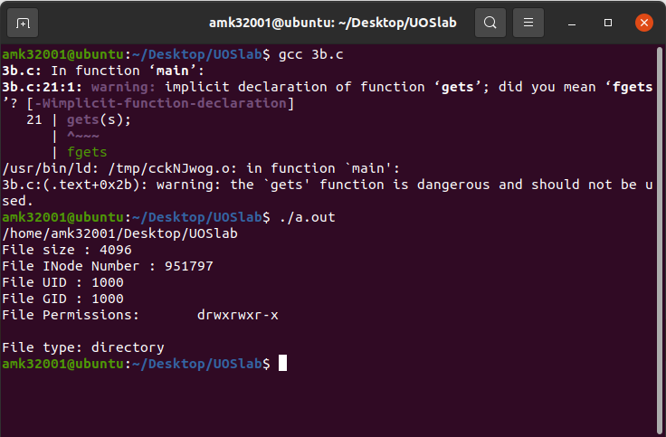

**Conclusion:**

Stats of file like UID, GIDfile size,links, permissions, inode number and type of link can be retrieved using stat(),fstat() and link() and stored in a structure.

**References:**

https://www.lix.polytechnique.fr/~liberti/public/computing/prog/c/C/FUNCTIONS/stat.html