Name: - Atharva Manoj Kulkarni

PRN: - 2019BTEIT00076

**3c - Write a program to use link/unlink system call for creating logical link and identifying the difference using stat.**

**Objectives:**

1. To learn about File system Internals.

**Theory:**

1) Link:

Name:

link - make a new name for a file

Syntax:

#include <unistd.h>

int link(const char \**oldpath*, const char \**newpath*);

Description:

link() creates a new link (also known as a hard link) to an existing file.

If *newpath* exists it will *not* be overwritten.

This new name may be used exactly as the old one for any operation; both names refer to the same file (and so have the same permissions and ownership) and it is impossible to tell which name was the `original’.

Return Value:

On success, zero is returned. On error, -1 is returned, and *errno* is set appropriately.

2) Unlink:

Name:

unlink - delete a name and possibly the file it refers to

Syntax:

#include <unistd.h>

int unlink(const char \**pathname*);

Description:

unlink() deletes a name from the filesystem. If that name was last link to a file and no processes have the file open the file is deleted and the space it was using is made available for reuse.

If the name was the last link to a file but any processes still have the file open the file will remain in existence until the last file descriptor referring to it is closed.

If the name referred to a symbolic link the link is removed. If the name referred to a socket, fifo or device the name for it is removed but processes which have the object open may continue to use it.

Return Value:

On success, zero is returned. On error, -1 is returned, and *errno* is set appropriately.

**Data Dictionary:**

|  |  |  |  |
| --- | --- | --- | --- |
| Sr Number | Variable/Function | Datatype | Use |
|  |  |  |  |
| 1 | old | char[] | Old pathname. |
|  |  |  |  |
| 2 | new | char[] | New pathname. |
|  |  |  |  |
| 3 | ch | char | Choice asking to unlink or not. |
|  |  |  |  |

Table: 3.3 Data Dictionary

**Program:**

#include<stdio.h>

#include<unistd.h>

int main()

{

char old[100];

char new[100];

char ch;

printf("Enter the old and new pathname: \n");

gets(old);

gets(new);

int n = link(old,new);

if(n==0)

{

printf("Linked successfully\n");

}

else

{

printf("Linked unsuccessfully\n");

}

printf("Do you want to unlink the new file?\n1:Y\n2:N\n");

scanf("%c",&ch);

if(ch=='Y'||ch=='y')

{

int m = unlink(new);

if(m==0)

{

printf("Unlinked successfully\n");

}

else

{

printf("Unlinked unsuccessfully\n");

}

}

else

{

printf("Not Unlinked\n");

}

}

**Output:**

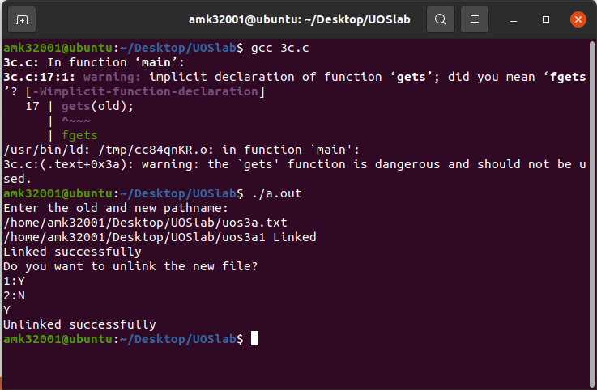

**Conclusion:**

* The concepts of creating link or shortcut to file and unlinking it understood through link and unlink function calls.
* The change in number of links takes place as we implement the program.

**References:**

[1]www.tutorialspoint.com/unix_system_