**Name:Rohan Nivas Chavan**

**PRN:2019BTEIT00084**

**UOS LAB**

**5.3** Using shell sort the given 10 number in ascending order (use ofarray).

**Objectives:**

To learn shell programming and use it for write effective programs.

**Theory:**

The shell provides you with an interface to the UNIX system. It gathers input from you and executes programs based on that input. When a program finishes executing, it displays that program's output.

A shell is an environment in which we can run our commands, programs, and shell scripts. There are different flavors of shells, just as there are different flavors of operating systems. Each flavor of shell has its own set of recognized commands and functions.

**Flowchart**:

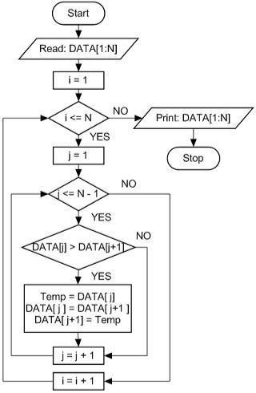

**Data Variables:**

|  |  |  |  |
| --- | --- | --- | --- |
| no | Variable | Type | use |
|  |  |  |  |
| 1 | a[i] | array | array |
|  |  |  |  |
| 2 | i | int | outer loop |
|  |  |  |  |
| 3 | j | int | inner loop |
|  |  |  |  |

**Program:**

for i in {0..9}

do

echo "Enter the element"

read a[i]

done

#array display before sorting

echo "The array elements are:"

for i in {0..9}

do

echo ${a[i]}

done

#algorithm to sort the array..bubble sort

for ((i=0;i<10;i++))

do

for (( j = $i; j < 10; j++ ))

do

if [ ${a[$i]} -gt ${a[$j]} ]; then

t=${a[$i]}

a[$i]=${a[$j]}

a[$j]=$t

fi

done

done

#array display after sorting

echo "The array elements are:"

for i in {0..9}

do

echo ${a[i]}

done

**Output:**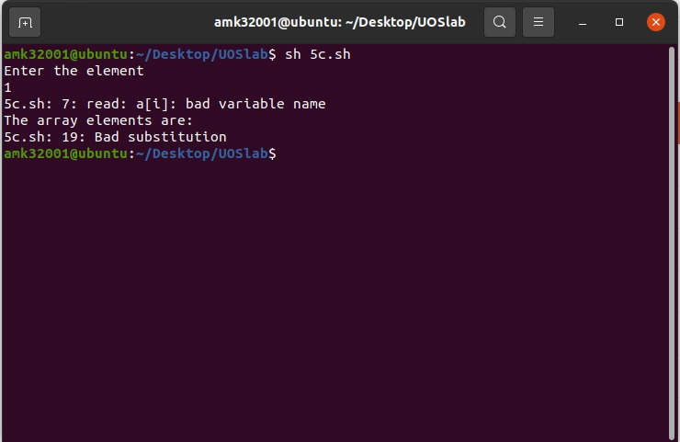

**Conclusion:**

Array sorted constructed using shell programming.

**References:**

http://www.tutorialspoint.com/unix/unix-shell.htm/