**Name: Rohan Nivas Chavan**

**PRN:2019BTEIT00084**

**UOS LAB**

**5.4** Shell script to print &quot;Hello World&quot; message, in Bold,Blink effect, and in different colors like red, brown etc.

**Objectives:**

To learn shell programming and use it for write effective programs.

**Theory:**

The shell provides you with an interface to the UNIX system. It gathers input from you and executes programs based on that input. When a program finishes executing, it displays that program's output.

A shell is an environment in which we can run our commands, programs, and shell scripts. There are different flavors of shells, just as there are different flavors of operating systems. Each flavor of shell has its own set of recognized commands and functions.

**Flowchart**:

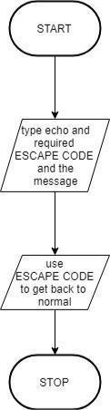

**Program:**

clear

echo -e "\033[1m Hello World"

# bold effect

echo -e "\033[5m Hello World"

# blink effect

echo -e "\033[0m Hello World"

# back to noraml

echo -e "\033[31m Hello World"

# Red color

echo -e "\033[32m Hello World"

# Green color

echo -e "\033[33m Hello World"

# See remaing on screen

echo -e "\033[34m Hello World"

echo -e "\033[35m Hello World"

echo -e "\033[36m Hello World"

echo -e -n "\033[0m "

# back to normal

echo -e "\033[41m Hello World"

echo -e "\033[42m Hello World"

echo -e "\033[43m Hello World"

echo -e "\033[44m Hello World"

echo -e "\033[45m Hello World"

echo -e "\033[46m Hello World"

echo -e "\033[0m Hello World"

# back to noraml

**Output:**

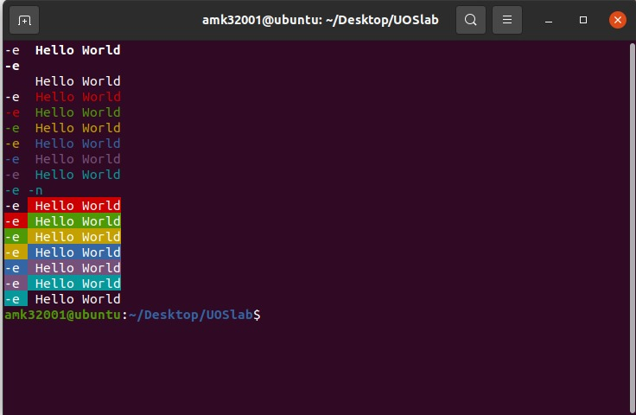

**Conclusion:**

Given text effectively styled in various formats

**References:**

http://www.tutorialspoint.com/unix/unix-shell.htm/