**A**

**Project Report**

Submitted in partial fulfilment of

the requirements for the degree of

**Master of Computer Application**

On

**“Smart Electricity Bill Calculator Using Blockchain Technology”**



Submitted By:

**Ashish Kumar (2144006)**

**Devesh (2144017)**

**Gyanesh Ray (2144019)**

**Rishu (2144022)**

Under The Supervision Of

**Dr. Ditipriya Sinha**

Department of Computer Science & Engineering

**National Institute of Technology Patna**

# DECLARATION

We the undersigned solemnly declare that the work reported in the project titled **“SMART ELECTRICITY BILL CALCULATOR USING BLOCKCHAIN”** submitted for the partial fulfilment of MCA degree at the Department of Computer Science and Engineering, National Institute of Technology Patna, is record of our work carried out under the supervision of **Asst. Prof.** **Dr. Ditipriya Sinha**.

We assert the statements made and conclusions drawn are an outcome of our research work. We further certify that

1. The work has not been submitted to any other Institution for any other degree/diploma/certificate in this university or any other University in India or abroad.
2. We have followed the guidelines provided by the university in writing the report.
3. Whenever we have used materials (data, theoretical analysis, and text) from other sources, we have given due credit to them in the text of the report and given their details in the references.

Ashish Kumar (2144006)

Devesh (2144017)

Gyanesh Ray (2144019)

Rishu (2144022)

## CERTIFICATE

This is to certify that **Ashish Kumar**, **Devesh**, **Gyanesh Ray**, and **Rishu**, thestudents of MCA, IIIRD Semester of this institute have submitted the project titled **“Smart Electricity Bill Calculator Using Blockchain Technology”** under my supervision for partial fulfilment of MCA degree. It is further certified that the above candidates have carried out the project work under my guidance during the academic session 2021-2023 at the Department of CSE, National Institute of Technology Patna. To the best of my knowledge and belief, the above report has been prepared by the above-said students.

They possess a good moral character and I wish them success in their life.

**Dr H.P. Singh**

Head of Department

CSE Department

NIT Patna

**Dr. Ditipriya Sinha**

Assistant Professor

CSE Department

NIT Patna

# ACKNOWLEDGEMENT

We have great pleasure expressing our thanks to those who have contributed their valuable time in helping to achieve success in our project report.

We are obliged to our **HOD Dr. M. P. Singh,** for providing us necessary facilities to perform project work on college premises and assigning us such a demanding and useful project. We wish to place our sincere gratitude and deep appreciation on him.

We would like to sincerely thank and expresses our gratitude to our **Assistant Professor Dr. Ditipriya Sinha,** for her continuous encouragement, guidance, and help in the completion of our practical work.

Finally, we wish to say thanks to all those people who have a contribution to developing our project and project report successfully.

Ashish Kumar (2144006)

Devesh (2144017)

Gyanesh Ray (2144019)

Rishu (2144022)

**Table of Contents:**

|  |  |
| --- | --- |
| **Topic** | **Page No.** |
| Declaration | 2 |
| Certificate | 3 |
| Acknowledgement | 4 |
| Abstract | 6 |
| Introduction | 7 |
| Tools and Technologies Used | 8 |
| Working Model | 11 |
| Flow Chart | 12 |
| Screenshots   1. Home Page 2. Registration 3. Electricity Bill Generation 4. Generated Electricity Bill 5. Printing of Bill 6. Transactions in Ganache | 13  14  15  16  16  17 |
| Conclusion and Future Scope | 18 |
| References | 19 |

# Abstract

The electricity industry has always been under scrutiny in order to improve the quality of electricity supply, measurement and billing services to have the at most user transparency, while providing these services with the highest efficiency. Although many solutions have emerged, of which the smart meter was considered a viable option, it was quick to perish under the prodigious complications with the real-life feasibilities. Decentralized application(dApp), an electricity bill calculation application solution, harnessing the Blockchain utilities to provide a decentralized and secure recording mechanism, that provides an improved architecture to the smart meter is proposed in this article. The dApp provides a high security and cost-efficient decentralized electricity bill calculation on Ethereum network.

# Introduction

The electricity sector has been an ever-growing industry, as majority of the economies are adapting industrialization. The global power consumption is at its peak in the current state consuming over 4000 thousand units of power per capita. This market pave way to smart solutions that efficiently, accurately and securely measure the usage with minimum man power. The conventional method of measuring electricity, majorly adapted by most of the regions utilizing domestic electricity are the variations of the mechanical meter that requires extensive manual labor in measuring and generating electricity bills for every site user. One of the major solutions in improving the conventional energy calculator system is the smart energy calculator. The smart meter takes the advantages of the client server architecture in providing a modernized solution to the man power inducing energy meter while also providing an architecture that can measure the electricity accurately.

# Tools and Technologies Used

The experiment consists of six tools and technologies that are used in our project “Smart Electricity Bill Calculator using blockchain technology” attain distribution and security. We have used **Truffle**, **MetaMask** wallet for **Ethereum** transactions, **Ganache** for transaction confirmation, **Visual studio code**, **web3** framework, and **node.js** in our project.

* **Truffle** is a world-class development environment, testing framework and asset pipeline for blockchains using the Ethereum Virtual Machine (EVM), aiming to make life as a developer easier. Truffle is widely considered the most popular tool for blockchain application development with over 1.5 million lifetime downloads. Truffle supports developers across the full lifecycle of their projects, whether they are looking to build on Ethereum, Hyperledger, Quorum, or one of an ever-growing list of other supported platforms. Paired with Ganache, a personal blockchain, and Drizzle, a front-end dApp development kit, the full Truffle suite of tools promises to be an end-to-end dApp development platform.
* **MetaMask** is a browser plugin that serves as an Ethereum wallet, and is installed like any other browser plugin. Once it's installed, it allows users to store Ether and other ERC-20 tokens, enabling them to transact with any Ethereum address. By connecting to MetaMask to Ethereum-based dapps, users can spend their coins in games, stake tokens in gambling applications, and trade them on decentralized exchanges (DEXs). It also provides users with an entry point into the emerging world of decentralized finance, or DeFi, providing a way to access DeFi apps such as Compound and PoolTogether.
* **Ethereum** is a decentralized blockchain platform that establishes a peer-to-peer network that securely executes and verifies application code, called smart contracts. Smart contracts allow participants to transact with each other without a trusted central authority. Transaction records are immutable, verifiable, and securely distributed across the network, giving participants full ownership and visibility into transaction data. Transactions are sent from and received by user-created Ethereum accounts. A sender must sign transactions and spend Ether, Ethereum's native cryptocurrency, as a cost of processing transactions on the network.
* **Ganache** is a personal blockchain for rapid Ethereum and Corda distributed application development. You can use Ganache across the entire development cycle; enabling you to develop, deploy, and test your dApps in a safe and deterministic environment. Ganache comes in two flavours: a **UI and CLI**. Ganache UI is a desktop application supporting both Ethereum and Corda technology. It provides more features when compared to Remix.
* **Visual Studio Code** (famously known as **VS Code**) is a free open-source text editor by Microsoft. VS Code is available for Windows, Linux, and macOS. Although the editor is relatively lightweight, it includes some powerful features that have made VS Code one of the most popular development environment tools in recent times. VS Code supports a wide array of programming languages from Java, C++, and Python to CSS, Go, and Dockerfile. Moreover, VS Code allows you to add on and even creating new extensions including code linters, debuggers, and cloud and web development support. The VS Code user interface allows for a lot of interaction compared to other text editors.
* **Web3** shifted the way we use the internet today, moving us from Web 1.0 which was the online version that operated from around 1991 and 2004. Web3 refers to the decentralized internet based on distributed technologies such as Blockchains and Decentralized Autonomous Organizations (DAOs) and not centralized servers. The objective is that this will result in a more democratic Internet. No one party will be able to restrict the flow of information and terminate a network just because they possess the hardware on which it runs. In principle, the servers, systems, and networks from which applications are run and data is kept will be owned by the users, who would have voting rights over what rules and restrictions are in place and how they may be utilized.
* **Node.js** is a platform built on Chrome's JavaScript runtime for easily building fast and scalable network applications. Node.js uses an event-driven, non-blocking I/O model that makes it lightweight and efficient, perfect for data-intensive real-time applications that run across distributed devices. Node.js applications are written in JavaScript, and can be run within the Node.js runtime on OS X, Microsoft Windows, and Linux. Node.js also provides a rich library of various JavaScript modules which simplifies the development of web applications using Node.js to a great extent.

# Working Model

This project contains Blockchain technology, where we made GUI based Web application which helps to calculate the electricity bill.

Firstly, the user needs to register to the application in order to generate the electricity bill. Then the provided information of the user will be added to the blockchain as a transaction through **MetaMask**.

The registered user can generate the electricity bill by providing his **Customer Account (CA) number** (which he gets after his successful registration to the application) and the **number of units** that has been used. Then the application will check for the entered CA number in the blockchain. If yes, only then the electricity bill gets generated and this transaction is added to the blockchain through MetaMask. Otherwise, “No result found !!” message will be displayed.

The user can also print the electricity bill for records.

# Flow Chart

# Screenshots

1. **Home Page**

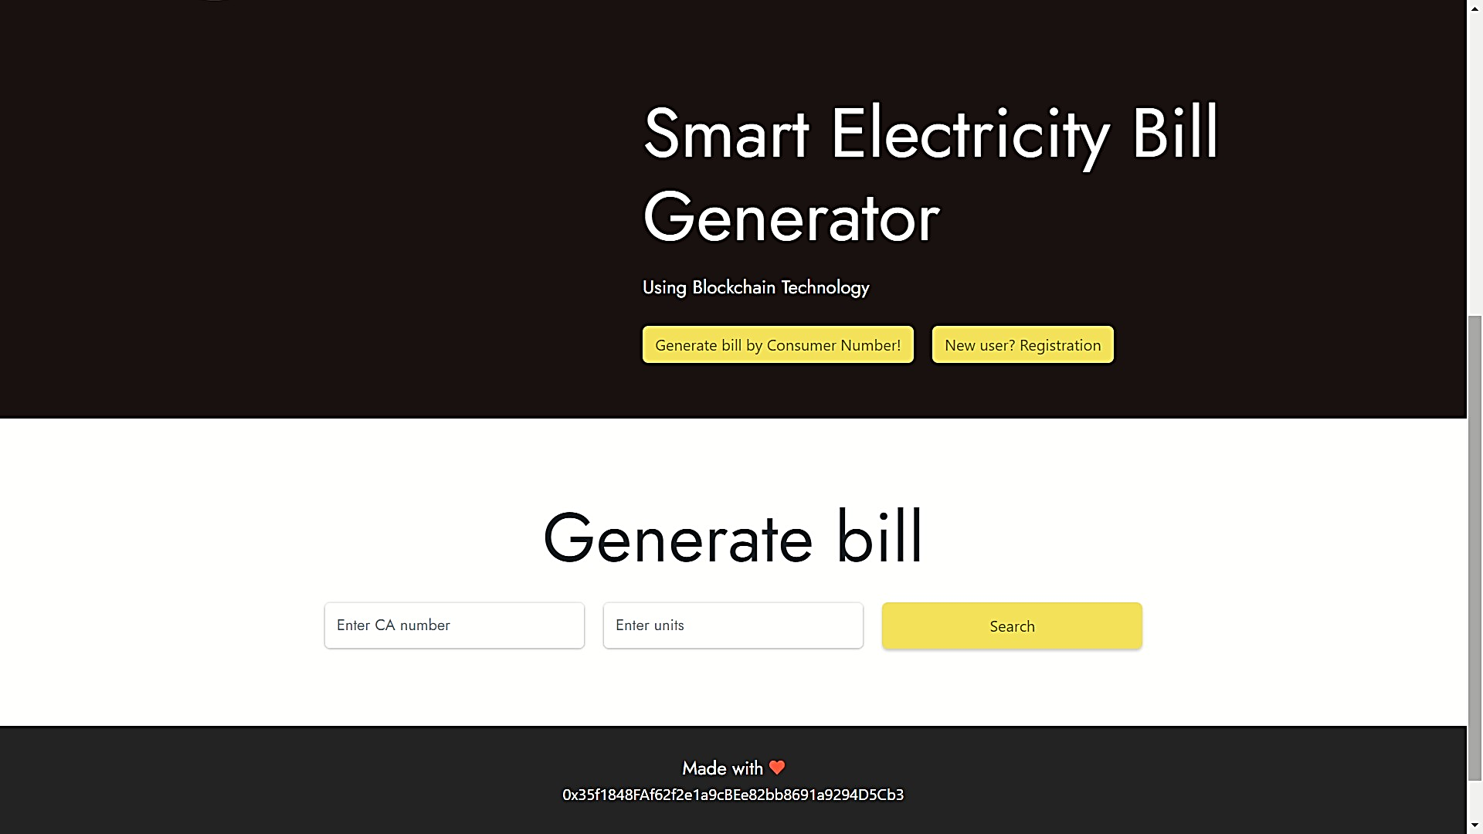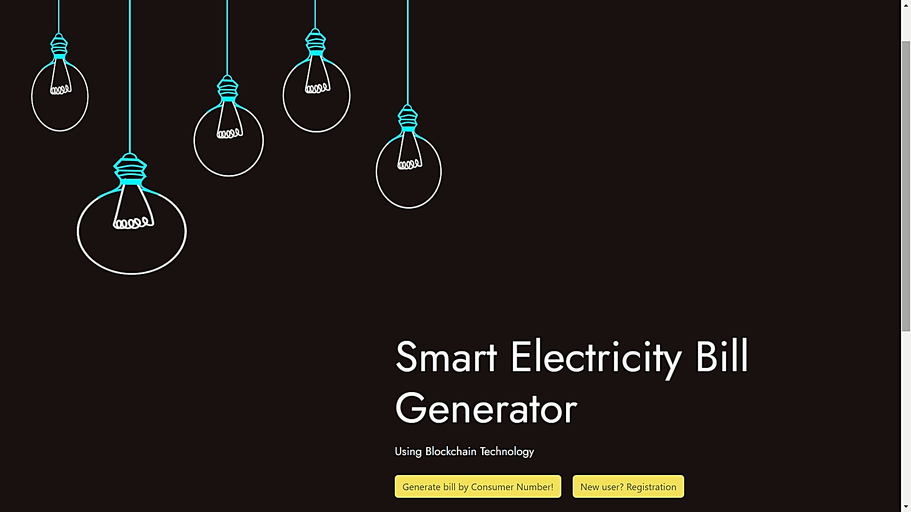

1. 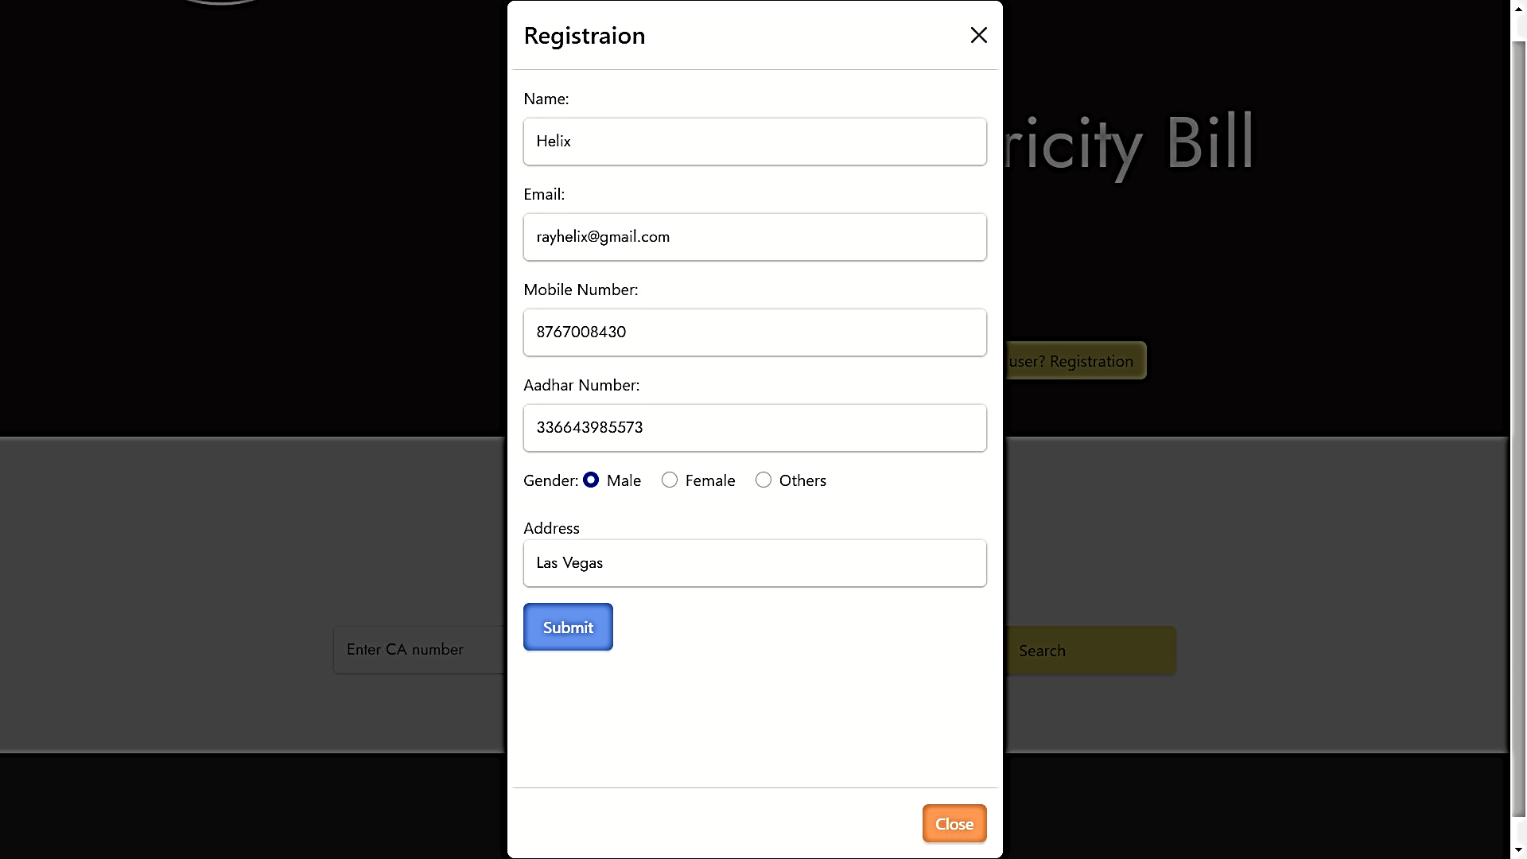**Registration**

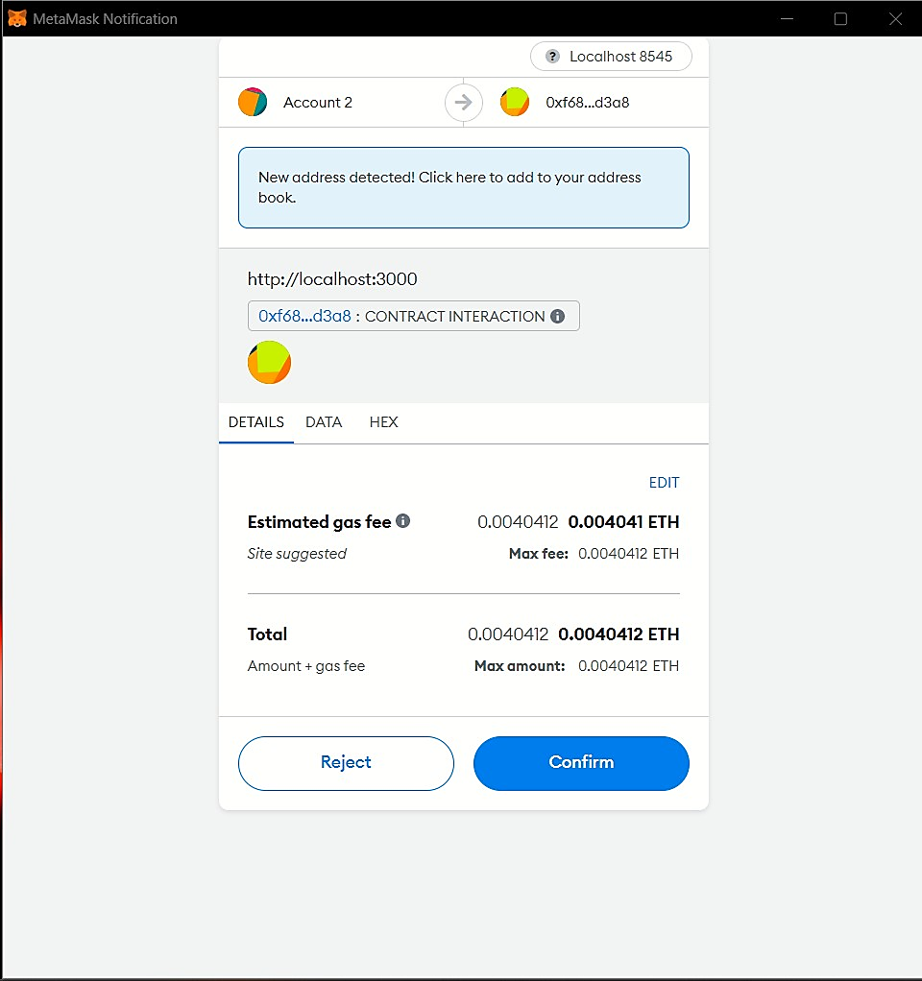

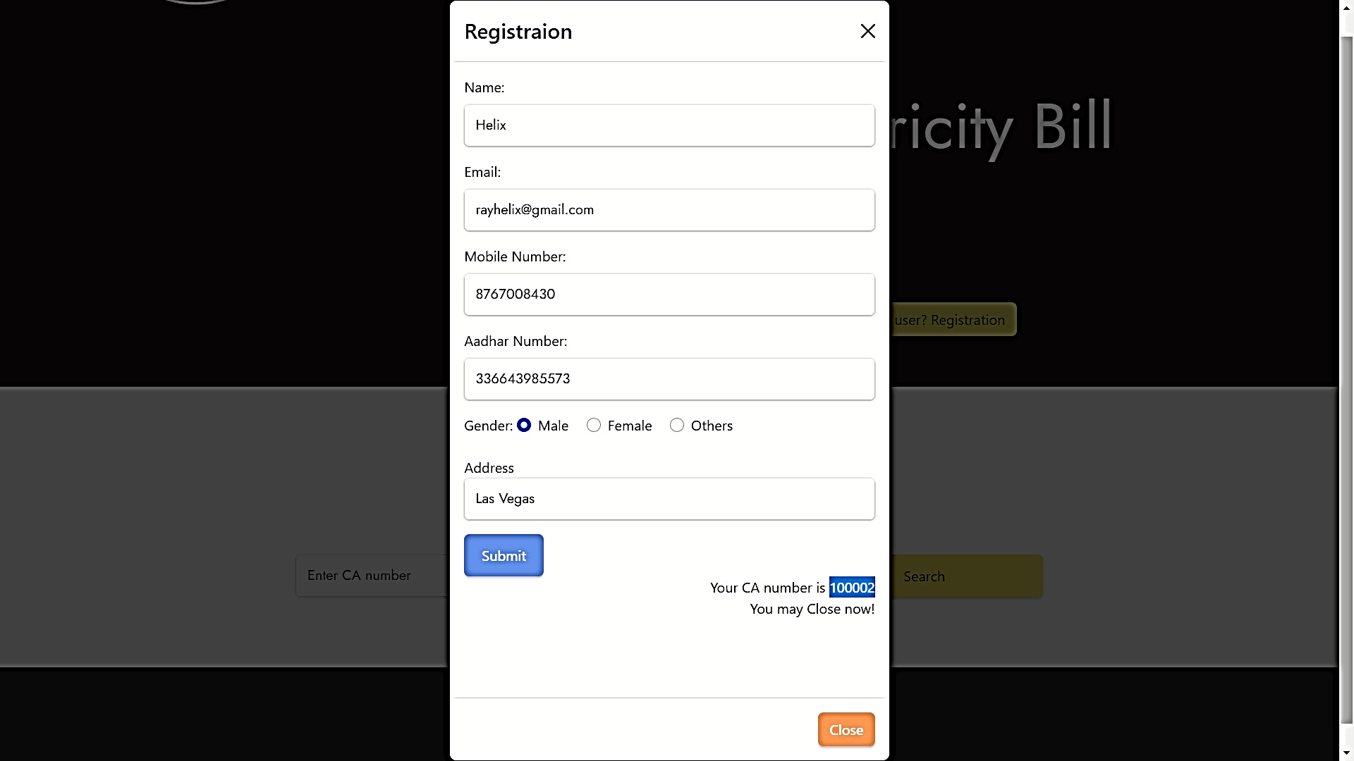

1. 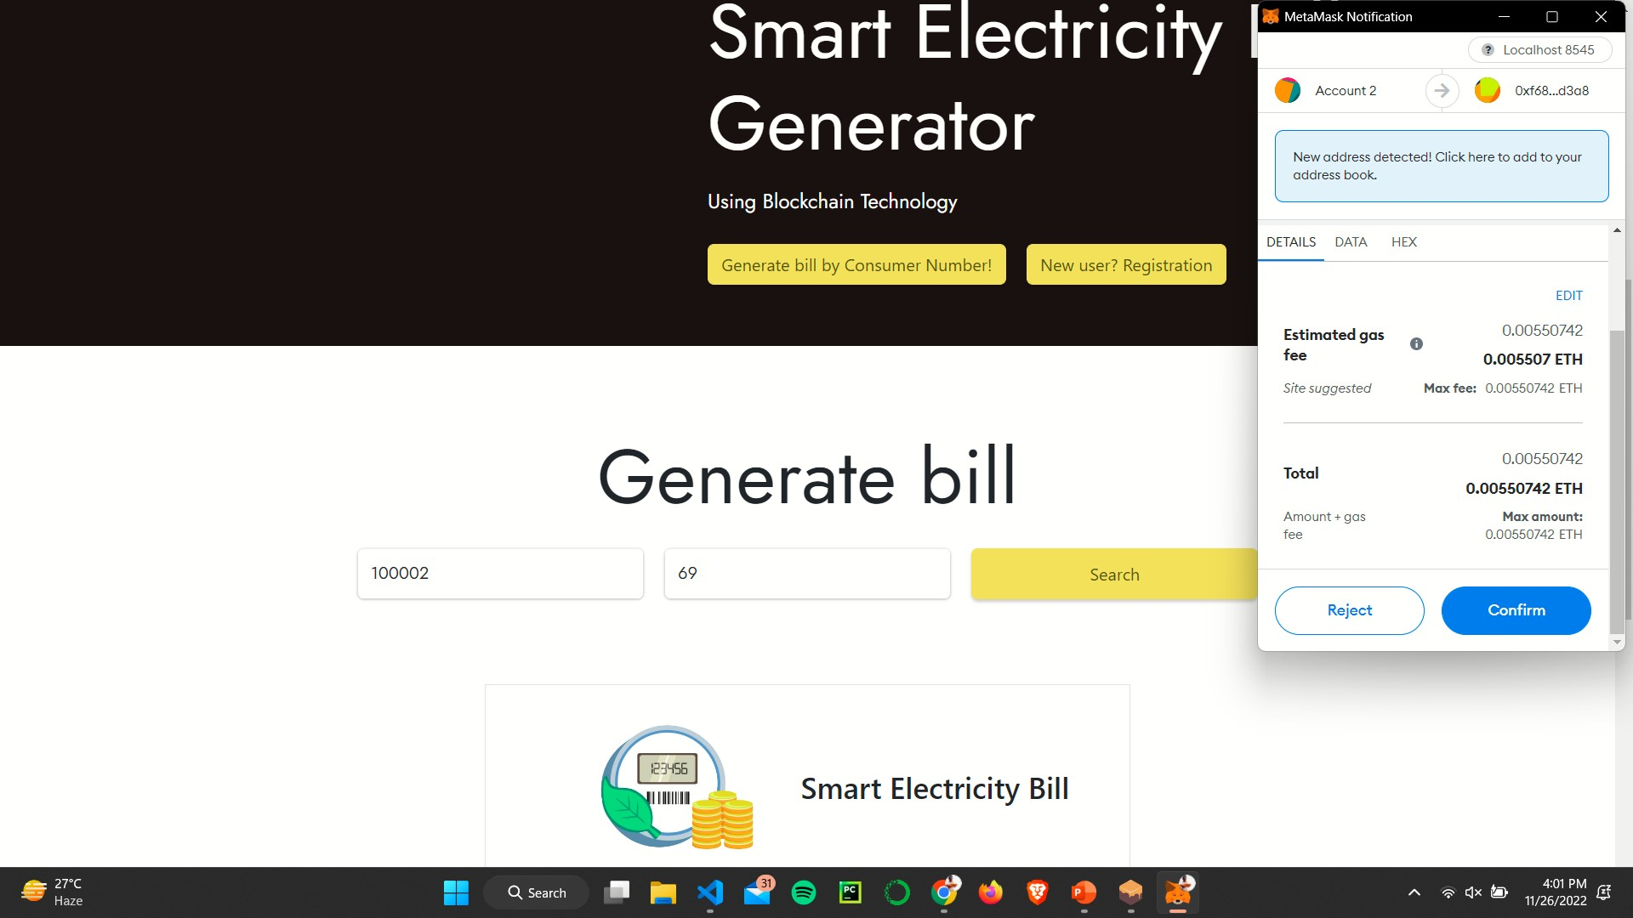**Electricity Bill Generation**
2. **Generated Electricity Bill**

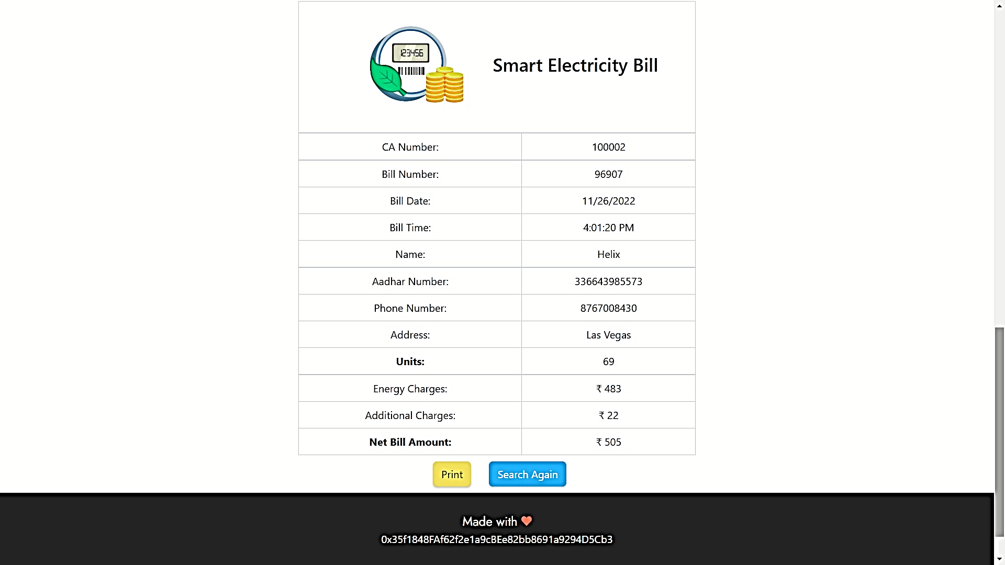

1. **Printing of Bill**

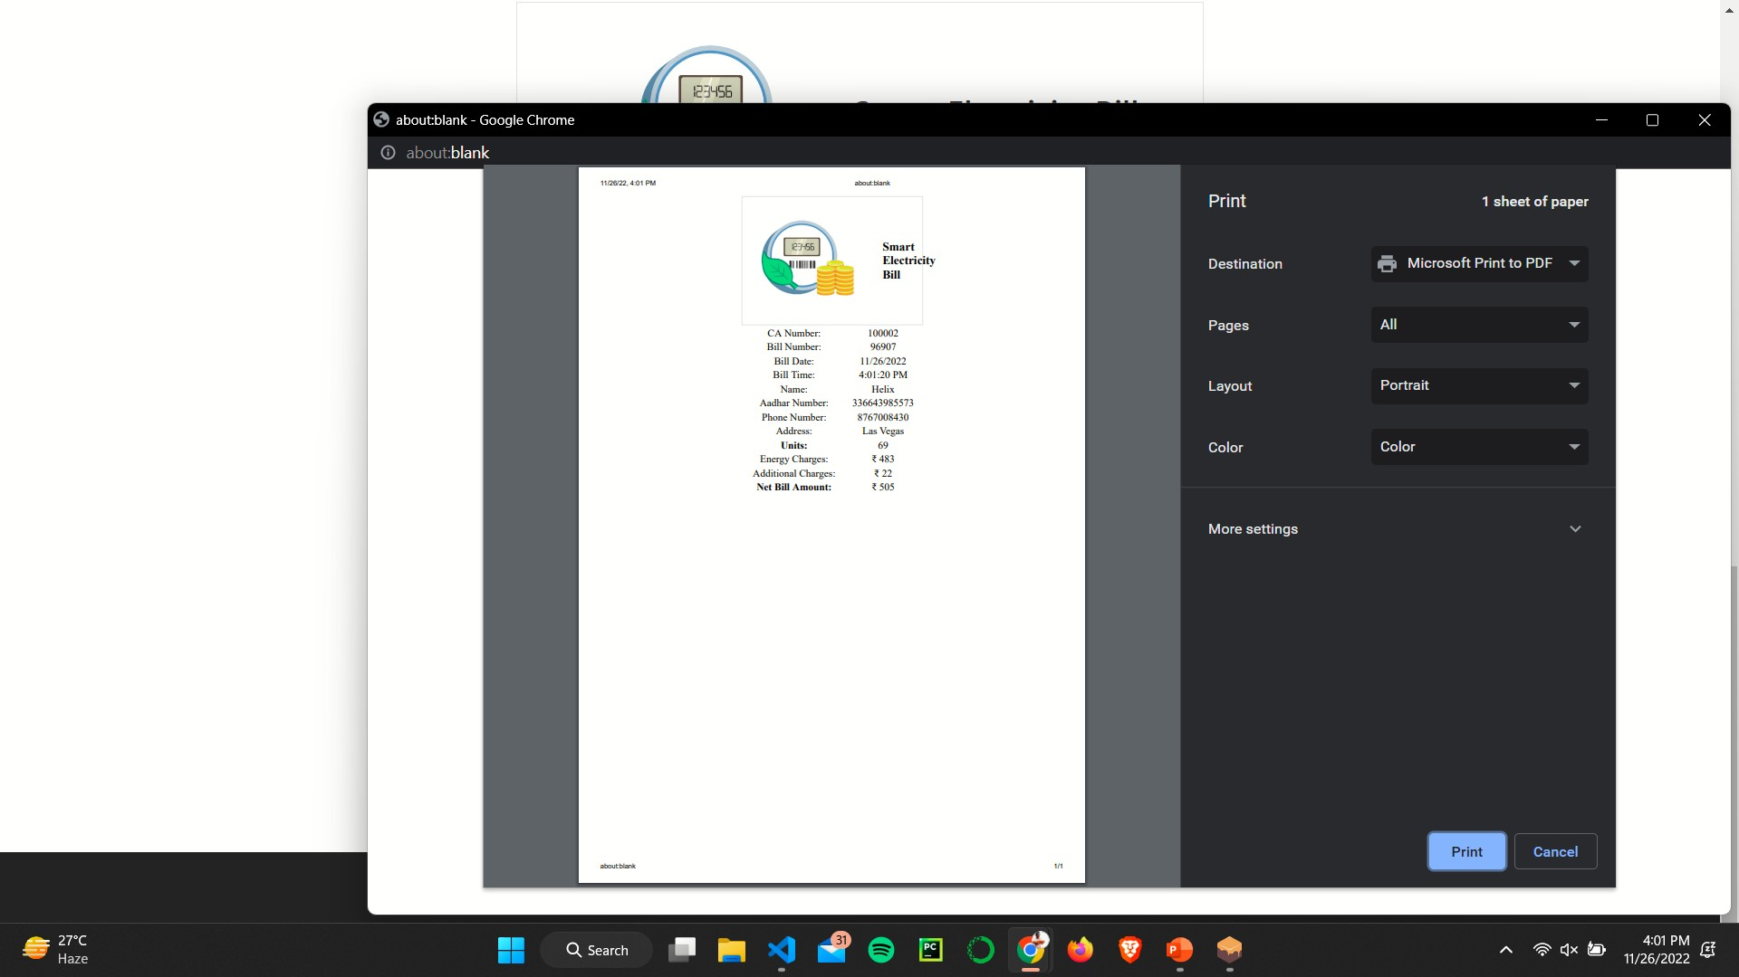

1. 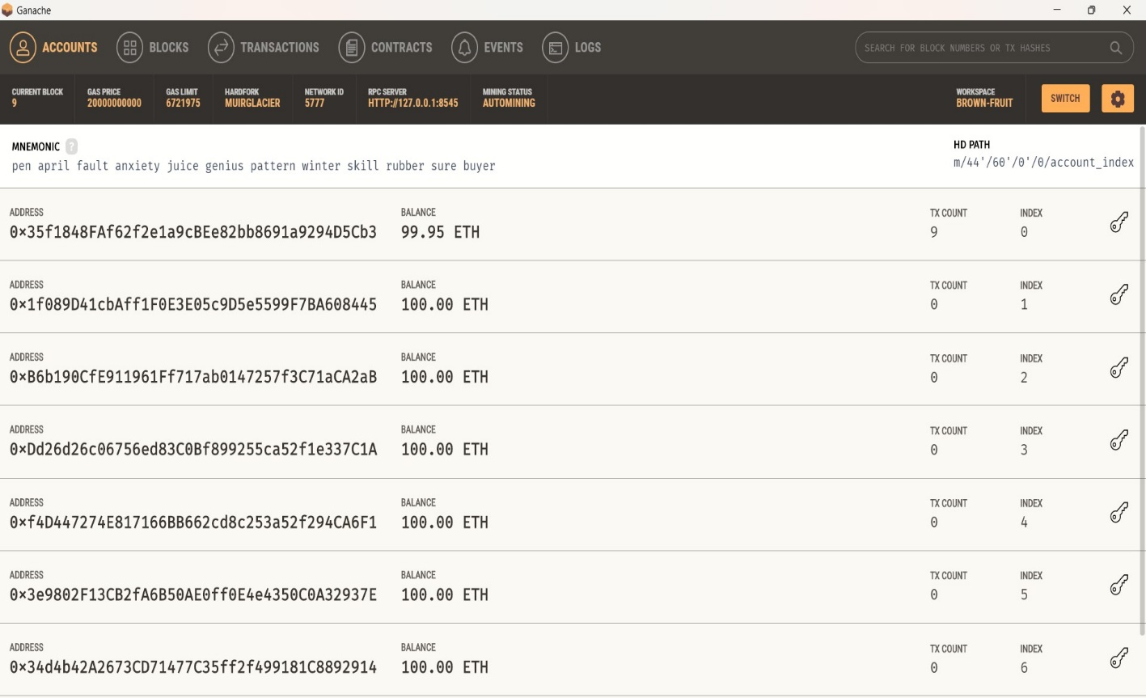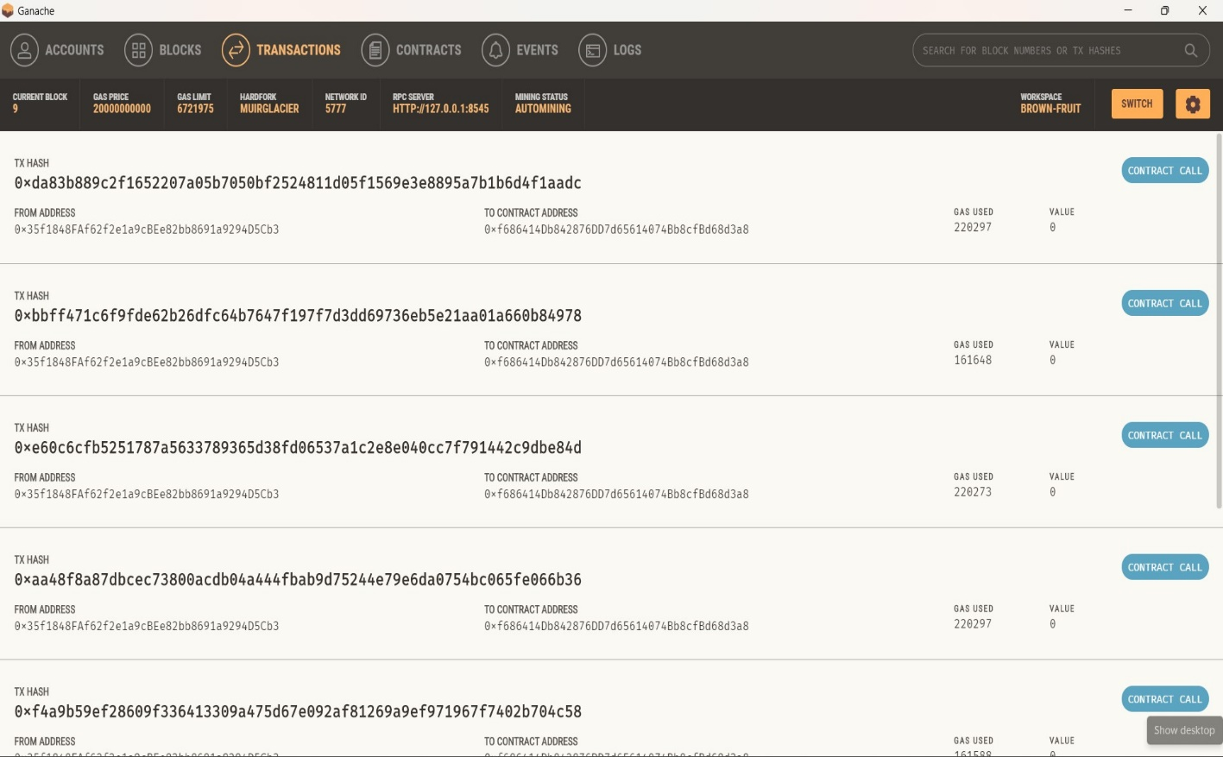**Transactions in Ganache**

# Conclusion and Future Scope

In this paper, we presented an approach to implement the electricity bill generator utilising a blockchain platform. The smart contract is designed to the make transactions and requests to the Ethereum Virtual Machine. We made this application which can be accessed through a web browser of a computer to generate electricity bill by providing CA number and number of units consumed.

In real implementation of this project, the electricity meter with plugged IoT device can periodically sends the electricity units consumed by the user over the Ethereum platform to generate the bill. Since it is feasible to build such a system, a further study involves the automatic generation of electricity bills based on the periodically received electricity units.

# References

1. Cao, Y., Energy Internet blockchain technology. The Energy Internet, (2019).

2. G. Wood, *Ethereum:* A secure decentralised generalised transaction ledger, (2014).

3. Mamula O, Mejzrova L Vodrazka J, Failure Analysis of Current and Future Electricity

Meters and their Components in Relation to the Costs of Ownership, (2018).

4. <https://ethereum.org>

5. https://solidity.readthedocs.io/en/v0.5.0/resources.html.

6. https://geth.ethereum.org 7.<https://www.trufflesuite.com>. 8.https://metamask.io.