**DBMS Assessment**

**Module-5) Se - Introduction To Dbms**

**COMMAND:**

[CREATE](http://localhost/phpmyadmin/url.php?url=https://dev.mysql.com/doc/refman/8.0/en/create-table.html" \t "mysql_doc) [TABLE](http://localhost/phpmyadmin/url.php?url=https://dev.mysql.com/doc/refman/8.0/en/create-table.html) salesman( saleman\_id int PRIMARY KEY, name varchar(30), city varchar(30), commission text );

**COMMAND:**

[CREATE](http://localhost/phpmyadmin/url.php?url=https://dev.mysql.com/doc/refman/8.0/en/create-table.html) [TABLE](http://localhost/phpmyadmin/url.php?url=https://dev.mysql.com/doc/refman/8.0/en/create-table.html) Customer ( customer\_id INT PRIMARY KEY, customer\_name VARCHAR(100), city VARCHAR(100), grade CHAR(1), saleman\_id INT, FOREIGN KEY (saleman\_id) REFERENCES Salesman(saleman\_id));

**COMMAND:**

[INSERT](http://localhost/phpmyadmin/url.php?url=https://dev.mysql.com/doc/refman/8.0/en/insert.html) INTO salesman (saleman\_id, name, city, commission) [VALUES](http://localhost/phpmyadmin/url.php?url=https://dev.mysql.com/doc/refman/8.0/en/miscellaneous-functions.html%23function_values) (101, 'Alex Brown', 'New York', '0.10'), (102, 'Mary Green', 'Chicago', '0.12'), (103, 'Peter Parker', 'Los Angeles', '0.08');

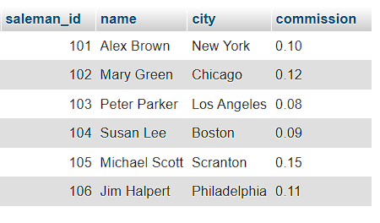

**COMMAND:**

[INSERT](http://localhost/phpmyadmin/url.php?url=https://dev.mysql.com/doc/refman/8.0/en/insert.html) INTO Customer (customer\_id, cust\_name, city, grade, saleman\_id) [VALUES](http://localhost/phpmyadmin/url.php?url=https://dev.mysql.com/doc/refman/8.0/en/miscellaneous-functions.html%23function_values) (1, 'John Doe', 'New York', 'A', 101), (2, 'Jane Smith', 'Chicago', 'B', 102), (3, 'Sam Wilson', 'Los Angeles', 'C', 103);

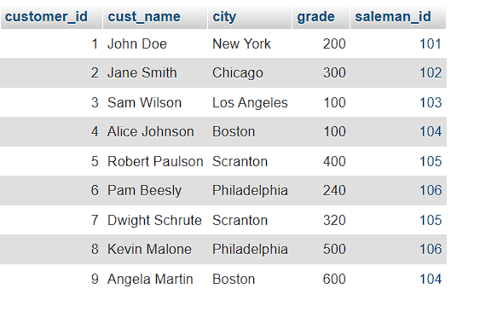

**COMMAND:**

[SELECT](http://localhost/phpmyadmin/url.php?url=https://dev.mysql.com/doc/refman/8.0/en/select.html) c.cust\_name AS CustomerName, c.city AS CustomerCity, s.name AS SalesmanName, s.commission AS SalesmanCommission FROM Customer c JOIN Salesman s ON c.saleman\_id = s.saleman\_id;

