EXPERIMENT – 10

TITLE: JAVA SWING

Name : RISHU KUMAR
Batch no. : 04
SAP ID : 500126596
Roll no. : R2142232046
Sem : 04

- 1.Write a Java Swing program to create a Login Form using JTextField, JPasswordField, JButton, and JLabel. When the login button is clicked, validate if the username is "admin" and the password is "password".

import java.awt.*;
import java.awt.event.*;
import javax.swing.*;

public class LoginForm extends JFrame implements ActionListener {
JTextField usernameField;
JPasswordField passwordField;
JButton loginButton;
JLabel message;

public LoginForm() {
setTitle("Login Form");
setSize(300, 200);
setDefaultCloseOperation(EXIT_ON_CLOSE);
setLayout(new GridLayout(4, 2));

add(new JLabel("Username:"));
usernameField = new JTextField();
add(usernameField);

add(new JLabel("Password:"));
passwordField = new JPasswordField();
add(passwordField);

loginButton = new JButton("Login");
loginButton.addActionListener(this);
add(loginButton);

message = new JLabel();
add(message);

setVisible(true);
}

public void actionPerformed(ActionEvent e) {
String username = usernameField.getText();
String password = new String(passwordField.getPassword());

if (username.equals("admin") && password.equals("password")) {
message.setText("Login Successful!");
} else {
message.setText("Invalid credentials");
}
}

public static void main(String[] args) {
new LoginForm();
}
}

OUTPUT :-

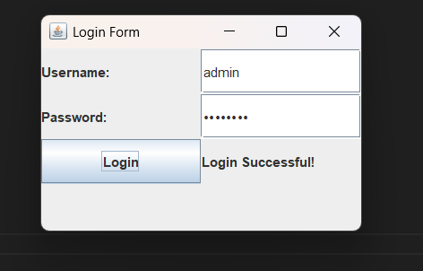

- Design a simple calculator using Java Swing with buttons for digits (0-9), addition (+), subtraction (-), multiplication (*), and division (/). Implement event handling for button clicks and display the result in a JTextField.

import javax.swing.*;
import java.awt.*;
import java.awt.event.*;

public class SimpleCalculator extends JFrame implements ActionListener {
JTextField display;
String operand1 = "", operator = "", operand2 = "";

public SimpleCalculator() {
setTitle("Calculator");
setSize(300, 400);
setLayout(new BorderLayout());

display = new JTextField();
display.setEditable(false);
add(display, BorderLayout.NORTH);

JPanel panel = new JPanel(new GridLayout(4, 4));
String[] buttons = {
"7", "8", "9", "/",
"4", "5", "6", "*",
"1", "2", "3", "-",
"0", "C", "=", "+"
};

for (String text : buttons) {
JButton btn = new JButton(text);
btn.addActionListener(this);
panel.add(btn);
}

add(panel, BorderLayout.CENTER);
setDefaultCloseOperation(EXIT_ON_CLOSE);
setVisible(true);
}

public void actionPerformed(ActionEvent e) {
String input = e.getActionCommand();

if (input.matches("[0-9]")) {
if (operator.isEmpty()) {
operand1 += input;
display.setText(operand1);
} else {
operand2 += input;
display.setText(operand2);
}
} else if (input.matches("[+\\-*/]")) {
operator = input;
} else if (input.equals("=")) {
double num1 = Double.parseDouble(operand1);
double num2 = Double.parseDouble(operand2);
double result = 0;

switch (operator) {
case "+": result = num1 + num2; break;
case "-": result = num1 - num2; break;
case "*": result = num1 * num2; break;
case "/": result = num2 != 0 ? num1 / num2 : 0; break;
}

display.setText("" + result);
operand1 = "" + result;
operand2 = "";
operator = "";
} else if (input.equals("C")) {
operand1 = operand2 = operator = "";
display.setText("");
}
}

public static void main(String[] args) {
new SimpleCalculator();
}
}

OUTPUT:-
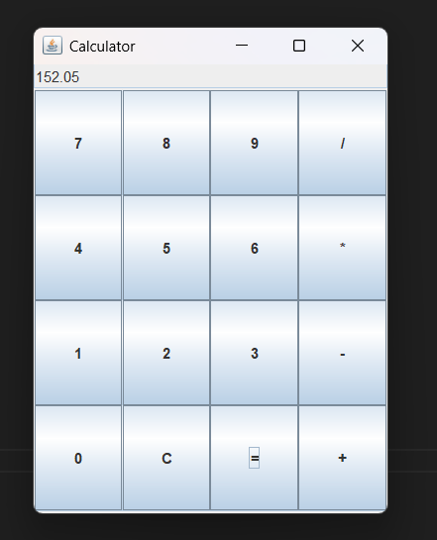

- Write a Java Swing program to implement a To-Do List using JList. Provide:
a.A JTextField to enter tasks
b.An Add button to add tasks to the list
c.A Remove button to delete selected tasks

import javax.swing.*;
import java.awt.*;
import java.awt.event.*;

public class ToDoList extends JFrame {
DefaultListModel<String> listModel = new DefaultListModel<>();
JList<String> taskList = new JList<>(listModel);
JTextField taskField = new JTextField(20);
JButton addButton = new JButton("Add");
JButton removeButton = new JButton("Remove");

public ToDoList() {
setTitle("To-Do List");
setLayout(new FlowLayout());
setSize(350, 300);
setDefaultCloseOperation(EXIT_ON_CLOSE);

add(new JLabel("Enter Task:"));
add(taskField);
add(addButton);
add(removeButton);

add(new JScrollPane(taskList));

addButton.addActionListener(e -> {
String task = taskField.getText();
if (!task.isEmpty()) {
listModel.addElement(task);
taskField.setText("");
}
});

removeButton.addActionListener(e -> {
int index = taskList.getSelectedIndex();
if (index != -1) {
listModel.remove(index);
}
});

setVisible(true);
}

public static void main(String[] args) {
new ToDoList();
}
}

OUTPUT:-
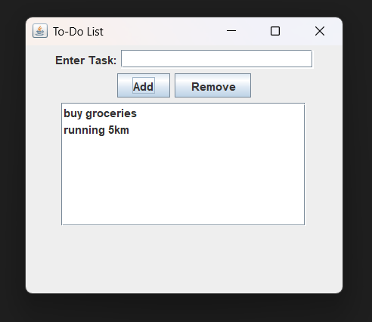

- Write a Java Swing program to create a Registration Form that collects user details such as Name, Email, Password, and Confirm Password. Use a combination of JTextField for the name and email inputs, JPasswordField for the password inputs, and a JButton labeled "Register". When the Register button is clicked, validate that none of the fields are empty, that the Password and Confirm Password fields match, and that the email appears valid (for example, containing an “@” symbol). Display a success message on the form if all validations pass; otherwise, show appropriate error messages next to the respective fields.

import javax.swing.*;
import java.awt.*;
import java.awt.event.*;

public class RegistrationForm extends JFrame implements ActionListener {
JTextField nameField, emailField;
JPasswordField passField, confirmPassField;
JLabel messageLabel;

public RegistrationForm() {
setTitle("Registration Form");
setLayout(new GridLayout(6, 2));
setSize(400, 250);
setDefaultCloseOperation(EXIT_ON_CLOSE);

add(new JLabel("Name:"));
nameField = new JTextField();
add(nameField);

add(new JLabel("Email:"));
emailField = new JTextField();
add(emailField);

add(new JLabel("Password:"));
passField = new JPasswordField();
add(passField);

add(new JLabel("Confirm Password:"));
confirmPassField = new JPasswordField();
add(confirmPassField);

JButton registerButton = new JButton("Register");
registerButton.addActionListener(this);
add(registerButton);

messageLabel = new JLabel();
add(messageLabel);

setVisible(true);
}

public void actionPerformed(ActionEvent e) {
String name = nameField.getText().trim();
String email = emailField.getText().trim();
String pass = new String(passField.getPassword());
String confirmPass = new String(confirmPassField.getPassword());

if (name.isEmpty() || email.isEmpty() || pass.isEmpty() || confirmPass.isEmpty()) {
messageLabel.setText("All fields are required.");
} else if (!email.contains("@")) {
messageLabel.setText("Invalid email address.");
} else if (!pass.equals(confirmPass)) {
messageLabel.setText("Passwords do not match.");
} else {
messageLabel.setText("Registration Successful!");
}
}

public static void main(String[] args) {
new RegistrationForm();
}
}

OUTPUT:-

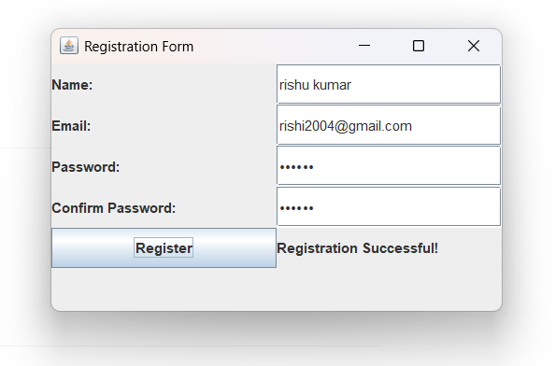

- Write a Java Swing program to implement a simple Stopwatch. The GUI should include a JLabel to display the elapsed time (in seconds) and three JButtons labeled "Start", "Stop", and "Reset". Use a Swing Timer to update the JLabel every second while the stopwatch is running. The "Start" button should begin timing, the "Stop" button should pause the timer, and the "Reset" button should set the elapsed time back to zero. Ensure that the GUI updates correctly based on the user’s interactions.

import javax.swing.*;
import java.awt.*;
import java.awt.event.*;

public class Stopwatch extends JFrame {
private int elapsedSeconds = 0;
private Timer timer;
private JLabel timeLabel;
private JButton startButton, stopButton, resetButton;

public Stopwatch() {
setTitle("Stopwatch");
setSize(300, 150);
setLayout(new FlowLayout());
setDefaultCloseOperation(EXIT_ON_CLOSE);

timeLabel = new JLabel("Time: 0 sec");
add(timeLabel);

startButton = new JButton("Start");
stopButton = new JButton("Stop");
resetButton = new JButton("Reset");

add(startButton);
add(stopButton);
add(resetButton);

timer = new Timer(1000, e -> {
elapsedSeconds++;
timeLabel.setText("Time: " + elapsedSeconds + " sec");
});

startButton.addActionListener(e -> timer.start());
stopButton.addActionListener(e -> timer.stop());
resetButton.addActionListener(e -> {
timer.stop();
elapsedSeconds = 0;
timeLabel.setText("Time: 0 sec");
});

setVisible(true);
}

public static void main(String[] args) {
new Stopwatch();
OUTPUT:- 