Name : RISHU KUMAR
Batch no. : 04
SAP ID : 500126596
Roll no. : R2142232046
Sem : 04
EXPERIMENT :- 3

- Write a Java program that counts how many times a given number appears in an array.

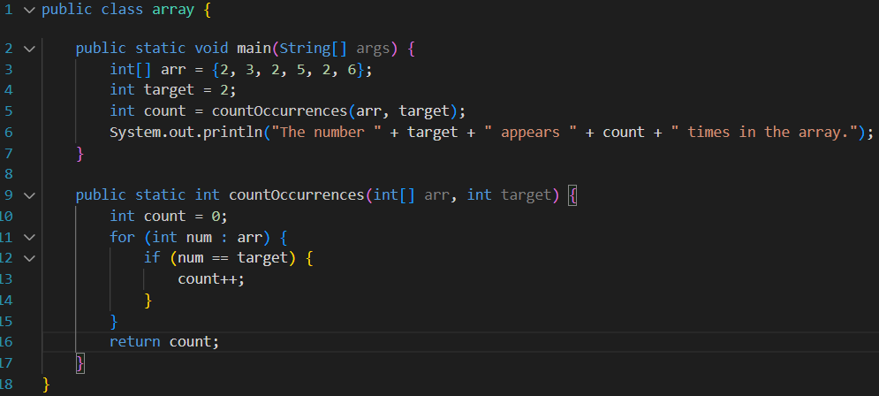

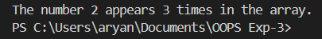

- Given an array containing N-1 unique numbers from 1 to N, write a Java program to find the missing number.

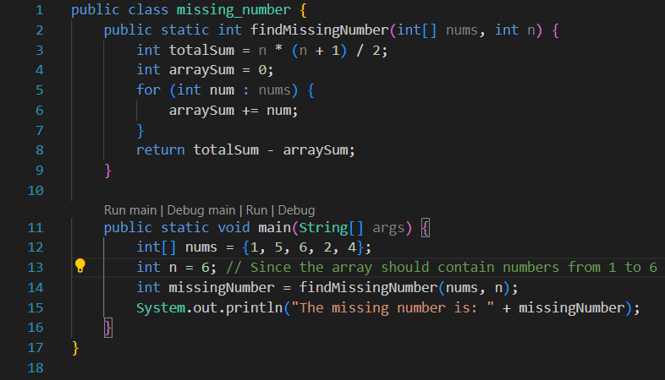

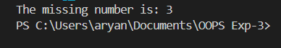

- Write a Java program to find the second largest element in an integer array without sorting the array, if not exist return -1.

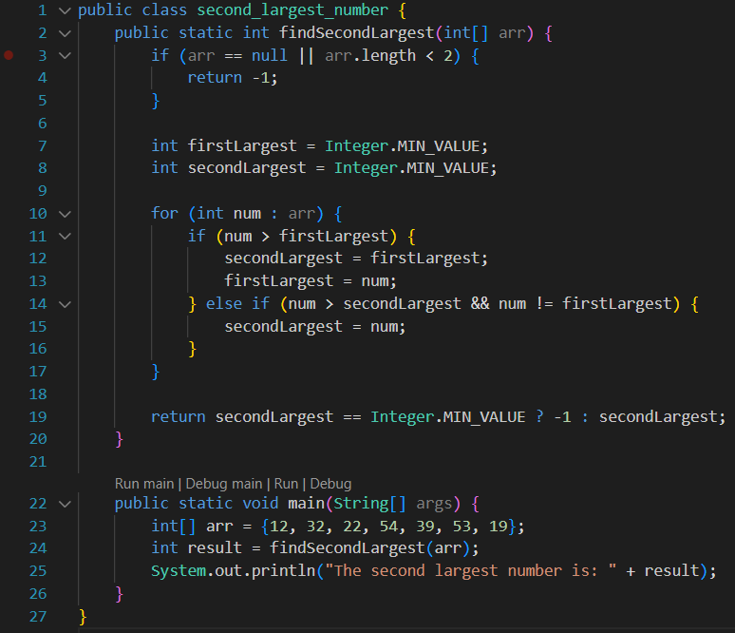

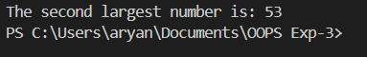

- Given two strings s and t, return true if t is an anagram of s, and false otherwise.

