Name : RISHU KUMAR
Batch no. : 04
SAP ID : 500126596
Roll no. : R2142232046
Sem : 04

EXPERIMENT – 5

- Write a Java program to demonstrate that a private member of a superclass cannot be accessed directly from a derived class.

public class sup {
private int privateVar = 10;

public int getPrivateVar() {
return privateVar;
}

public static void main(String[] args) {
sub obj = new sub();
System.out.println("Private variable accessed through getter: " + obj.getPrivateVar());
}
}

class sub extends sup {
public void display() {
// System.out.println(privateVar); // This will cause a compilation error
System.out.println("Private variable accessed through getter: " + getPrivateVar());
}
}
Output:-
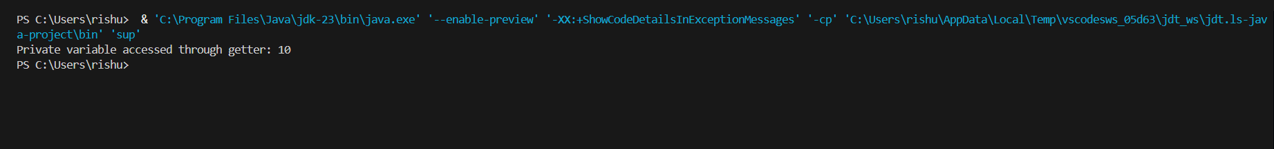

- Design a Java class Employee with attributes name, empid, and salary. Implement a default
constructor, a parameterized constructor, and methods to return the employee’s name and salary. Add a method increaseSalary(double percentage) to raise the salary by a userspecified percentage. Create a subclass Manager with an additional instance variable department. Develop a test program to validate these functionalities.

public class Employee {
private String name;
private double salary;

public Employee() {
this.name = "";
this.salary = 0.0;
}

public Employee(String name, int empid, double salary) {
this.name = name;
this.salary = salary;
}

public String getName() {
return name;
}

public double getSalary() {
return salary;
}

public void increaseSalary(double percentage) {
if (percentage > 0) {
salary += salary * percentage / 100;
}
}
}

class Manager extends Employee {
private String department;

public Manager(String name, int empid, double salary, String department) {
super(name, empid, salary);
this.department = department;
}

public String getDepartment() {
return department;
}
}

class TestProgram {
public static void main(String[] args) {
Employee emp = new Employee("John Doe", 12345, 50000);
System.out.println("Employee Name: " + emp.getName());
System.out.println("Employee Salary: " + emp.getSalary());
emp.increaseSalary(10);
System.out.println("Employee Salary after increase: " + emp.getSalary());

Manager mgr = new Manager("Jane Smith", 67890, 70000, "HR");
System.out.println("Manager Name: " + mgr.getName());
System.out.println("Manager Salary: " + mgr.getSalary());
System.out.println("Manager Department: " + mgr.getDepartment());
mgr.increaseSalary(15);
System.out.println("Manager Salary after increase: " + mgr.getSalary());
}
}
Output:-
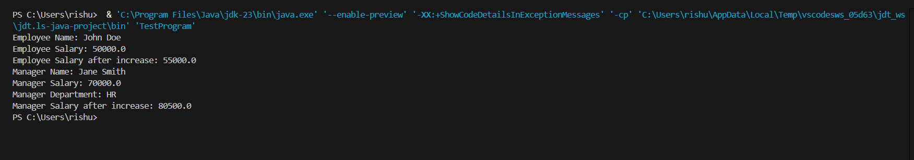

- A university has different types of people associated with it, including staff members and students. The base class Person contains common attributes such as name, age, and address.The class Staff extends Person and adds attributes like staffId and department. Further, a subclass Professor extends Staff by introducing an additional attribute, specialization, and a method conductLecture(). Similarly, the Student class extends Person and adds studentId and course. Finally, the subclassGraduateStudent extends Student, adding researchTopic and a method submitThesis(). Implement this university management system in Java using multilevel inheritance andmethodoverriding.Demonstrate polymorphism by creating an array of Person objects containing instances of Professor and GraduateStudent, and call their respective methods.

public class person {
private String name;
private int age;
private String address;

public person(String name, int age, String address) {
this.name = name;
this.age = age;
this.address = address;
}

public void displayInfo() {
System.out.println("Name: " + name);
System.out.println("Age: " + age);
System.out.println("Address: " + address);
}
}

class Staff extends person {
private String staffId;
private String department;

public Staff(String name, int age, String address, String staffId, String department) {
super(name, age, address);
this.staffId = staffId;
this.department = department;
}

@Override
public void displayInfo() {
super.displayInfo();
System.out.println("Staff ID: " + staffId);
System.out.println("Department: " + department);
}
}

class Professor extends Staff {
private String specialization;

public Professor(String name, int age, String address, String staffId, String department, String specialization) {
super(name, age, address, staffId, department);
this.specialization = specialization;
}

public void conductLecture() {
System.out.println("Conducting lecture on " + specialization);
}

@Override
public void displayInfo() {
super.displayInfo();
System.out.println("Specialization: " + specialization);
}
}

class Student extends person {
private String studentId;
private String course;

public Student(String name, int age, String address, String studentId, String course) {
super(name, age, address);
this.studentId = studentId;
this.course = course;
}

@Override
public void displayInfo() {
super.displayInfo();
System.out.println("Student ID: " + studentId);
System.out.println("Course: " + course);
}
}

class GraduateStudent extends Student {
private String researchTopic;

public GraduateStudent(String name, int age, String address, String studentId, String course, String researchTopic) {
super(name, age, address, studentId, course);
this.researchTopic = researchTopic;
}

public void submitThesis() {
System.out.println("Submitting thesis on " + researchTopic);
}

@Override
public void displayInfo() {
super.displayInfo();
System.out.println("Research Topic: " + researchTopic);
}
}

Output:-

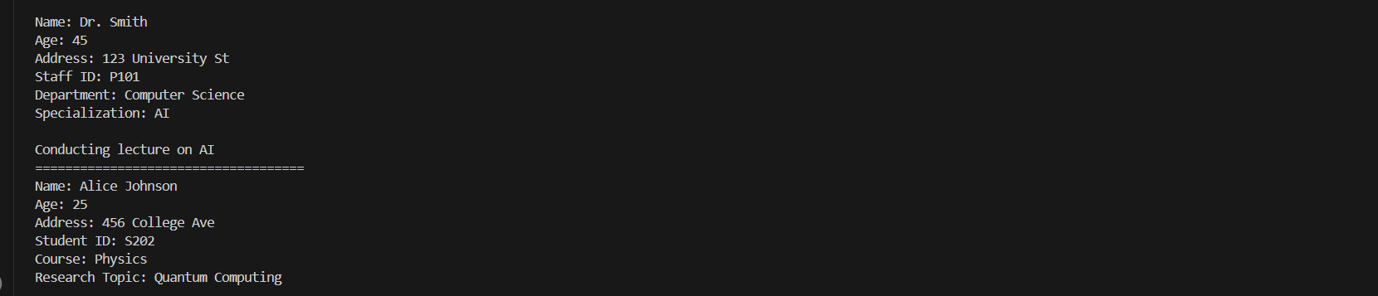

- Design an abstract class named Vehicle with abstract methods such as startEngine() and stopEngine(), as well as a non-abstract method serviceInfo() that prints basic servicing instructions. Include a couple of protected or private fields (e.g., make, model) and a constructor for Vehicle that initializes those fields.Create a concrete class Car that extends Vehicle and provides implementations for startEngine() and stopEngine(). Within these methods, include print statements or logic that simulates starting and stopping a car engine. Finally, instantiate a Car object in the main method, call all available methods (including the inherited non-abstract method), and verify that your abstraction works as intended.
public class Car extends Vehicle {

public Car(String make, String model) {
super(make, model);
}

@Override
public void startEngine() {
System.out.println("Car engine starting");
}

@Override
public void stopEngine() {
System.out.println("Car engine stopping");
}

public static void main(String[] args) {
Car myCar = new Car("Toyota", "Camry");
myCar.startEngine();
myCar.stopEngine();
myCar.serviceInfo();
}
}

public abstract class Vehicle {
protected String make;
protected String model;

public Vehicle(String make, String model) {
this.make = make;
this.model = model;
}

public abstract void startEngine();

public abstract void stopEngine();

public void serviceInfo() {
System.out.println("Basic servicing instructions for " + make + " " + model + ":");
System.out.println("1. Check engine oil level.");
System.out.println("2. Inspect tire pressure.");
System.out.println("3. Replace air filter as needed.");
}
}
Output:-

- Imagine you’re designing a restaurant management system where you have a base class called Chef with a method makeSpecialDish(). This method simply prints a generic message indicating that the chef is making a special dish. Next, create three subclasses called ItalianChef, ChineseChef, and MexicanChef—each overrides makeSpecialDish() with a distinct print statement, such as "Making pasta", "Making dumplings", or "Making tacos".
In your main method, declare an array or list of Chef references, but assign each element to a different subclass (ItalianChef, ChineseChef, MexicanChef). Use a loop to call the makeSpecialDish() method on each array element and observe how runtime polymorphism ensures that the correct subclass version of makeSpecialDish() is invoked.

public class Chef {
public void makeSpecialDish() {
System.out.println("The chef is making a special dish.");
}

public static void main(String[] args) {
Chef[] chefs = {new ItalianChef(), new ChineseChef(), new MexicanChef()};

for (Chef chef : chefs) {
chef.makeSpecialDish();
}
}
}

class ItalianChef extends Chef {
@Override
public void makeSpecialDish() {
System.out.println("Making pasta");
}
}

class ChineseChef extends Chef {
@Override
public void makeSpecialDish() {
System.out.println("Making dumplings");
}
}

class MexicanChef extends Chef {
@Override
public void makeSpecialDish() {
System.out.println("Making tacos");
}
}

Output:-
