Name : RISHU KUMAR
Batch no. : 04
SAP ID : 500126596
Roll no. : R2142232046
Sem : 04
Experiment -2

TITLE: Basic Java Programming

- Print this Pattern:

*****
****
***
**
*
public class pattern {
public static void main(String[] args) {
int n = 5; // Number of rows
for (int i = 0; i < n; i++) {
for (int j = 0; j < i; j++) {
System.out.print(" ");
}
for (int j = i; j < n; j++) {
System.out.print("*");
}
System.out.println();
}
}
}
output:-
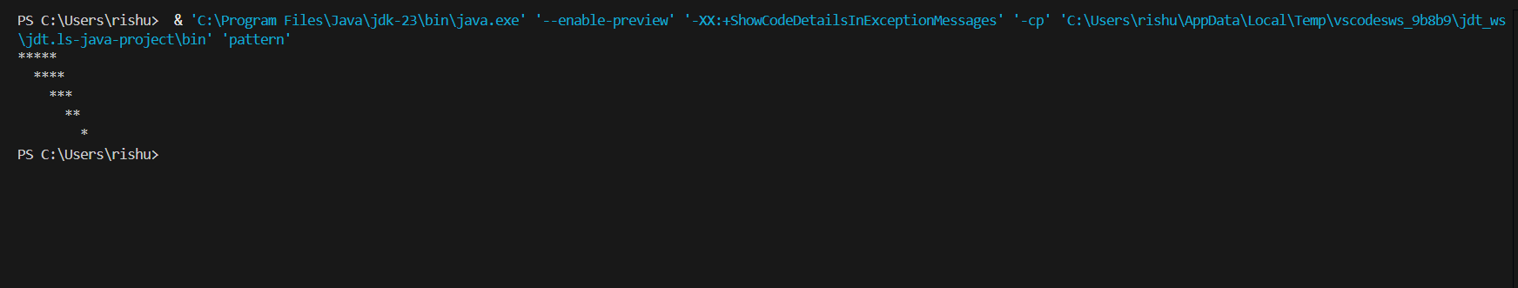

- Write a Java program that calculates the electricity bill based on the number of units consumed by a user. The electricity charges are determined as follows:
- For consumption between 1 and 100 units, the cost is Rs 5 per unit.
- For consumption between 101 and 200 units, the cost is Rs 7 per unit.
- For consumption between 201 and 300 units, the cost is Rs 10 per unit.
- For consumption exceeding 300 units, the cost is Rs 15 per unit.
The program should:
- Take the total units consumed as input.
- Calculate the total electricity bill based on the charges above.
- Display the total electricity bill.
Example Input/Output:
- Input: 150
- Output: The total electricity bill is Rs 850.

import java.util.Scanner;

public class Electricity_bill {
public static void main(String[] args) {
Scanner scanner = new Scanner(System.in);
System.out.print("Enter the total units consumed: ");
int units = scanner.nextInt();
double bill = calculateBill(units);
System.out.println("The total electricity bill is: Rs " + bill);
scanner.close();
}

public static double calculateBill(int units) {
double bill = 0;
if (units <= 100) {
bill = units * 5;
} else if (units <= 200) {
bill = 100 * 5 + (units - 100) * 7;
} else if (units <= 300) {
bill = 100 * 5 + 100 * 7 + (units - 200) * 10;
} else {
bill = 100 * 5 + 100 * 7 + 100 * 10 + (units - 300) * 15;
}
return bill;
}
}
Output:-
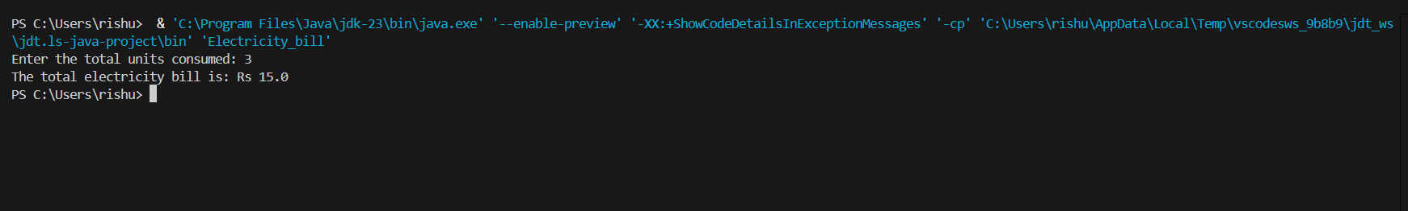

- Write a program to find the area of a shape (Rectangle, Square, Circle, Triangle) using method overloading.

public class area {
// Method to calculate the area of a rectangle
public double calculateArea(double length, double breadth) {
return length * breadth;
}

// Method to calculate the area of a square
public double calculateArea(double side) {
return side * side;
}

// Method to calculate the area of a circle
public double calculateArea(double radius, boolean isCircle) {
if (isCircle) {
return Math.PI * radius * radius;
}
return 0;
}

// Method to calculate the area of a triangle
public double calculateArea(double base, double height, boolean isTriangle) {
if (isTriangle) {
return 0.5 * base * height;
}
return 0;
}

public static void main(String[] args) {
area shape = new area();

// Rectangle
System.out.println("Area of Rectangle: " + shape.calculateArea(5, 10));

System.out.println("Area of Square: " + shape.calculateArea(4));

// Circle
System.out.println("Area of Circle: " + shape.calculateArea(7, true));

// Triangle
System.out.println("Area of Triangle: " + shape.calculateArea(6, 8, true));
}
}
Output:-

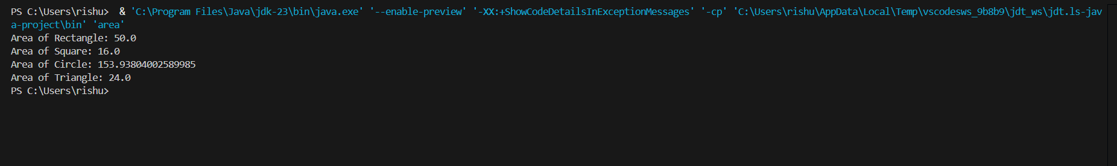
- Write a Java program that takes an operator (+, -, *, /, %) and two numbers as input from the user. Use a switch statement to perform the specified operation and display the result.
import java.util.Scanner;

public class Operator {
public static void main(String[] args) {
Scanner scanner = new Scanner(System.in);

System.out.print("Enter first number: ");
double num1 = scanner.nextDouble();

System.out.print("Enter second number: ");
double num2 = scanner.nextDouble();

System.out.print("Enter an operator (+, -, *, /, %): ");
char operator = scanner.next().charAt(0);

double result;

switch (operator) {
case '+':
result = num1 + num2;
break;
case '-':
result = num1 - num2;
break;
case '*':
result = num1 * num2;
break;
output:-
