Design Sample - <https://course.learnbay.co/s2-data-science>

Header will same like



Left Side Logo

Right Side Call Now Button. Phone Number – 9205534439

Second Section



Content

Top CAT 2023/24 Coaching Institute in Delhi

**Crack CAT & Other MBA Entrances in First Attempt & Target 99+ Percentile**

**Apply For Counselling (Button)**

**Images are attached**

6192+ IIM Selections

Right Side will appear form like below

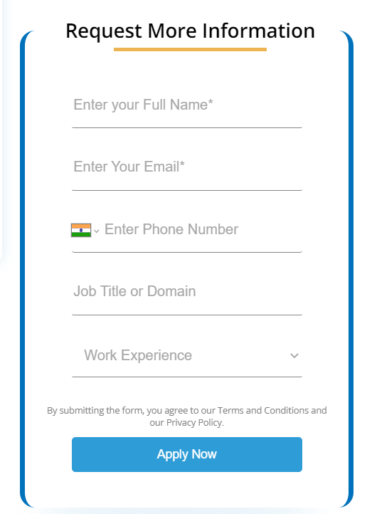

Filed will

Name

Email ID

Phone Number

Apply for (Dropdown) CAT 2023/CAT 2024

Message



This section

**Best IIM Success Ratio**

6192+ IIM Selections  
1100+ IIM calls in Last Year

**Learning**

500+ hours Classroom Sessions  
Free Recorded Course

**Personalised Attention**

Unlimited one-to-one doubt sessions

**Highly Experienced Faculty**

Actual consistently 99.99%ile cracker faculty members.

Like This

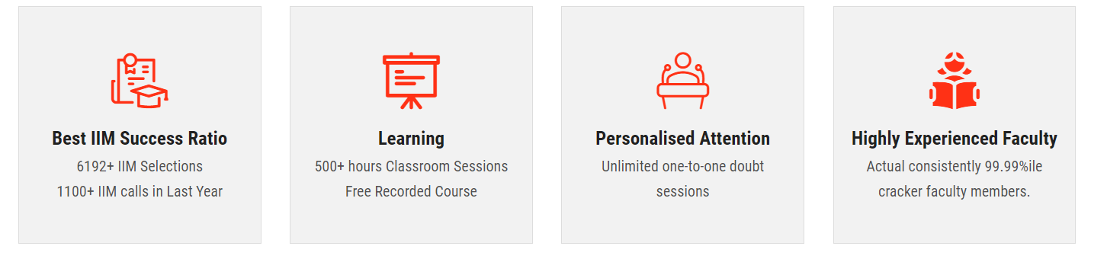

This Section



Full width with 4 section

**2022 CAT Result**

8 total dummy images, Name & Add below button for popup details image

**Student Testimonials**

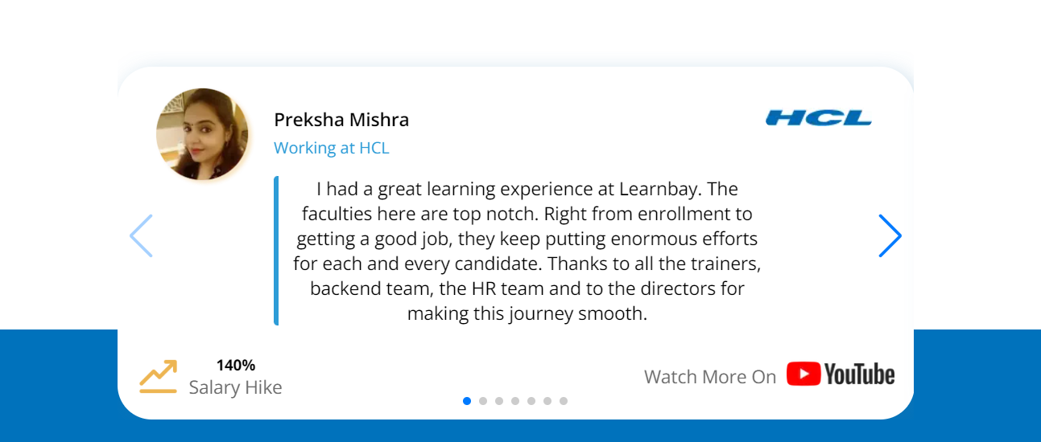

## EXPERIENCED FACULTIES

Team possesses a unique combination of corporate experience as well as Domain expertise

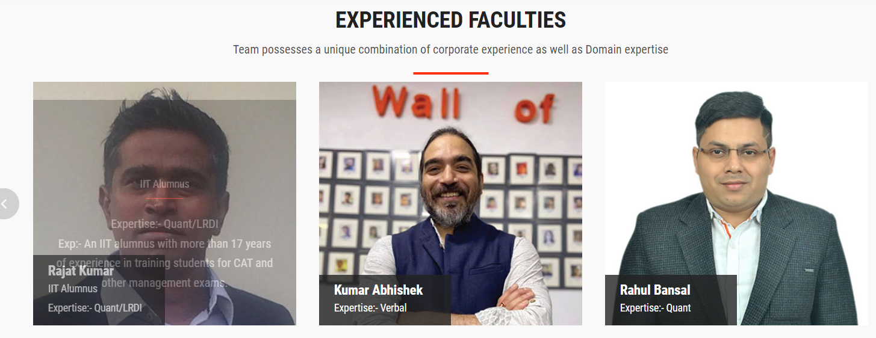

**Next Section**



Phone Number - +91 9205534439

**Footer**

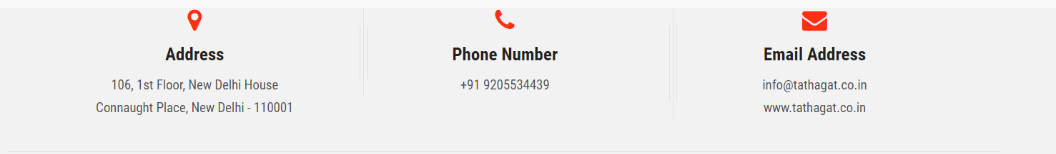

Reference website - <https://tathagat.co.in/delhi/>

Also add Whatsapp option like this.