

Announcement
WB India Seal Requirements

Dear Valued Customers,

Due to India Customs Regulations, all containers moving into India are required to have a “Bullet Seal” placed on the container. In order to avoid the cost of replacing the seals at the transshipment port, we are asking our customer’s to apply the proper seal at Origin.

Many of our valued customers are already complying with this requirement. Due to the additional cost of resealing the containers, we are now asking for a 100% compliance from our customers. If at all possible, we do not want to pass on the additional cost of the resealing to our customers. Below is a picture of a “Bullet Seal” and how it should be assembled.

ASSEMBLY
- Apply the seal on the 3rd bar (Fig 1)
- Inserting bolt section through the locking hole from bottom.(Fig 2)
- Position barrel section under and snap together using simple hand pressure.( Fig2)
A positive clicking sound will indicate correct locking.( Please try to pull the bolt to
check locking.)
- After locking, the barrel should be with numbers facing-out.
- Finally, please check the locking by pulling bolt section from bottom.
Fig 1 Fig 2 Fig 3
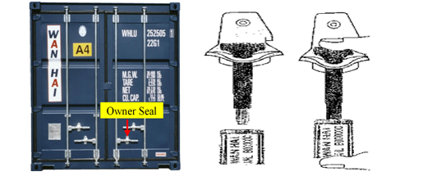
We thank your for your corporation in this matter.

Should you have any questions, please contact your local sales representatives or contact customer service at 1-866-4-WANHAI.

