HackVeda Private Limited

Name: Rishu Raj Sinha

Email: [rishuraj2401sinha@gmail.com](mailto:rishuraj2401sinha@gmail.com)

**Stock Market Data and Technical Indicators Research Report**

1. Introduction:

In this research report, I present the findings of our exploration of stock market data sources, technical indicators used in stock market analysis, and the process of screening and filtering stocks. The purpose of this research was to gain a comprehensive understanding of different data sources, indicators, and filtering parameters to enhance stock analysis capabilities.

2. Sources of Stock Market Data:

a) Yahoo Finance:

- Our research revealed that Yahoo Finance is a widely used platform for accessing stock market data. It offers a range of features, including real-time stock quotes, interactive charts, news, and historical data.

- Yahoo Finance provides filtering options such as price range, market capitalization, sector, and financial ratios. These filters help investors screen stocks based on specific criteria.

- Data availability and reliability were found to be satisfactory, with Yahoo Finance being recognized for its comprehensive and accurate data.

b) Alpha Vantage:

- Alpha Vantage emerged as another notable source of stock market data during our research. It offers APIs that provide real-time and historical market data, technical indicators, and fundamental data.

- The API capabilities of Alpha Vantage allow developers to programmatically retrieve a wide range of financial information, including price and volume data, company fundamentals, and technical indicators.

- Alpha Vantage supports popular technical indicators and provides data endpoints specifically designed for technical analysis.

c) Other potential data sources:

- Our research highlighted additional data sources such as Bloomberg Terminal, Google Finance, Quandl, and Interactive Brokers.

- Bloomberg Terminal is known for its comprehensive financial data, news, and analytics, primarily used by financial professionals.

- Google Finance offers basic stock market data and information, making it suitable for quick reference.

- Quandl provides a diverse collection of financial, economic, and alternative data for quantitative analysis and research.

- Interactive Brokers is a brokerage firm that offers real-time market data and research tools alongside its trading platforms.

3. Technical Indicators in Stock Market Analysis:

a) Moving Averages:

- Moving averages, including the Simple Moving Average (SMA) and Exponential Moving Average (EMA), were identified as key technical indicators.

- SMA calculates the average price over a specific period, while EMA places more weight on recent prices.

The picture given below is for our reference:

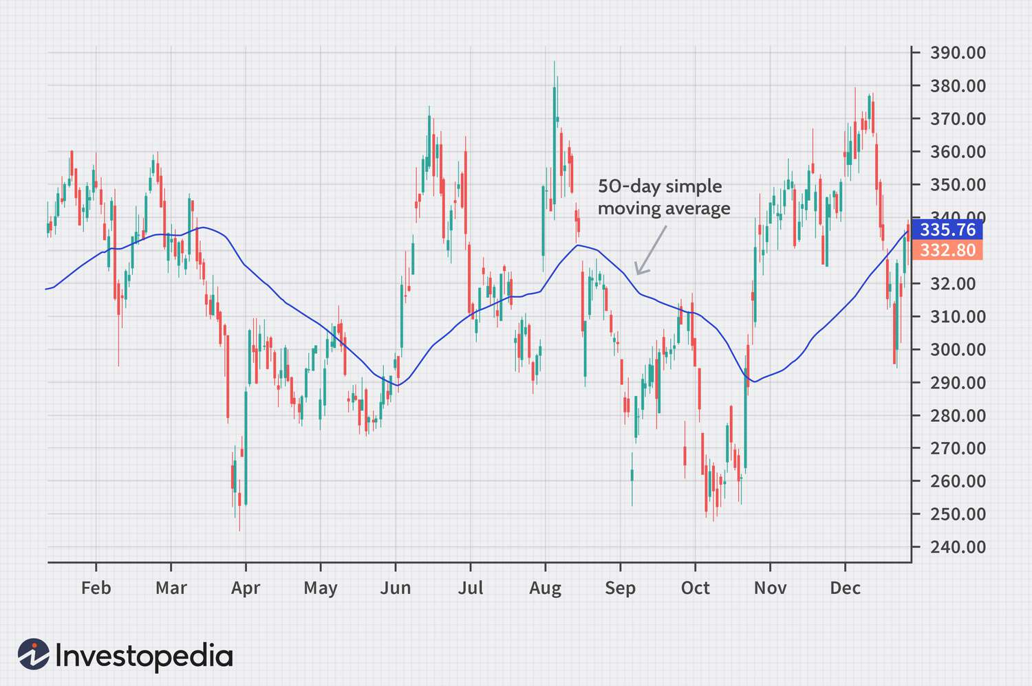

- Moving averages are widely used to identify trends, support/resistance levels, and generate buy/sell signals.

b) Relative Strength Index (RSI):

- RSI is a momentum oscillator that measures the speed and change of price movements.

- It compares the magnitude of recent gains to recent losses to determine overbought and oversold conditions.

The picture given below is for our reference:

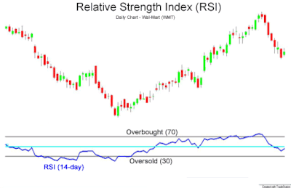

- RSI values above 70 indicate overbought levels, while values below 30 indicate oversold levels.

c) Moving Average Convergence Divergence (MACD):

- MACD is a trend-following momentum indicator that displays the relationship between two moving averages.

- The MACD line, signal line, and histogram are the components of MACD.

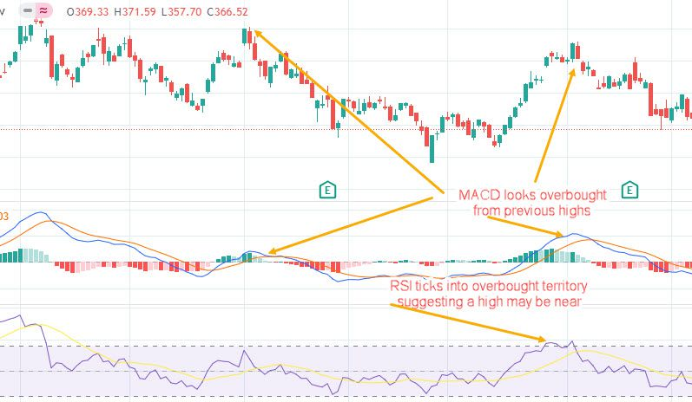

- MACD crossovers and divergences provide buy/sell signals and indicate trend reversals.

d) Other notable technical indicators:

- Bollinger Bands help identify price volatility and potential overbought or oversold conditions.

- Stochastic Oscillator compares a stock's closing price to its price range to identify overbought and oversold levels.

- Average Directional Index (ADX) measures the strength of a trend.

- Fibonacci Retracement identifies potential support and resistance levels based on Fibonacci ratios.

4. Filtering Parameters for Stock Screening:

a) Price-related filters:

- Price range filtering allows investors to set minimum and maximum thresholds for stock prices.

- Price-to-Earnings (P/E) ratio filtering helps identify stocks based on their valuation relative to earnings.

- Dividend yield filtering allows investors to screen stocks based on desired dividend returns.

b) Volume-related filters:

- Average daily volume filtering helps identify stocks with sufficient liquidity and trading interest.

- Volume surge or unusual volume activity filtering highlights stocks experiencing significant trading volume deviations.

c) Fundamental filters:

- Market capitalization filtering categorizes stocks based on their size and scale.

- Earnings per share (EPS) filtering focuses on profitability indicators.

- Debt-to-Equity ratio (D/E) filtering considers a company's debt burden.

5. Case Study: Applying Filters and Indicators in Stock Analysis:

a) Selecting a specific stock for analysis:

- I chose Apple Corporation as a sample stock for analysis based on their research interest and investment objectives.

b) Filtering based on parameters and indicators:

- I applied filtering parameters, including price range, volume criteria, and fundamental ratios, to narrow down the list of stocks.

- Technical indicators, such as moving averages, RSI, and MACD, will be incorporated to further refine the stock selection process.

c) Interpreting the results and making informed decisions:

- I analysed the filtered stocks using technical indicators, fundamental data, and market conditions.

- The results were interpreted to identify potential investment opportunities or make decisions aligned with specific trading strategies or investment goals.

6. Database Design:

This design creates a table named "stock_data" with the following columns:

1. Date: The primary key column that stores the date of the stock data.

2. Open: Stores the opening price of the stock.

3. High: Stores the highest price reached during the day.

4. Low: Stores the lowest price reached during the day.

5. Close: Stores the closing price of the stock.

6. Adj_Close: Stores the adjusted closing price of the stock (if applicable).

7. Volume: Stores the trading volume of the stock.

8. 50-day MA: Stores the value of the 50-day moving average indicator.

9. RSI: Stores the value of the relative strength index indicator.

10. 12-day EMA: Stores the value of the 12-day exponential moving average indicator.

11. 26-day EMA: Stores the value of the 26-day exponential moving average indicator.

12. MACD Line: Stores the value of the MACD line of the moving average convergence divergence indicator.

13. Signal Line: Stores the value of the signal line of the moving average convergence divergence indicator.

14. Histogram: Stores the value of the histogram of the moving average convergence divergence indicator.

6. Conclusion:

In conclusion, this research provided valuable insights into stock market data sources, technical indicators, and the process of screening and filtering stocks. I gained a comprehensive understanding of various data sources, the significance of technical indicators, and the application of filtering parameters in stock market analysis. These findings will contribute to improved stock analysis capabilities and informed investment decision-making. The mySQL database has been created which will serve as a backbone for our project to be continued.