IOT BASED HEALTH
MONITERING SYSTEM

A PROJECT REPORT SUBMITTED IN PARTIAL FULFILLMENT OF THE REQUIREMENTS FOR THE DEGREE OF BACHELOR OF TECHNOLOGY IN ELECTRONICS AND COMMUNICATION ENGINEERING

(YEAR 2018-2019)

Prepared & Submitted By:
CHANDAN SINGH
RISHU RAJ



Under the Guidance of:
PROF. SUTAPA RAY ADHIKARY
Department of Electronics and Communication Engineering Institute of Engineering & Management, Kolkata
CERTIFICATE OF APPROVAL
The report is hereby approved as a bonafide and creditable project work “IOT BASED HEALTH MONITERING SYSTEM” carried out and presented by:
NAME | UNIVERSITY ROLL NUMBER | REGISTRATION NUMBER
CHANDAN SINGH | 10400315054 | 151040110398
RISHU RAJ | 10400315117 | 151040110461

In a manner to warrant its acceptance as a pre-requisite for award of the degree of Bachelor of Technology in Electronics and Communication Engineering. However, the undersigned do not necessarily endorse or take responsibility for any statement made or opinion expressed or conclusion drawn there in but only approve the report for the purpose for which it is submitted.
…………......................................Prof. A. K. Nayak
Principal
Institute of Engineering &
Management

…………...........................................Prof. Dr. Malay Gangopadhyay
Head of Department
Electronics & Communication Dept. Institute of Engineering & Management
.........................................................
Prof. Sutapa Ray Adhikary.
Assistant Professor
Electronics & Communication Dept. Institute of Engineering & Management

DECLARATION

The entire document of this project report is complete on its own and authorized by Institute of Engineering & Management, Kolkata. In many cases, we took help of various application notes circulated by the manufacturers on the Internet. We confirm that data or figure presented in this document is privileged under the Intellectual Property or Copyright Act. The authors stand in strong support for the originality of the project.

...................................
(CHANDAN SINGH)

....................................
(RISHU RAJ)

ACKNOWLEDGEMENT
This project work, in spite of being our brainchild, could not have been successfully completed without the constant guidance of our Mentor, Prof. SUTAPA RAY ADHIKARY. She has been a constant source of inspiration all through this journey and has also been a guide and mentor in its true sense. We thereby, extend our sincere and humble appreciation towards him. Our mentor took the responsibility of our group at the onset of our 7th semester.
A lot of concepts were unknown to us when we first started with the basic discussions of the project. As time passed by, the doubts kept increasing but simultaneously, the eagerness and interest with which our Mentor clarified those doubts also kept on increasing. It is more than safe to state that Prof. SUTAPA RAY ADHIKARY is undoubtedly one of the most enthusiastic and inspirational teachers we have come across. It was already decided at the beginning that we would do a project in the domain of Internet of Things (IoT).
As a B.Tech final year project, it has been a great learning experience working under such a wonderful and supportive Mentor. We can proudly say that after imbibing the available knowledge from Mam, our values as engineers have increased by some margin.
We would like to express our sincere gratitude to Prof. MALAY GANGOPADHYAY (H.O.D.), all the teachers, staffs and members of ECE department, Prof SUTAPA RAY ADHIKARY again and as a whole INSTITUTE OF ENGINEERING & MANAGEMENT for giving us the opportunity to explore new dimensions of knowledge.
Finally, we thank our director Prof. Dr. SATYAJIT CHAKRABORTY , who has always been inspirational and has given us an opportunity to do this project.
Contents
Abstract………………………………………………………………….8
- Introduction ……………………………………………………… 9
  - Introduction ………………………………………………. 9
  - Literature survey………………………………………. 10
  - Objective …………………….…………………………… 12
  - Necessity ………………………………………………….. 13
- Motivation and Background ……………………………..14
  - Motivation and Background ………………………14
  - Existing System ………………………………………….15
  - Proposed System ……………………………………….15
- Major Contributions …………………………………………17
  - Related Works …………………………………………..17
  - Contributions …………………………………………….18
- Methodology ……………………………………………………19
  - Hardware …………………………………………………..19
    - Temperature Sensor ……………………………19
    - Pulse Sensor ……………………………………….19
    - Arduino ………………………………………………20
    - Wi-Fi Module ……………………………………..21
  - Circuit Connection …………………………………….21
    - Wi-Fi Module ……………………………………..21
    - Temperature Sensor …………………………..22
    - Pulse Sensor ……………………………………….23
  - Data Collection ………………………………………….24
  - Data Storage ……………………………………………..25
  - ThingSpeak ………………………………………………..25
- Experimental Design ………………………………………..26
  - Implementation Steps ……………………………….26
  - Individual collection of data ………………………26
  - Sending data to ThingSpeak ………………………28
  - Analyze the already stored data ………………..31
  - Display and alert ………………………………………..31
- Result and Alert ………………………………………………..34
  - Result Display …………………………………………….34
    - Display of Body temperature ………………34
    - Display of Heartrate ……………………………35
    - Heartrate V/S Temp ……………………………35
  - Alerts …………………………………………………………36
  - Export data ………………………………………………..36
- Conclusion ………………………………………………………..37
  - Challenges …………………………………………………37
    - ESP-8266 Wi-Fi Module ………………………37
    - Pulse Sensor ……………………………………….37
    - Serial communication …………………………38
    - Data Analysis and React ……………………..38
  - Future work ……………………………………………….38
- References ……………………………………………………….39

List of figures
- Basic centigrade Temperature sensor ………..19
- LM35 pinout ………………………………………………19
- Pulse rate sensor ………………………………………..20
- Arduino Uno ………………………………………………20
- ESP-8266 NodeMCU …………………………………..21
- Connection between Arduino and Wi-Fi module ………………………………………………………………………22
- Connection of LM35 sensor ……………………….23
- Connection of Pulse sensor ………………………..23
- Full circuit block Diagram……………………………24
- Full Circuit picture……………………………………...32
- Snapshot of ThingSpeak channel………………..33
- Display of Body temperature graph ……………34
- Display of Heartrate graph …………………………35
- Heartrate V/S Temp …………………………………..35
- Alerts …………………………………………………………36
- Exported Datasheet …………………………………..36

Abstract

Internet of Things (IOT) is an ecosystem where data collection is done via devices which communicates with each other and stores those data in cloud. From which it is possible to extract, analyze and send data way faster with efficiency. Healthcare has been secluded from this revolution for long as its diversity and heterogeneity. Health monitoring of elderly is one of the most crucial subjects in modern era health care. And it is a new challenge to remotely monitor the health condition. In this paper, we will demonstrate the current situation of the technology of the health monitoring projects based on IOT and propose how we can improve the actual implementations of the monitoring system for the health care of the elderly people. We will also discuss how we can make the concerning people aware with precision if any alarming situation is spotted so that instant action can be taken thus ensuring reduction of casualty.
Keywords: IoT, Arduino, NodeMCU, Health monitoring.

Chapter - 1
Introduction
1.1 Introduction
Nowadays Health-care Environment has developed science and knowledge based on Wireless-Sensing node Technology oriented. Patients are facing a problematic situation of unforeseen demise due to the specific reason of heart problems and attack which is because of non-existence of good medical maintenance to patients at the needed time. This is for specially monitoring the old age patients and informing doctors and loved ones. So, we are proposing an innovative project to dodge such sudden death rates by using Patient Health Monitoring that uses sensor technology and uses internet to communicate to the loved ones in case of problems.
Medical Electronics is also going to advance with the application of Internet of Things. Internet of Things is the fastest growing technology. IoT is about to find application everywhere and in everything. In this project, a simple patient health monitoring device is developed as an IoT application. This IoT device could read pulse rate and measure surrounding temperature. It continuously monitors the pulse rate and surrounding temperature and updates them to an IoT platform.
This system uses Temperature and heartbeat sensor for tracking patient’s health. Both the sensors are connected to the Arduino Uno. To track the patient health micro-controller is in turn interfaced to a LCD display and wi-fi connection to send the data to the web-server(wireless sensing node). In case of any abrupt changes in patient heart-rate or body temperature alert is sent about the patient using IoT. This system also shows patients temperature and heartbeat tracked live data with timestamps over the Internet.

1.2 Literature Survey
1.2.1 Health monitoring using Internet of Things (IoT)
During this paper, the researchers are trying to trace patient's health with the assistance of sensors and internet. Internet is employed to tell their beloved if there is a drag. The health observation system can keep track of patient's pulse rate, eco rate of heart, pressure level rate, temperature etc. If system detects any abrupt changes in patient heartbeat or temperature, the system mechanically alerts the user concerning the patients standing over IOT and additionally shows details of heartbeat and temperature of patient live over the internet.
1.2.2 Internet of Thing based healthcare monitoring system
When monitored on a continual basis, aggregated and effectively analyzed - such information can bring about a massive positive transformation in the field of healthcare. The proposed system monitors the vital health parameters and transmits the data through a wireless communication. In order to design an efficient remote monitoring system, security plays an important part. Cloud computing and password protected Wi-Fi module handles authentication, privacy and security of patient details by allowing restricted access to the database. Hence the system provides quality healthcare to all.

1.2.3 Health care monitoring system in Internet of Things (IoT) by using RFID

Hospitals have started using the cell instruments for communication intent and for this intent internet of things (IoT) has been used and fused with wi-fi sensor node reminiscent of RFID, NFC tag and small sensor nodes. The usage of a cellular agent in healthcare procedure underneath wi-fi community environment gives a chance to explore improved services for patients and staffs reminiscent of medical professionals and nurses given that of its mobility. In this paper novel method to utilize it IoT within the field of scientific and crafty wellness care are presented. This paper describes and proposes a complete monitoring existence cycle and effective healthcare monitoring system designed by using the IoT and RFID tags. The experimental results in this paper show the robust output against various medical emergencies. In this system to get the veracious evaluation results, supervising and weighing the health status of patient and to increase the power of IoT, the combination of microcontroller with sensors is presented.

1.2.4 Smart health monitoring system with IoT
The system was designed for collecting data on health through wearable device using API technology. The data composed of energy metabolism, heart rate and moments of sleep. The system was designed to be a web and mobile application. Database system was designed using MySQL software, programming with PHP-script, JavaScript, Java and HTML5. Android studio was used to develop mobile application. Data mining technique with Rule Induction algorithm was used to find an association rules for recommendation system.

1.2.5 Patient Monitoring System Based on Internet of Things
The Internet of things is increasingly allowing to integrate devices capable of connecting to the Internet and provide information on the state of health of patients and provide information in real time to doctors who assist. It is clear that chronic diseases such as diabetes, heart and pressure among others, are remarkable in the world economic and social level problem. The aim of this article is to develop an architecture based on an ontology capable of monitoring the health and workout routine recommendations to patients with chronic diseases.

1.3 Objective
Here in this project, we will make an IoT based Health Monitoring System which records the patient heart beat rate and body temperature and also send the readings to the ThingSpeak server so that the doctor can check whenever those readings goes beyond critical values, It generates the alert. Pulse rate and body temperature readings are recorded over ThingSpeak and Google sheets so that patient health can be monitored from anywhere in the world over internet.
Health monitoring is the major problem in today’s world. Due to lack of proper health monitoring, patient suffer from serious health issues. There are lots of IoT devices now days to monitor the health of patient over internet. Health experts are also taking advantage of these smart devices to keep an eye on their patients. With tons of new healthcare technology start-ups, IoT is rapidly revolutionizing the healthcare industry.Patient monitoring is relevant in various circumstances when a patient is in the accompanying conditions:
1. In unstable physiological regulatory systems - for instance, in the case of overdose of anesthesia.
2. In a life-threatening condition – for instance, when there is an indication of heart attack in a patient.
3. In a situation leading to the developing of a risky life-threatening condition.
4. In a critical physiological state.
In the recent years use of wireless technology is increasing for the need of upholding various sectors. In these recent years IoT groped the most of industrial area specially automation and control. Biomedical is one of recent trends to provide better health care. Not only in hospitals but also the personal health care facilities are opened by the IoT technology. So, having a smart system, various parameters are observed that consume power, cost and increase efficiency. In accordance with this smart system, this paper is reviewed.

1.4 Necessity
In traditional method, doctors play an important role in health check-up. For this process requires a lot of time for registration, appointment and then check-up. Also reports are generated later. Due to this lengthy process working people tend to ignore the checkups or postpone it. This modern approach reduces time consumption in the process. Their contribution in medical area is very important to us and cannot be neglected. Today’s automotive structures have the root ideas coming from yesterday’s basics. Also Early detection of chronic diseases can be easy with these technology. The body temperature, heart rate, blood pressure, respiration rate are prime parameters to diagnose the disease. This project gives temperature and heart rate values using IoT.
Modern health care system introduces new technologies like wearable devices or cloud of things. It provides flexibility in terms of recording patients monitored data and send it remotely via IOT. For this connection, there is need of secure data transmission. To transmit the data with privacy is the Moto of this paper. The proposed system introduces security of health care and cloud of things. System works in two major parts viz. storage stage and data retrieving stage. In storage stage, data is stored, updated for future use. In data retrieving stage, retrieve data from cloud. The cloud server can share with authenticated user as per request. A patient with wearable devices continually updates his record every 5 or 10 min. In emergency mode, it updates for every 1min.
Medical scientists are trying in the field of innovation and research since many decades to get better health services and happiness in human lives.

Chapter - 2
Motivation and Background

2.1 Motivation and Background
A large portion of the developing nations have extremely poor healthcare foundation there are not very many clinics [2] in contrast with blasting population. Few of doctor’s facilities are deficiently prepared where very less number of specialists is available. The basic diagnostic equipment for the diagnosis of life-threatening diseases is absent. In the event that this paper could fabricate an ease compact health detecting gadget, involving a few sensors, equipped for measuring the vital attributes of a human body, and can speak with the doctor’s facility database, it could furnish with quality therapeutic guidance. The restorative administration is given after one of the authority specialists from a group of particular specialists display everywhere throughout the globe assesses those health parameters on the clinic’s database.
In today’s social protection system for patients who remains in home amid post operational days checking is done either by means of administrator/medicinal guardian. Endless watching may not be expected by this system, in light of the fact that anything can change in prosperity parameter within some fraction of seconds and in the midst of that time if the specialist is not in the premises causes more important damage. So with this advancement made period where the web directs the world gives an idea to add to doctors from a group of specialized doctors present all over the globe [3] where time to time consistent checking of the patient is refined.
Also, if the health detecting gadget is made to speak with a compact system like a tab or a cell phone which has the default capacity of speaking with Cloud (hospital or clinic database), then the entire system would be considerably more financially effective. This is on thegrounds that these days a great many people have entry to versatile specialized devices and these devices have turned out to be very shabby. The system can likewise be made IoT (Internet of Things) empowered and M2M (Machine To Machine) is good. This system, usage of such a healthcare checking system is displayed. Thus, this will possibly profit an extensive population. For the healthcare checking system to be solid, every sensor should timely measure the information taking the recommended examining rate of the parameter, and the information should be sent to the data processor with no overlap.
Every sensor has fluctuating necessities regarding information length or size and examining rate the sensor information gathered without overlap by information processor can replace notepad at patient’s bed with smart gadget and patient’s information can be accessed to from specialist’s Smartphone or web.These systems are utilized for the practice of medicinal and general health with the assistance of cell phones. These frameworks observation can be utilized nearby or remotely. Patient monitoring is relevant in various circumstances when a patient is in the crucial conditions.
2.2 Existing System
In a hospital, either the nurse or the doctor has to move physically from one person to another for health check, which may not be possible to monitor their conditions continuously. Thus, any critical situations cannot be found easily unless the nurse or doctor checks the person’s health at that moment. This may be a strain for the doctors who have to take care of a lot number of people in the hospital. Also, when medical emergencies happen to the patient, they are often unconscious and unable to press an Emergency Alert Button.
One of the application protocols that are being used to transfer data is Hyper Text Transfer Protocol (HTTP) for general communication over Internet. However, when HTTP is applied to communication in IOT, protocol overhead and resulting performance degradation are a serious problem. Moreover, IP addressing depends on physical location, which causes the problem of complexity of network control.

2.3 Proposed System
Our system continuously monitors patient’s vital signs and sense abnormalities. The monitored data is delivered to medical staff. Upon encountering abnormalities, the system alerts the medical staff about the abnormal parameter. Thus, reduces the need for manual monitoring done by the medical staff.
Our proposed system uses MQTT client to send data from sensors to cloud platform. It is a publish/subscribe, extremely simple and lightweight messaging protocol, designed for constrained devices and low-bandwidth, high-latency or unreliable networks. The design principles are to minimize network bandwidth and device resource requirements whilst also attempting to ensure reliability and some degree of assurance of delivery.
In rural hospitals, the facilities for health caring are limited. The poor quality of health management enables issues in health care system Everyone should get the knowledge of own health as easy and early as possible. Also, it should be worth for each. Latest report of The India Spend analysis of data says that the 500,000 doctors shortage in India. WHO defines the doctor patient ratio will be 1:1000 which has been failed in India.
In developing countries there is lack of resources and management to reach out the problems of individuals. A common man cannot afford the expensive and daily check-up for his health. For this purpose, various systems which give easy and assured caring unit has been developed. Theses system reduces time with safely handled equipment.

Chapter - 3
Major Contributions
3.1 Related Works
Of all these ideas, models, frameworks and platforms that are surveyed for this research, we differ with all the above with a very basic and fundamental ways. The above researches conducted may use many monitoring variable on the contrary we are using more specific variable. Still, the basic functionality difference is that our motive to develop this project is to generate a functional response and to give a feedback to the relatives of the host, so that they can quickly take steps for the wellbeing of the host. The source of this response will be e-mail and social networking site twitter. But the basic idea of the research is totally of a different paradigm.
Though, it is true that health monitoring and the prediction from anomalies as well as giving a useful feedback to the use is neither a very easy process nor the framework a very easy to set foot to. But, this research will take the health monitoring which now one of the most exciting topics (related to IoT) to a very different level. The useful information gathered from the research conducted has provided very handy to carry out and provide a workable model which will be discussed in the next segment of the paper. Workable data is something which we had to toil to obtain but the data’s were managed properly to continue the research.
Thus, most the related works done related to our project was highlighted in this segment and how our research differs from those works were also explained thoroughly. Some of those researches conducted really helped us understanding the importance of this sector and inspired to go the extra-mile on this field. The platform monitoring the daily activities of the host will be useful for the physician attending the host. The daily activities monitoring conducted by the system will help the physician to develop a conclusion and prediction to diagnose the host in a swift manner.

3.2 Contributions
The IoT project developed here is built on Arduino UNO. The Arduino is one of the earliest and most popular prototyping boards. So, the major part of the project is to get familiar with the arduino and Interface LCD with arduino. The Arduino is interfaced with ESP8266 Wi-Fi modem to connect with an internet router and access the cloud server. The Arduino is interfaced with LM-35 temperature sensor to sense the surrounding temperature and a pulse sensor to read pulse rate. The measured pulse rate and temperature are displayed on a character LCD interfaced to the Arduino and are passed to the cloud platform by transmitting data to a Wi-Fi access point. With this simple yet effective device, health status of a critically ill patient can be constantly monitored. It can be used to keep track of health of aged people who frequently have heart or blood pressure issues.
The health related data i.e. pulse rate and temperature are periodically updated and logged to the ThingSpeak platform. That data can be further utilized to keep medical history of the patient. The Freeboard.io is used as Dashboard to graphically represent the recorded data.
The Arduino Sketch running over the device implements the various functionalities of the project like reading sensor data, converting them into strings, passing them to the IoT platform and displaying measured pulse rate and temperature on character LCD. The Sketch is written, compiled and loaded using the Arduino IDE. The IoT platform used is ThingSpeak to send the readings of heartbeat and temperature to the ThingSpeak server.

Chapter – 4
Methodology
4.1 Hardware
To conduct this project, we need sensors so that we can monitor the health condition of the elderly people. In order to do so, we chose two different criterions to monitor people. The two criteria’s we chose are body temperature, pulse rate of the host. So, for those two criteria’s we chose the following sensors.

4.1.1 Temperature Sensor
LM35 is an analog linear temperature sensor. Its output is proportional to the temperature (in degree Celsius). The operating temperature range is from -55°C to 150°C. The output voltage varies by 10mV in response to every oC rise or fall in temperature. It can be operated from a 5V as well as 3.3 V supply and the stand by current is less than 60uA.
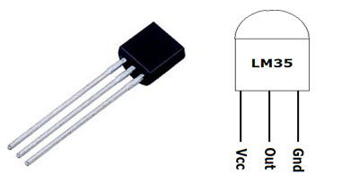
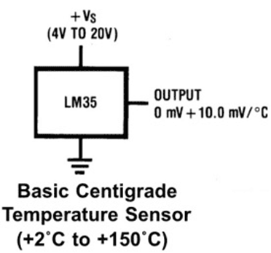

4.1.2 Pulse Sensor
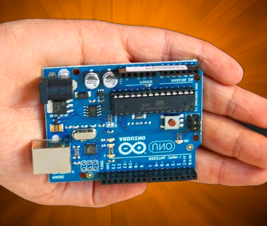
For collecting the pulse rate data from the host, we chose the model SEN-11574. The Pulse Sensor is a plug-and-play heart-rate sensor for Arduino. It can be used by anyone who wants to easily incorporate live heart-rate data. Essence it is an integrated optical amplifying circuit and noise eliminating circuit sensor. It is very easy to use by clipping the pulse Sensor to the hosts earlobe or fingertip and plug it into the Arduino. This sensor can give data’s like Pulse Rate, Cardio Graph and Inter Beat Interval. However, for our convenience we only used the Pulse Rate per minute from the sensor. The data from the sensor can be retrieved from the host via the host’s fingertip or the lobe of the ear.
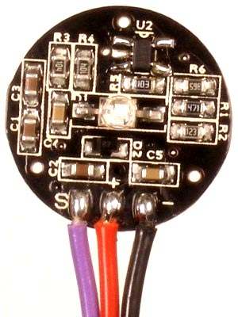
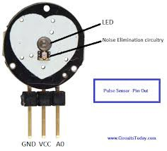

4.1.3 Arduino

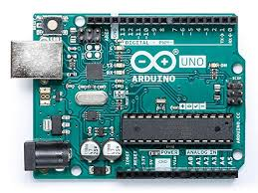
We used Arduino Uno for the purpose of this project. All the sensors are connected with the Arduino. Arduino Uno [13] is a microcontroller board based on the ATmega328P. It has 14 digital input/output pins of which 6 can be used as PWM outputs, 6 analog inputs, a 16 MHz quartz crystal, a USB connection, a power jack, an ICSP header and a reset button. The sensors are powered from the Arduino Uno so is the Wi-Fi module. The Wi-Fi module is getting the data from the sensors through this Arduino Uno. It has 14 digital input/output pins of which 6 can be used as PWM outputs, 6 analog inputs, a 16 MHz quartz crystal, a USB connection, a power jack, an ICSP header and a reset button.

4.1.4 Wi-Fi Module
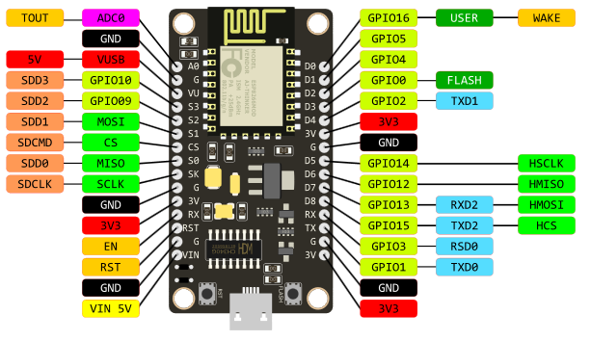
For the purpose of this project, we chose ESP-8266 NodeMCU.The ESP8266 Wi-Fi Module is a self-contained SOC with integrated TCP/IP protocol stack that can give any microcontroller for our case the Arduino access to Wi-Fi network. The ESP8266 is capable of either hosting an application or offloading all Wi-Fi networking functions from another application processor. Each ESP8266 module is pre-programmed with an AT command set firmware, meaning, it can be simply connected with the Arduino device and get about as much Wi-Fi-ability as a Wi-Fi Shield offers! The ESP8266 module is an extremely cost-effective board. The module helps to transmit the sensor data to Thingspeak cloud storage. It remains connected with the Arduino and connects with the server via internet and sends the data to that server.

4.2 Circuit Connection
4.2.1 Wi-Fi Module
The ESP-8266 has eight ports, one of them is the power port which is used to supply power to the module and this was connected with the Arduino’s 3.3v. ESP-8266 is very sensitive to high power so it was not connected to the 5v power besides it works better at 3.3v. Another port of the ESP-8266 is the ground port which is connected with the Arduino’s ground. ESP-8266 sends and receives data with 2 different ports these ports are called TX and RX ports. ESP-8266’s TX port was connected with Arduino’s digital port number 2 and ESP-8266’s Rx port was connected with Arduino’s digital port 3. There is a reset port on the ESP-8266 which was not used as we did not need it, there is a port called ch-pd on ESP-8266 which is connected to the Arduino’s 3.3v port. There are 2 GPIO ports on the ESP-8266, the GPIO1 is connected with the Arduino’s 3.3v and the other port, GPIO0 is left unused.
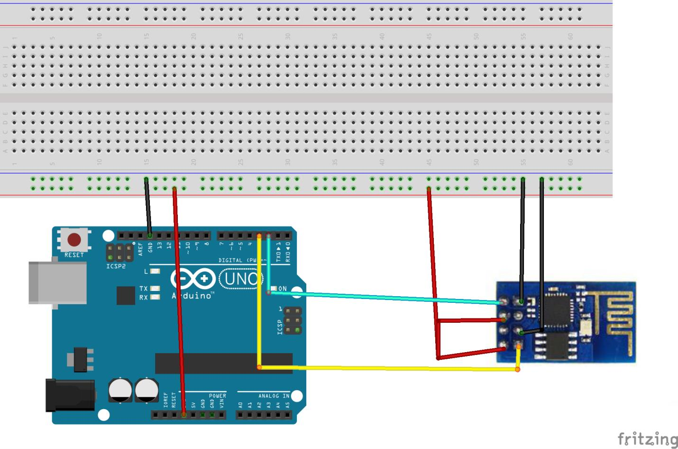

4.2.2 Temperature Sensor
LM35 is a analog linear temperature sensor. Its output is proportional to the temperature (in degree Celsius). The operating temperature range is from -55°C to 150°C. The output voltage varies by 10mV in response to every ̊ C rise or fall in temperature. It can be operated from a 5V as well as 3.3 V supply and the stand by current is less than 60uA. The Vcc and ground pins are connected to 5v and ground respectively. The data out pin is connected to analog pin A3 to that of Arduino.

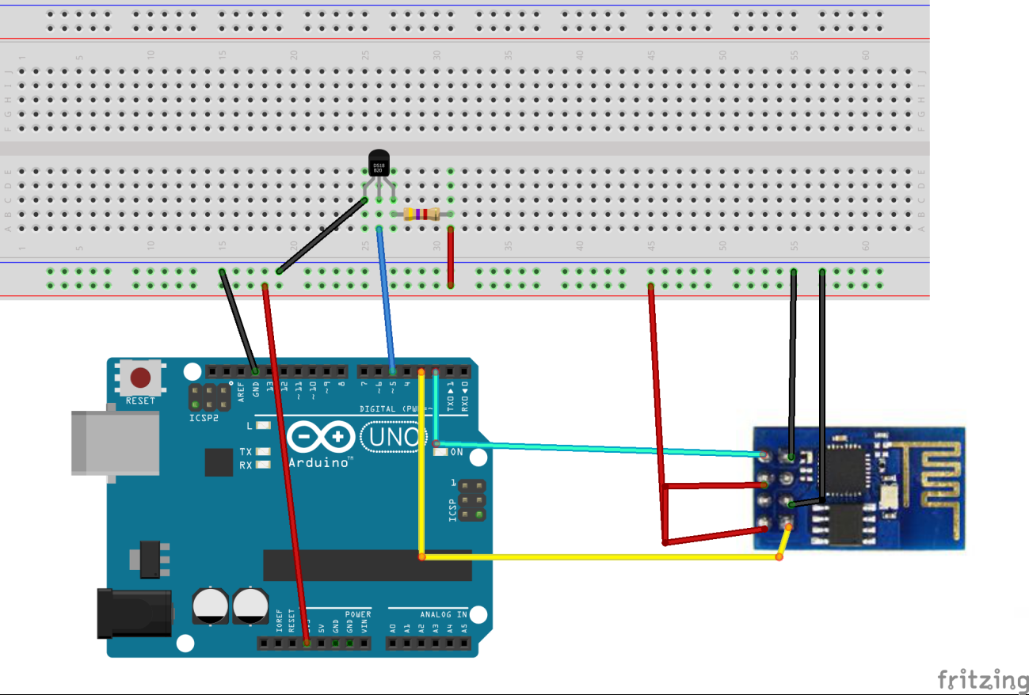

4.2.3 Pulse Sensor
The pulse sensor has three pins; one of them is the VCC pin to power the pulse sensor as usual. This pin is connected with Arduino’s 5v power supply. There is also a ground pin in the pulse sensor which is connected with the Arduino’s ground port. The other pin of the pulse sensor is the data pin. This pin sends analog data to the Arduino so we had to attach this pin with the Arduino’s analog pin 0. This way the Arduino will be converting the analog data to digital and we can avoid using an extra analog to digital converter.

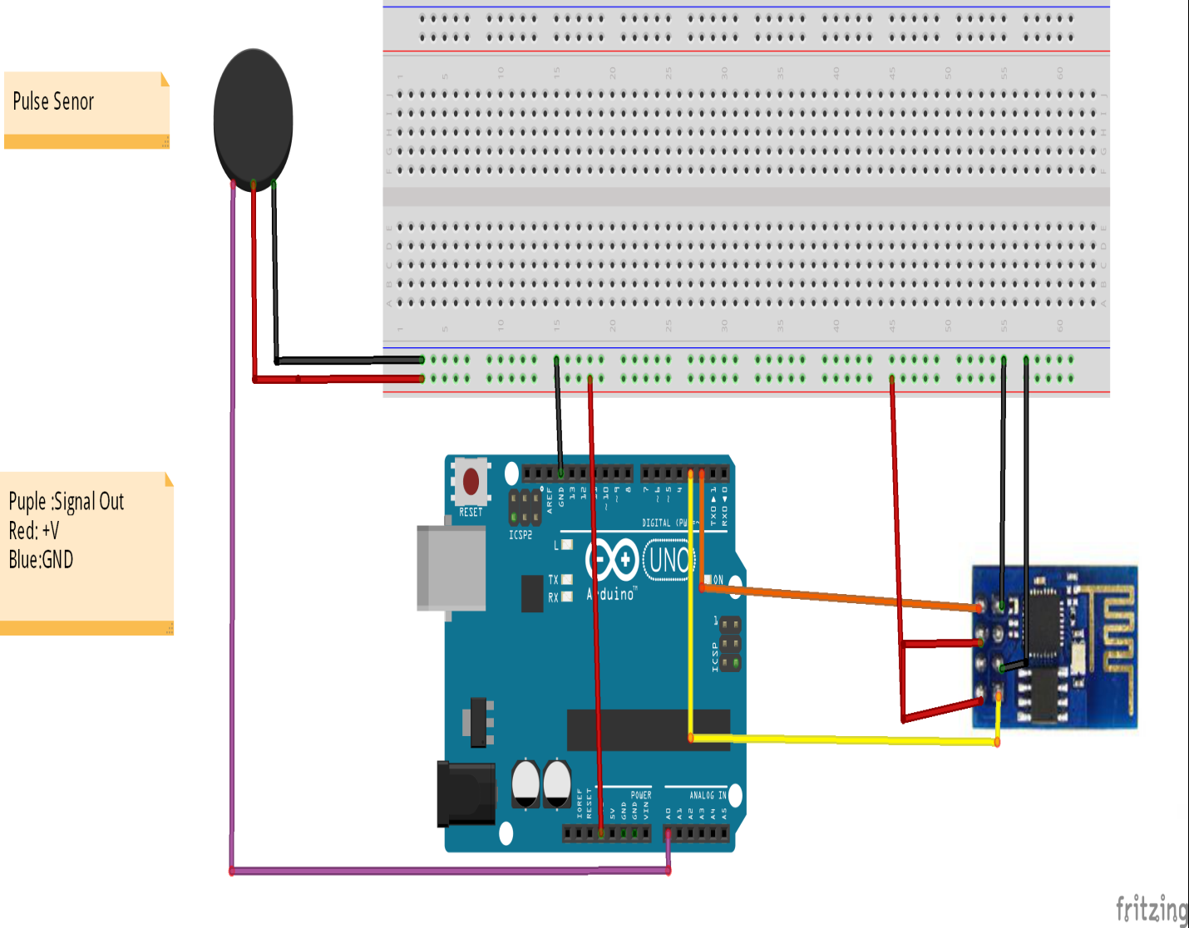
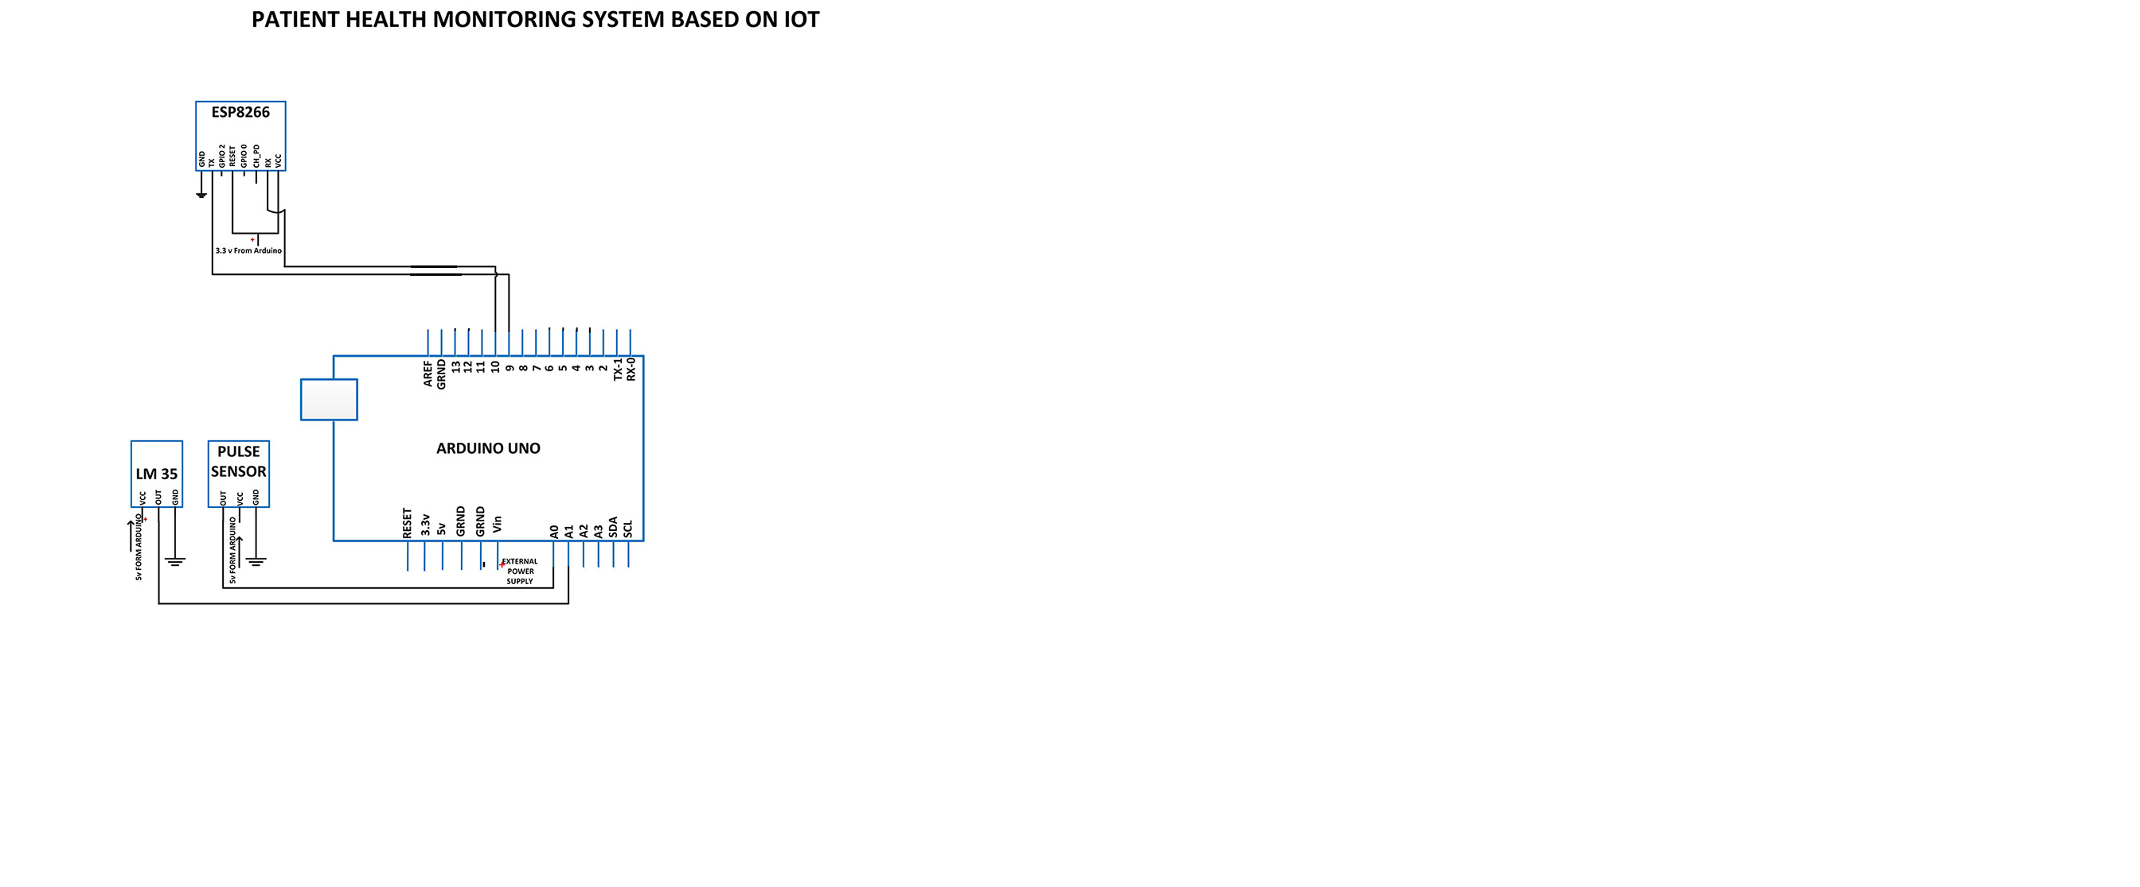
4.3 Data Collection
After we are done connecting all the hardware and the Arduino, we can collect data from the sensors through the Arduino.
The temperature sensor is a small semi-circle hardware, to measure temperature the host just has to put their finger on the temperature sensor and the sensor will gradually adapt with the hosts temperature and take that data in the Arduino. The data that this sensor collects is in Celsius format so we have to convert it to Fahrenheit format.
The pulse sensor is a small round, disc shaped hardware, it has a green light in middle of the sensor, when the sensor receives power from the Arduino this green light will be lit. To measure the pulse of the host, they simply have to put their finger on the green light and the sensor will automatically send the pulse per minute data to the Arduino.

4.4 Data Storage
The data that were collected from the sensors through the Arduino should be stored somewhere to analysis on those data. For that purpose Thingspeak, a website that allows storing data and analysis them is used in this thesis. The ESP-8266 is used for connecting the Arduino with the internet and stores that necessary data’s to Thingspeak server. The ESP-8266 will receive data’s from the Arduino and with the help of a Wi-Fi connection, the ESP-8266 will send the acquired data’s to Thingspeak server.
For different data’s different types of channels are created in Thingspeak. The temperature of the host can be continuously uploaded to Thingspeak with the ESP-8266. From the temperature sensor, the temperature of the host will be saved at one channel and also the highest temperature measured will be stored too. This way we can alert the responsible person in terms of constant high temperature on the host.
Same goes for pulse sensor data’s, pressure pad’s data and the data collected from the sonar sensor. All of these are being stored in the Thingspeak server to analyze.

4.5 ThingSpeak
Thingspeak is an open source IoT application and API. It helps to store and retrieve data from things using the HTTP protocol all over the internet or from the local area network (LAN). ioBridge launched Thingspeak in 2010 to support IoT based application. It allows its users to use MATLAB which they integrated to analyze and visualize the uploaded data without purchasing the license. Thingspeak was written in ruby, has a Cross-Platform operating system and stores it’s data in cloud.
A user can have a free sign in Thingspeak and after signing can open up unlimited channel under that account. Each channel has different fields and in those fields data’s are displayed in graphical forms. User can analyze the data according to the need using the MATLAB. This manipulation of data is one of the most fascinating features of Thingspeak.
Another important feature of Thingspeak is it provides a react option to its users. The react option helps to give an instant reaction to the concerning authority whenever a definite condition is fulfilled via social networking site Twitter and even e-mail as well. This is one of the most unique features of Thingspeak which helped us along the way to complete the project.

Chapter-5
Experimental Design
5.1 Implementation Steps
- Individually collect data from the sensors through Arduino.
- Send the data’s to ThingSpeak with the ESP-8266.
- Analyze the already stored data.
- Display the data’s to Doctors and concerning people for relative host and alarm the necessary person for abnormal health situation

5.2 Individual collection of data
The data collection from each Sensor is done through simple Arduino codes. The temperature sensor can measure the temperature of the surrounding. At first, the temperature sensor gives only the room temperature. When the host directly touches the sensor, it will gradually adjust with the host’s body temperature and that data is taken to the Arduino.
In case of pulse sensor, we collect the data from the analog zero or A0 pin. Whenever a heartbeat is discovered in the then beats per minute (BPM) is calculated. Then the print in the serial monitor is done for the value. We selected the calculation necessary for Arduino Uno.
CODE:
#define USE_ARDUINO_INTERRUPTS true // Set-up interrupts for acurate BPM
#include <PulseSensorPlayground.h> // PulseSensorPlayground Library.
#include <SoftwareSerial.h>
#include <ArduinoJson.h>
SoftwareSerial s(5,6);
// Variables
//int val=0;
const int tempPin = 3; // Temperature sensor input to ANALOG PIN 3
const int PulseWire = 1; // PulseSensor connected to ANALOG PIN 1
const int LED13 = 13; // The on-board Arduino LED, close to PIN 13.
int Threshold = 550; // Determine which Signal to "count as a beat"
PulseSensorPlayground pulseSensor; // Creates an instance of the PulseSensorPlayground

void setup() {
Serial.begin(9600); // For Serial Monitor
s.begin(9600);
pulseSensor.analogInput(PulseWire);
pulseSensor.blinkOnPulse(LED13); // blink Arduino's LED with heartbeat.
pulseSensor.setThreshold(Threshold);
if (pulseSensor.begin()) {
Serial.println("We created a pulseSensor Object !");
}
}

void loop() {
int myBPM = pulseSensor.getBeatsPerMinute(); // "myBPM" hold this BPM value
int val = analogRead(tempPin);
float mv = (val/1024.0)*5000; //=(val/(no. of lvls of analog input))*(vcc)
float cel = mv/10;
int cel10 = cel*10;
if (pulseSensor.sawStartOfBeat())
{
Serial.print("BPM: "); // Print phrase "BPM: "
Serial.println(myBPM); // Print the value inside of myBPM.
Serial.print("TEMPRATURE = ");
Serial.print(cel);
Serial.print("*C");
StaticJsonBuffer<1000> jsonBuffer; //JSON object for serial communication
JsonObject& root = jsonBuffer.createObject();
root["data1"] = myBPM;
root["data2"] = cel10;
if(s.available()>0)
{
root.printTo(s);
Serial.println("DATA SENT");
}
else
Serial.println("DATA NOT SENT");
}
delay(1000);
}

5.3 Sending data to ThingSpeak
In order to send data to ThingSpeak storage, we need the help of esp-8266. The only thing need is to merge the esp-8266 code with every sensor arduino code will help in the sending the data to ThingSpeak. There are some common features of ThingSpeak that we need to ensure during the merging of the code. Esp-8266 has a different set of language of its own. Every code will need the SSID and password to connect to the network. It will need the IP for the ThingSpeak website.It will need the channel ID and field number of that ID. And lastly, whenever we reading or writing data on the field each channel has its own unique data reading and writing number. But since Esp8266 Node mcu have only one analog pin so we need to use serial communication between arduino and Node mcu. For that we need to JSON(JavaScript Object Notation) and we need to convert one set of data into a JSON object and use serial communication.
CODE:
#include <ESP8266WiFi.h>
#include <ESP8266HTTPClient.h>
#include <SoftwareSerial.h>
#include <ArduinoJson.h>
SoftwareSerial s(D6,D5);
WiFiClient client;
String thingSpeakAddress= "http://api.thingspeak.com/update?";
HTTPClient http;

void setup()
{
Serial.begin(9600); // Initialize Serial port
s.begin(9600);
while (!Serial) continue;
WiFi.disconnect();
WiFi.begin("Username","Password");
while ((!(WiFi.status() == WL_CONNECTED))){
delay(500);
}
pinMode(LED_BUILTIN, OUTPUT); // set the LED_BUILTIN pin as an output
}
void loop()
{
StaticJsonBuffer<1000> jsonBuffer;
JsonObject& root = jsonBuffer.parseObject(s);
if (root == JsonObject::invalid()){
Serial.println("ERROR");
return;
}
int data1=root["data1"];
int data2=root["data2"];
int tempB =data2/10;
int tempA=(data2%10);
String stringOne = String(tempB);
String stringTwo = String(tempA);
String stringThree = stringOne+"."+stringTwo;
float temp = (stringThree.toFloat());
Serial.println("JSON received and parsed");
Serial.println(" Data 1 ");
Serial.println(data1);
Serial.println(" Data 2 ");
Serial.print(temp);
Serial.println("---------------------xxxxx--------------------");
if (client.connect("api.thingspeak.com",80)) {
request_string = thingSpeakAddress;
request_string += " key=Y2J6TJFLGL2KSM94"; //channel key
request_string += "&field1=";
request_string += data1;
request_string += "&field2=";
request_string += temp;
http.begin(request_string);
http.GET();
http.end();
digitalWrite(LED_BUILTIN, LOW);
}
delay(1000);
digitalWrite(LED_BUILTIN, HIGH);
}

5.4 Analyze the already stored data.
Already stored data can be used for further manipulation. Here we have written the code for plotting the graph between heartbeat and body temperature.
CODE:
readChannelID = 770532;
fieldID1 = 1;
fieldID2 = 2;
readAPIKey = 'IH1U8P7JPP2XK439';
data1 = thingSpeakRead(readChannelID, 'Field', fieldID1, 'NumPoints', 100,'ReadKey', readAPIKey);
data2 = thingSpeakRead(readChannelID, 'Field', fieldID2, 'NumPoints', 100,'ReadKey', readAPIKey);
scatter(data1, data2);
xlabel('heartbeat');
ylabel('body temp');

5.5 Display and alert
As data is sent to Thingspeak, it is updated in real time in graphical form. A doctor can monitor that in real time for multiple patients. In case of any alarming situation the alert can be seen on the screen. We can retrieve raw data from ThingSpeak using an option provided in it called the Export/Import Data. The updated data of the entire field in the corresponding channel can be downloaded. The data which we can retrieve are provided in the .CSV format. We can also use external APIs that will trigger the various actions when called.

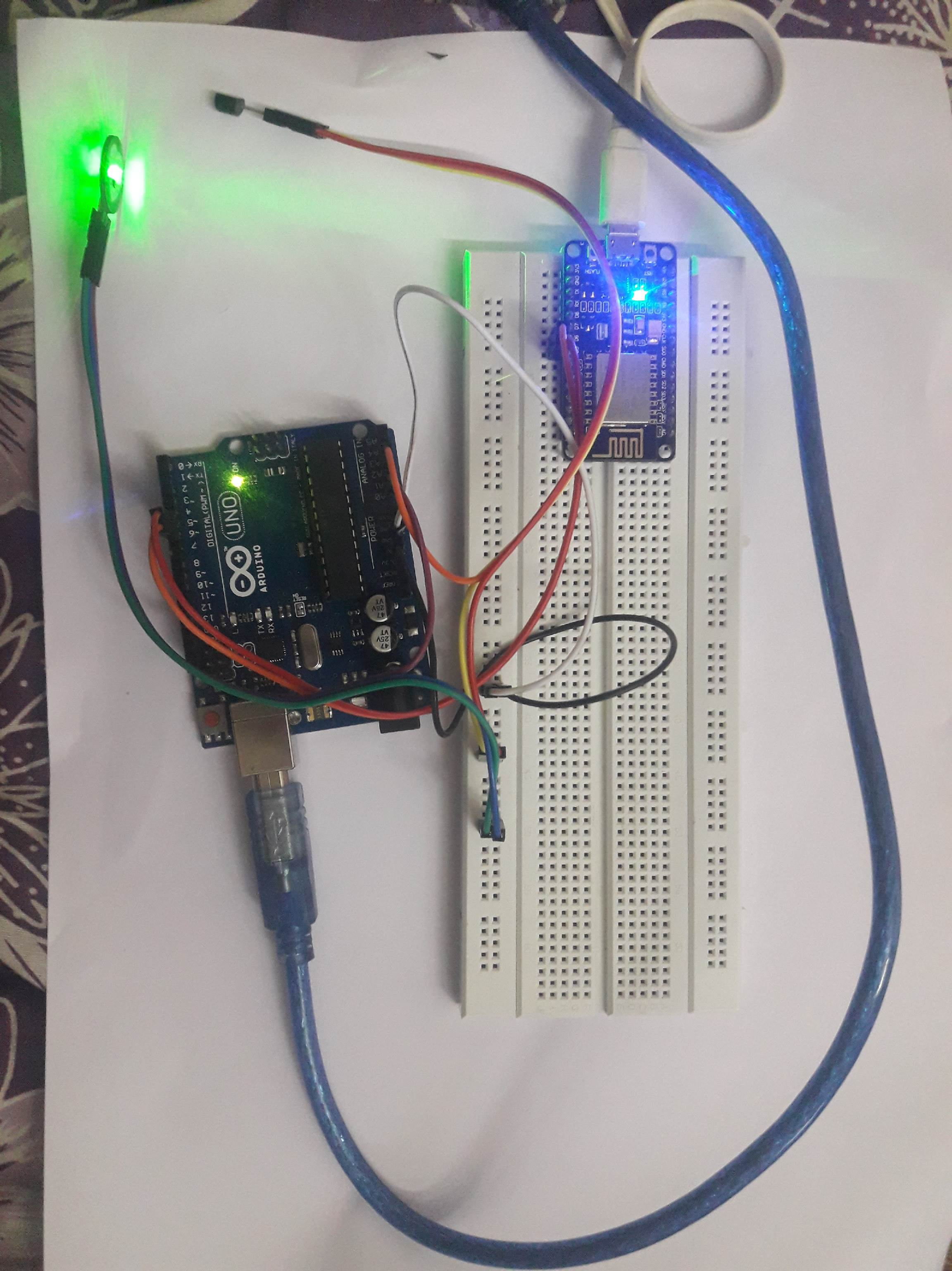
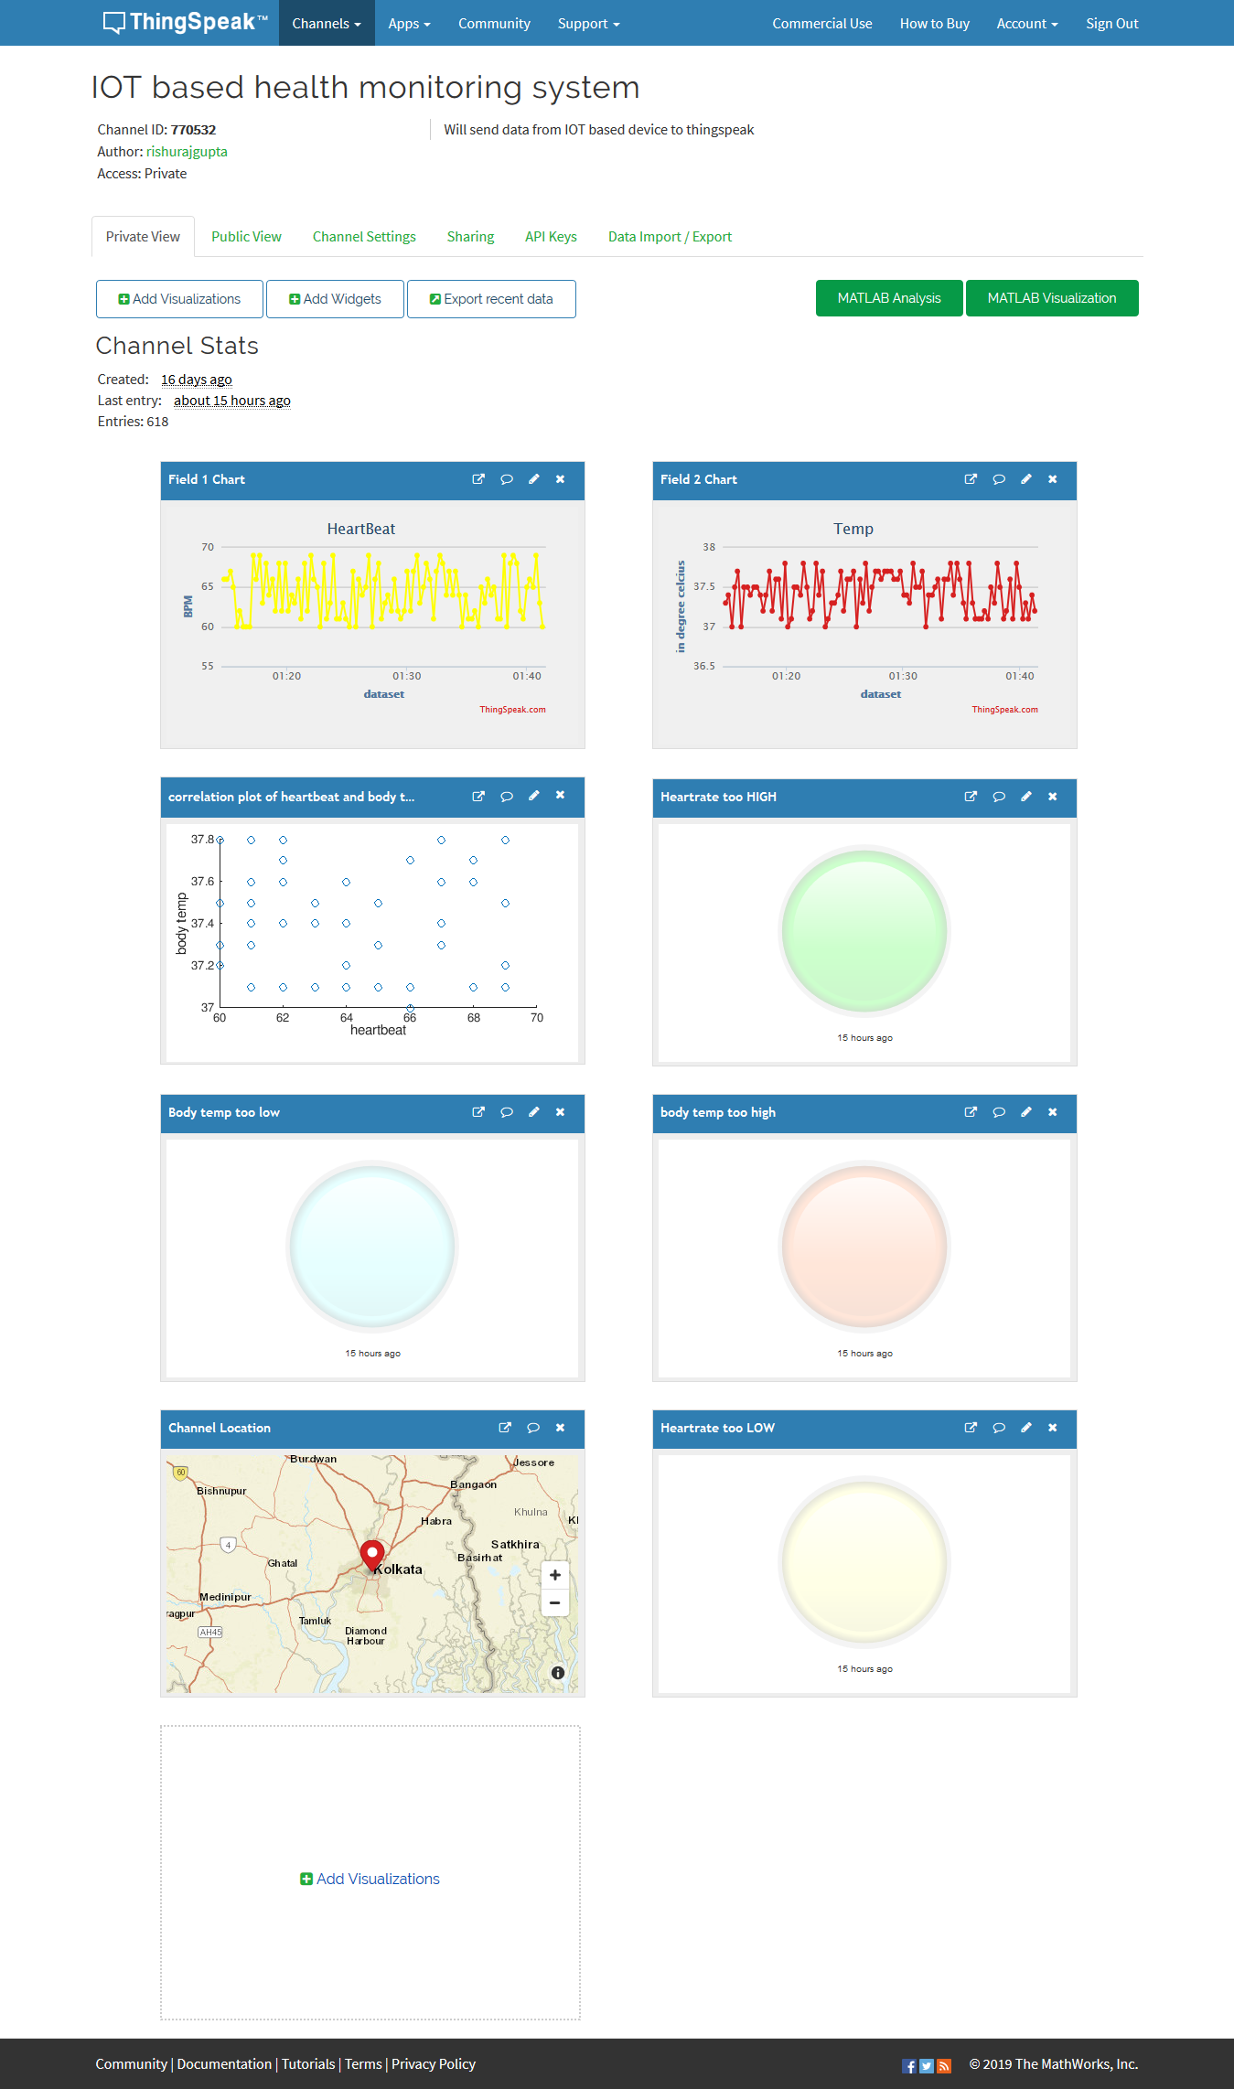
Chapter-6
Result and Alert
In this segment after implementing the code we will discuss how it is displayed in the ThingSpeak account of a user. The data’s we obtained after transmitting is saved in the cloud of ThingSpeak server and from there with the help the features provided from ThingSpeak we are able to display data and send alarming message.
6.1 Result Display
ThingSpeak server it takes 15 second delays for each data entry. The data entered in the storage is then graphically portrayed in the display. The data entered in the storage is channel and field specific.
6.1.1 Display of Body temperature
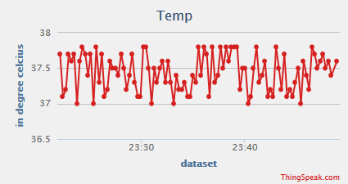

6.1.2 Display of Heartrate
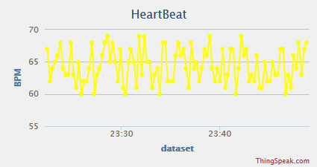
6.1.3 Heartrate V/S Temp
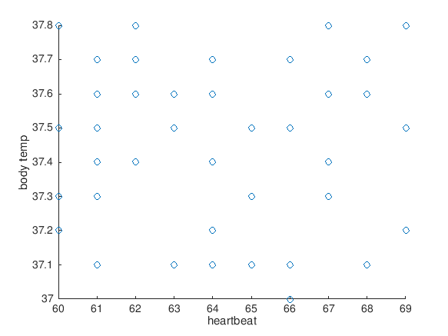

6.2 Alerts
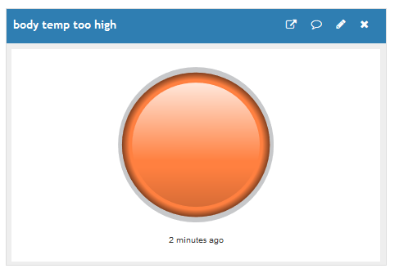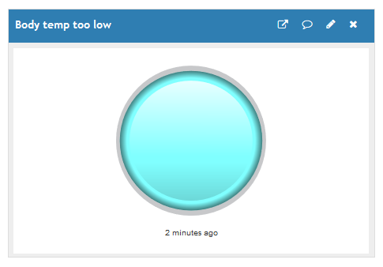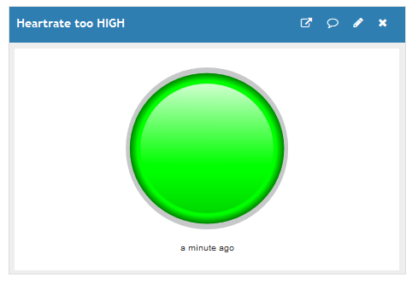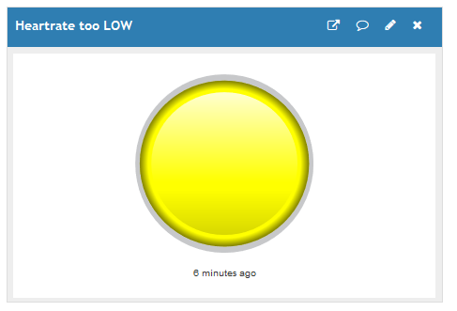
6.3 Export data
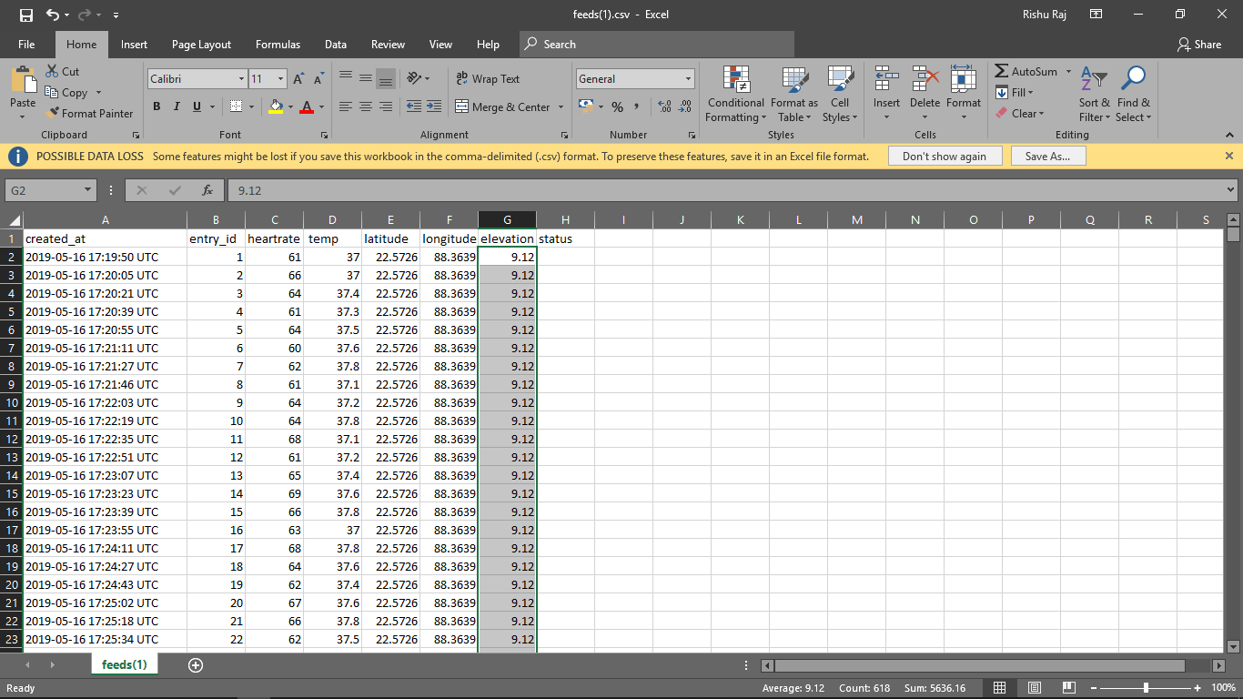
Chapter-7
Conclusion
Our main objective in this project was to successfully monitor the basic criteria’s namely temperature, pulse and react during emergency situation without any human interaction. With the rise of IoT, the era of technology is moving towards a far superior dimension. In order to keep pace with the new technologies, this project can sure make way for the advancement in this sector. Though our model is tested and implemented, it will be difficult to continue the project without superior quality hardware support along with a lot of new integration. The real benefit of this work can only be fully realized when it can be implemented in full scale.

7.1 Challenges
7.1.1 ESP-8266 Wi-Fi Module
The Wi-Fi module works in its own specific language. So, we had to face a lot problem regarding he ways of its language. Sometimes the Wi-Fi module itself cannot with the local network as a result the data sending got interrupted many a times. So, a better hardware support for Wi-Fi module is expected to send data smoothly.
7.1.2 Pulse Sensor
The data that is retrieved from the pulse sensor can give some error reading sometimes. The sensor is not very accurate and the readings also depends upon the amount of pressure you exert on the sensor during the reading. This delayed our implementation of the project in some ways as pulse sensor is an integral part of this project.

7.1.3 Serial communication
We collected data from Arduino but as the nodeMCU has only one analog pin thus we were in need to use any other way to send from Arduino to nodeMCU for that we chose JSON object and serial communication between both.
7.1.4 Data Analysis and React
The data analysis with MATLAB of Thingspeak and react of the Thingspeak gave us some challenges. Especially with alarm message, it was difficult to link with.

7.2 Future work
Here are some of the expansions that can be done with the project.
- Integrating more sensors for more specific data acquisition and analysis.
- Will be used to provide health service to rural areas in affordable price.
- Huge database will be built for doctors to diagnose people
- Multiple monitoring of remote people will allow lesser healthcare expenditure.
- Instant medical help will be available for any alarming situation.

References
[1] Brock, D. L. (2001). The electronic product code (epc). Auto-ID Center White Paper MIT-AUTOID-WH-002.
[2] Ni, Q., García Hernando, A. B., & de la Cruz, I. P. (2015). The elderly’s independent living in smart homes: A characterization of activities and sensing infrastructure survey to facilitate services development. Sensors, 15(5), 11312-11362
[3] Ray, P. P. (2014, November). Home Health Hub Internet of Things (H 3 IoT): an architectural framework for monitoring health of elderly people. In Science Engineering and Management Research (ICSEMR), 2014 International Conference on (pp. 1-3). IEEE.
[4] Niewolny, D. (2013). How the internet of things is revolutionizing healthcare. White paper.
[5] Patel, S., Park, H., Bonato, P., Chan, L., & Rodgers, M. (2012). A review of wearable sensors and systems with application in rehabilitation. Journal of neuroengineering and rehabilitation, 9(1), 21
[6] de Battista, N., Rice, J. A., Sim, S. H., Brownjohn, J. M. W., & Tan, H. P. STRUCTURAL HEALTH MONITORING OF CIVIL INFRASTRUCTURE USING WIRELESS SENSOR NETWORKS.
[7] Hassanalieragh, M., Page, A., Soyata, T., Sharma, G., Aktas, M., Mateos, G., & Andreescu, S. (2015, June). Health monitoring and management using Internet-of-Things (IoT) sensing with cloud-based processing: Opportunities and challenges. In Services Computing (SCC), 2015 IEEE International Conference on (pp. 285-292). IEEE.
[8] Tyagi, S., Agarwal, A., & Maheshwari, P. (2016). A conceptual framework for IoT-based healthcare system using cloud computing. In Cloud System and Big Data Engineering (Confluence), 2016 6th International Conference (pp. 503-507). IEEE.

[9] Himadri Nath Saha; Supratim Auddy; Subrata Pal; Shubham Kumar; Shivesh Pandey. Health monitoring using Internet of Things (IoT) by 2017 8th Annual Industrial Automation and Electromechanical Engineering Conference (IEMECON)

[10] Jorge Gómez,Byron Oviedo,Emilio Zhuma. Patient Monitoring System Based on Internet of Things
[11] S.F. Khan. Health care monitoring system in Internet of Things (IoT) by using RFID
[12] S Kajornkasirat. Smart health monitoring system with IoT

