
School of Computer Science and Engineering
IILM University, Greater Noida, U.P.
INTERNSHIP EVALUATION REPORT
on
LeadOne 2.0
Enterprise Lead Management System, CRM & Cloud Telephony Platform
Submitted To
School of Computer Science and Engineering
IILM University, Greater Noida, U.P.
In partial fulfilment of the requirement for the award of the degree of
Bachelor of Technology in Computer Science and Engineering (B.Tech CSE)
By
Name of Student: RISHU RAJ
Roll Number: CS-2341354
Section: 4CSE6
Batch: 2023 – 2027

TABLE OF CONTENTS
Chapter No. | Chapter Name | Page No.
— | Cover Page | —
1. | Candidate's Declaration | ii
2. | Acknowledgement | iii
3. | Internship Completion Certificate | iv
— | List of Tables | v
— | List of Figures | vi
4. | Project Description | 1
 | 4.1 Introduction | 1
 | 4.2 Organization Profile | 2
 | 4.3 Problem Statement | 2
 | 4.4 Project Objectives | 3
 | 4.5 Scope of the Project | 3
 | 4.6 Technologies and Tools Used | 4
 | 4.7 System Architecture | 7
 | 4.8 Methodology | 11
 | 4.9 Expected Outcomes | 12
 | 4.10 Certificate of Completion (Attached) | 13
5. | Bibliography / References | 15

CANDIDATE'S DECLARATION
I, RISHU RAJ, Roll No. CS-2341354, do hereby declare that the internship report titled “Internship Evaluation Report on LeadOne 2.0 – Enterprise Lead Management System, CRM & Cloud Telephony Platform” has been completed by me to fulfil the requirement for the award of the degree of Bachelor of Technology in Computer Science and Engineering. All the references used in the preparation of this report have been duly acknowledged, and I have not taken as such any material from any other source without appropriate citation.
I further affirm that this report is my own work, prepared on the basis of the internship undertaken by me at FinZ, and has not been submitted, in part or in full, to any other institute for the award of any other degree or diploma. I shall be solely responsible for any kind of copyright violation in this regard.
Signature:

Student Name: RISHU RAJ
Roll No.: CS-2341354
Date: 30-Aug-2026

ACKNOWLEDGEMENT
I take this opportunity to express my sincere gratitude to everyone who supported and guided me throughout the internship program at FinZ. I am thankful for the guidance, constructive feedback, and encouragement extended to me during the course of my internship, which enabled me to gain practical exposure to the development of the LeadOne 2.0 platform.
I would like to thank the organization for providing me with the opportunity to work on a live, enterprise-grade project, which greatly enhanced my technical understanding of backend web development, API design, real-time systems, and enterprise software architecture. I am also grateful to the faculty of the School of Computer Science and Engineering, IILM University, Greater Noida, for their academic guidance and for providing the necessary framework for the successful completion of this internship evaluation report.
Finally, I express my heartfelt gratitude to my parents and peers for their continuous support, encouragement, and blessings throughout this endeavour.
Signature:

Student Name: RISHU RAJ
Roll No.: CS-2341354

INTERNSHIP COMPLETION CERTIFICATE
The following is a reproduction of the official Internship Completion Certificate issued to the candidate by the organization (FinZ) upon successful completion of the internship.
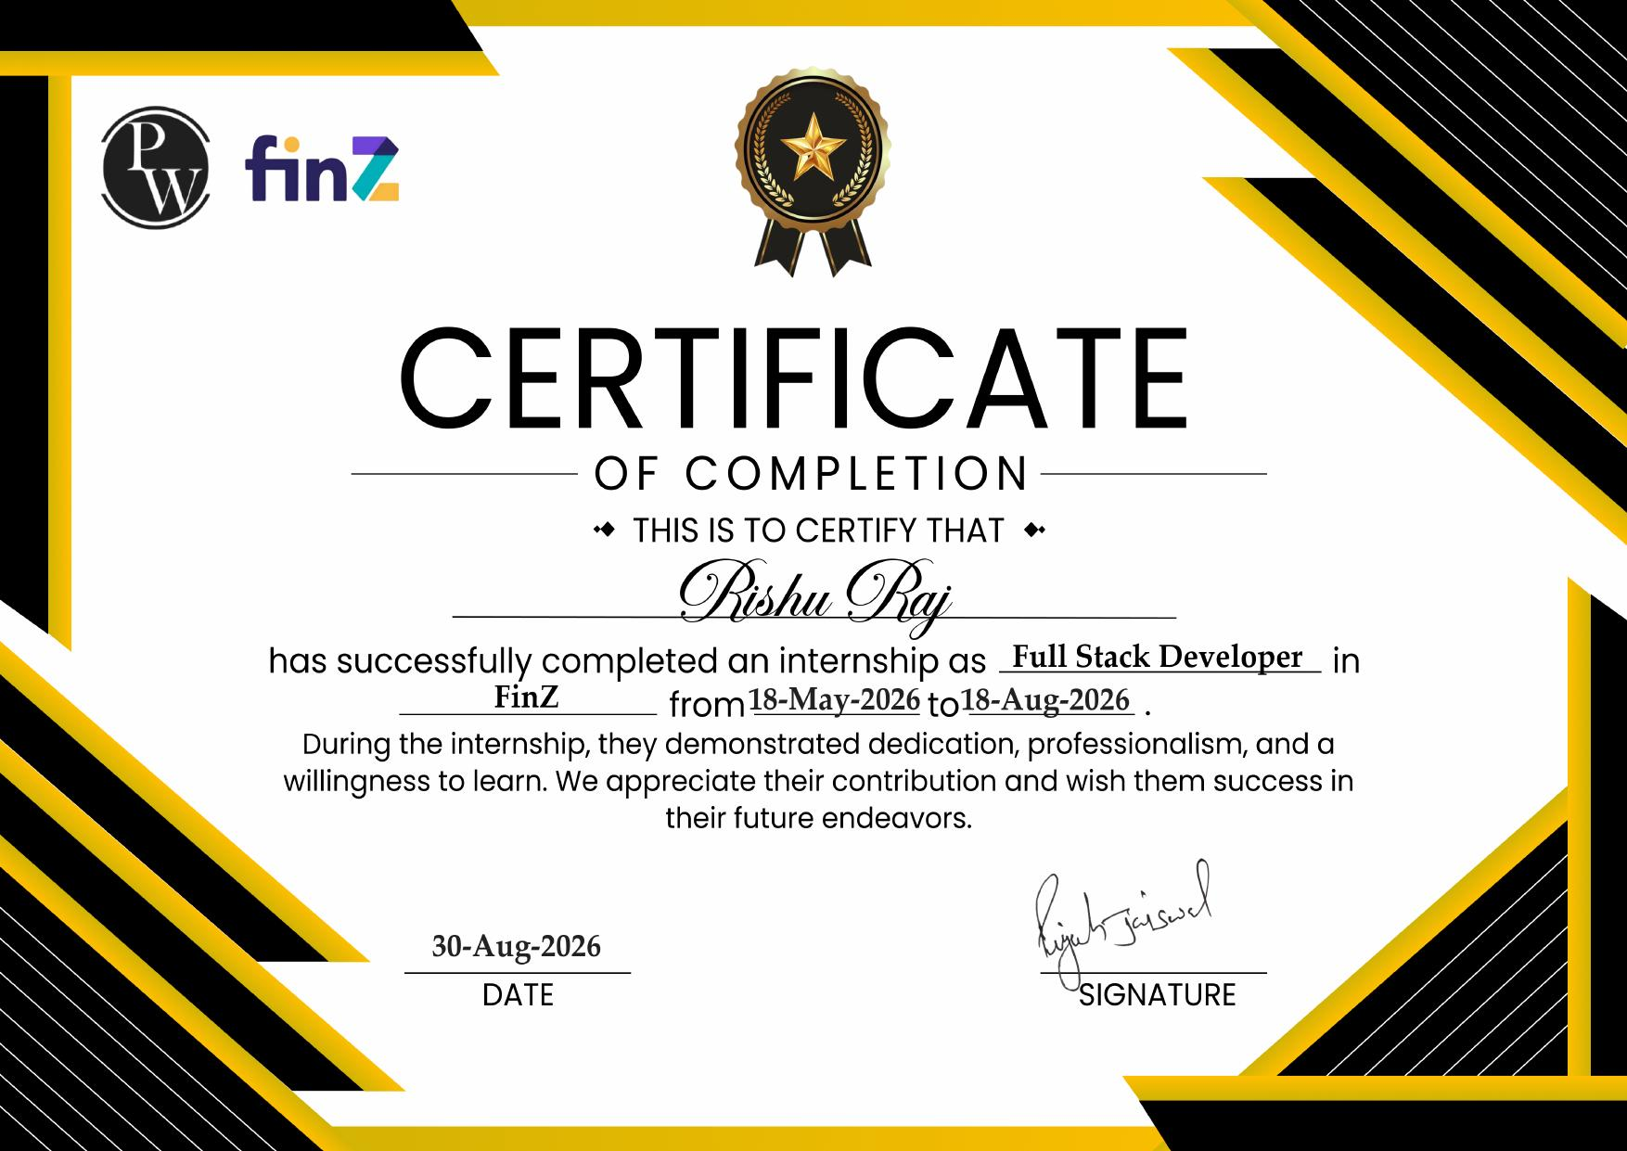

LIST OF TABLES
Table No. | Title | Page No.
4.1 | Internship and Student Details Summary | 1
4.2 | Technology Stack Used in LeadOne 2.0 | 4

LIST OF FIGURES
Figure No. | Title | Page No.
4.1 | High-Level System Architecture of LeadOne 2.0 (Conceptual) | 7
4.2 | Modular Architecture of LeadOne 2.0 | 8
4.3 | Lead Management Workflow in LeadOne 2.0 | 8

CHAPTER 4: PROJECT DESCRIPTION

4.1 Introduction
As part of the curriculum requirement for the degree of Bachelor of Technology in Computer Science and Engineering, I undertook an internship as a Full Stack Developer at FinZ from 18-May-2026 to 18-Aug-2026, as recorded on the official Internship Completion Certificate issued to me. During this internship, I was exposed to and contributed to the development and integration of various components of LeadOne 2.0, an enterprise-grade Lead Management System (LMS), Customer Relationship Management (CRM) platform, and Cloud Telephony / Call Center solution.
This report presents an academic account of the LeadOne 2.0 platform, the problem domain it addresses, the technologies used in its development, its architectural design, and the practical knowledge and skills I gained while working on it. The report has been prepared strictly on the basis of verified information from the internship certificate and the technical documentation of the project made available to me, and does not include any fabricated statistics, achievements, or organizational details.
The remainder of this chapter is organized as follows: Section 4.2 introduces the organization; Section 4.3 discusses the problem statement addressed by LeadOne 2.0; Section 4.4 lists the project objectives; Section 4.5 defines the scope of the project and of my personal contribution; Section 4.6 describes the technologies and tools used; Section 4.7 explains the system architecture; Section 4.8 discusses the development methodology, testing, and challenges encountered; and Section 4.9 summarizes the expected outcomes and learning gained. Section 4.10 attaches the certificate of completion.

4.2 Organization Profile
Table 4.1: Internship and Student Details Summary
Particular | Detail
Organization | FinZ
Designation | Full Stack Developer (Intern)
Internship Duration | 18-May-2026 to 18-Aug-2026
Certificate Issue Date | 30-Aug-2026
Student Name | RISHU RAJ
Roll Number | CS-2341354
Batch | 2023 – 2027
Section | 4CSE6
Project Worked On | LeadOne 2.0

The internship was undertaken at FinZ, as officially recorded on the Internship Completion Certificate issued to the candidate. The certificate also displays the logo of PW alongside the FinZ logo, indicating an association between the two; however, detailed information regarding the organization's history, scale of operations, official address, and organizational structure was not independently provided as part of the internship documentation available for this report. To avoid presenting inaccurate or unverified information, such details have intentionally been left out of this report.
[Organization Profile – to be expanded with the official company description, address, and background, as provided by FinZ / the internship coordinator, if required by the evaluator.]

4.3 Problem Statement
Organizations that rely on manual or fragmented processes for managing sales leads, customer interactions, and call center operations typically face several operational challenges. Leads captured through multiple channels (web forms, campaigns, or manual entry) are often difficult to track consistently, resulting in duplicate records, delayed follow-ups, and an unclear view of the lead lifecycle. Similarly, when telephony operations are not integrated with the CRM layer, agents and supervisors lack real-time visibility into call queues, agent availability, and call outcomes, which affects response times and customer experience.
Field-based sales or service teams face an additional challenge of demonstrating accountability for on-ground visits, as manual attendance and visit-logging methods are prone to inaccuracies. Support and helpdesk functions, when handled outside a structured ticketing and SLA framework, often suffer from missed deadlines and inconsistent escalation. LeadOne 2.0 is designed as an integrated platform that addresses these interconnected problems — lead management, cloud telephony, mobile call logging, geofenced attendance, helpdesk/SLA management, agent performance tracking, and workflow automation — within a single, modular enterprise application.

4.4 Project Objectives
The broad objectives of the LeadOne 2.0 platform, as understood from the project documentation, are:
- To provide a centralized system for capturing, tracking, and managing leads throughout their lifecycle, from initial capture to conversion or closure.
- To integrate cloud telephony and call center functionality directly with the CRM, enabling inbound/outbound call handling, live queue monitoring, and call disposition tracking.
- To extend CRM functionality to mobile devices through an Android call logger and a dedicated mobile API, allowing field and telecalling agents to operate on the move.
- To enable geofenced, GPS-based attendance and field-visit logging for on-ground executives.
- To provide a structured helpdesk and Service Level Agreement (SLA) engine for ticket management, prioritization, and automated escalation.
- To track agent performance through break management, violation logging, and attendance compliance reporting.
- To support configurable workflow automation and system-level diagnostics to keep the platform maintainable and observable.

4.5 Scope of the Project
The scope of LeadOne 2.0, at the project level, spans seven major functional areas: Lead Management, Cloud Telephony & Call Center, Android Call Logger & Mobile API, Geofenced Attendance & Field Executive Interaction, Helpdesk & SLA Engine, Agent Performance, and Automation & Diagnostics. These modules are described in detail in Section 4.7 of this report.
With regard to my personal contribution during the internship, I was involved in the development and integration of components across these modules under the guidance of the organization's engineering team. Given the enterprise scale of the platform and the collaborative nature of the development process, I was exposed to, and contributed to, the development and integration of various components of the LeadOne 2.0 platform, gaining practical experience in backend development with Laravel, REST API design, authentication, real-time communication, and related areas, rather than being solely responsible for the platform in its entirety. This report therefore describes both the system as a whole (to demonstrate technical understanding) and, separately, the nature of my own learning and contribution.

4.6 Technologies and Tools Used
Table 4.2: Technology Stack Used in LeadOne 2.0
Layer | Technology
Backend Framework | Laravel 13 (PHP 8.3+)
Frontend Interactivity | Alpine.js
Styling | Tailwind CSS 4.0
Build Tool / Asset Bundler | Vite 8, Node.js / npm
Real-Time Communication | Laravel Reverb (WebSockets)
API Authentication | Laravel Sanctum
Social/OAuth Login | Laravel Socialite
Data Visualization | Chart.js
Database | MySQL 8.0+ / PostgreSQL / SQLite
Dependency Management | Composer, npm
CLI / Task Automation | Laravel Artisan

Laravel 13 and PHP 8.3+
Laravel serves as the backend framework for LeadOne 2.0. It provides an expressive, structured way to implement routing, controllers, models (via the Eloquent ORM), and middleware, and it organizes the application into a clean Model-View-Controller (MVC)-oriented structure. PHP 8.3+ is the underlying server-side language in which Laravel itself is written and in which the application's business logic is implemented. Laravel also provides built-in support for building REST APIs, handling form validation, queuing background jobs, and scheduling tasks — all of which are relevant to an enterprise CRM/telephony platform of this scale.

Laravel Sanctum
Sanctum provides a lightweight authentication mechanism for Laravel applications, suited to both traditional session-based web authentication and token-based API authentication. In the context of LeadOne 2.0, it is relevant for securing the mobile API used by the Android Call Logger, ensuring that only authenticated agents and devices can access lead, call, and attendance data.

Laravel Reverb
Reverb is Laravel's first-party WebSocket server, used for real-time, bidirectional communication between the backend and connected clients. In a platform such as LeadOne 2.0, this class of technology is what enables features like live call-queue monitoring, real-time agent status updates, and instant notification delivery without requiring the client to repeatedly poll the server.

Alpine.js and Tailwind CSS
Alpine.js is a lightweight JavaScript framework that adds declarative interactivity directly within HTML markup, without the overhead of a full front-end framework. It is well suited to a server-rendered Laravel application that still needs dynamic, reactive UI components such as filters, dashboards, and modals. Tailwind CSS is a utility-first CSS framework that allows UI styling to be composed directly from small, reusable utility classes, which speeds up front-end development and keeps styling consistent across a large application.

Vite
Vite is the front-end build tool and development server used to bundle JavaScript and CSS assets, offering fast Hot Module Replacement (HMR) during development and optimized production builds.

Databases (MySQL / PostgreSQL / SQLite)
Laravel's Eloquent ORM is designed to work with multiple relational database engines, including MySQL, PostgreSQL, and SQLite, through a common query interface. This allows the same application code to be deployed against different database backends depending on the environment (for example, SQLite for local development and MySQL/PostgreSQL for production). The project material available does not specify which specific database engine is used in FinZ's production deployment, and this report does not assume one.

REST APIs
REST (Representational State Transfer) APIs expose the platform's functionality — leads, calls, tickets, attendance records — over HTTP in a stateless, resource-oriented manner. In LeadOne 2.0, REST APIs are what allow the Android Call Logger and other external or mobile clients to communicate with the central Laravel application.

4.7 System Architecture
LeadOne 2.0 follows a layered, modular architecture in which a Laravel-based application layer sits between the various client surfaces (web dashboard, Android application, and public lead-capture forms) and the underlying database. Figure 4.1 presents a conceptual, high-level view of this architecture, and Figure 4.2 presents the platform's functional modules organized around a common core. Both diagrams are conceptual representations prepared for this report on the basis of the project documentation, and do not represent the actual database schema or infrastructure diagram of the deployed system.
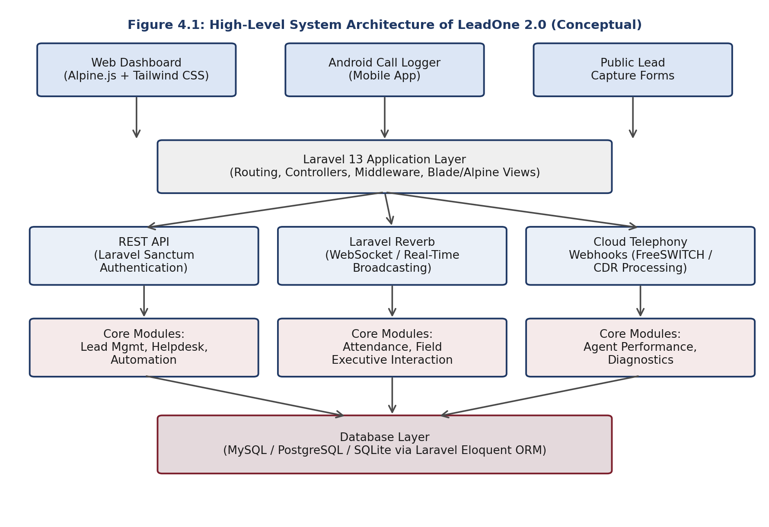
Figure 4.1: High-Level System Architecture of LeadOne 2.0 (Conceptual)
As shown in Figure 4.1, client-facing surfaces (the web dashboard built with Alpine.js and Tailwind CSS, the Android call logger application, and public lead-capture forms) all communicate with a common Laravel 13 application layer. This layer routes requests through REST APIs secured by Laravel Sanctum, real-time WebSocket channels powered by Laravel Reverb, and cloud telephony webhooks that process Call Detail Records (CDRs) from the telephony provider. All modules ultimately persist and retrieve data through the database layer via Laravel's Eloquent ORM.

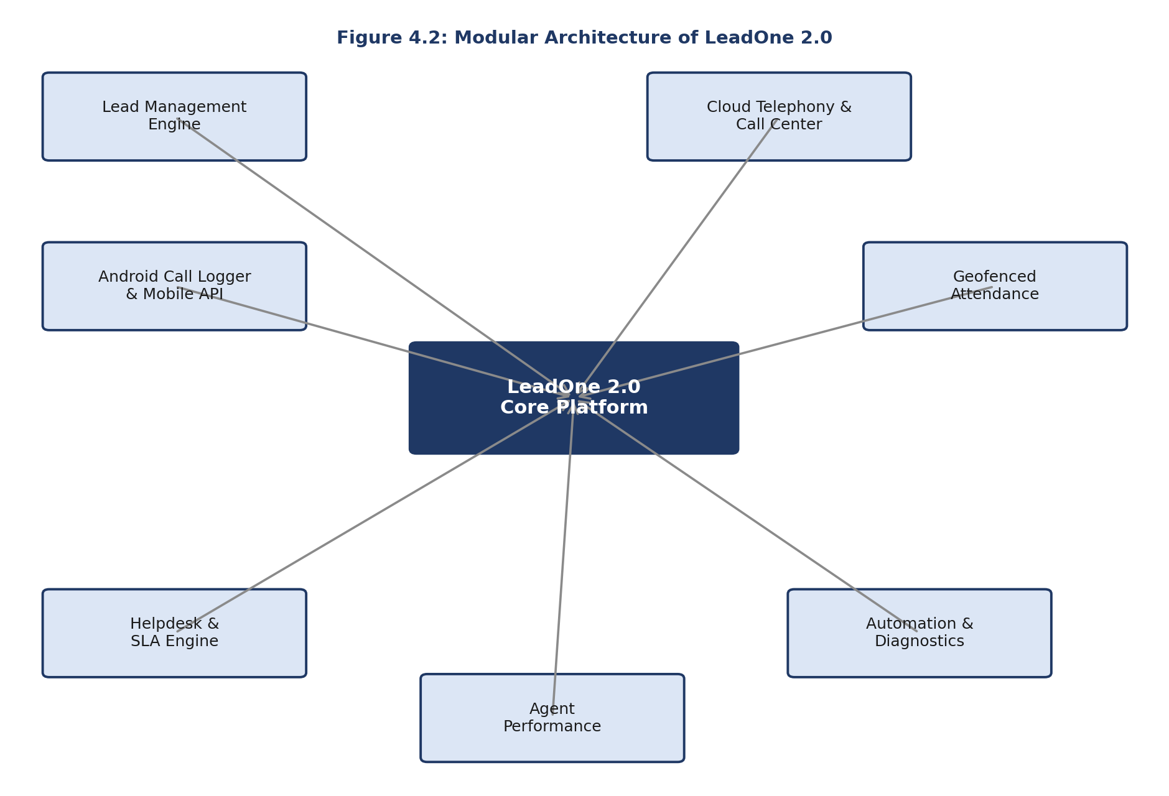
Figure 4.2: Modular Architecture of LeadOne 2.0
Figure 4.2 illustrates the seven functional modules that together constitute the LeadOne 2.0 platform, all of which interact with a shared core application. Each module is described briefly below.

4.7.1 Lead Management Engine
This module manages the complete lead lifecycle, from capture through to conversion or closure. It supports lead categorization by industry and stage, dynamic and configurable lead statuses, a chronological lead history timeline, and dynamic custom fields that allow the data model to be adapted to different business requirements without code changes. Leads can be allocated manually or distributed automatically via a round-robin mechanism, including in bulk. A campaign form builder and public lead-capture forms allow leads to be captured directly from marketing campaigns, while duplicate phone/email prevention and activity logs help maintain data quality and auditability.
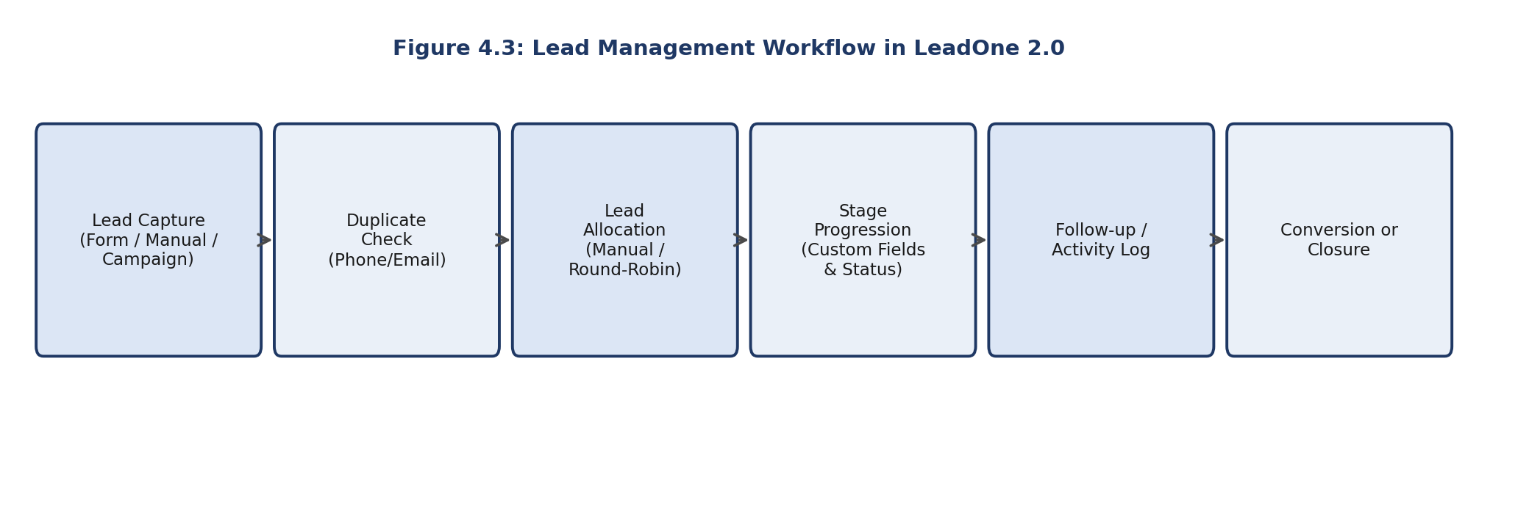
Figure 4.3: Lead Management Workflow in LeadOne 2.0

4.7.2 Cloud Telephony & Call Center
This module integrates inbound and outbound call queues, live queue monitoring, and agent status management into the CRM. A click-to-call API allows agents to initiate calls directly from the platform, while FreeSWITCH-based cloud telephony webhooks feed Call Detail Records (CDRs) back into the system for processing. Calls can be tagged with dispositions and categories, and call recordings are managed alongside the corresponding lead or ticket record, giving supervisors and agents a unified view of every customer interaction.

4.7.3 Android Call Logger & Mobile API
This module extends the platform to Android devices used by field and telecalling agents. It synchronizes call logs and, where applicable, call audio from the device back to the central system in near real time, authenticated through an OTP-based login mechanism. A dedicated mobile API exposes agent dashboards, lead profiles, call history, and configurable filters so that agents can work effectively from a mobile device.

4.7.4 Geofenced Attendance & Field Executive Interaction
This module implements GPS-based check-in and check-out for field executives, validated against a configurable geofence radius around the office or a designated location. It also supports logging of field/customer visits with GPS-tagged interactions, recorded meeting outcomes, and follow-up scheduling, giving management visibility into on-ground activity without manual reporting.

4.7.5 Helpdesk & SLA Engine
This module provides ticket management with configurable priorities, agent assignment, threaded replies, and bulk status updates. An SLA (Service Level Agreement) management engine tracks response and resolution timelines, detects SLA breaches, and triggers automated escalation. A knowledge base component supports self-service resolution of common issues.

4.7.6 Agent Performance
This module tracks agent break management, including break start/end times, break reasons, and live break status, along with violation logging where policy thresholds are exceeded. Attendance compliance reports provide a consolidated view of agent performance over time.

4.7.7 Automation & Diagnostics
This module allows administrators to define custom workflows using a trigger-action automation builder, covering scenarios such as automated notifications, stage-update automation, and external API integration. A system telemetry and diagnostic dashboard monitors service health, queue status, and WebSocket connectivity, supporting the operational maintainability of the platform.

4.8 Methodology
The development of an enterprise application such as LeadOne 2.0 follows the general phases of the Software Development Life Cycle (SDLC): requirement understanding, design, implementation, testing, and deployment. During my internship, I was introduced to this workflow in a practical setting — understanding existing modules of the platform, implementing or extending specific components under guidance, and validating my changes before they were integrated into the broader codebase. Laravel's modular structure (separate directories for routes, controllers, models, migrations, and views) made it possible to work on individual modules, such as a part of the lead management or helpdesk functionality, without needing to modify the entire application at once.
Where applicable, development was supported by Laravel Artisan commands for scaffolding and running database migrations, and by Composer and npm for managing PHP and JavaScript/CSS dependencies respectively. Enterprise Laravel projects of this nature are typically developed using a version control system such as Git to manage collaborative changes across a team; I followed this practice while working on my assigned tasks.

4.8.1 Testing and Debugging
Testing during the internship primarily involved functional verification of the specific components I worked on — confirming that API endpoints returned the expected responses, that form validations behaved correctly, and that changes did not break existing functionality. Debugging typically involved tracing issues through Laravel's logging and error-reporting mechanisms, inspecting database state, and verifying request/response payloads for the REST APIs and webhooks involved.

4.8.2 Challenges and Solutions
The following technical challenges are characteristic of a platform with the scope of LeadOne 2.0, and were addressed by the system's design as I came to understand it during the internship:
- Role-based access control: With multiple user types (agents, supervisors, administrators), managing what each role can view or modify required careful use of Laravel's authorization (middleware/policy) mechanisms.
- API authentication for mobile clients: Ensuring that only authenticated Android devices could synchronize call logs and access lead data required correct configuration of Laravel Sanctum and OTP-based verification.
- Real-time consistency: Keeping call-queue status and agent availability updated across multiple connected clients in real time relied on correctly broadcasting events through Laravel Reverb.
- Processing telephony webhooks reliably: Cloud telephony webhooks (CDRs) needed to be validated and processed idempotently, to avoid duplicate or inconsistent call records.
- Preventing duplicate leads: Enforcing phone/email uniqueness checks at the point of lead capture, across multiple intake channels (forms, campaigns, manual entry), required consistent validation logic.
- GPS/location validation: Geofenced attendance required accurate, tolerant handling of GPS coordinates against a configurable radius, accounting for natural GPS variance.
These points are presented as technical challenges addressed by the overall system design, based on the complexity of the modules described in Section 4.7, rather than as specific incidents that I personally debugged, except where I was directly involved in the corresponding task.

4.9 Expected Outcomes
The internship was expected to, and did, provide practical exposure to enterprise-grade software development practices, beyond what is typically covered in a classroom setting. The key learning outcomes and skills gained during this internship include:
- Practical experience with backend web development using the Laravel framework and PHP.
- Exposure to REST API design, development, and integration between backend services and client applications.
- Understanding of authentication and authorization mechanisms in web applications, including token-based API authentication via Laravel Sanctum.
- Familiarity with relational database concepts and Laravel's Eloquent ORM across MySQL, PostgreSQL, and SQLite.
- Exposure to frontend development practices using Alpine.js and Tailwind CSS, and asset bundling using Vite.
- Understanding of real-time communication concepts using WebSockets, as implemented through Laravel Reverb.
- Conceptual understanding of cloud telephony integration, including webhooks and Call Detail Record (CDR) processing.
- Exposure to mobile API integration patterns, as used by the Android Call Logger component.
- Understanding of geolocation and geofencing concepts as applied to attendance verification.
- Practical experience in debugging and testing components of a large, modular enterprise codebase.
- Exposure to standard professional software development practices, including modular code organization and (where applicable) version control.
- Improved problem-solving ability through working on real, production-oriented enterprise software rather than isolated academic exercises.
These outcomes are described as practical exposure and skills gained during the internship, rather than as claims of mastery, and reflect the learning that reasonably follows from the internship duration and the nature of the LeadOne 2.0 platform described in this report.

4.10 Certificate of Completion and Communication Proof
The official Internship Completion Certificate issued by FinZ has been included in the preliminary section of this report (Page iv).

[Additional communication/mail proof – e.g., offer letter, joining confirmation, or completion email – to be attached here if available and required by the evaluator.]

CHAPTER 5: BIBLIOGRAPHY / REFERENCES
The following official documentation sources were referred to for the technical concepts discussed in this report:
Laravel Documentation – https://laravel.com/docs
PHP Documentation – https://www.php.net/docs.php
Laravel Sanctum Documentation – https://laravel.com/docs/sanctum
Laravel Reverb Documentation – https://laravel.com/docs/reverb
Alpine.js Documentation – https://alpinejs.dev/start-here
Tailwind CSS Documentation – https://tailwindcss.com/docs
Vite Documentation – https://vitejs.dev/guide/
Chart.js Documentation – https://www.chartjs.org/docs/latest/
LeadOne 2.0 – Project README, as provided during the internship (internal project documentation).
Internship Completion Certificate issued by FinZ, dated 30-Aug-2026 (internal document, reproduced in Chapter 3 of this report).

