DAV INSTITUTIONS, JHARKHAND ZONE-F
Half Yearly Examination, 2026-27
Class: XII FULL MARKS: 80
Subject: Mathematics (Set A) TIME ALLOWED: 3 HOURS
************
General Instructions:
1. This question paper contains five sections — A, B, C, D and E. All questions are compulsory.
2. Section A consists of 20 questions of 1 mark each (Q1–Q20).
3. Question numbers 19 and 20 are Assertion–Reason based questions. Two statements are given, marked Assertion (A) and Reason (R). Select the correct option from the four given below each question.
4. Section B consists of 5 questions of 2 marks each (Q21–Q25).
5. Section C consists of 6 questions of 3 marks each (Q26–Q31).
6. Section D consists of 4 questions of 5 marks each (Q32–Q35).
7. Section E consists of 3 case-based/source-based questions of 4 marks each (Q36–Q38), with sub-parts of 2, 1 and 1 marks.
8. There is no overall choice. All questions are compulsory as set.
9. Use of calculators is not permitted.
——————————————————————————————————————————————————————————————————————
SECTION A
(Question numbers 1 to 18 carry 1 mark each. Questions 19 and 20 are Assertion–Reason based, 1 mark each.)
1. Let A = {1, 2, 3} and R = {(1,1), (2,2), (3,3), (1,2)} be a relation on A. Then R is:
(a) An equivalence relation (b) Reflexive and transitive only
(c) Reflexive and symmetric only (d) Symmetric and transitive only
2. The function f : ℝ → ℝ defined by f(x) = x² is:
(a) One-one and onto (b) One-one but not onto
(c) Onto but not one-one (d) Neither one-one nor onto
3. The principal value of sin⁻¹(−1/2) is:
(a) π/6 (b) −π/6 (c) 5π/6 (d) −5π/6
4. The domain of cos⁻¹(2x − 1) is:
(a) [0, 1] (b) [−1, 1] (c) [−1, 0] (d) [0, 2]
5. The range of the principal value branch of tan⁻¹x is:
(a) [−π/2, π/2] (b) (−π/2, π/2) (c) [0, π] (d) (0, π)
6. The value of x for which the matrix A = $\left[\begin{matrix}0 & 1 & -2 \\ -1 & 0 & x \\ 2 & -3 & 0\end{matrix}\right]$ is skew-symmetric, is:
(a) 3 (b) −3 (c) 2 (d) −2
7. For any square matrix A, the matrix (A + Aᵀ) is always:
(a) Skew-symmetric (b) Symmetric
(c) A diagonal matrix (d) A null matrix
8. If A and B are symmetric matrices of same order, then (AB − BA) is a:
(a) Symmetric matrix (b) Skew-symmetric matrix
(c) Null matrix (d) Identity matrix
9. If A is a 3 × 3 matrix such that |A| = 5, then the value of |3A| is:
(a) 15 (b) 45 (c) 135 (d) 405
10. If A is a square matrix of order 3 with |A| = 4, then |adj A| equals:
(a) 4 (b) 8 (c) 16 (d) 64
11. If y = e²ˣ, then dy/dx equals:
(a) e²ˣ (b) 2e²ˣ (c) 2x e²ˣ (d) eˣ
12. The rate of change of the area of a circle with respect to its radius r, at r = 5 cm, is:
(a) 5π cm²/cm (b) 10π cm²/cm (c) 25π cm²/cm (d) 2π cm²/cm
13. ∫ sec²x dx equals:
(a) tan x + C (b) −cot x + C (c) sec x tan x + C (d) cot x + C
14. ∫ 1/(1 + x²) dx equals:
(a) tan⁻¹x + C (b) sin⁻¹x + C (c) cot⁻¹x + C (d) sec⁻¹x + C
15. ∫ 1/√(1 − x²) dx equals:
(a) sin⁻¹x + C (b) cos⁻¹x + C (c) tan⁻¹x + C (d) sec⁻¹x + C
16. ∫ e³ˣ dx equals:
(a) e³ˣ + C (b) 3e³ˣ + C (c) (1/3)e³ˣ + C (d) eˣ + C
17. ∫ cos(2x) dx equals:
(a) sin(2x) + C (b) (1/2)sin(2x) + C (c) −2sin(2x) + C (d) −(1/2)sin(2x) + C
18. ∫ (1/x) dx (for x > 0) equals:
(a) 1/x² + C (b) −1/x² + C (c) ln(x) + C (d) x + C
19. The graph of a function y = f(x) is shown below:
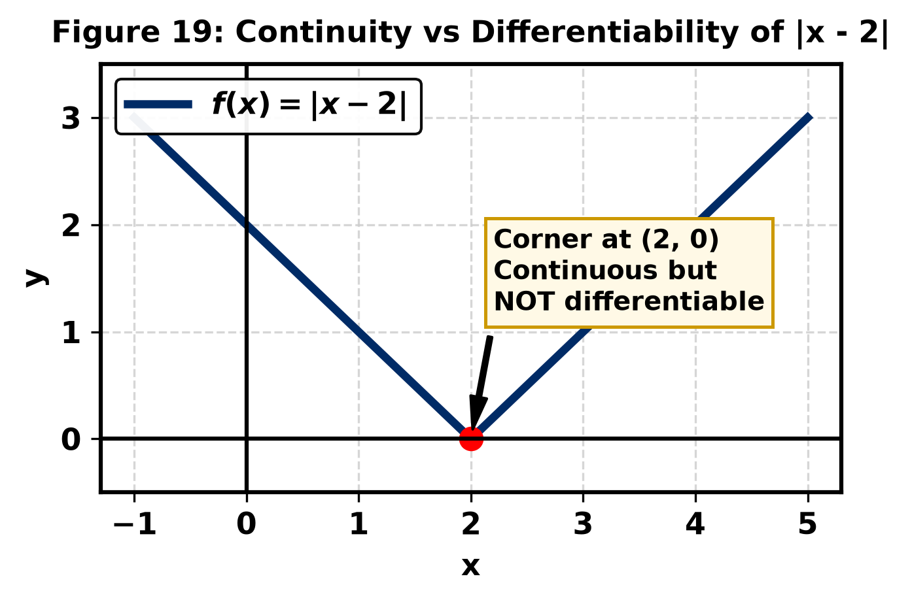
Assertion (A): The function f(x) = |x − 2| shown in the graph is continuous at x = 2.
Reason (R): The function f(x) = |x − 2| is differentiable at x = 2.
(a) Both A and R are true, and R is the correct explanation of A.
(b) Both A and R are true, but R is not the correct explanation of A.
(c) A is true, but R is false.
(d) A is false, but R is true.
20. The graph of a function y = f(x) is shown below:
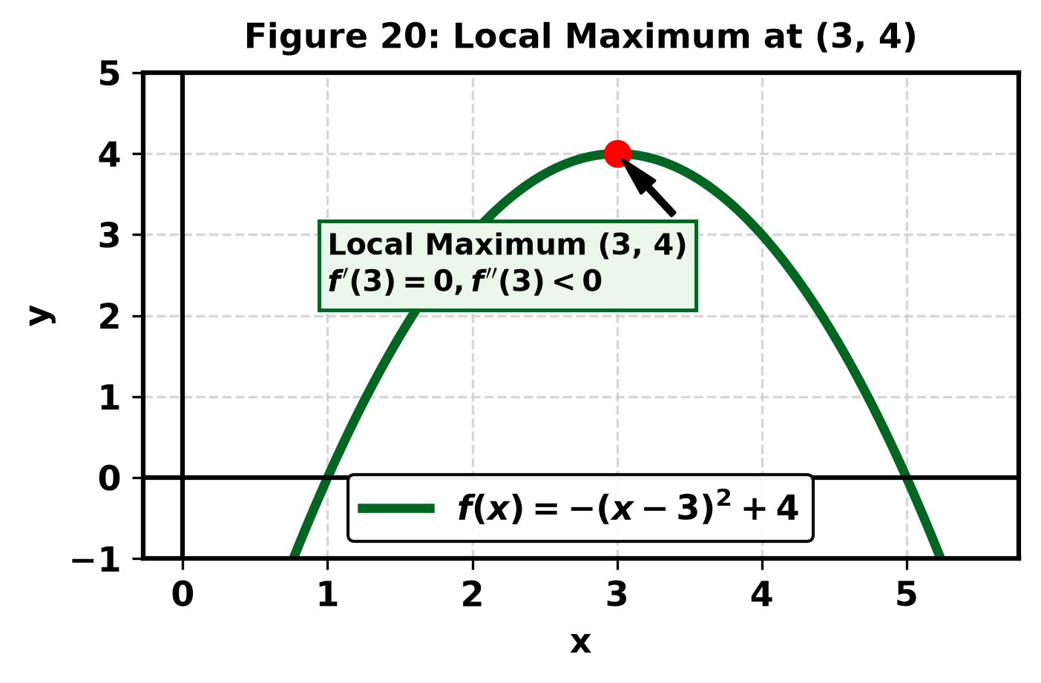
Assertion (A): The point (3, 4) marked on the graph of f(x) = −(x − 3)² + 4 is a point of local maximum.
Reason (R): At a point of local maximum, f′(x) = 0 and f″(x) < 0.
(a) Both A and R are true, and R is the correct explanation of A.
(b) Both A and R are true, but R is not the correct explanation of A.
(c) A is true, but R is false.
(d) A is false, but R is true.
SECTION B
(Question numbers 21 to 25 carry 2 marks each.)
21. Check whether the relation R = {(1,1), (2,2), (3,3), (1,2), (2,3)} on the set A = {1, 2, 3} is reflexive, symmetric and transitive. Justify your answer.
22. Find the principal value of: tan⁻¹(√3) − sec⁻¹(−2).
23. If f(x) = kx + 1 for x ≤ 5 and f(x) = 3x − 5 for x > 5 is continuous at x = 5, find the value of k.
24. Differentiate y = sin(x² + 1) with respect to x.
25. Evaluate: ∫ x e^(x²) dx.
SECTION C
(Question numbers 26 to 31 carry 3 marks each.)
26. Find the value of:
(i) sin⁻¹(sin(2π/3)) (ii) cos⁻¹(cos(7π/6)) (iii) tan⁻¹(tan(3π/4))
27. If A = $\left[\begin{matrix}1 & 2 \\ 3 & 4\end{matrix}\right]$ and B = $\left[\begin{matrix}2 & 0 \\ 1 & 3\end{matrix}\right]$, find (2A − 3B) and verify that (A + B)ᵀ = Aᵀ + Bᵀ.
28. Using minors and cofactors, evaluate the determinant:
|A| = $\left|\begin{matrix}1 & 2 & 3 \\ 0 & 1 & 4 \\ 5 & 6 & 0\end{matrix}\right|$
29. If y = xˣ (x > 0), find dy/dx.
30. Find the intervals in which the function f(x) = 2x³ − 15x² + 36x + 1 is (i) strictly increasing (ii) strictly decreasing.
31. Evaluate ∫ x sin x dx using integration by parts.
SECTION D
(Question numbers 32 to 35 carry 5 marks each.)
32. For the system of linear equations:
x + y + z = 6
y + 3z = 11
x − 2y + z = 0
write the coefficient matrix A = $\left[\begin{matrix}1 & 1 & 1 \\ 0 & 1 & 3 \\ 1 & -2 & 1\end{matrix}\right]$. Evaluate the determinant |A|, find adj(A), determine A⁻¹ = adj(A)/|A|, and hence solve the system of equations.
33. If y = (sin⁻¹x)², prove that (1 − x²) d²y/dx² − x dy/dx − 2 = 0.
34. An open topped box is to be constructed by removing equal squares of side x from each corner of a 24 cm × 9 cm rectangular sheet of tin and folding up the sides. Find the value of x for which the volume of the box is maximum, and determine this maximum volume.
35. Evaluate: ∫ (x² + 1)/(x² − 5x + 6) dx.
SECTION E
(Question numbers 36 to 38 are case-based questions of 4 marks each, with sub-parts of 2, 1 and 1 marks.)
36. Case Study 1 — Relations and Functions
Two friends, Rohan and Simran, are studying equivalence relations on sets. Consider the set A = {1, 2, 3, 4, 5} and the relation R on A defined by R = {(a, b) : |a − b| is even}. The diagram below illustrates the partition of set A into equivalence classes under relation R:
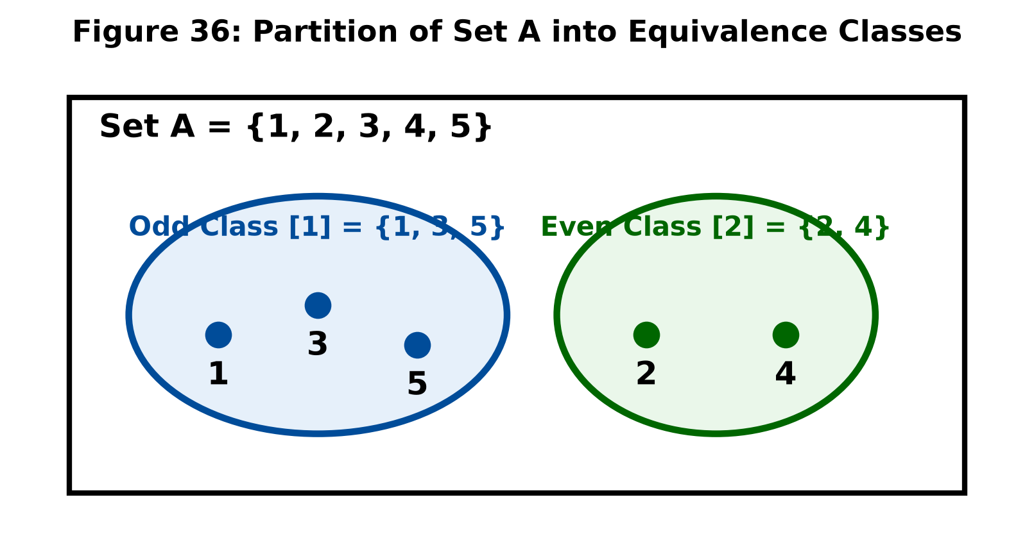
Based on the above information, answer the following:
(i) Show that R is an equivalence relation on A. (2 marks)
(ii) Write the equivalence class of the element 2. (1 mark)
(iii) Is (1, 5) ∈ R? Justify your answer. (1 mark)
37. Case Study 2 — Matrices
A school management committee decides to award prizes to students for three core values: Discipline (x), Cleanliness (y), and Regularity (z). Two schools P and Q decide to award their students as per the allocation scheme shown in the table below:
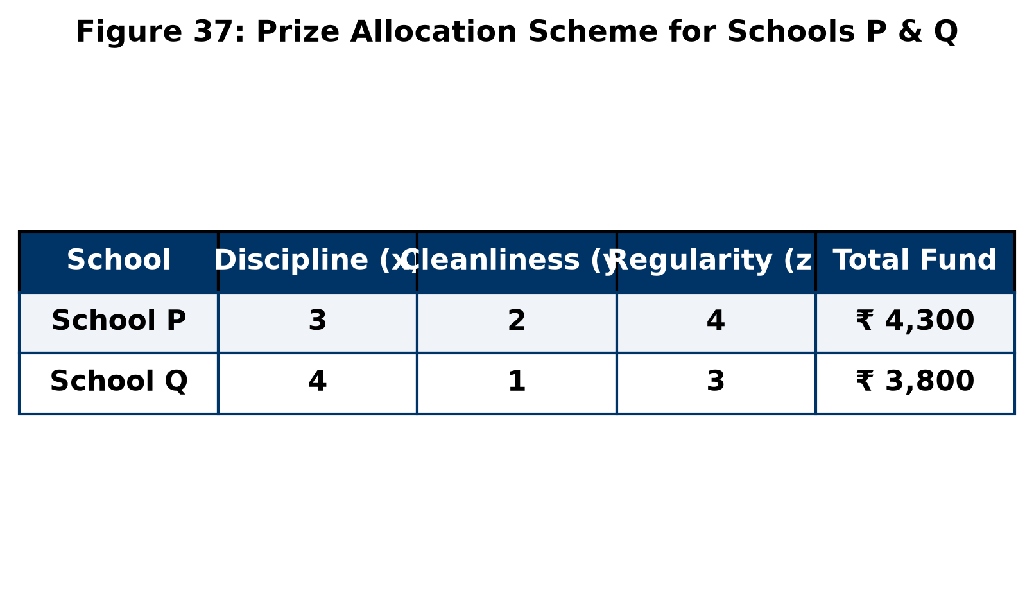
Based on the above information, answer the following:
(i) Represent the given problem in the form of a matrix equation AX = B. (2 marks)
(ii) If the prize money for Discipline is ₹ 500 and Regularity is ₹ 600, calculate the prize money for Cleanliness. (1 mark)
(iii) State one moral/social benefit of recognizing Cleanliness among students. (1 mark)
38. Case Study 3 — Application of Derivatives
An automobile manufacturing company models its commercial performance. The total revenue received (in thousands of ₹) from the sale of x units of cars is given by R(x) = 3x² + 36x + 5, while the total cost of production is given by C(x) = 0.005x³ − 0.02x² + 30x + 5000. The revenue curve is depicted below:
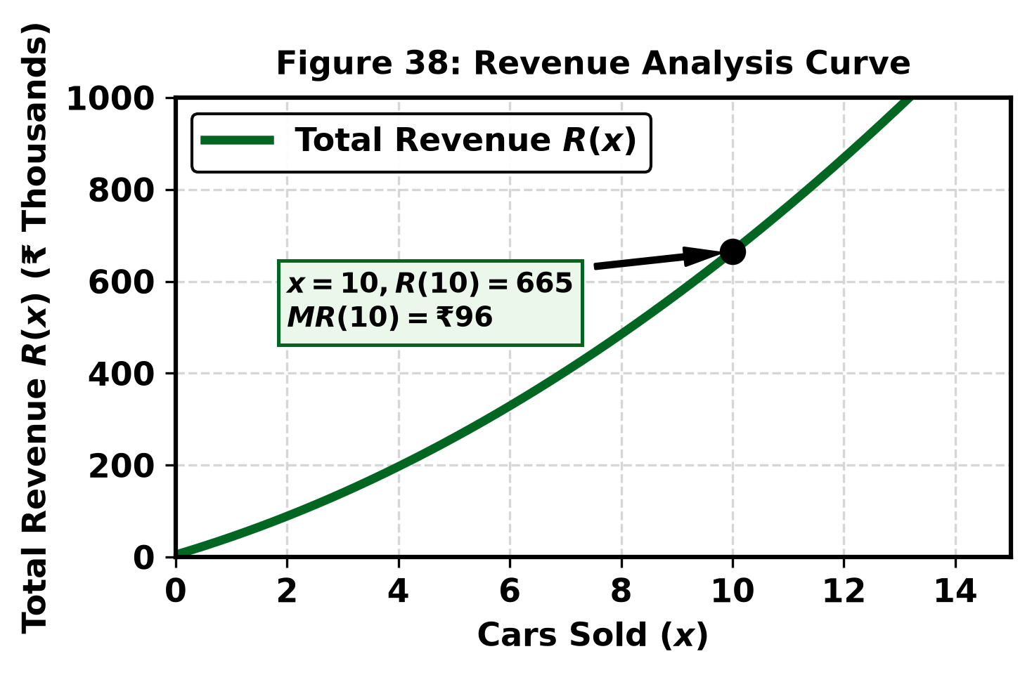
Based on the above information, answer the following:
(i) Find the marginal revenue function, MR(x) = dR/dx, and evaluate it at x = 10 cars. (2 marks)
(ii) Find the marginal cost when x = 2 cars. (1 mark)
(iii) Write the profit function P(x) in terms of R(x) and C(x). (1 mark)
— End of Question Paper —

