DAV INSTITUTIONS, JHARKHAND ZONE-F
Half Yearly Examination, 2026-27
Class: XII FULL MARKS: 80
Subject: Mathematics (Set B) TIME ALLOWED: 3 HOURS
************
General Instructions:
1. This question paper contains five sections — A, B, C, D and E. All questions are compulsory.
2. Section A consists of 20 questions of 1 mark each (Q1–Q20).
3. Question numbers 19 and 20 are Assertion–Reason based questions. Two statements are given, marked Assertion (A) and Reason (R). Select the correct option from the four given below each question.
4. Section B consists of 5 questions of 2 marks each (Q21–Q25).
5. Section C consists of 6 questions of 3 marks each (Q26–Q31).
6. Section D consists of 4 questions of 5 marks each (Q32–Q35).
7. Section E consists of 3 case-based/source-based questions of 4 marks each (Q36–Q38), with sub-parts of 2, 1 and 1 marks.
8. There is no overall choice. All questions are compulsory as set.
9. Use of calculators is not permitted.
——————————————————————————————————————————————————————————————————————
SECTION A
(Question numbers 1 to 18 carry 1 mark each. Questions 19 and 20 are Assertion–Reason based, 1 mark each.)
1. Let R = {(1,1), (2,2), (3,3), (1,3), (3,1)} be a relation on A = {1, 2, 3}. Then R is:
(a) Reflexive only (b) Symmetric only
(c) An equivalence relation (d) Reflexive and symmetric only
2. The number of all one-one functions from the set {1, 2, 3} to itself is:
(a) 3 (b) 6 (c) 9 (d) 27
3. The principal value of cos⁻¹(−1/√2) is:
(a) π/4 (b) 3π/4 (c) −π/4 (d) 5π/4
4. The domain of sin⁻¹(3x − 1) is:
(a) [0, 2/3] (b) [−1, 1] (c) [0, 1] (d) [−2/3, 2/3]
5. The principal value of tan⁻¹(−1) is:
(a) π/4 (b) −π/4 (c) 3π/4 (d) −3π/4
6. If the matrix A = $\left[\begin{matrix}0 & a & -3 \\ 2 & 0 & -1 \\ b & 1 & 0\end{matrix}\right]$ is skew-symmetric, then the value of (a + b) is:
(a) 1 (b) −1 (c) 5 (d) −5
7. A matrix A = [aᵢⱼ]₃ₓ₃ is a diagonal matrix if:
(a) aᵢⱼ = 0 for all i, j (b) aᵢⱼ = 0 for i ≠ j
(c) aᵢⱼ = 0 for i = j (d) aᵢⱼ ≠ 0 for all i, j
8. If A and B are square matrices of the same order, then (A + B)ᵀ equals:
(a) Aᵀ + Bᵀ (b) Aᵀ − Bᵀ (c) AᵀBᵀ (d) BᵀAᵀ
9. If A is a 3 × 3 matrix with |A| = −2, then |3A| equals:
(a) −6 (b) −54 (c) 54 (d) −18
10. The area of the triangle with vertices (1, 0), (6, 0) and (4, 3), found using determinants, is:
(a) 15 sq units (b) 15/2 sq units (c) 7 sq units (d) 12 sq units
11. If y = sin(3x), then dy/dx is:
(a) cos(3x) (b) 3cos(3x) (c) −3cos(3x) (d) 3sin(3x)
12. The rate of change of the volume V = (4/3)πr³ of a sphere with respect to its radius r is:
(a) 4πr² (b) 2πr (c) (4/3)πr² (d) 4πr
13. ∫ cos x dx equals:
(a) sin x + C (b) −sin x + C (c) cos x + C (d) −cos x + C
14. ∫ 1/√(a² − x²) dx equals:
(a) sin⁻¹(x/a) + C (b) (1/a)sin⁻¹(x/a) + C (c) cos⁻¹(x/a) + C (d) tan⁻¹(x/a) + C
15. ∫ e⁻ˣ dx equals:
(a) e⁻ˣ + C (b) −e⁻ˣ + C (c) eˣ + C (d) −eˣ + C
16. ∫ csc²x dx equals:
(a) cot x + C (b) −cot x + C (c) tan x + C (d) −csc x + C
17. ∫ sec x tan x dx equals:
(a) sec x + C (b) tan x + C (c) −sec x + C (d) cot x + C
18. ∫ x⁴ dx equals:
(a) 4x³ + C (b) x⁵/5 + C (c) 5x⁵ + C (d) x³/3 + C
19. The graph of the greatest integer function y = [x] is shown below:
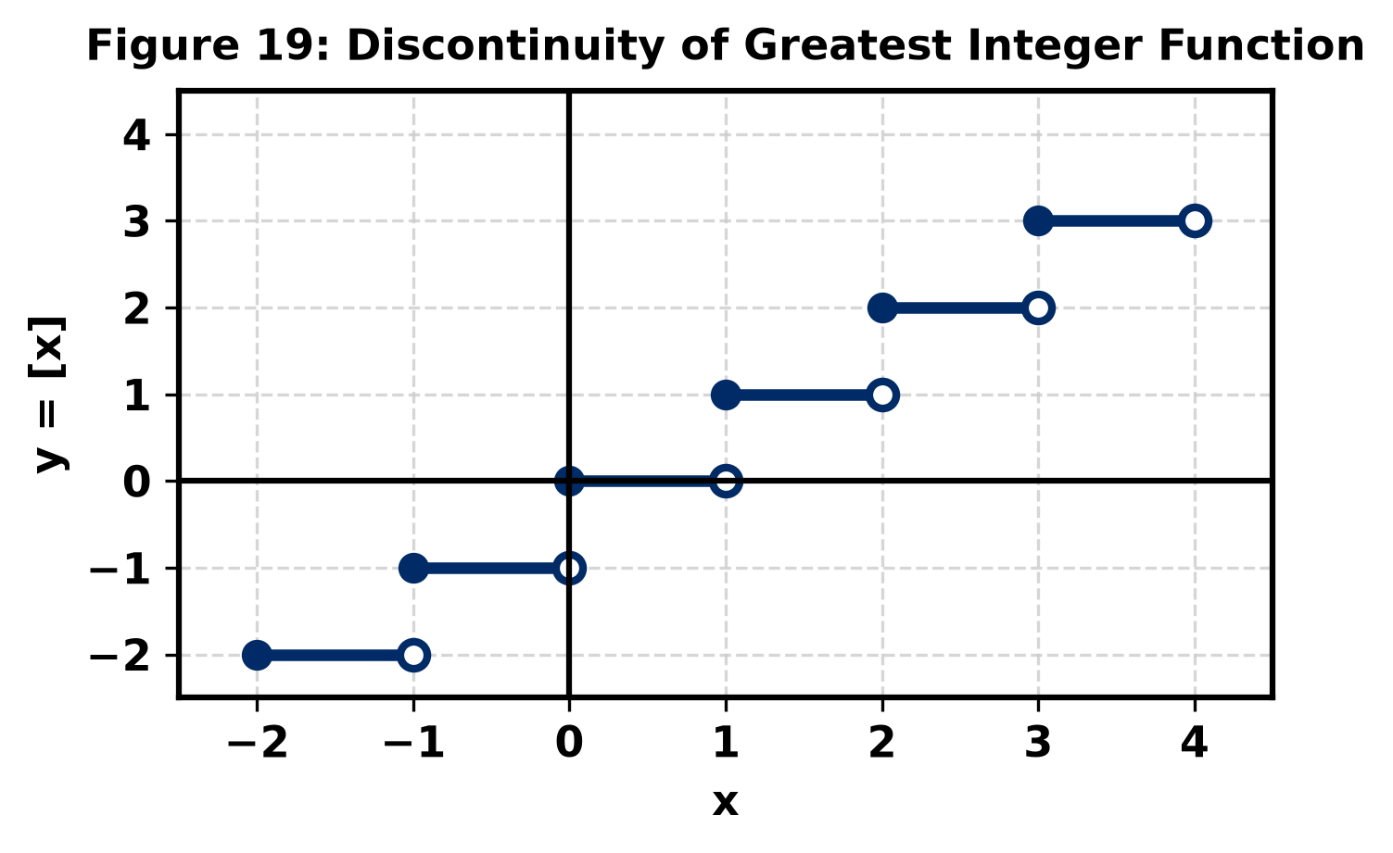
Assertion (A): The function f(x) = [x] (greatest integer function) is discontinuous at every integer.
Reason (R): For any integer n, lim(x→n) [x] does not exist.
(a) Both A and R are true, and R is the correct explanation of A.
(b) Both A and R are true, but R is not the correct explanation of A.
(c) A is true, but R is false.
(d) A is false, but R is true.
20. The graph of the logarithmic function y = ln(x) is shown below:
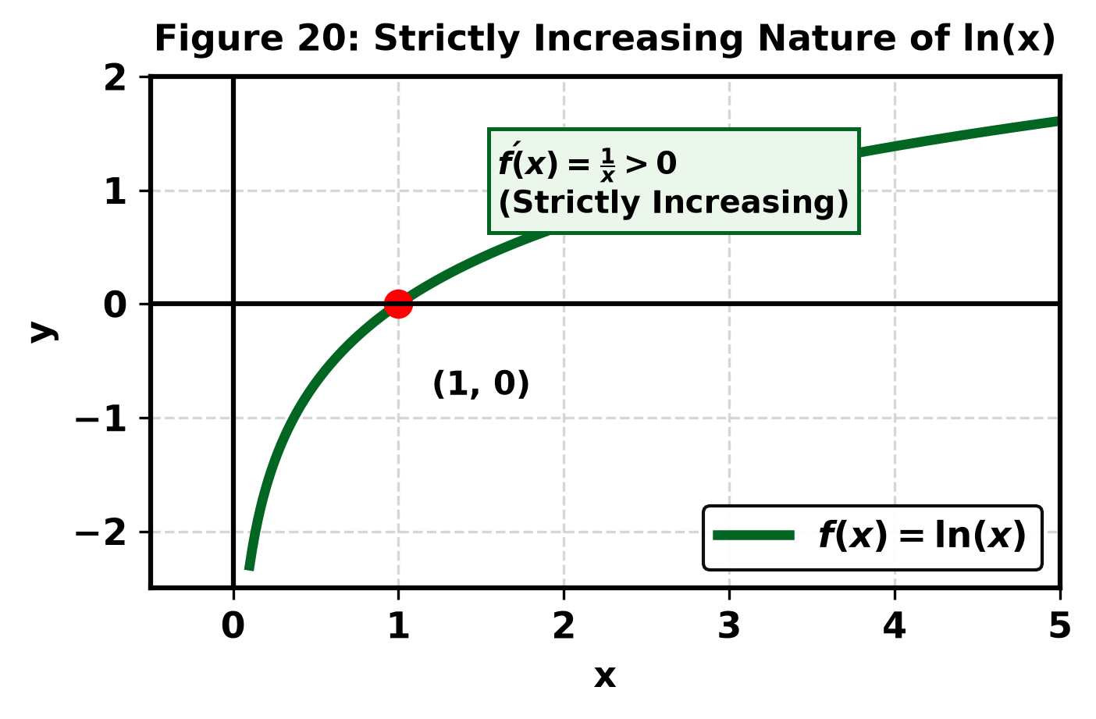
Assertion (A): The function f(x) = log x is strictly increasing on (0, ∞).
Reason (R): f′(x) = 1/x > 0 for all x ∈ (0, ∞).
(a) Both A and R are true, and R is the correct explanation of A.
(b) Both A and R are true, but R is not the correct explanation of A.
(c) A is true, but R is false.
(d) A is false, but R is true.
SECTION B
(Question numbers 21 to 25 carry 2 marks each.)
21. Let A = {1, 2, 3} and R = {(1,1), (2,2), (3,3), (1,3), (3,1)} be a relation on A. Is R an equivalence relation? Justify your answer.
22. Find the principal value of: cos⁻¹(−1/2) + 2sin⁻¹(1/2).
23. The value of k for which f(x) = kx² (for x ≤ 2) and f(x) = 3 (for x > 2) is continuous at x = 2, is:
24. Differentiate y = cos(x²) with respect to x.
25. Evaluate: ∫ e^(sin x) · cos x dx.
SECTION C
(Question numbers 26 to 31 carry 3 marks each.)
26. Find the value of:
(i) cos⁻¹(cos(5π/4)) (ii) sin⁻¹(sin(−π/3)) (iii) tan⁻¹(tan(5π/6))
27. If A = $\left[\begin{matrix}3 & 1 \\ -1 & 2\end{matrix}\right]$ and B = $\left[\begin{matrix}1 & 0 \\ -1 & 2\end{matrix}\right]$, find (A + 2B) and verify that (A + B)ᵀ = Aᵀ + Bᵀ.
28. Evaluate the determinant:
|A| = $\left|\begin{matrix}2 & -1 & 3 \\ 1 & 2 & -1 \\ 0 & 3 & 2\end{matrix}\right|$
29. If y = x^(sin x) (x > 0), find dy/dx.
30. Find the intervals in which the function f(x) = x³ − 6x² + 9x + 15 is (i) strictly increasing (ii) strictly decreasing.
31. Evaluate ∫ x cos x dx using integration by parts.
SECTION D
(Question numbers 32 to 35 carry 5 marks each.)
32. For the system of linear equations:
x − y + 2z = 7
3x + 4y − 5z = −5
2x − y + 3z = 12
write the coefficient matrix A = $\left[\begin{matrix}1 & -1 & 2 \\ 3 & 4 & -5 \\ 2 & -1 & 3\end{matrix}\right]$. Evaluate the determinant |A|, find adj(A), determine A⁻¹ = adj(A)/|A|, and hence solve the system of equations.
33. If y = (tan⁻¹x)², show that (1 + x²)² d²y/dx² + 2x(1 + x²) dy/dx = 2.
34. A rectangular sheet of tin 45 cm × 24 cm is to be made into a box without top, by cutting off squares of side x from each corner and folding up the flaps. Find the value of x for which the volume of the box is maximum, and determine this maximum volume.
35. Evaluate: ∫ (x² + x + 1)/((x + 1)(x + 2)) dx.
SECTION E
(Question numbers 36 to 38 are case-based questions of 4 marks each, with sub-parts of 2, 1 and 1 marks.)
36. Case Study 1 — Relations and Functions
A mathematics club defines a relation R on the set A = {1, 2, 3, 4, 6} as R = {(a, b) : a divides b, where a, b ∈ A}. The directed graph below illustrates the divisibility relation among the elements:
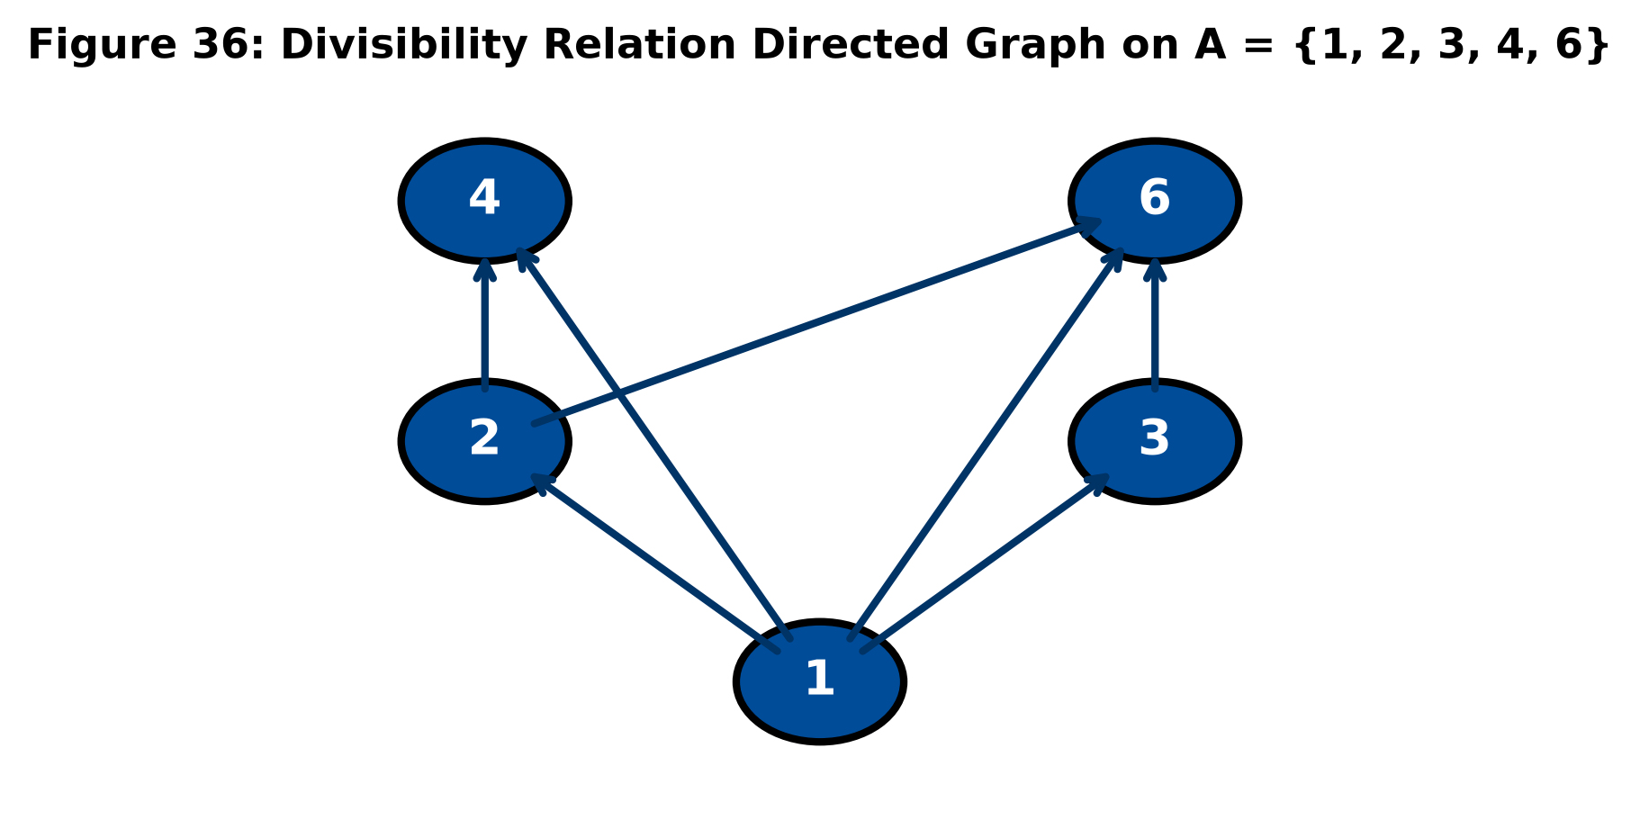
Based on the above information, answer the following:
(i) Show that R is reflexive and transitive. (2 marks)
(ii) Is R symmetric? Justify with an example. (1 mark)
(iii) Is R an equivalence relation? Give reason. (1 mark)
37. Case Study 2 — Matrices
Two schools A and B decided to award prizes to their students for three exemplary values: Honesty (x), Hard Work (y), and Cooperation (z). The prize distribution is organized as shown in Figure 37:
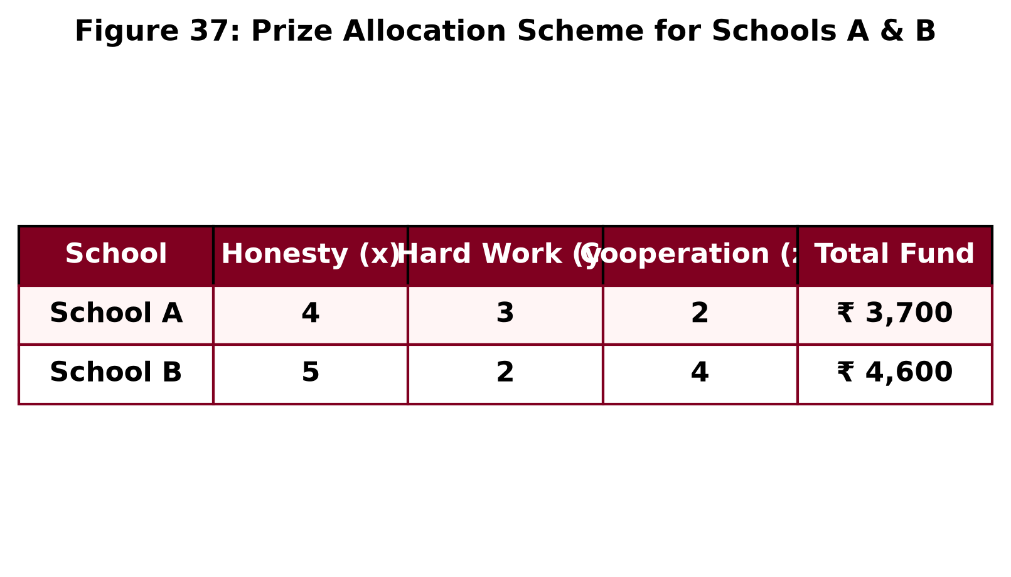
Based on the above information, answer the following:
(i) Represent the given problem in the form of a matrix equation AX = B. (2 marks)
(ii) If the prize money for Honesty is ₹ 500 and Cooperation is ₹ 400, find the prize money for Hard Work. (1 mark)
(iii) State one moral benefit of recognizing Hard Work in schools. (1 mark)
38. Case Study 3 — Application of Derivatives
A manufacturing firm's total revenue (in ₹) received from selling x units of a product is given by R(x) = 13x² + 26x + 15. The revenue function curve is shown below:

Based on the above information, answer the following:
(i) Find the marginal revenue function, MR(x) = dR/dx. (2 marks)
(ii) Find the marginal revenue when x = 7 units. (1 mark)
(iii) State, with reason, whether the revenue is increasing or decreasing at x = 7. (1 mark)
— End of Question Paper —

