Name: Rishu Singh

Date: 21st May 2019

Place: New Delhi, INDIA

UDACITY

Data Analysis Nanodegree

Project 01:



Exploring weather Trends

# Overview:

# In this project, I have analyzed local temperature of New Delhi, India in accordance with the global temperature data and compared. I had been provided with a database on Udacity portal from where I have to extract, manipulate and visualize the data as in the following goals.

# Goals:

# 1. Extraction of data from the database and export to CSV file

# 2. Making a line chart visualization based on extracted data

# 3. Observation based on chart

# Tools Used:

# 1. SQL: To extract the data from the database.

# 2. Python: For calculating moving average and plotting line chart.

# 3. ANACONDA - Jupyter Notebook: For writing python code and making observations.

# 4. Excel: Having a look at the data and writing project.

# STEP 1 –

# Extraction of Data from provided Database I have done the following activity in order to make a relevant dataset. I have learnt the SQL basics from lessons provided before this project.

# I have also done an introductory course on SQL and relational database from which I have used some concepts.

# 1. To see which cities are available for "India" in the given dataset:

# SELECT * FROM city_list WHERE country LIKE ‘India’

# 2. I know that I can make a relevant dataset by joining the two tables. But, I found from the SCHEMA that both city_data and global_data contains same column named 'avg_temp'.

# So I have changed the names of the columns respectively in order to have distinct columns.

# ALTER TABLE city_data RENAME COLUMN avg_temp to CAT;

# -- CAT = City Average Temp.

# ALTER TABLE global_data RENAME COLUMN avg_temp to GAT;

# -- GAT = Global Average Temp.

# 3. Now I have written following code in order to join the two tables and have the relevant data:

# SELECT global_data.year, global_data.GAT, city_data.CAT

# FROM global_data JOIN city_data

# ON global_data.year = city_data.year

# WHERE city LIKE 'New Delhi';

# Now I have got an option of downloading the file as CSV format.

# Moving Averages:

* To observe the trends in temperature I calculated moving average(MA).
* I used 10 years Moving Average to get the smooth line chart.

# Excel commands for Moving Averages:

|  |  |
| --- | --- |
| **Moving Average** | **Excel Commands** |
| For 10 years Moving Average | =AVERAGE(B2:B11) |

This is how the excel sheet looks like:

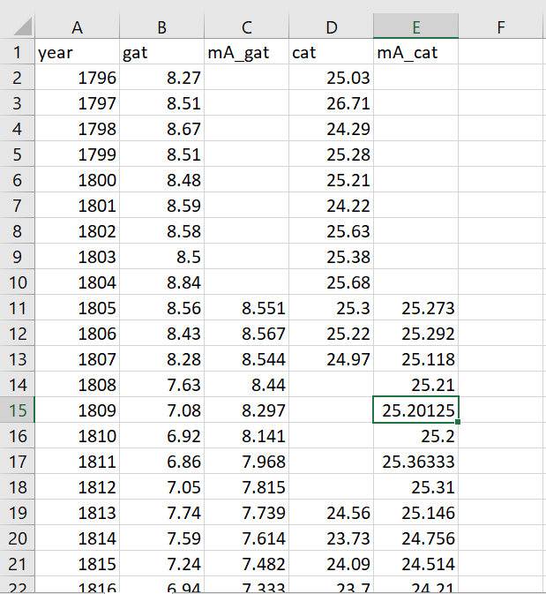

STEP 2 – Python Code for Making Line Chart

So I have used some python libraries here, I have written these codes on Jupyter Notebook.

# Importing the important Libraries

import numpy as np

import pandas as pd

from matplotlib import pyplot as plt

# Importing the extracted Data Set

data = pd.read_csv("results.csv")

**Line Chart for New Delhi and Global Temperature:**

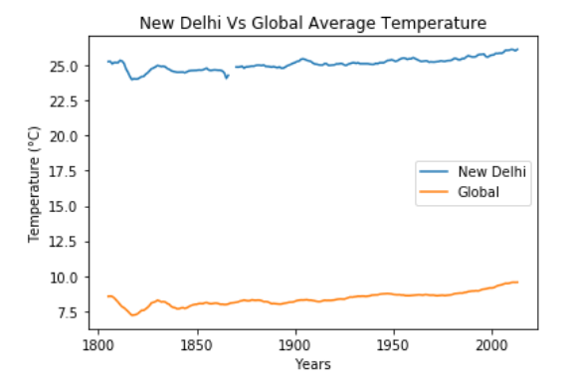

**Observation:**

* **Global** average temperature varies between **7.20 to 9.56** Degree Celsius but **New Delhi** city average temperature is varies between **24.03 to 26.14** Degree Celsius.
* If comparing the Global average temperature and New Delhi average temperature, then the **New Delhi city is hotter** than Global average temperature.
* Change in temperature over time:

|  |  |  |  |
| --- | --- | --- | --- |
| **Year** | **Change in Global average temperature** | **Change in New Delhi average temperature** | **Increasing/Decreasing over time** |
| **1796 - 1866** | 8.27 – 8.04 | 25.03 – 24.30 | Decreasing |
| **1880 - 1950** | 8.27 – 8.68 | 25.01 – 25.36 | Increasing |
| **1951 - 2013** | 8.67 – 9.56 | 25.28 – 26.14 | Increasing |

* According to the graph and above table the difference between Global average temperature and New Delhi average temperature is been **consistent over time**.
* New Delhi and Global average temperature have similar kind of trends. During early years, both trends seems to have ups and downs then approx. around **1982** the moving average temperature starts to **increase** at a steady rate.
* According to the graph the **world is getting hotter** because from 1834 to 2013 Temperature increases.

**Final Conclusion:**

# Global Temperature ∞ New Delhi Temperature

The World is Getting Hotter.