1. Menu will be printed in each iteration so we can easily follow the flow of program

2. Following tables are needed :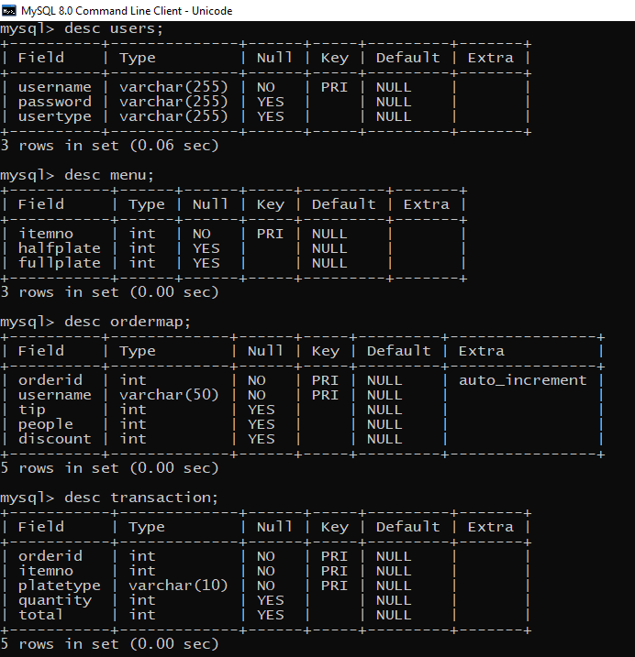

3. To get some data in menu use menu.csv file.