1. Following tables are needed :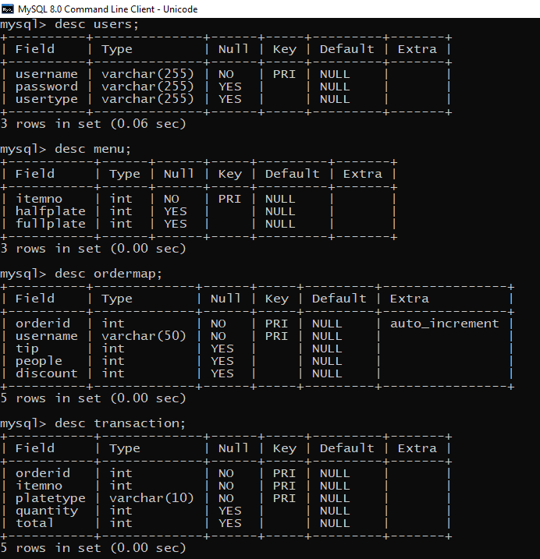

2. To get some data in menu use menu.csv file.