Indian Institute of Technology, Bombay

Department of Electrical Engineering

Academic Session: 2023-24, Semester: I

**B.Tech Project Report**

Submitted by: -

**Rishuv Gorka**

**(190070052)**

November 27th, 2023

**Course: EE 491 (BTP-1)**

**Faculty Mentor: Prof. Madhu Belur**

**Project Title: Post Processing of crew Schedules Generated for Long-distance Passenger Trains**

1. **Introduction**

Crew scheduling plays a crucial role in transportation systems, with distinct features and challenges in various applications. Rail operations, for instance, encompass passenger and freight services. Passenger services adhere to predetermined timetables, categorized into long-distance, suburban, and urban operations. Unlike passengers, freight services involve a mix of scheduled and ad-hoc operations.

In the context of passenger railway transportation, the operational planning process is outlined in Figure 1. It initiates with line planning, determining lines, stations, and train types to meet travel demands. Train timetabling follows, establishing arrival and departure times while ensuring safety constraints. Subsequently, train platforming assigns platforms at stations. Rolling stock scheduling allocates railway vehicles to scheduled trains, incorporating regular maintenance. During non-operational periods, such as at night, parked trains need shunting, referred to as the train unit shunting problem. Specialized research often addresses specific applications rather than a generalized approach due to these unique features and challenges.



Figure 1: Operational Planning Process in Passenger railway transportation

Two key planning activities are centered around crew members, specifically addressing the crew scheduling and rostering challenges. Crew scheduling involves the generation of unattributed duties that span all trains within a specified timeframe, aligning with a predetermined timetable. Each duty delineates a sequence of tasks or trips, ensuring compliance with operational constraints and labor union regulations. Subsequently, these duties are aggregated over an extended duration and allocated to individual crew members, a process referred to as crew rostering. The assignment of duties to crew members takes into account factors such as equitable workload distribution, proficiency in tracks and rolling stock, consideration of vacation schedules, and other relevant considerations.

In addressing the crew scheduling challenge specific to the long-distance passenger service within the Indian Railways, the term "crew" pertains to the operational staff actively engaged in the train's operations. Presently, a committee of seasoned railway personnel at Indian Railways undertakes the manual preparation of crew duties. They generate a document known as the 'detail book' based on the timetable, outlining groups of tasks assigned to the crew members for a given day, referred to as a detail (Appendix A.1). Additionally, these details are organized in a specific sequence to form cycles, considering factors such as the train type (daily or non-daily), speed (slow or fast), crew seniority, etc. The intention is to ensure that after completing a specific duty, the crew proceeds to operate the subsequent duty within the cycle.

While the cyclic nature of this planning results in a balanced workload over the long term, where each crew member handles every task, the current method of duty preparation is labor-intensive and time-consuming. Moreover, it proves inefficient since the process must be reiterated each time there is a timetable update, and satisfying all crew-related constraints becomes a challenging task. [1] provides a better alternative to existing crew scheduling practices.

This study aims for the post processing of [1]. In post processing, linking of the data is done. Linking is very necessary as after completing a duty the next duty should start from the same station, making it a more feasible solution. If the rest time at outstation exceeds 8 hours and there is no train for crew to run from that station, crew members is brought to the departure station of next task by a deadhead trip, in which crew member travel as a passenger, it is also included as a task in the duties. After linking, the sorting of the task details that is duties is done according to the links formed. Here, important statistics like total rest time, total night duty hours, and total duty hours are calculated. It is mandatory that all the “**Statistical data**” should satisfy the constraints according to Railway Servants Rules, 2005, which occasionally get amended. In the end file formatting comes, which is very necessary. In this, a specific format that is used by the Indian Railways, is tried to be achieved. But with the provided data, it can’t be fully achieved as some details are missing. If that data is provided a file can be generated which will fully look like their format.

1. **Problem**

The Indian Railways (IR), owned by the Government of India's Ministry of Railways, boasts one of the world's most extensive rail networks. Organized under a Railway Board, IR comprises 17 administrative zones, each headed by General Managers reporting to the board. These zones are further divided into 68 divisions, led by Divisional General Managers. IR holds significant stakes in entities related to rail transport in India. Crew members are associated with specific divisions and crew bases, often located at high-frequency terminals. Long-distance services involve crews handling segmented tasks, with Crew Change Points (CCPs) at major or border stations. CCPs, also home bases, are rest locations after tasks. Crews operate within a crew beat, the territory between connected CCPs, primarily within their division's jurisdiction. Deadhead trips enhance workforce utilization and satisfaction. The goal, outlined in [1], is to minimize duties covering all tasks within a defined period based on the train timetable, distinguishing between tasks and duties as individual trips and task sequences satisfying operational and union constraints.

After calculating output from [1], linking must be done. In linking, sometimes one or two task numbers are different for the same group of task numbers, making it hard to link the data. After completing the linking process, the sorting of the task details had to be done and different statistics like total duty hours, total night hours duty, and total rest time had to be calculated to check whether they are following the constraints or not. Lastly, file formatting is very necessary, as the final format should resemble as close as to their initial format, so that crew members can easily understand the generated data.

1. **Input and Output**

**Input to the code: -**

This section explains the input to the post processing code. In [1], there are three data outputs: first week duties, second week duties and task details. These outputs are fed to the post processing code as input. In week 1 and week 2, each line shows the tasks that crew members have to do throughout the week, whereas, in task details, details about tasks is given such as, running day of the train, train number, and timings of sign on, sign off, departure and arrival, also other important details as shown in Appendix A.2.

**Output to the code: -**

This section explains the output of the post processing code. The output of the code is, basically, generation of two files: an excel file and other a markdown file. As the crew is familiar with the detail book (Appendix A.1), it will be easy for them to understand the data, if it is given in a similar format. That’s why a markdown file is generated. On conversion of markdown file into pdf (Appendix A.3), it will generate a pdf file which resembles the detail book (Appendix A.1) with the data provided. Whereas the excel file just stored the output generated in simple format as shown in Appendix A.4. The output consists of firstly task details and then important parameters like total duty time, total night duty hours and total rest time throughout the week for all duties (Appendix A.5) as summary.

1. **Procedure**

This section discusses the logic and process of post processing. The logic behind is very simple. Firstly, a duty list is generated from [1], and this duty list is marked as week 1 duty list and from the same algorithm by running it again, another duty list is generated which is week 2 duty list. As both duties lists are generated from the same algorithm, it follows a cycle to generate these duties for the crew members. For example, in appendix A.2, week 2’s duty number 1 is basically week 1’s duty number 17, further week2’s duty number 17 is week 1’s duty number 3 and similarly if you follow this you will end the cycle on duty number 1 of week 1.

Figure 2: Formed Cycles

In figure 2, the cycles formed in appendix A.2 are shown, notice that each row starts and ends with same duty number, representing that cycle is formed and all the duties are part of one or other cycles. After identifying all the cycles, the task details are sorted according to these cycles and important parameters like total rest time, total duty time and total night duty hours are calculated for each duty. These parameters are stored separately. After sorting the task details, the parameters are merged into task details. From this database, the excel file and a markdown file are generated. Conversion of markdown file into pdf, will generate a pdf file (Appendix A.3) that resembles the original detail book (Appendix A.1).

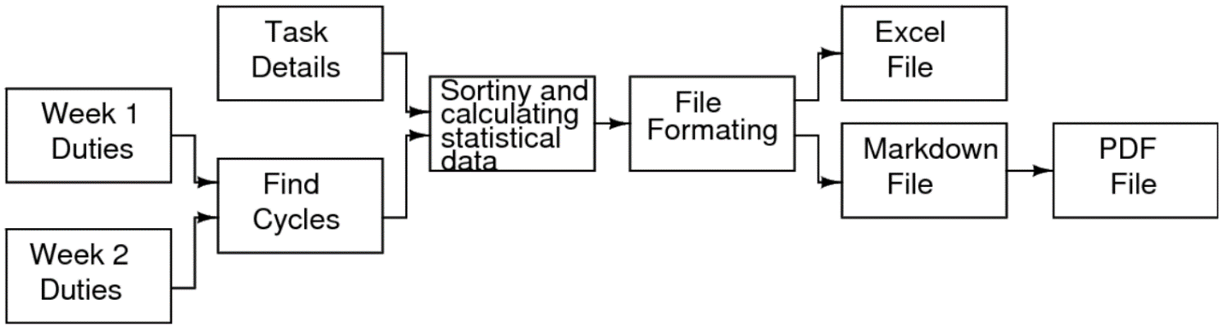

Figure 3: Flow Chart of Procedure

1. **Functions**

This section discusses the functions used in the post processing code and the code is also uploaded in drive. Drive’s link is provided in the reference section.

**findcycle function: -**

This function is one of the most important functions in post processing. It takes two 2-D vectors as input that is week 1 and week2 data. It finds all the cycle formed by the data and stored it in another 2-D vector which is output of this function. The logic is simple, start with the first vector in first 2d vector and store its index, then find the index of first vector of second 2d vector in first 2d vector and store its index. This goes on till the cycle formed that is comes back to first vector. This process is also discussed in the procedure section.

**NDH function: -**

It is the most important function in post processing. It takes the task details and the output of findcycle function as input and sorts the task details according to the output of findcycle function while calculating parameters like total night duty hours, total rest time, and total duty hours. The output of this function is sorted task details followed by the summary of parameters for each duty, stored as single database. It also calculated the missing rest time for the last task of each duty.

**File formation: -**

File formation is done in the main function of the post processing code. The output of NDH function is used to generate the files. The code generates two files: one markdown file and another excel sheet.

**Other functions: -**

**compare**: this function is used to find the index of a vector in a 2-D vector. It takes two inputs: one 2-D vector in which index have to be find and other is 1-D vector whose index have to find.

**mintohour:** this function takes an integer as input and gives a string as output which is time in HH:MM format. It is used to convert minutes into number of hours.

**hourtomin:** this function takes a string as input and gives an integer as output. It is used to convert hours into minutes.

**rest function:** this function takes the last task details of nth duty and first task details of (n+1)th duty and calculates the rest time between these two task. It gives an integer as an output which is number of minutes.

1. **Acknowledgement**

I would like to express my sincere gratitude to Prof. Madhu Belur, Department of Electrical Engineering, IIT Bombay, for his support and guidance and for providing such an interesting topic.

I would also like to thank Dr. Anoop K P, Project Research Scientist, Department of IEOR, IIT Bombay, for his support and guidance.

I would also like to thank Akshat Bansal, Alumni, Department of IEOR, for providing his support.

1. **References**

[1] “Crew Scheduling for Long-distance Passenger Railway Transportation” by Akshat Bansal,

2022.

[2] <https://www.geeksforgeeks.org/file-handling-c-classes/?ref=lbp>

[3] <https://www.youtube.com/watch?v=DLLrcr9u_XI>

[4] code: <https://drive.google.com/drive/folders/1ayPfpjT9YfnZGU-ER1P5JqSGlrlwq92Z?usp=sharing>

**Appendix A**

**A.1 Snapshot of detail book: -**

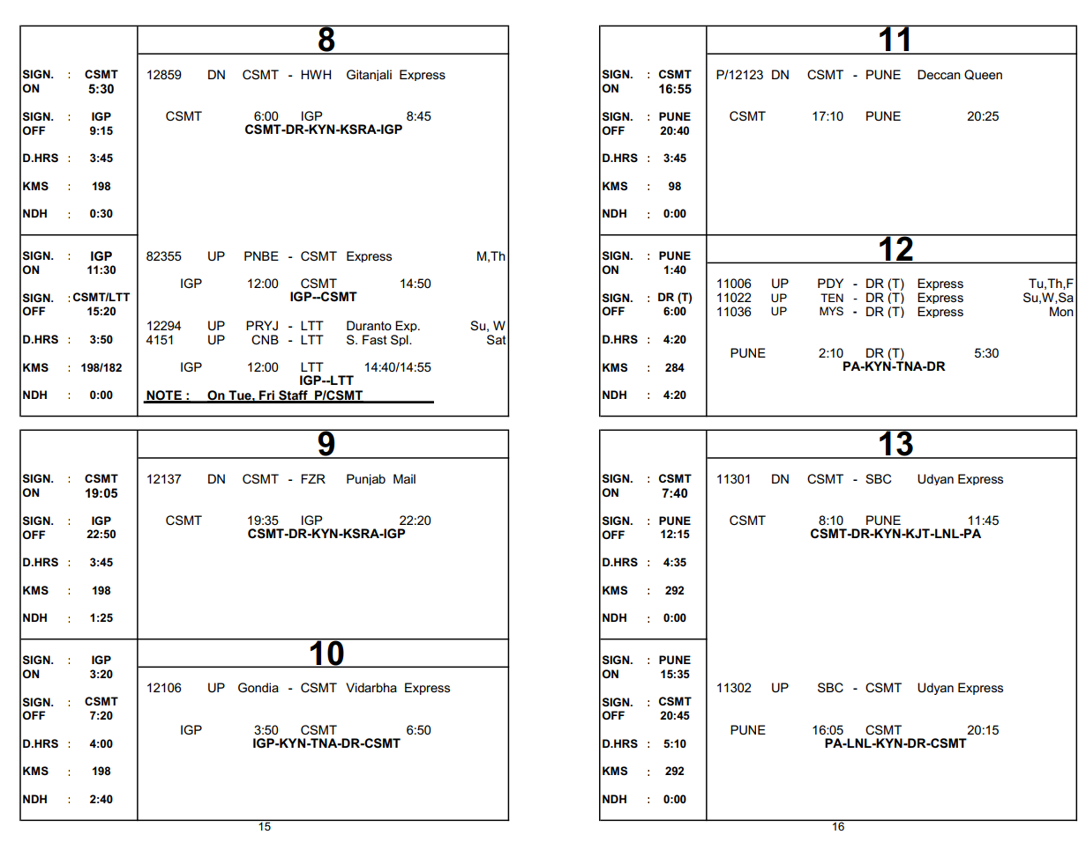

**A.2 Snapshot of the input to the code: -**

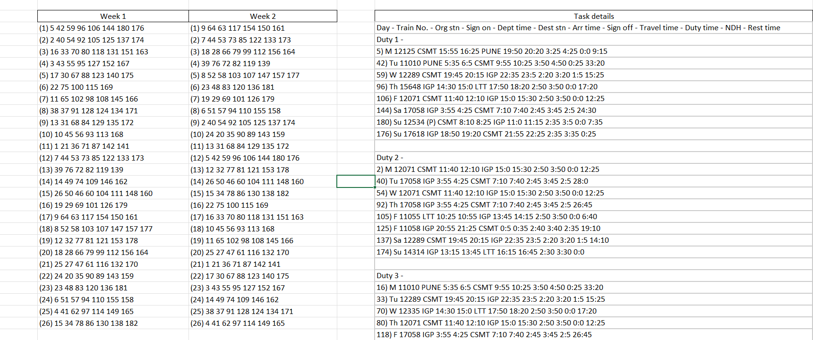

**A.3 Snapshot of the pdf file generated from markdown file: -**

**A.4 Snapshot of the excel file generated: -**

