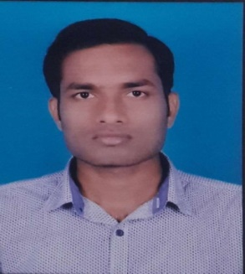

**Pradosh Kumar Pankaj**

**Title:** Analyst

**Location:** Kundanhalli, Bangalore

**Languages:** Hindi (native), English (*conversational*)

Experience Summary



**KEY SKILLS:**

* **Functional:** Team Building,Strategic Planning, Good Communication skills
* **Technical:** Angular 5,React JS ,Node JS, Express JS ,Java ,C,HTML5,CSS 3 with Bootstrap ,JavaScript, ES6, TypeScript ,Mongo DB

Training, Certifications & Affiliations



* Three Months training in JavaScript Full Stack Developer in Capgemini.
  1. Module 1 (21 days): HTML 5,CSS3 with Bootstrap,JavaScript,ES6
  2. Module 2(12 days):TypeScript,Angular 5,MongoDB
  3. Module 3(5 days):NodeJS,ExpressJS,ReactJS
  4. Module 4(13 days): Mini project,Plp

Higher Education



* B.TECH (Computer Science & Engineering), Noida Institute Of Engineering & Technology

Greater Noida

Resume |Pradosh Kumar Pankaj 108060 | Copyright © 2018 Capgemini. All rights reserved. Page 1 / 1