AI-Assignment 4.4
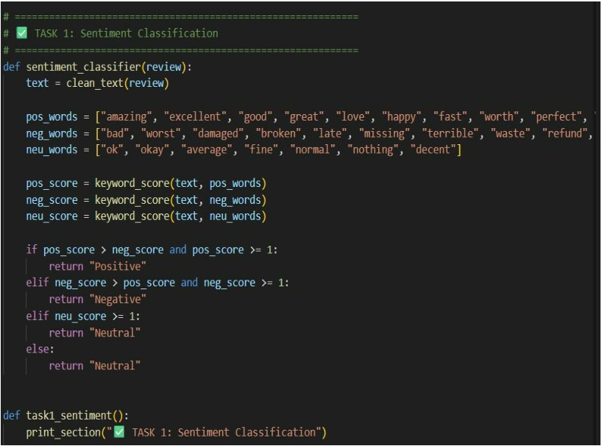
2303a52176

TASK 1: Sentiment Classification for Customer Reviews
AI-GENERATED -CODE:
Y.Rishwanth Reddy
Batch 41
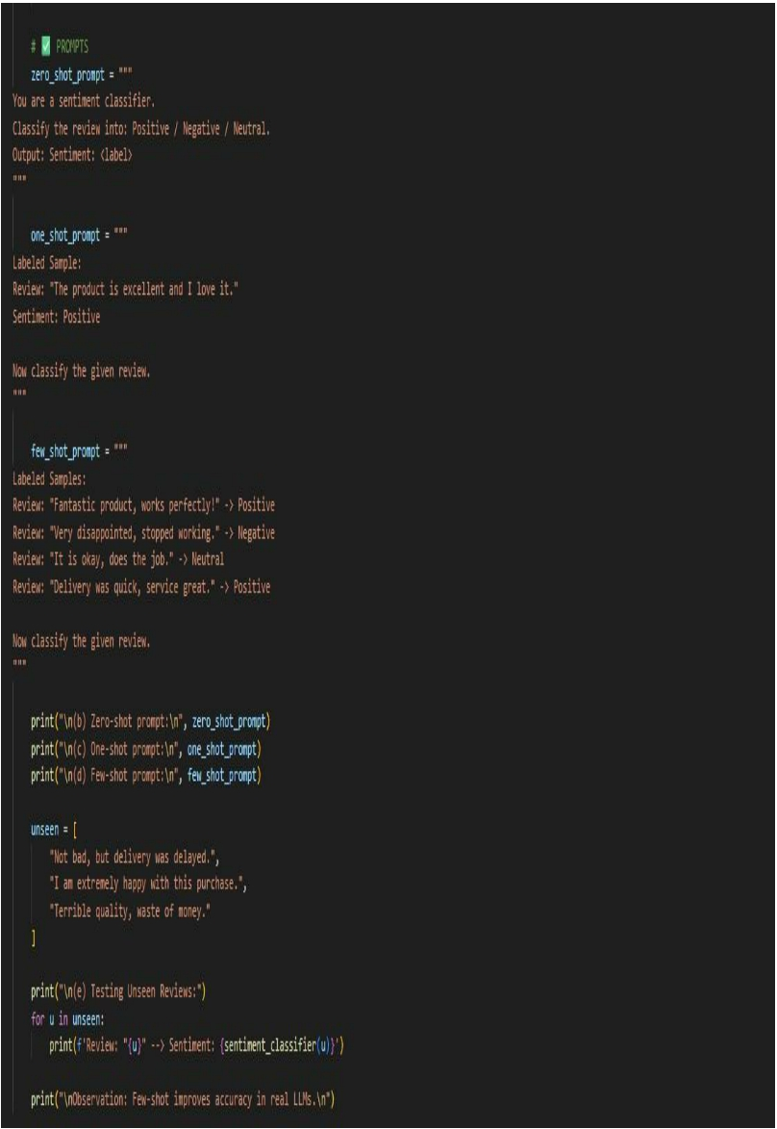
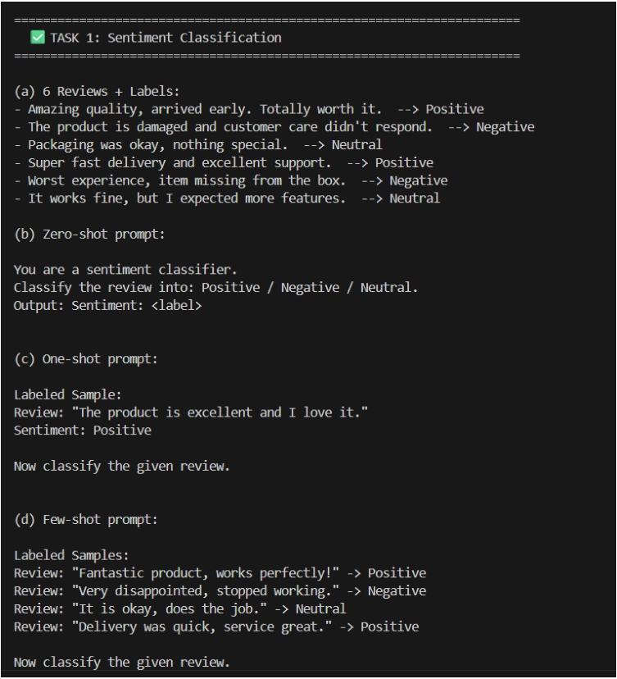
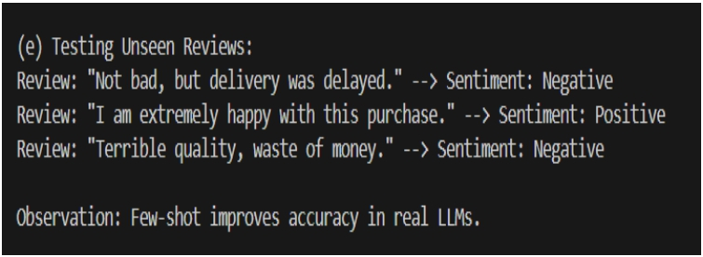
OUTPUT:
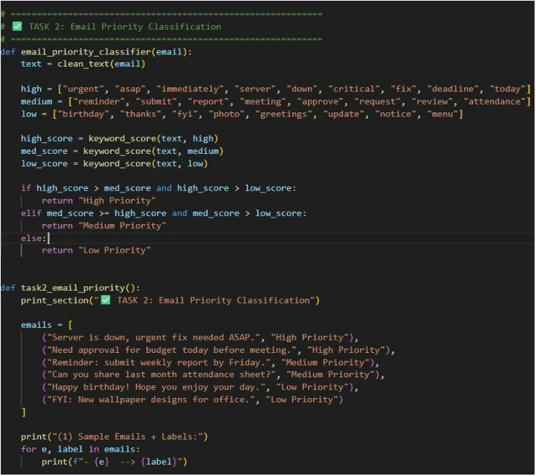
JUSTIFICATION:

This task helps classify customer reviews as Positive, Negative, or Neutral.It is useful for improving product quality and customer satisfaction.Few-shot prompting gives better accuracy for unclear reviews.

TASK 2: Email Priority Classification AI-GENERATED-CODE:
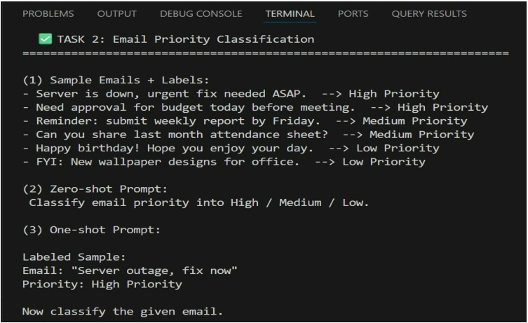
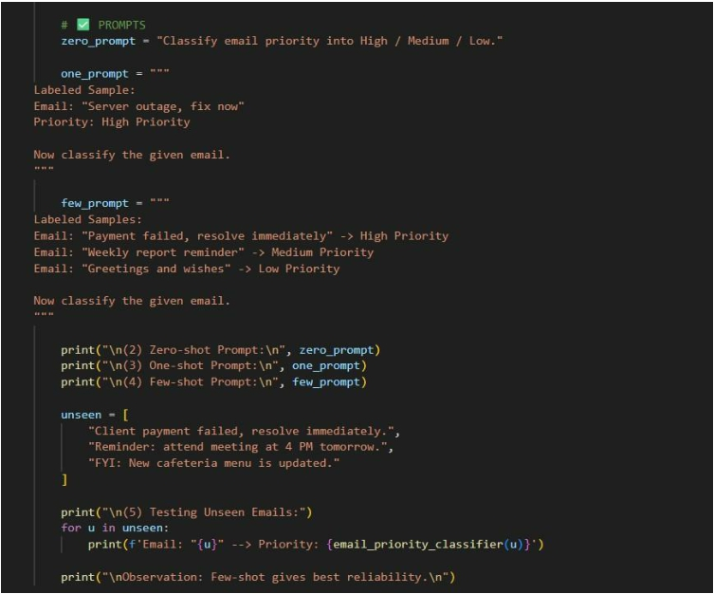
OUTPUT:
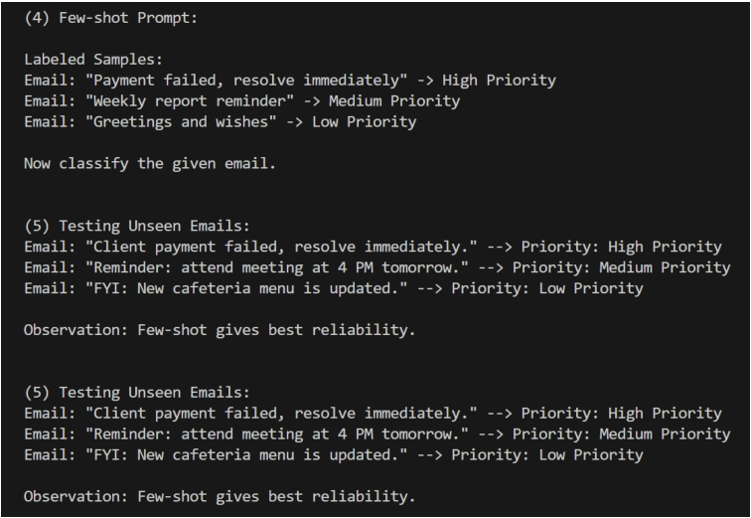
JUSTIFICATION:

This task helps automatically prioritize emails into High, Medium, or Low.It ensures urgent issues are handled quickly without delay.Few-shot prompting gives the most reliable priority results.

TASK 3: Student Query Routing
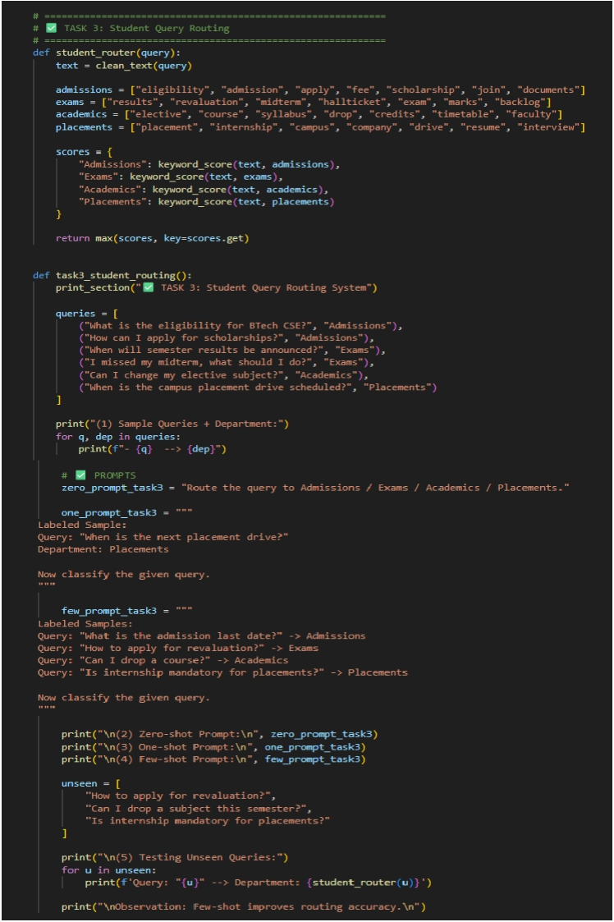
AI-GENERATED-CODE:
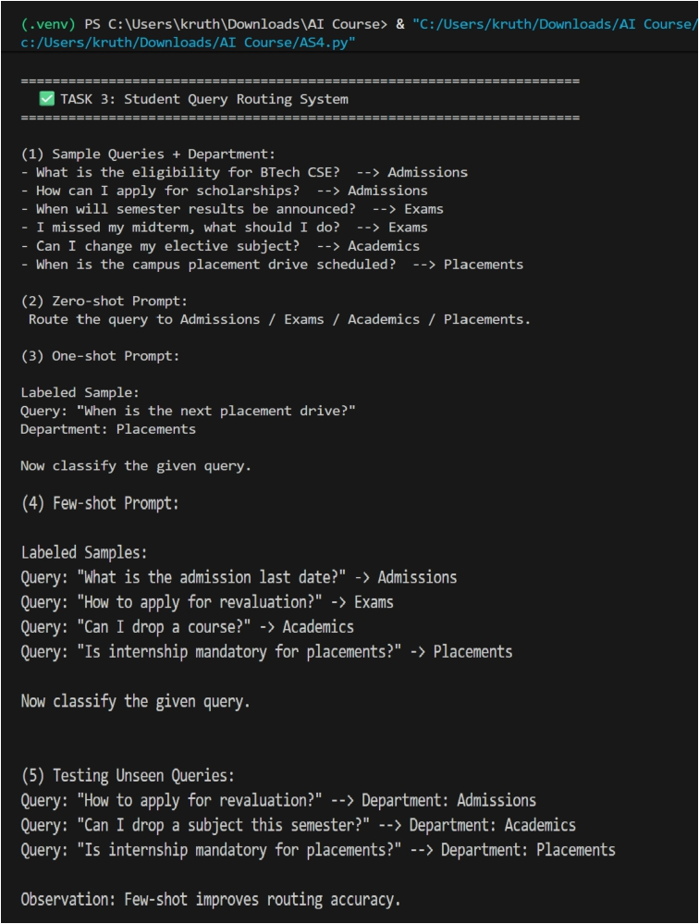
OUTPUT:

JUSTIFICATION:

This task routes student questions to the correct department.It reduces manual workload and gives faster responses.Few-shot examples improve routing accuracy.
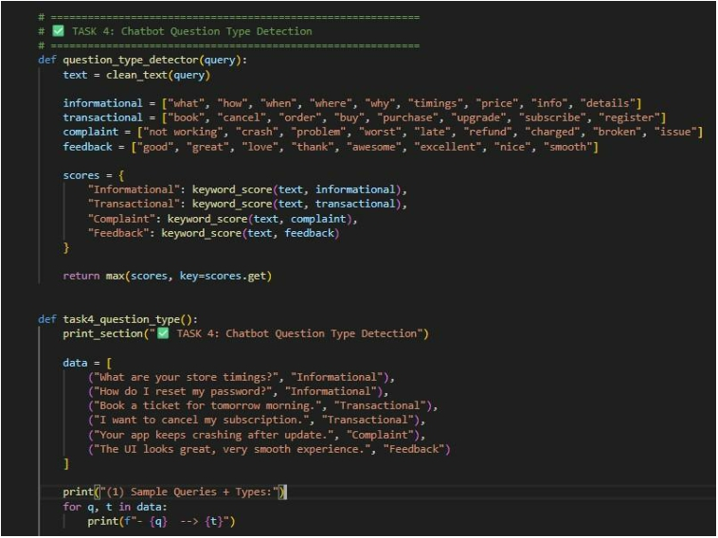
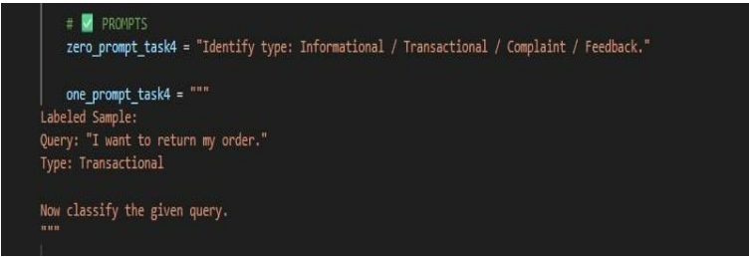
TASK 4: Chatbot Question Type Detection AI-GENERATED -CODE:
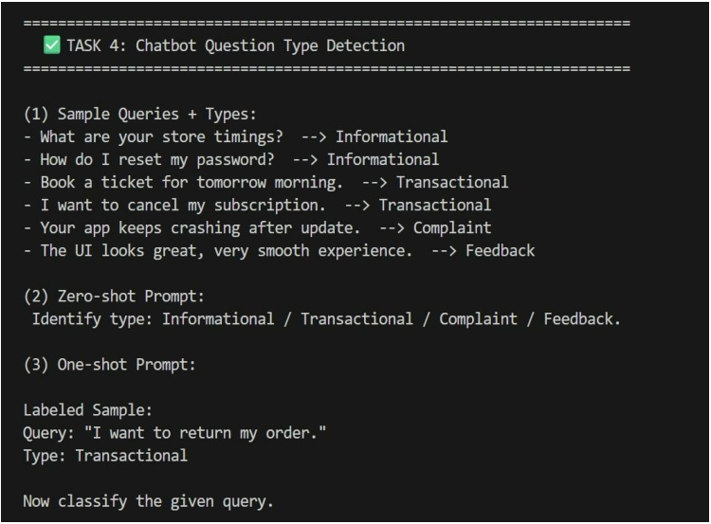
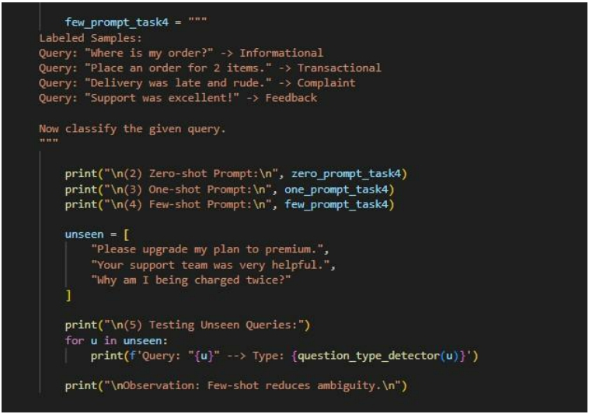
OUTPUT:
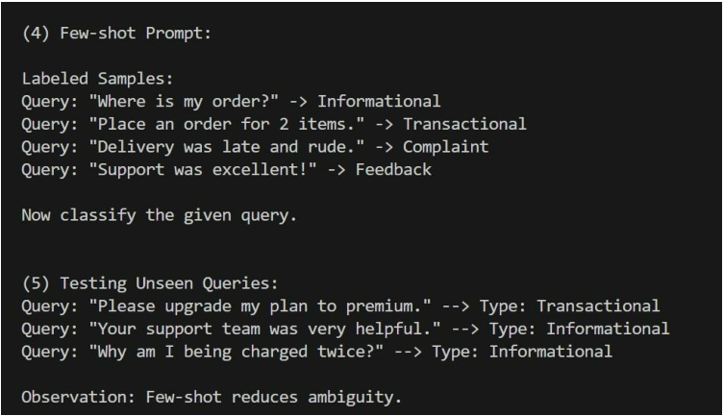
JUSTIFICATION:

This task identifies query type: informational, transactional, complaint, or feedback.
It helps the chatbot respond correctly based on user intent.Few-shot reduces confusion between similar query types.

TASK 5: Emotion Detection
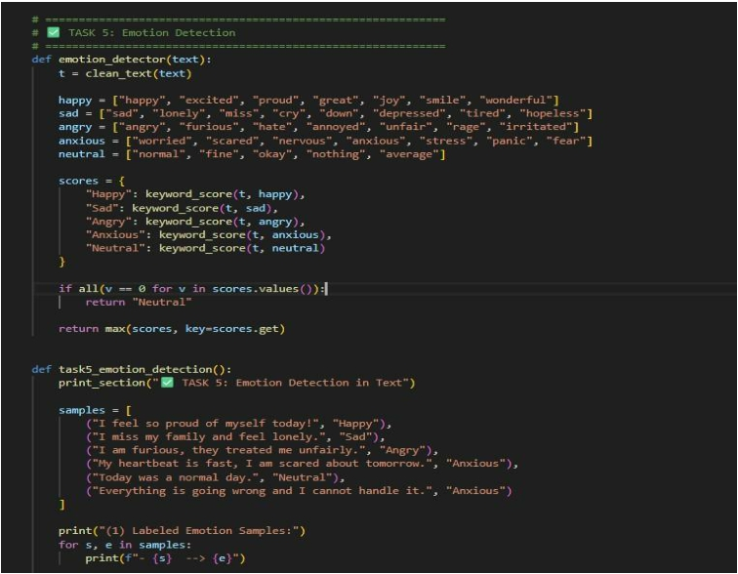
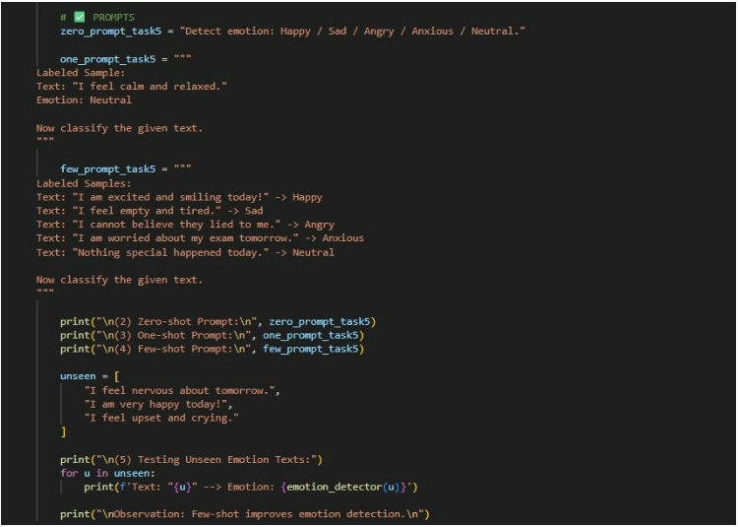
AI-GENERATED-CODE:
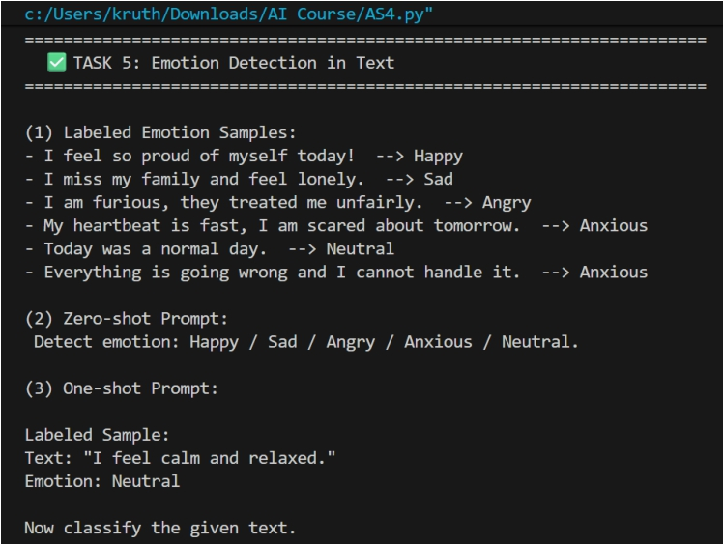
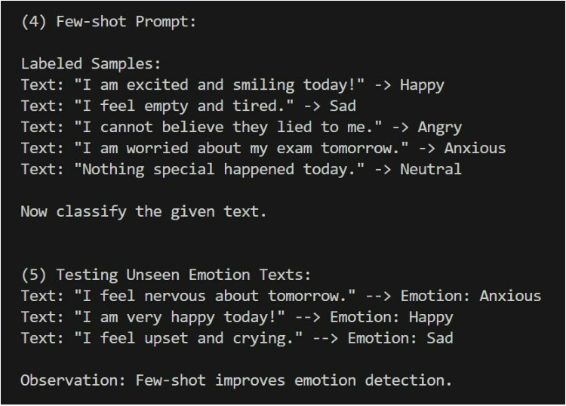
OUTPUT:
JUSTIFICATION:

This task detects emotions from user text for mental-health support.It helps provide correct guidance and empathetic responses.Few-shot handles mixed emotions better than zero-shot.

