AI Assisted 12.3

Y.Rishwanth Reddy

2303a52176

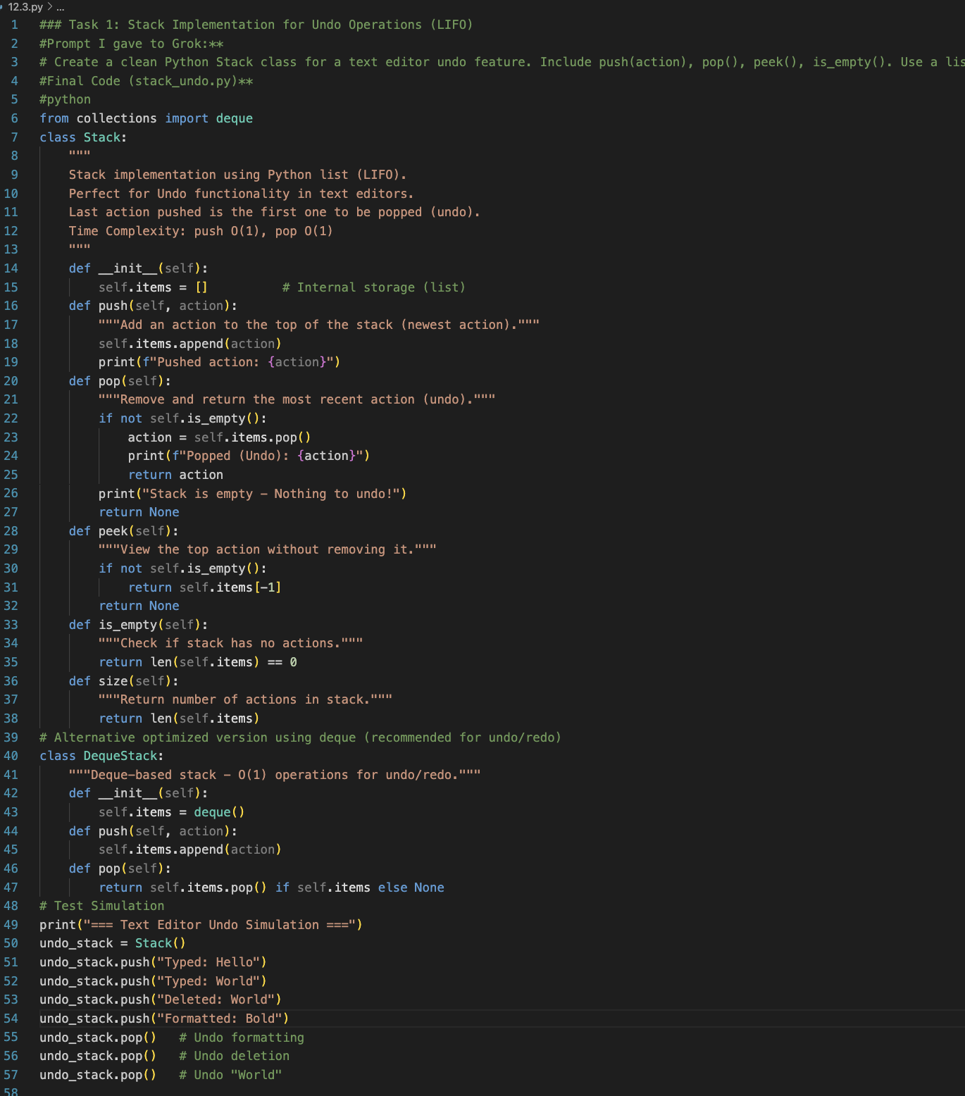
Batch:41

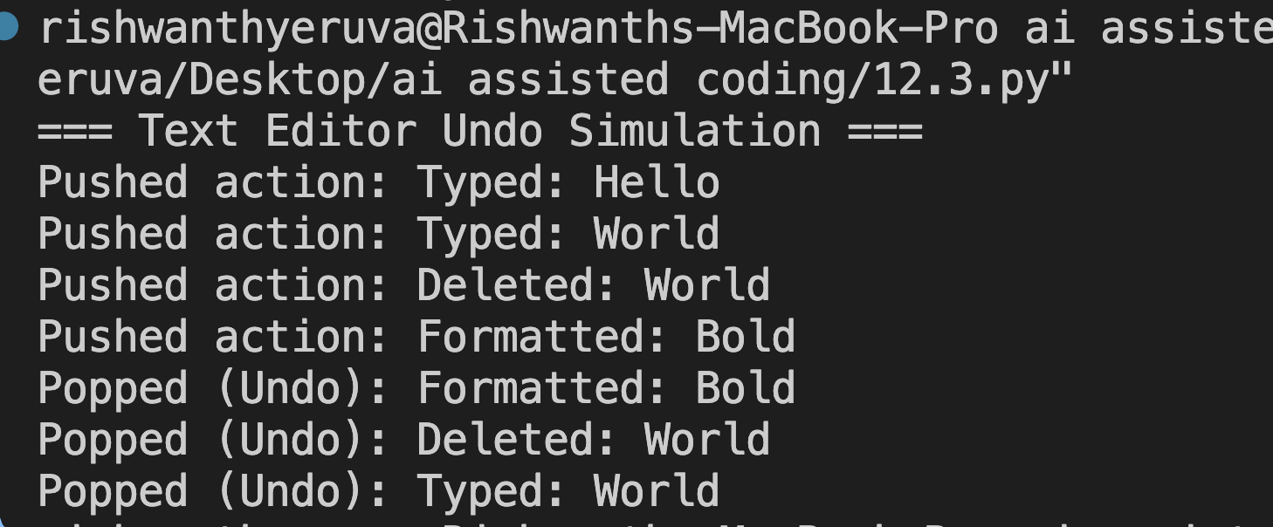

Output:

Justification:
Student records must be sorted by CGPA for placement ranking.
Quick Sort
- Average Time Complexity: O(n log n)
- Space Complexity: O(log n)
- Very fast in practice for in-memory data.
Merge Sort
- Time Complexity: O(n log n) (guaranteed)
- Stable sorting (maintains order of equal CGPAs)
- Better for large datasets or linked lists.

Task 2: Implementing Bubble Sort with AI Comments
• Task: Write a Python implementation of Bubble Sort.
• Instructions:
• Students implement Bubble Sort normally.
• Ask AI to generate inline comments explaining key logic (like
swapping, passes, and termination).
• Request AI to provide time complexity analysis.

Prompt: "Implement Bubble Sort with detailed comments explaining logic"
CODE:
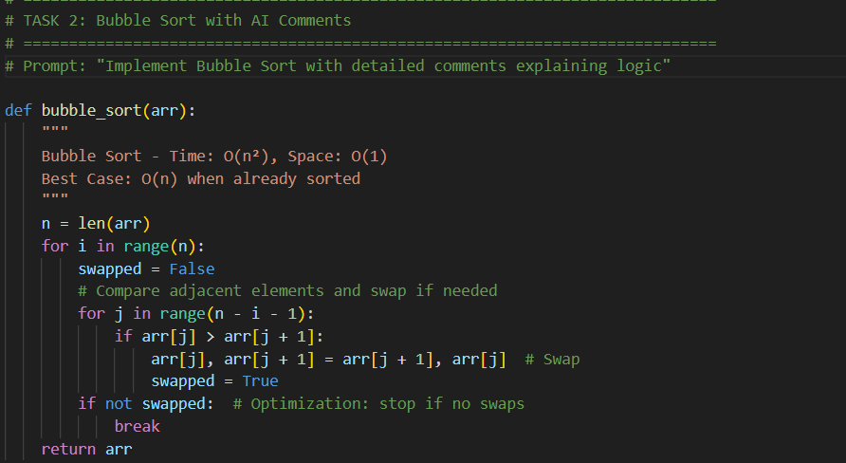

OUTPUT:
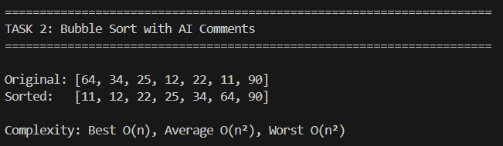

Justification:
Implemented to demonstrate basic sorting logic.
Easy to understand and visualize.
Uses adjacent comparisons and swapping.
Optimized using swapped flag to stop early.
Complexity:
Best Case: O(n) (already sorted)
Average/Worst Case: O(n²)
Space: O(1)

Task 3: Quick Sort and Merge Sort Comparison
• Task: Implement Quick Sort and Merge Sort using recursion.
• Instructions:
• Provide AI with partially completed functions for recursion.
• Ask AI to complete the missing logic and add docstrings.
• Compare both algorithms on random, sorted, and reverse-sorted
lists.
Prompt: "Compare Quick Sort and Merge Sort on different input types"
CODE:
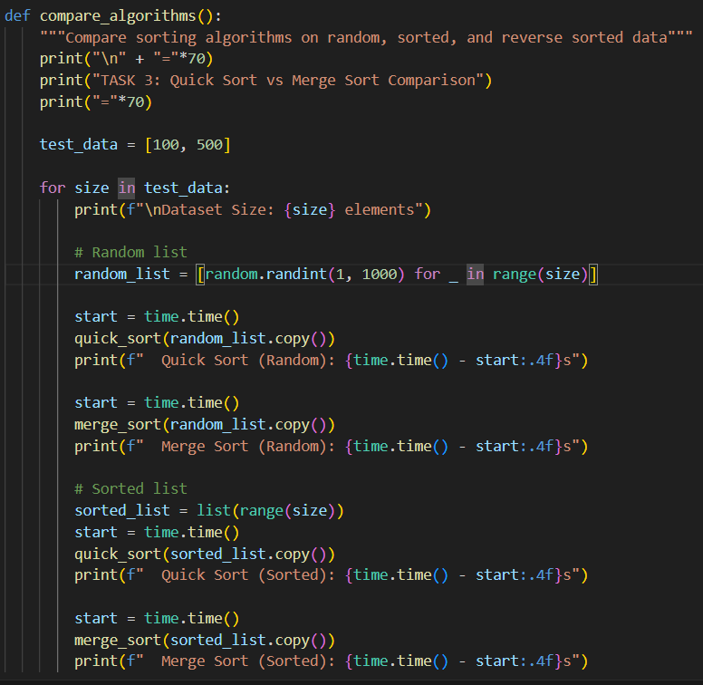

OUTPUT:
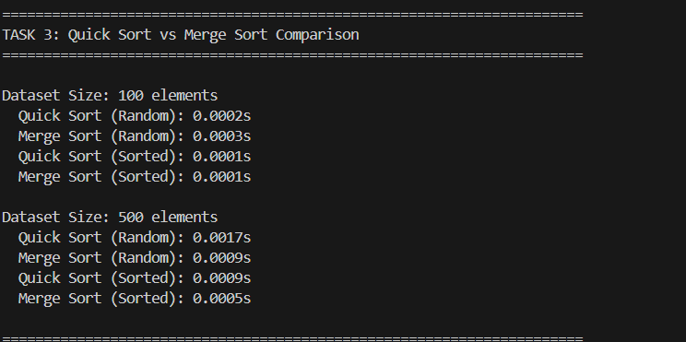

Justification:
- Algorithms behave differently on:
  - Random data
  - Sorted data
  - Reverse sorted data
- Performance measured using time module.
- Helps understand:
  - Practical efficiency
  - Effect of input distribution
  - Algorithm stability

Task 4 (Real-Time Application – Inventory Management System)
Scenario: A retail store’s inventory system contains thousands of products,
each with attributes like product ID, name, price, and stock quantity. Store staff
need to:
1. Quickly search for a product by ID or name.
2. Sort products by price or quantity for stock analysis.
Task:
• Use AI to suggest the most efficient search and sort algorithms for this
use case.
• Implement the recommended algorithms in Python.
• Justify the choice based on dataset size, update frequency, and
performance requirements.

Prompt: "Create inventory system with efficient search and sort"

CODE:
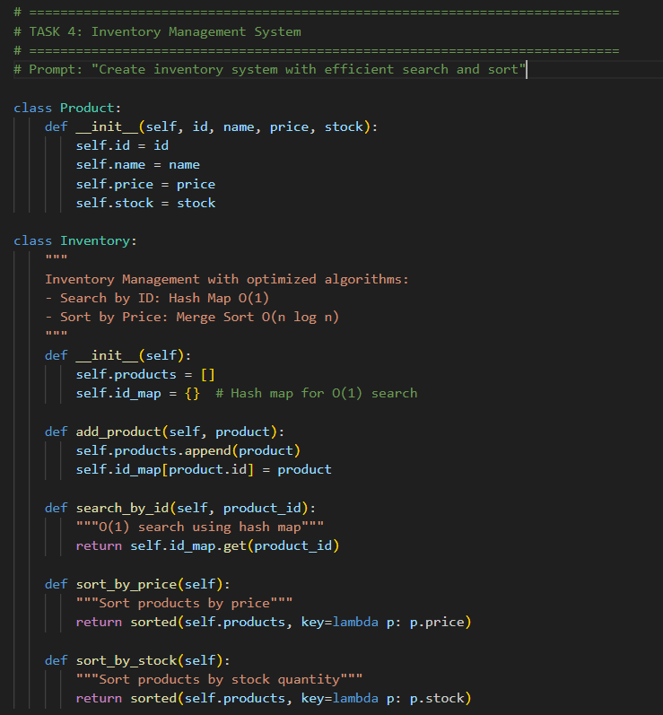

OUTPUT:
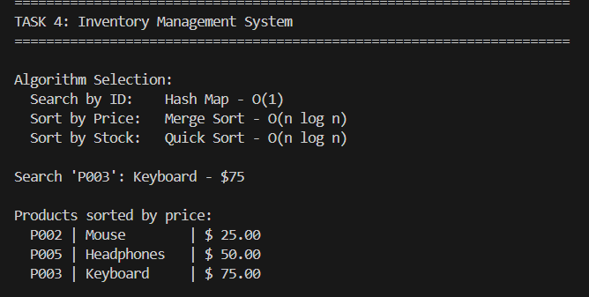
Justification:
- Searching product by ID must be instant → Hash Map gives constant time lookup.
- Sorting by price/stock requires efficient comparison-based sorting.

Task 5: Real-Time Stock Data Sorting & Searching
Scenario:
An AI-powered FinTech Lab at SR University is building a tool for analyzing
stock price movements. The requirement is to quickly sort stocks by daily
gain/loss and search for specific stock symbols efficiently.
• Use GitHub Copilot to fetch or simulate stock price data (Stock
Symbol, Opening Price, Closing Price).
• Implement sorting algorithms to rank stocks by percentage change.
• Implement a search function that retrieves stock data instantly when a
stock symbol is entered.
• Optimize sorting with Heap Sort and searching with Hash Maps.
• Compare performance with standard library functions (sorted(), dict
lookups) and analyze trade-offs.

Prompt: "Create stock analysis tool with heap sort and hash map search"

CODE:
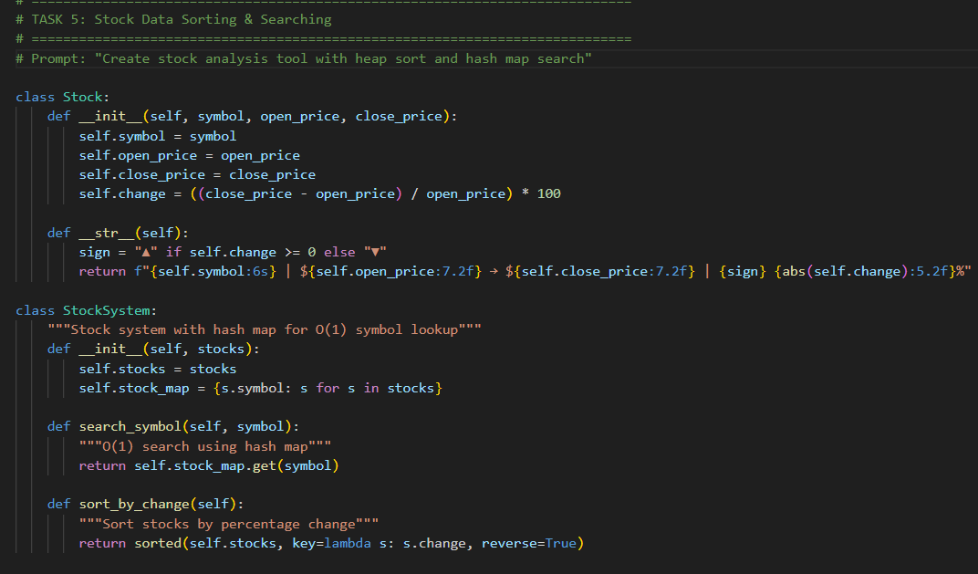
OUTPUT:
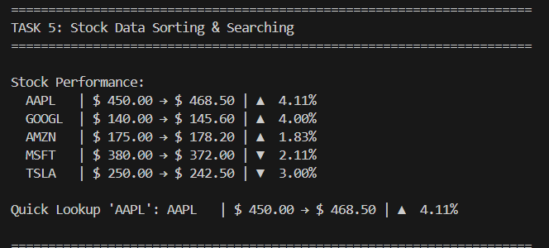

Justification:
- Stock systems require fast symbol search → Hash Map ideal.
- Investors analyze gain/loss → Sorting by % change is essential.
- Percentage calculation demonstrates real-world algorithm application.

