Assisgnment-9.4
Y.Rishwanth
2303a52176
Task-1:
Colab generated file without docstirng:
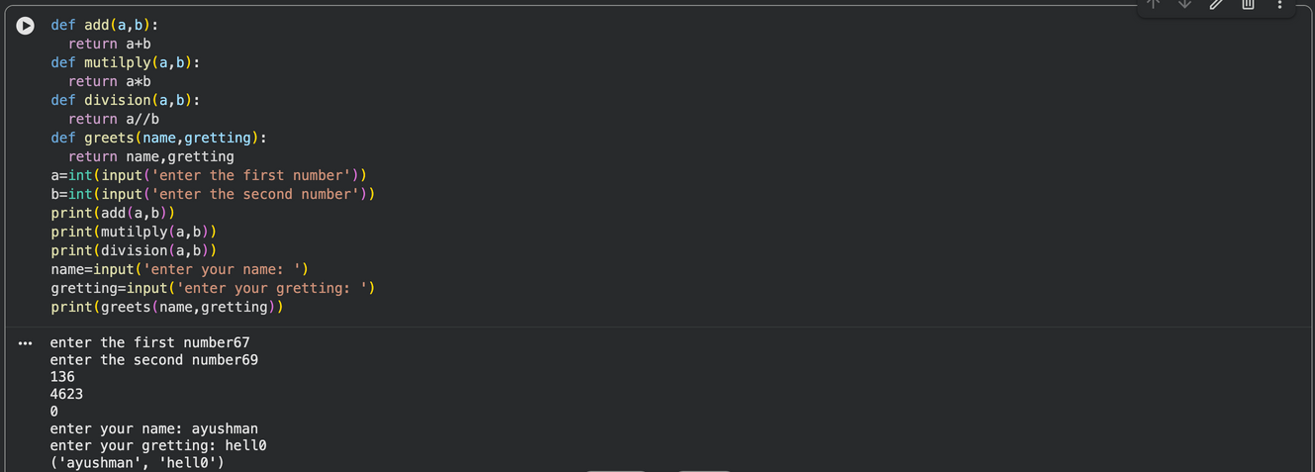
With Docstring:
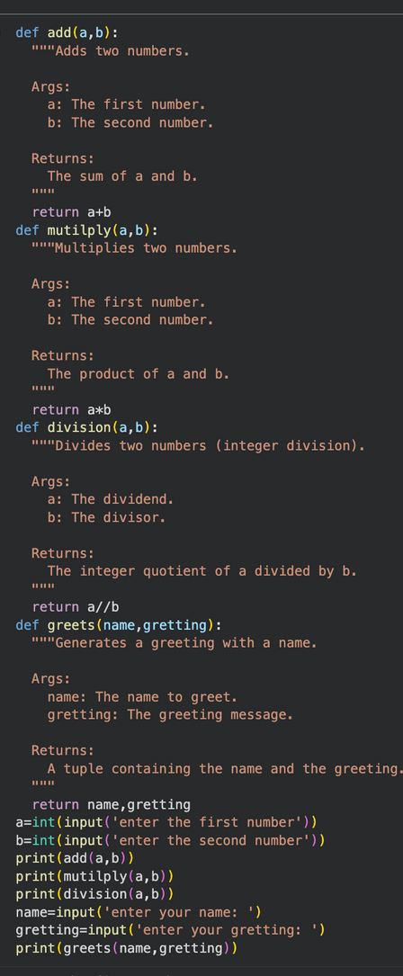

Task -2:
Colab generated code without inline comments:
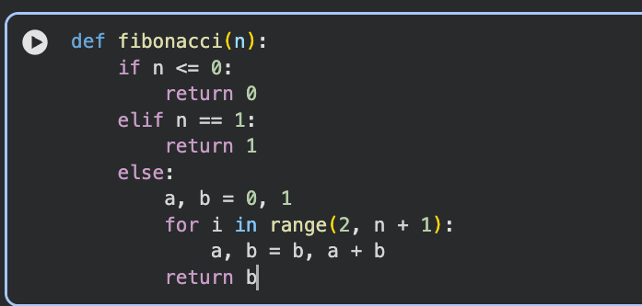
Colab generated inline comments:
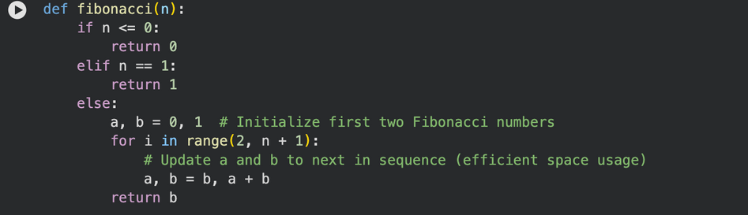
Task-3:
Colab generated module-Level Documentation for above code:
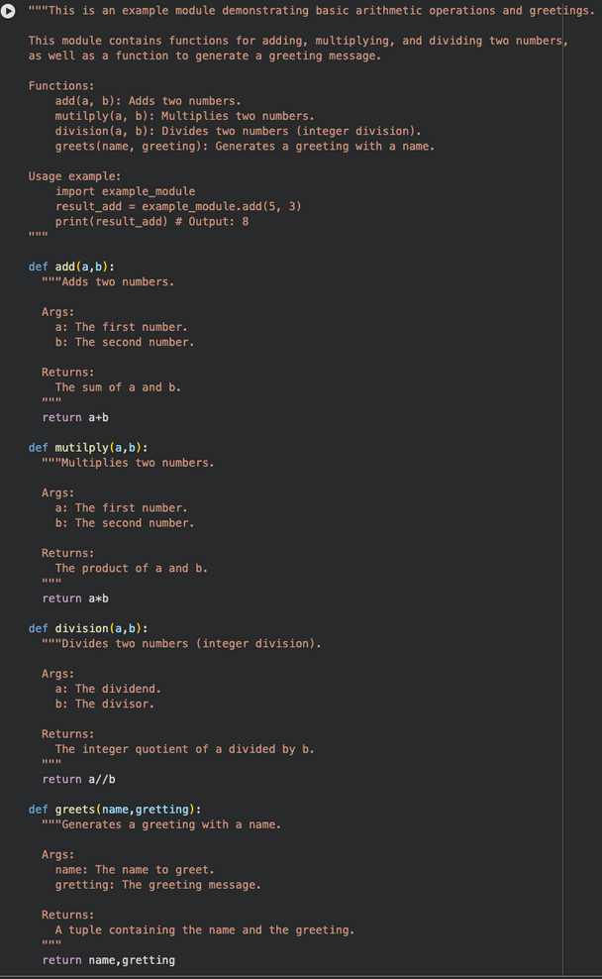
Task -4:
Colab Generated Inline comments
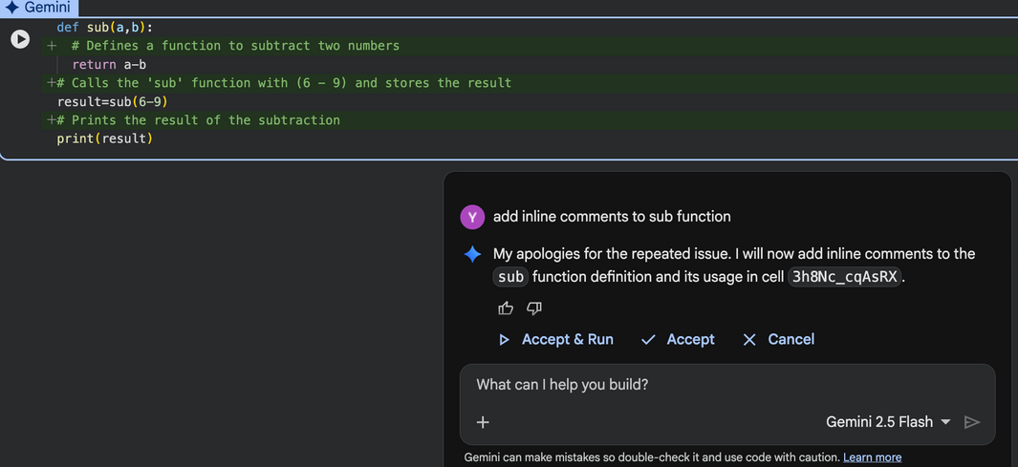
Colab converted inline to docstrings:
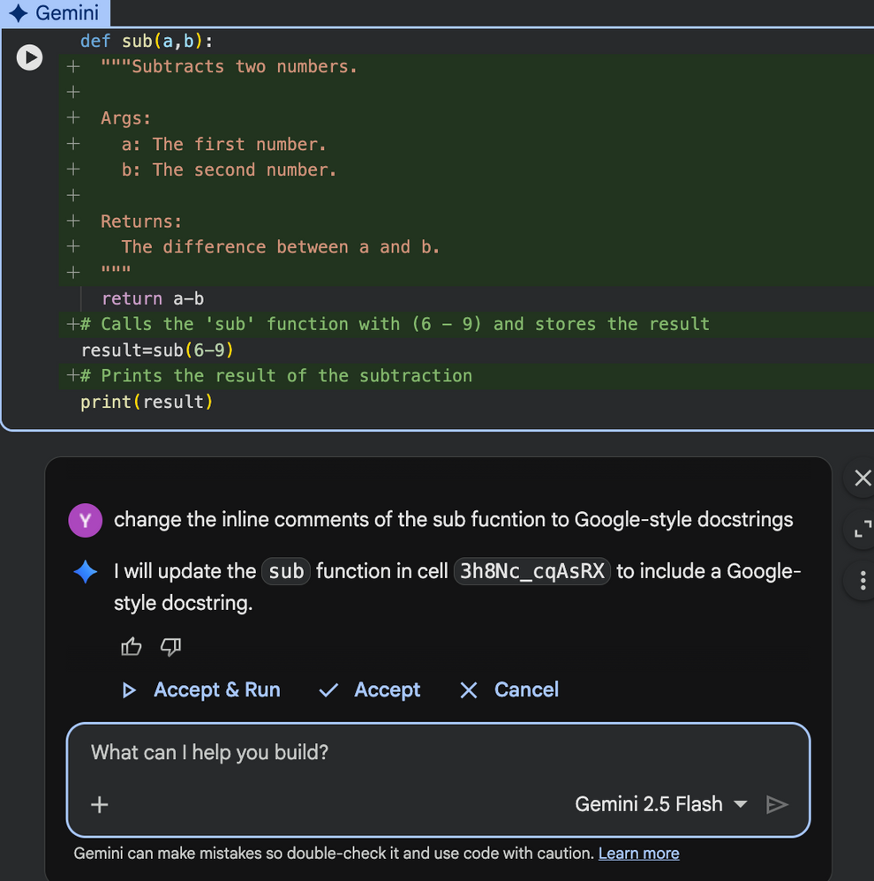
Task-5:
Code for Mini Automatic Documentation Generator:
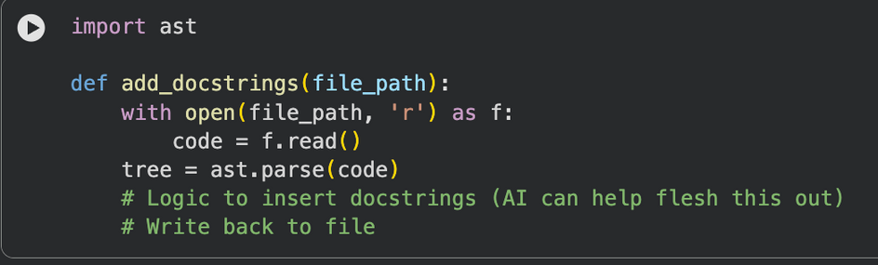
For Functions:
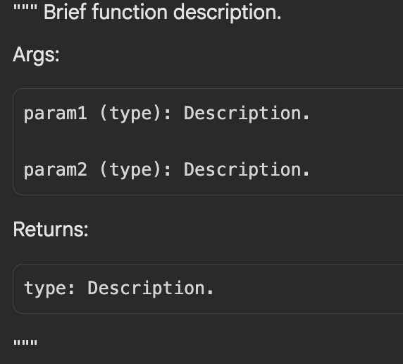
For Classes:
