Assisgnment 14.4
2303a52176
Y.Rishwanth Reddy
Task 1:
#Prompt given
You are designing a basic homepage for a startup company that needs
to look good on desktops, tablets, and mobile devices.
Task Description
• Create a web page structure using HTML that includes:
o A header with navigation links
o A main content section
o A footer with basic information
• Use AI assistance to generate responsive CSS using media
queries.
• Ensure the layout adjusts smoothly across different screen sizes.

#CODE
<!DOCTYPE html>
<html lang="en">
<head>
<meta charset="UTF-8">
<meta name="viewport" content="width=device-width, initial-scale=1.0">
<title>Startup Homepage</title>
<style>
/* Base styles */
body {
margin: 0;
font-family: Arial, sans-serif;
line-height: 1.6;
color: #333;
}

header {
background: #0073e6;
color: #fff;
padding: 1rem 2rem;
display: flex;
justify-content: space-between;
align-items: center;
flex-wrap: wrap;
}

nav a {
color: #fff;
text-decoration: none;
margin: 0 1rem;
font-weight: bold;
}

main {
padding: 2rem;
}

footer {
background: #f4f4f4;
text-align: center;
padding: 1rem;
font-size: 0.9rem;
}

/* Responsive layout */
@media (max-width: 900px) {
header {
flex-direction: column;
text-align: center;
}

nav {
margin-top: 1rem;
}

nav a {
display: block;
margin: 0.5rem 0;
}
}

@media (max-width: 600px) {
header {
padding: 1rem;
}

main {
padding: 1rem;
}
}
</style>
</head>
<body>
<header>
<h1>Startup Name</h1>
<nav>
<a href="#">Home</a>
<a href="#about">About</a>
<a href="#services">Services</a>
<a href="#contact">Contact</a>
</nav>
</header>
<main>
<section id="hero">
<h2>Welcome to our startup!</h2>
<p>We build innovative solutions to help your business grow. Our team is dedicated to delivering high-quality products and exceptional service.</p>
</section>
<section id="about">
<h3>About Us</h3>
<p>Our startup was founded with the mission to make technology accessible and impactful. Learn more about our journey and what drives us.</p>
</section>
<section id="services">
<h3>Our Services</h3>
<p>We offer a variety of services including web development, mobile apps, and digital marketing. Contact us to discuss your project.</p>
</section>
</main>
<footer>
<p>&copy; 2026 Startup Name. All rights reserved.</p>
<p>Contact: info@startup.com | 123-456-7890</p>
</footer>
</body>
</html>

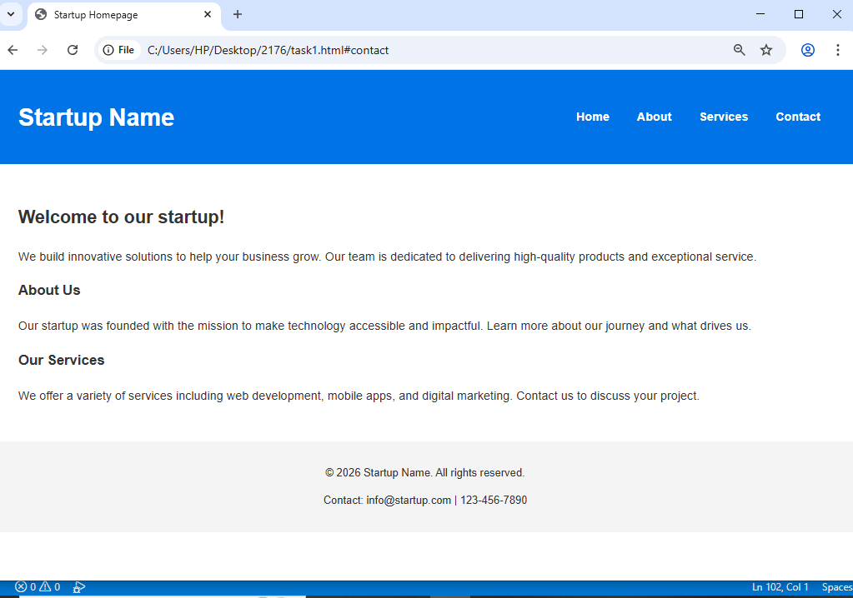

Task 2:
Prompt:
# Task 2: Interactive Call-to-Action Button
# Create a web page that includes a button for a marketing call-to-action.
# The button should:
# - Display a message when clicked
# - Use JavaScript to trigger an alert or message
# - Work without reloading the page
# - Include comments explaining the JavaScript logic

#Code:
<!DOCTYPE html>
<html lang="en">
<head>
<meta charset="UTF-8">
<title>Call To Action Button</title>
</head>

<body>

<h2>Marketing Page</h2>
<p>Click the button below to get started.</p>

<button onclick="showMessage()">Get Started</button>

<script>

/* Function to display alert when button is clicked */
function showMessage(){

// alert box will appear when the button is clicked
alert("Thank you for your interest in our startup!");

}

</script>

</body>
</html>

#Output:
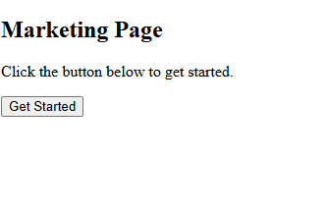
TASK 3:
Prompt:
# Task 3: Contact Form with Client-Side Validation
# Design a contact form for a website that includes:
# - Name field
# - Email field
# - Message field
# The form should:
# - Prevent empty submissions
# - Check if email format is valid
# - Display error messages for invalid input
# - Show a success message for valid input

Code:
<!DOCTYPE html>
<html lang="en">
<head>
<meta charset="UTF-8">
<title>Contact Form</title>

<style>

.error{
color:red;
}

</style>

</head>

<body>

<h2>Contact Us</h2>

<form onsubmit="return validateForm()">

Name:
<input type="text" id="name">
<div id="nameError" class="error"></div>

<br><br>

Email:
<input type="text" id="email">
<div id="emailError" class="error"></div>

<br><br>

Message:
<textarea id="message"></textarea>
<div id="messageError" class="error"></div>

<br><br>

<input type="submit" value="Submit">

</form>

<script>

function validateForm(){

let valid = true

let name = document.getElementById("name").value
let email = document.getElementById("email").value
let message = document.getElementById("message").value

// Clear previous errors
document.getElementById("nameError").innerHTML=""
document.getElementById("emailError").innerHTML=""
document.getElementById("messageError").innerHTML=""

// Check name
if(name === ""){
document.getElementById("nameError").innerHTML="Name cannot be empty"
valid=false
}

// Check email format
let emailPattern = /^[^ ]+@[^ ]+\.[a-z]{2,3}$/

if(!email.match(emailPattern)){
document.getElementById("emailError").innerHTML="Enter valid email"
valid=false
}

// Check message
if(message === ""){
document.getElementById("messageError").innerHTML="Message cannot be empty"
valid=false
}

// If valid show success message
if(valid){
alert("Form submitted successfully")
}

return valid

}

</script>

</body>
</html>

#output:

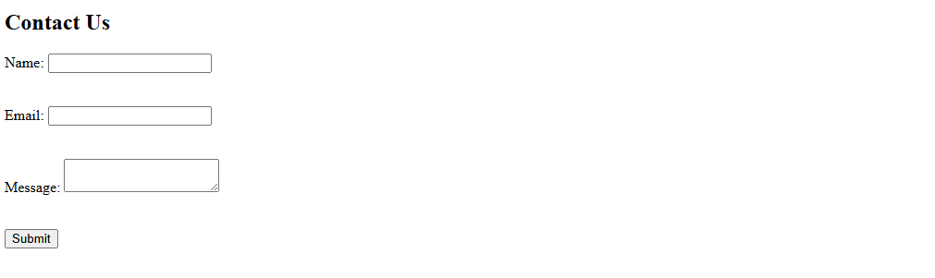

TASK 4:
#prompt
# Task 4: Dynamic List Management for a Product Page
# Create a product list where items can be dynamically added or removed.
# Requirements:
# - Display a list of items
# - Add a new item when the Add button is clicked
# - Remove the last item when Remove button is clicked
# - Changes should happen instantly without refreshing the page

#Code

<!DOCTYPE html>
<html lang="en">
<head>
<meta charset="UTF-8">
<title>Dynamic Product List</title>
</head>

<body>

<h2>Product List</h2>

<ul id="productList">
<li>Product 1</li>
<li>Product 2</li>
</ul>

<button onclick="addItem()">Add Item</button>
<button onclick="removeItem()">Remove Item</button>

<script>

let count = 3

function addItem(){

let list = document.getElementById("productList")

let newItem = document.createElement("li")

newItem.textContent = "Product " + count

list.appendChild(newItem)

count++

}

function removeItem(){

let list = document.getElementById("productList")

if(list.lastElementChild){

list.removeChild(list.lastElementChild)

}

}

</script>

</body>
</html>

#Output
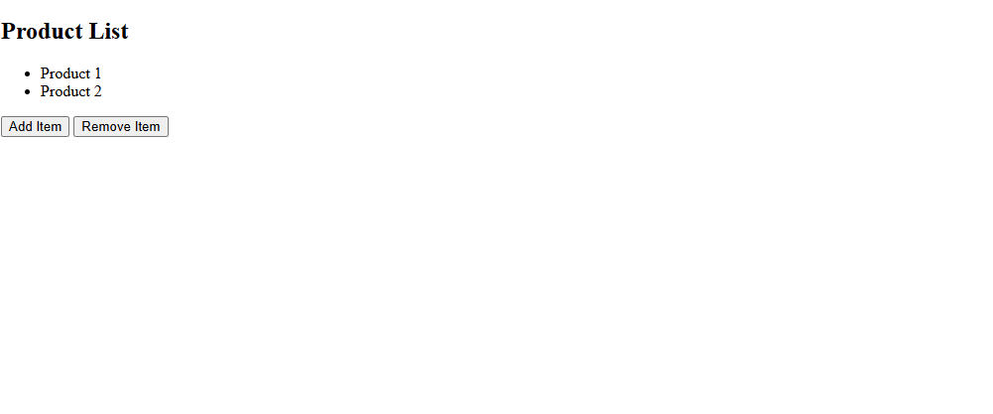
TASK 5:
#prompt
# Task 5: Modal Popup for User Notifications
# Create a modal popup for announcements.
# Requirements:
# - Button to open modal
# - Semi transparent background overlay
# - Button to close modal
# - Modal should also close when overlay is clicked

#Code
<!DOCTYPE html>
<html lang="en">
<head>
<meta charset="UTF-8">
<title>Modal Popup</title>

<style>

.modal{
display:none;
position:fixed;
top:0;
left:0;
width:100%;
height:100%;
background:rgba(0,0,0,0.5);
}

.modal-content{
background:white;
padding:20px;
margin:100px auto;
width:300px;
text-align:center;
}

</style>

</head>

<body>

<h2>Website Notification</h2>

<button onclick="openModal()">Open Modal</button>

<div id="modal" class="modal" onclick="closeModal()">

<div class="modal-content" onclick="event.stopPropagation()">

<h3>Announcement</h3>
<p>Welcome to our startup website!</p>

<button onclick="closeModal()">Close</button>

</div>

</div>

<script>

function openModal(){

document.getElementById("modal").style.display="block"

}

function closeModal(){

document.getElementById("modal").style.display="none"

}

</script>

</body>
</html>

#Output
