Assisgnment 13.4
2303a52176
Y.Rishwanth
Batch:41

Task 1:
Code:
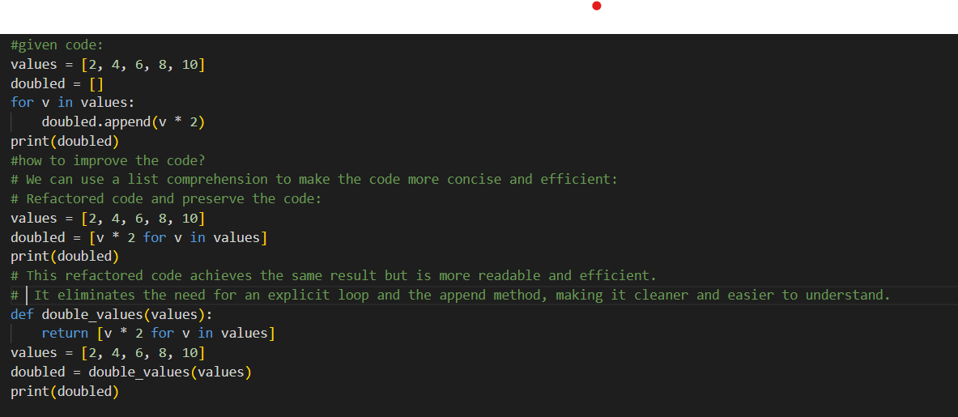
Output:
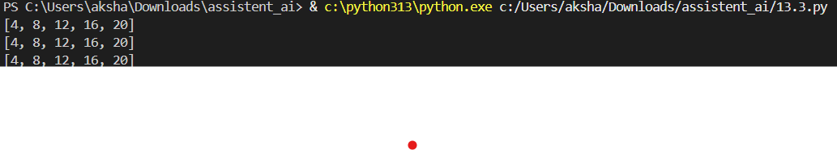

Task 2:
Code:
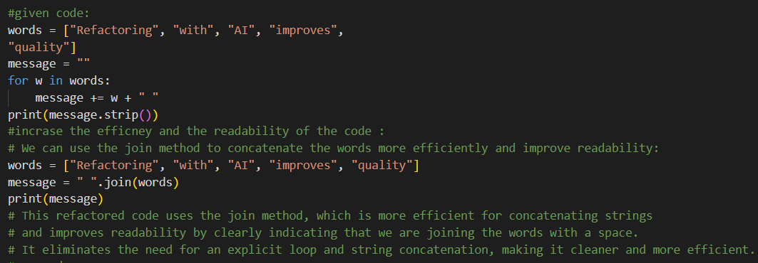
Output:

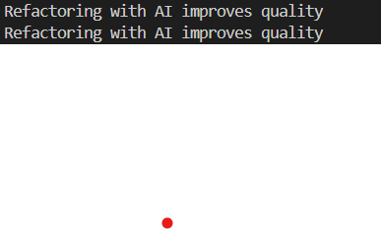

Task 3:
Code:
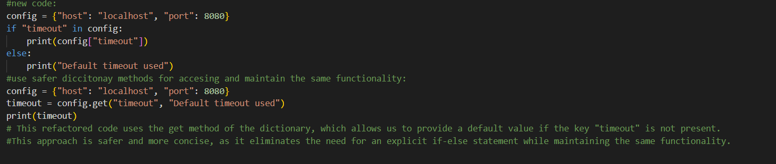
Ouput:
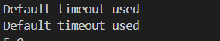
Task 4:
Code:
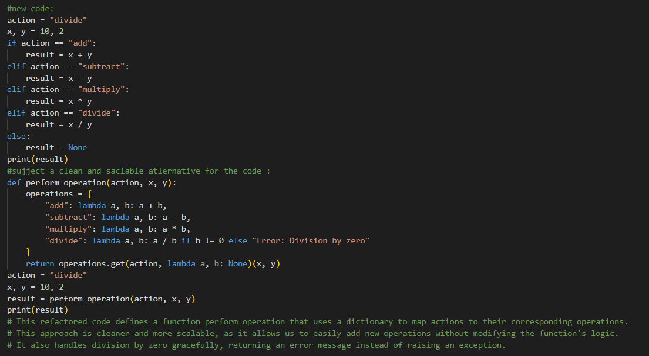
Output:
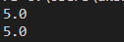

Task 5:
Code:
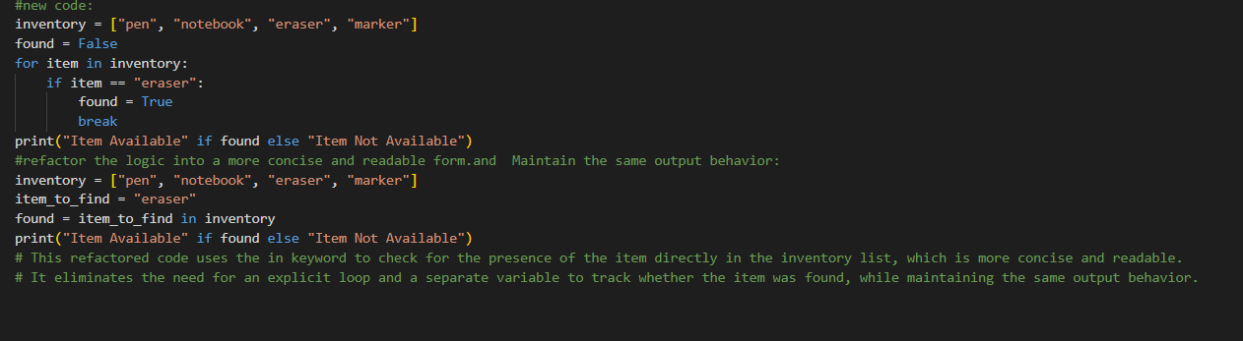
Output:
