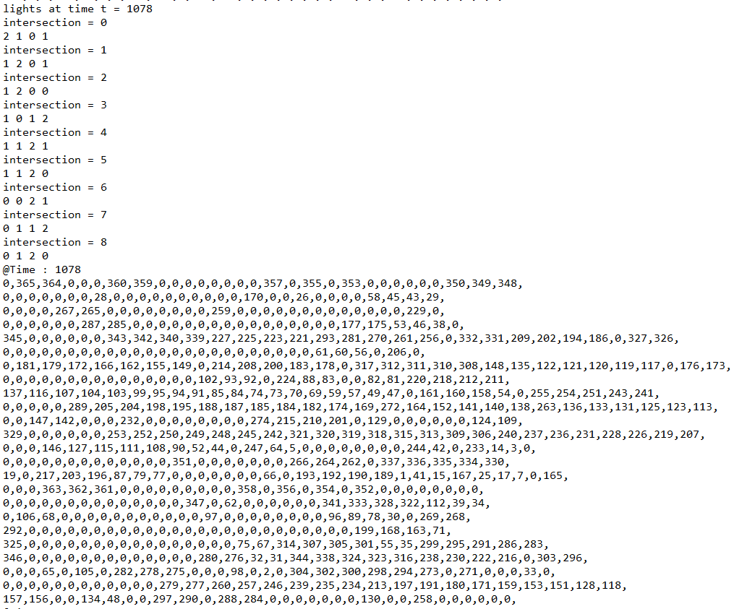

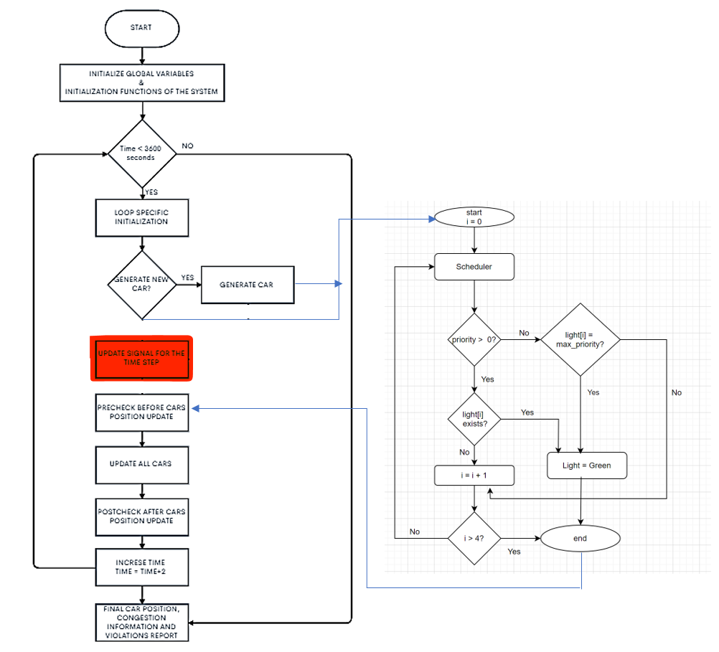

Sample output after integration that shows all the violations are 0

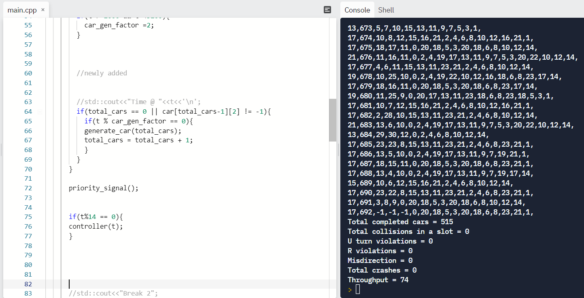

Case with car generated at every instance and signal switching:

|  |  |  |  |
| --- | --- | --- | --- |
| Time after which signal will change (in s) | Total cars | Total completed cars | Throughput (%) |
| 4 | 738 | 650 | 88 |
| 6 | 750 | 617 | 82 |
| 8 | 736 | 612 | 83 |
| 10 | 750 | 570 | 76 |
| 12 | 732 | 589 | 79 |
| 14 | 723 | 580 | 80 |
| 16 | 732 | 575 | 78 |
| 18 | 710 | 577 | 81 |
| 20 | 679 | 551 | 81 |
| 22 | 662 | 568 | 85 |

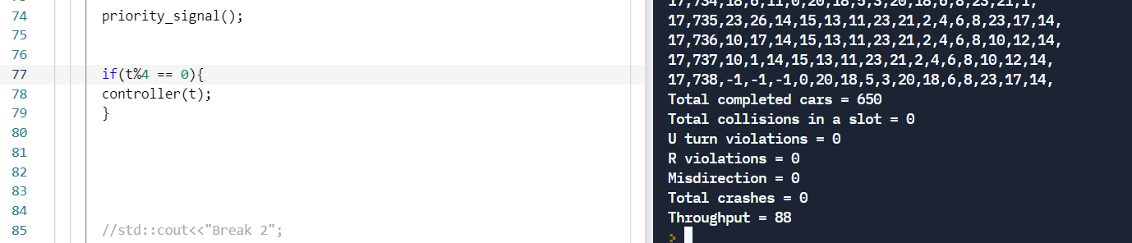

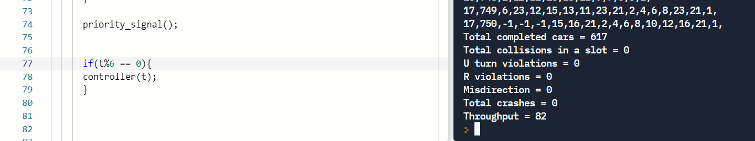

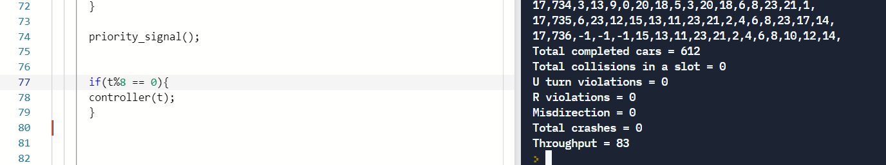

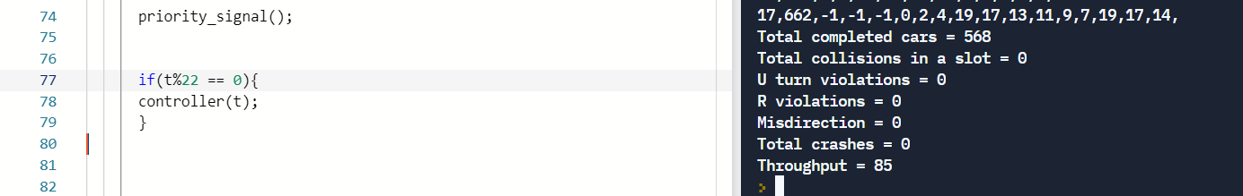

We tried calling the signal_controller for a variety of switching times: (Efficient car generation and signal switching)

|  |  |  |  |
| --- | --- | --- | --- |
| Time after which signal will change (in s) | Total cars | Total completed cars | Throughput (%) |
| 6 | 701 | 598 | 85 |
| 8 | 655 | 604 | 92 |
| 10 | 692 | 586 | 84 |
| 12 | 675 | 563 | 83 |
| 14 | 716 | 576 | 80 |
| 16 | 609 | 558 | 91 |
| 18 | 683 | 541 | 79 |
| 20 | 699 | 522 | 74 |
| 22 | 635 | 553 | 87 |

