PROJECT TITLE:

RYTHMIC TUNES: YOUR MELODIC COMPANION

TEAM DETAILS:

**TEAM ID:** NM2025TMID40084

**TEAM MEMBERS:**

TEAM LEADER: HARINI S

NM ID: 7B5FBDF14C60BA0B18E4C0F97C566B84

TEAM MEMBER: JAYA SRI R

NM ID: 46FA5ABC4F59736812C46F90B9A0A125

TEAM MEMBER: SANDHIYA M

NM ID: 88F43933E420CCA9A7849156A8769EA1

TEAM MEMBER: HARINI S

NM ID: CB5B2C4BAC94036817C4D076E70126E5

OBJECTIVE

The primary goal of Music Streaming is to provide a seamless platform for music enthusiasts, enjoying, and sharing diverse musical experiences. Our objectives include:

User-Friendly Interface: Develop an intuitive interface that allows users to effortlessly explore, save, and share their favorite music tracks and playlists.

Comprehensive Music Streaming: Provide robust features for organizing and managing music content, including advanced search options for easy discovery.

Modern Tech Stack: Harness cutting-edge web development technologies, such as React.js, to ensure an efficient and enjoyable user experience while navigating and interacting with the music streaming application.

PLATFORM AD TECHNOLOGY USED

**1. Frontend Development**

* **HTML5**: For structuring the web pages.
* **CSS3**: For styling, layout, and visual design.
* **React.js**: For creating dynamic, component-based user interfaces.

**2. Backend / Runtime Environment**

* **Node.js**: Provides the JavaScript runtime environment needed for React development and package execution.

**3. Package Management & Build Tool**

* **npm (Node Package Manager)**: For installing and managing project dependencies.
* **Vite**: Used as the development server and build tool for faster performance.

**4. Development Environment & Version Control**

* **Visual Studio Code (VS Code)**: Code editor for building and managing the project.
* **GitHub**: For version control, storing source code, and collaboration.

**5. Platform Compatibility**

* The website runs entirely in **web browsers** and is fully **responsive**, making it accessible on desktops, laptops, tablets, and smartphones.

IMPLEMENTATION/PROCESS

**1. Project Setup**

* The project was initialized using **Vite** along with **React.js** for fast development and modular design.
* **Node.js** and **npm** were installed to set up the runtime environment and manage required dependencies.
* A GitHub repository was created to store and maintain the project code.

**2. User Interface Design**

* The **HTML5** structure and **CSS3** styling were used to design the layout of the music player.
* A **navigation sidebar** was implemented to provide easy access to different sections such as Home, Playlist, and Favorites.
* The **main content area** was designed to display songs, album covers, and playback controls with a clean and responsive interface.

**3. Music Player Functionality**

* The built-in **HTML <audio> element** was integrated for song playback.
* Core features such as **play, pause, forward, backward, and volume control** were implemented using **JavaScript**.
* A **favorites system** was added, allowing users to mark and store their preferred songs.
* A **playlist section** was created to organize and display selected tracks.

**4. React.js Integration**

* The project was divided into **reusable React components** (Navbar, Sidebar, Player, Playlist, etc.).
* **State management** was implemented to handle user interactions like playing songs, adding favorites, and updating playlists.
* Smooth rendering and component reusability improved overall performance and code efficiency.

**5. Testing and Deployment**

* The application was tested locally in **Visual Studio Code (VS Code)** using the Vite development server (localhost:5173).
* Debugging was carried out to fix styling issues, broken links, and functionality errors.
* The final project was committed and pushed to **GitHub** for version control and future hosting.

OUTPUT

Project structure:

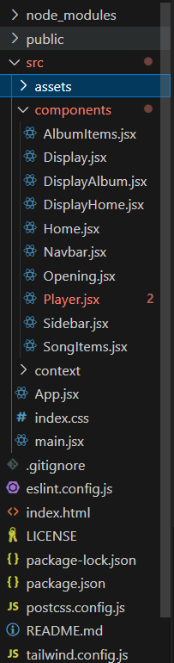

Homepage:  
  
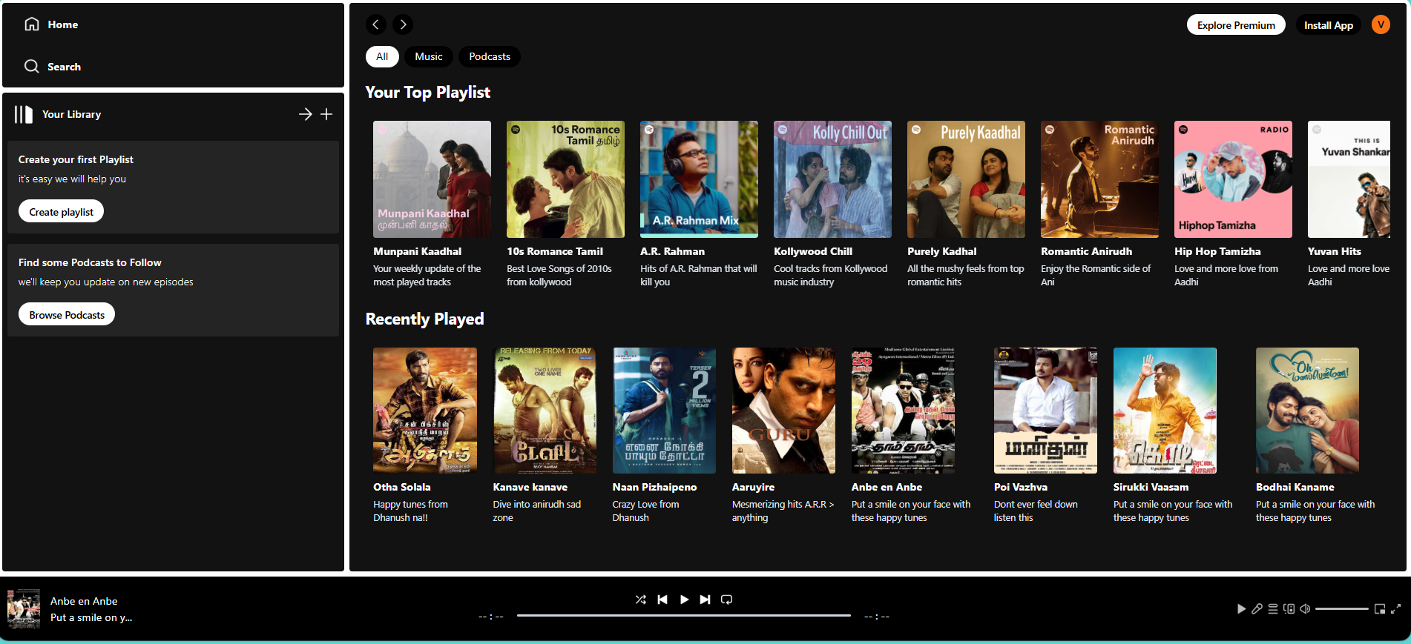

Playlist:

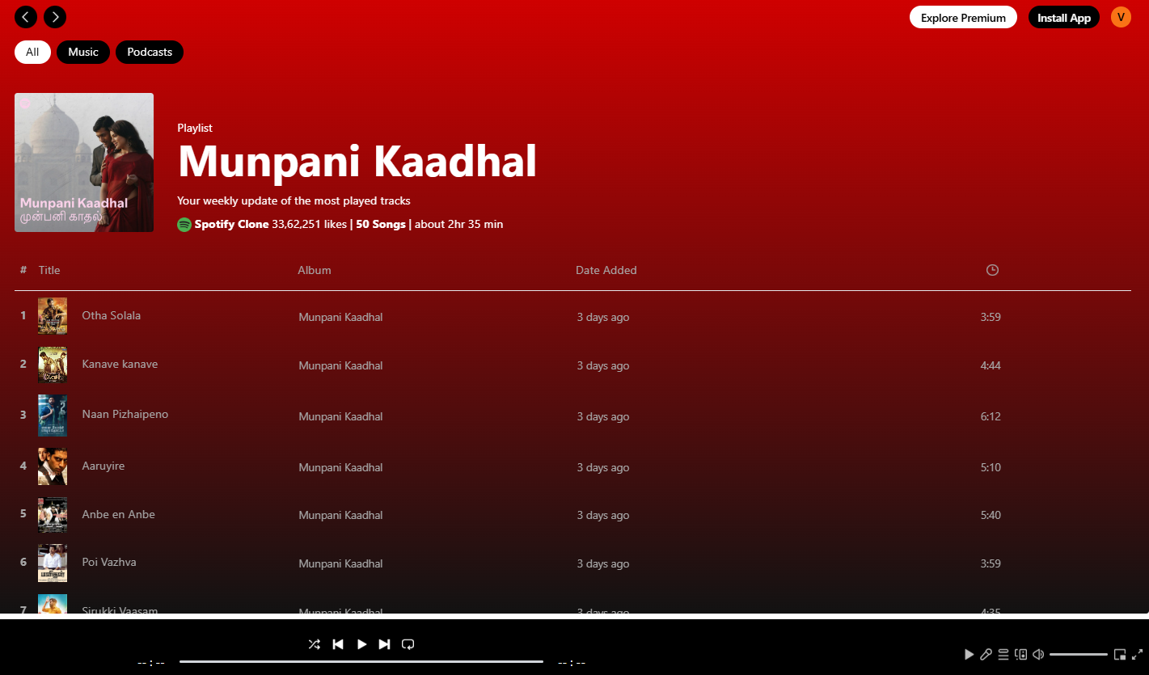

Player:

