**Technological Institute of the Philippines**

**938 Aurora Boulevard Cubao, Quezon City**

**College of Information Technology Education**

**“Flappy”***HCI 500 Final Project*

In partial fulfillment for the course

**HCI 500 – HCI ASPECTS APPLICATION DOMAINS**

**Submitted by:**

**Jose A. Perez Jr.**

**Submitted to:**

**Ms. Jean Angeles**

**Date Submitted:**

**March 15, 2020**

**Application Description**

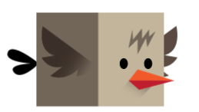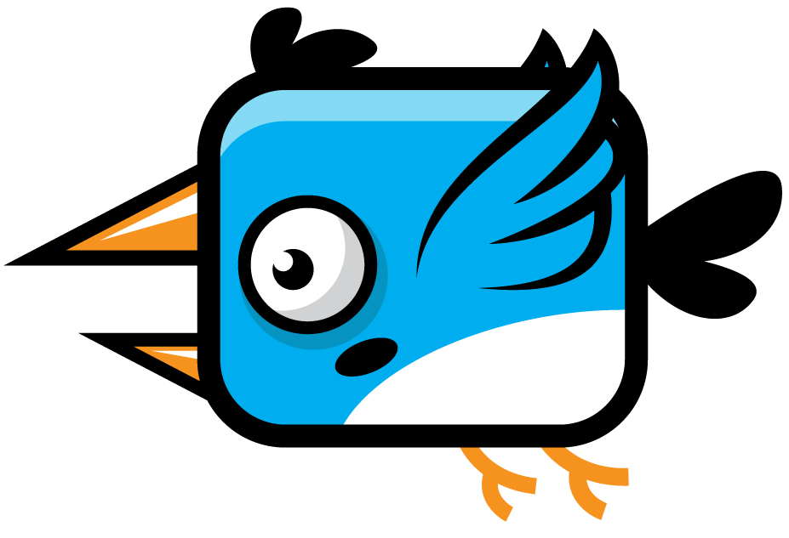

**Flappy** is a side scrolling 2d game. The game is about a bird named Flappy, who is trying to fight against large blue birds.

It is still unknown what the intentions of the opposing birds are, but they clearly out to get him, and our friend’s only choice... is to fight back.

Our goal is to help our little friend go back to his family ;)

**Mobile Features**

The game has the following features:

* Main Game
* Guide or Tutorial
* Sound effects toggle
* Background music toggle
* High Score
* Real time High Score counter
* Splash Screen
* Home Button pause and resume for background music
* Back Button destroy background music instance

**Screenshots and Description**

**Flappy:**



**Enemies:**



**Setting:**

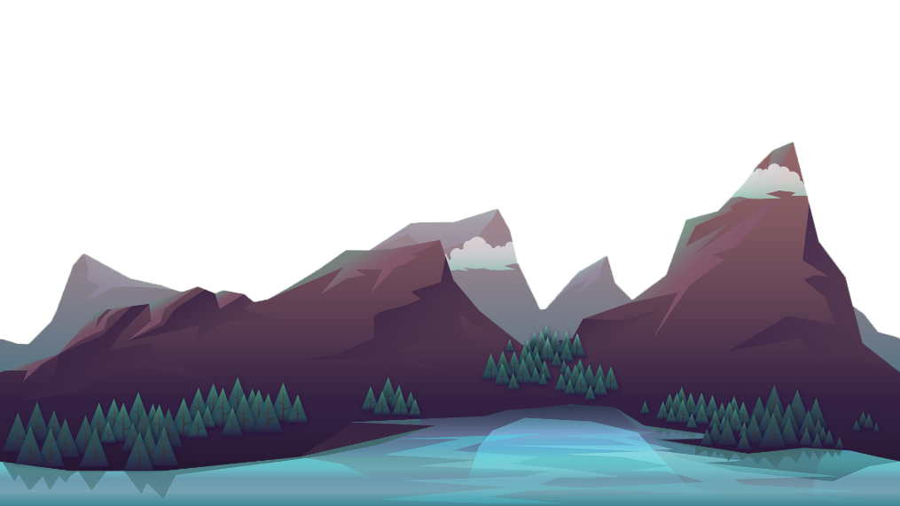

**Splash Screen:**

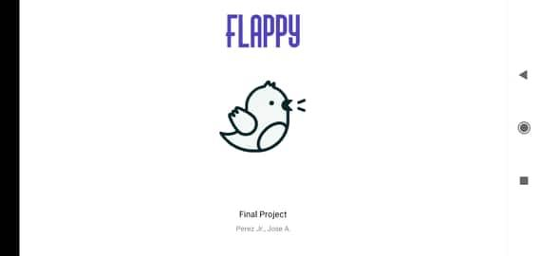

**Home Page:**

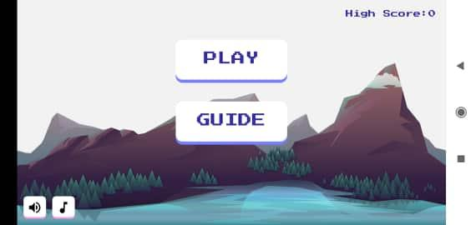

**Guide:**

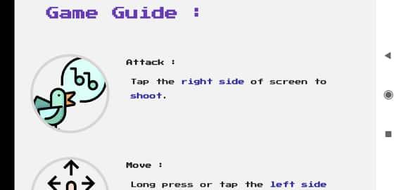

**Main Game:**

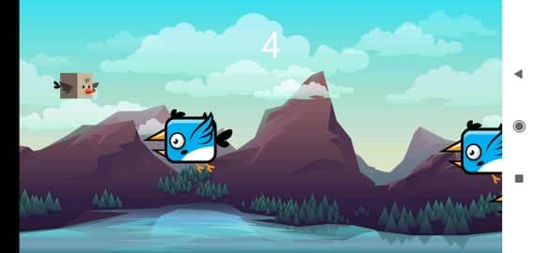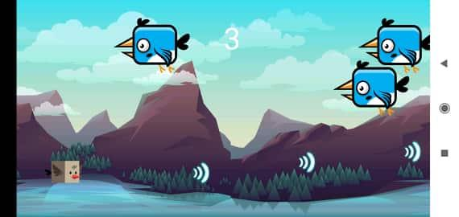

**Codes:**

https://drive.google.com/open?id=10134eHLnSMdEYc7_hclaT7-EpzVljvj2

**Manifest**

<?*xml version*="1.0" *encoding*="utf-8"?>  
<manifest *xmlns:android*="http://schemas.android.com/apk/res/android"  
 *package*="com.finals.game.flappy.perez">  
  
 <application  
 *android:allowBackup*="true"  
 *android:icon*="@mipmap/ic_launcher"  
 *android:label*="@string/app_name"  
 *android:roundIcon*="@mipmap/ic_launcher_round"  
 *android:supportsRtl*="true"  
 *android:theme*="@style/AppTheme">  
  
 <activity *android:name*=".Tutorial"  
 *android:screenOrientation*="landscape"  
 *android:theme*="@style/AppTheme.NoActionBar"  
 />  
  
 <service  
 *android:name*=".MusicService"  
 *android:enabled*="true" />  
 <service *android:name*=".MainActivity" />  
  
 <activity  
 *android:name*=".GameActivity"  
 *android:screenOrientation*="landscape"  
 *android:theme*="@style/AppTheme.NoActionBar" />  
 <activity  
 *android:name*=".MainActivity"  
 *android:screenOrientation*="landscape"  
 *android:theme*="@style/AppTheme.NoActionBar" />  
 <activity  
 *android:name*=".SplashScreen"  
 *android:screenOrientation*="landscape"  
 *android:theme*="@style/AppTheme.NoActionBar">  
 <intent-filter>  
 <action *android:name*="android.intent.action.MAIN" />  
  
 <category *android:name*="android.intent.category.LAUNCHER" />  
 </intent-filter>  
 </activity>  
 </application>  
  
</manifest>

**Background.java**

*package com.finals.game.flappy.perez*;  
  
  
  
*import android.content.res.Resources*;  
*import android.graphics.Bitmap*;  
*import android.graphics.BitmapFactory*;  
  
*public class Background* {  
  
 *int* x = 0, y = 0;  
 *Bitmap* background;  
  
 Background (*int screenX*, *int screenY*, *Resources res*) {  
  
 background = *BitmapFactory*.*decodeResource*(*res*, *R*.*drawable*.background);  
 background = *Bitmap*.*createScaledBitmap*(background, *screenX*, *screenY*, *false*);  
  
 }  
  
}

**Bird.java**

*package com.finals.game.flappy.perez*;  
  
  
*import android.content.res.Resources*;  
*import android.graphics.Bitmap*;  
*import android.graphics.BitmapFactory*;  
*import android.graphics.Rect*;  
  
*import static com.finals.game.flappy.perez.GameView*.*screenRatioX*;  
*import static com.finals.game.flappy.perez.GameView*.*screenRatioY*;  
  
  
  
  
*public class Bird* {  
  
 *public int* speed = 15;  
 *public boolean* wasShot = *true*;  
 *int* x = 0, y, width, height, birdCounter = 1;  
 *Bitmap* bird1, bird2, bird3, bird4;  
  
 Bird (*Resources res*) {  
  
 bird1 = *BitmapFactory*.*decodeResource*(*res*, *R*.*drawable*.bird1);  
 bird2 = *BitmapFactory*.*decodeResource*(*res*, *R*.*drawable*.bird2);  
 bird3 = *BitmapFactory*.*decodeResource*(*res*, *R*.*drawable*.bird3);  
 bird4 = *BitmapFactory*.*decodeResource*(*res*, *R*.*drawable*.bird4);  
  
 width = bird1.getWidth();  
 height = bird1.getHeight();  
  
 width /= 10;  
 height /= 10;  
  
 width = (*int*) (width * *screenRatioX*);  
 height = (*int*) (height * *screenRatioY*);  
  
 bird1 = *Bitmap*.*createScaledBitmap*(bird1, width, height, *false*);  
 bird2 = *Bitmap*.*createScaledBitmap*(bird2, width, height, *false*);  
 bird3 = *Bitmap*.*createScaledBitmap*(bird3, width, height, *false*);  
 bird4 = *Bitmap*.*createScaledBitmap*(bird4, width, height, *false*);  
  
 y = -height;  
 }  
  
 *Bitmap* getBird () {  
  
 *if* (birdCounter == 1) {  
 birdCounter++;  
 *return* bird1;  
 }  
  
 *if* (birdCounter == 2) {  
 birdCounter++;  
 *return* bird2;  
 }  
  
 *if* (birdCounter == 3) {  
 birdCounter++;  
 *return* bird3;  
 }  
  
 birdCounter = 1;  
  
 *return* bird4;  
 }  
  
 *Rect* getCollisionShape () {  
 *return new* Rect(x, y, x + width, y + height);  
 }  
  
}

**Bullet.java**

*package com.finals.game.flappy.perez*;  
  
*import android.content.res.Resources*;  
*import android.graphics.Bitmap*;  
*import android.graphics.BitmapFactory*;  
*import android.graphics.Rect*;  
  
  
*import static com.finals.game.flappy.perez.GameView*.*screenRatioX*;  
*import static com.finals.game.flappy.perez.GameView*.*screenRatioY*;  
  
*public class Bullet* {  
  
 *int* x, y, width, height;  
 *Bitmap* bullet;  
  
 Bullet (*Resources res*) {  
  
 bullet = *BitmapFactory*.*decodeResource*(*res*, *R*.*drawable*.bullet);  
  
 width = bullet.getWidth();  
 height = bullet.getHeight();  
  
 width /= 4;  
 height /= 4;  
  
 width = (*int*) (width * *screenRatioX*);  
 height = (*int*) (height * *screenRatioY*);  
  
 bullet = *Bitmap*.*createScaledBitmap*(bullet, width, height, *false*);  
  
 }  
  
 *Rect* getCollisionShape () {  
 *return new* Rect(x, y, x + width, y + height);  
 }  
  
}

**Flight.java**

*package com.finals.game.flappy.perez*;  
  
*import android.content.res.Resources*;  
*import android.graphics.Bitmap*;  
*import android.graphics.BitmapFactory*;  
*import android.graphics.Rect*;  
  
  
*import static com.finals.game.flappy.perez.GameView*.*screenRatioX*;  
*import static com.finals.game.flappy.perez.GameView*.*screenRatioY*;  
  
*public class Flight* {  
  
 *int* toShoot = 0;  
 *boolean* isGoingUp = *false*;  
 *int* x, y, width, height, wingCounter = 0, shootCounter = 1;  
 *Bitmap* flight1, flight2, shoot1, shoot2, shoot3, shoot4, shoot5, dead;  
 *private GameView* gameView;  
  
 Flight (*GameView gameView*, *int screenY*, *Resources res*) {  
  
 *this*.gameView = *gameView*;  
  
 flight1 = *BitmapFactory*.*decodeResource*(*res*, *R*.*drawable*.fly1);  
 flight2 = *BitmapFactory*.*decodeResource*(*res*, *R*.*drawable*.fly2);  
  
 width = flight1.getWidth();  
 height = flight1.getHeight();  
  
 width /= 5;  
 height /= 5;  
  
 width = (*int*) (width * *screenRatioX*);  
 height = (*int*) (height * *screenRatioY*);  
  
 flight1 = *Bitmap*.*createScaledBitmap*(flight1, width, height, *false*);  
 flight2 = *Bitmap*.*createScaledBitmap*(flight2, width, height, *false*);  
  
 shoot1 = *BitmapFactory*.*decodeResource*(*res*, *R*.*drawable*.shoot1);  
 shoot2 = *BitmapFactory*.*decodeResource*(*res*, *R*.*drawable*.shoot2);  
 shoot3 = *BitmapFactory*.*decodeResource*(*res*, *R*.*drawable*.shoot3);  
 shoot4 = *BitmapFactory*.*decodeResource*(*res*, *R*.*drawable*.shoot4);  
 shoot5 = *BitmapFactory*.*decodeResource*(*res*, *R*.*drawable*.shoot5);  
  
 shoot1 = *Bitmap*.*createScaledBitmap*(shoot1, width, height, *false*);  
 shoot2 = *Bitmap*.*createScaledBitmap*(shoot2, width, height, *false*);  
 shoot3 = *Bitmap*.*createScaledBitmap*(shoot3, width, height, *false*);  
 shoot4 = *Bitmap*.*createScaledBitmap*(shoot4, width, height, *false*);  
 shoot5 = *Bitmap*.*createScaledBitmap*(shoot5, width, height, *false*);  
  
 dead = *BitmapFactory*.*decodeResource*(*res*, *R*.*drawable*.dead);  
 dead = *Bitmap*.*createScaledBitmap*(dead, width, height, *false*);  
  
 y = *screenY* / 2;  
 x = (*int*) (64 * *screenRatioX*);  
  
 }  
  
 *Bitmap* getFlight () {  
  
 *if* (toShoot != 0) {  
  
 *if* (shootCounter == 1) {  
 shootCounter++;  
 *return* shoot1;  
 }  
  
 *if* (shootCounter == 2) {  
 shootCounter++;  
 *return* shoot2;  
 }  
  
 *if* (shootCounter == 3) {  
 shootCounter++;  
 *return* shoot3;  
 }  
  
 *if* (shootCounter == 4) {  
 shootCounter++;  
 *return* shoot4;  
 }  
  
 shootCounter = 1;  
 toShoot--;  
 gameView.newBullet();  
  
 *return* shoot5;  
 }  
  
 *if* (wingCounter == 0) {  
 wingCounter++;  
 *return* flight1;  
 }  
 wingCounter--;  
  
 *return* flight2;  
 }  
  
 *Rect* getCollisionShape () {  
 *return new* Rect(x, y, x + width, y + height);  
 }  
  
 *Bitmap* getDead () {  
 *return* dead;  
 }  
  
}

**GameActivity.java**

*package com.finals.game.flappy.perez*;  
  
*import android.graphics.Point*;  
*import android.os.Bundle*;  
*import android.view.WindowManager*;  
  
*import androidx.appcompat.app.AppCompatActivity*;  
  
*public class GameActivity extends AppCompatActivity* {  
  
 *private GameView* gameView;  
  
 *@Override  
 protected void* onCreate(*Bundle savedInstanceState*) {  
 *super*.onCreate(*savedInstanceState*);  
  
 getWindow().setFlags(*WindowManager*.*LayoutParams*.FLAG_FULLSCREEN, *WindowManager*.*LayoutParams*.FLAG_FULLSCREEN);  
  
 *Point* point = *new* Point();  
 getWindowManager().getDefaultDisplay().getSize(point);  
  
 gameView = *new* GameView(*this*, point.x, point.y);  
  
 setContentView(gameView);  
 }  
  
 *@Override  
 protected void* onPause() {  
 *super*.onPause();  
 gameView.pause();  
 }  
  
 *@Override  
 protected void* onResume() {  
 *super*.onResume();  
 gameView.resume();  
 }  
}

**GameView.java**

*package com.finals.game.flappy.perez*;  
  
*import android.content.*Context;  
*import android.content.Intent*;  
*import android.content.SharedPreferences*;  
*import android.graphics.Canvas*;  
*import android.graphics.Color*;  
*import android.graphics.Paint*;  
*import android.graphics.Rect*;  
*import android.media.AudioAttributes*;  
*import android.media.AudioManager*;  
*import android.media.MediaPlayer*;  
*import android.media.SoundPool*;  
*import android.os.Build*;  
*import android.view.MotionEvent*;  
*import android.view.SurfaceView*;  
  
*import java.util.ArrayList*;  
*import java.util.List*;  
*import java.util.Random*;  
  
*public class GameView extends SurfaceView implements Runnable* {  
  
 *private Thread* thread;  
 *private boolean* isPlaying, isGameOver = *false*;  
 *private int* screenX, screenY, score = 0;  
 *public static float screenRatioX*, *screenRatioY*;  
 *private Paint* paint;  
 *private Bird*[] birds;  
 *private SharedPreferences* prefs;  
 *private Random* random;  
 *private SoundPool* soundPool;  
 *private List*<*Bullet*> bullets;  
 *private int* sound;  
 *private Flight* flight;  
 *private GameActivity* activity;  
 *private Background* background1, background2;  
 *//bg music  
 private MediaPlayer* bgMusic;  
  
 *public* GameView(*GameActivity activity*, *int* screenX, *int* screenY) {  
 *super*(*activity*);  
  
 *this*.activity = *activity*;  
  
 prefs = *activity*.getSharedPreferences("game", Context.MODE_PRIVATE);  
  
  
 *if* (*Build*.*VERSION*.SDK_INT >= *Build*.*VERSION_CODES*.M) {  
  
 *AudioAttributes* audioAttributes = *new AudioAttributes*.Builder()  
 .setContentType(*AudioAttributes*.CONTENT_TYPE_MUSIC)  
 .setUsage(*AudioAttributes*.USAGE_GAME)  
 .build();  
  
 soundPool = *new SoundPool*.Builder()  
 .setAudioAttributes(audioAttributes)  
 .build();  
  
 } *else* soundPool = *new* SoundPool(1, *AudioManager*.STREAM_MUSIC, 0);  
  
 sound = soundPool.load(*activity*, *R*.*raw*.shoot, 1);  
  
 *this*.screenX = *screenX*;  
 *this*.screenY = *screenY*;  
 *screenRatioX* = 1920f / *screenX*;  
 *screenRatioY* = 1080f / *screenY*;  
  
 background1 = *new* Background(*screenX*, *screenY*, getResources());  
 background2 = *new* Background(*screenX*, *screenY*, getResources());  
  
 flight = *new* Flight(*this*, *screenY*, getResources());  
  
 bullets = *new* ArrayList<>();  
  
 background2.x = *screenX*;  
  
 paint = *new* Paint();  
 paint.setTextSize(100);  
 paint.setColor(*Color*.WHITE);  
  
 birds = *new* Bird[3];  
  
 *for* (*int* i = 0;i < 3;i++) {  
  
 *Bird* bird = *new* Bird(getResources());  
 birds[i] = bird;  
  
 }  
  
 random = *new* Random();  
  
 }  
  
 @Override  
 *public void* run() {  
  
 *while* (isPlaying) {  
  
 update ();  
 draw ();  
 sleep ();  
  
 }  
  
 }  
  
 *private void* update () {  
  
 background1.x -= 10 * screenRatioX;  
 background2.x -= 10 * screenRatioX;  
  
 *if* (background1.x + background1.background.getWidth() < 0) {  
 background1.x = screenX;  
 }  
  
 *if* (background2.x + background2.background.getWidth() < 0) {  
 background2.x = screenX;  
 }  
  
 *if* (flight.isGoingUp)  
 *//fly up* flight.y -= 18 * screenRatioY;  
 *else  
 //go down* flight.y += 5 * screenRatioY;  
  
 *if* (flight.y < 0)  
 flight.y = 0;  
  
 *if* (flight.y >= screenY - flight.height)  
 flight.y = screenY - flight.height;  
  
 List<Bullet> trash = *new* ArrayList<>();  
  
 *for* (Bullet bullet : bullets) {  
  
 *if* (bullet.x > screenX)  
 trash.add(bullet);  
  
 bullet.x += 50 * screenRatioX;  
  
 *for* (Bird bird : birds) {  
  
 *if* (Rect.intersects(bird.getCollisionShape(),  
 bullet.getCollisionShape())) {  
  
 score++;  
 bird.x = -500;  
 bullet.x = screenX + 500;  
 bird.wasShot = *true*;  
  
 }  
  
 }  
  
 }  
  
 *for* (Bullet bullet : trash)  
 bullets.remove(bullet);  
  
 *for* (Bird bird : birds) {  
  
 bird.x -= bird.speed;  
  
 *if* (bird.x + bird.width < 0) {  
  
*// if (!bird.wasShot) {  
// isGameOver = true;  
// return;  
// }  
  
 int* bound = (*int*) (30 * screenRatioX);  
 bird.speed = random.nextInt(bound);  
  
 *if* (bird.speed < 10 * screenRatioX)  
 bird.speed = (*int*) (10 * screenRatioX);  
  
 bird.x = screenX;  
 bird.y = random.nextInt(screenY - bird.height);  
  
 bird.wasShot = *false*;  
 }  
  
 *if* (Rect.intersects(bird.getCollisionShape(), flight.getCollisionShape())) {  
  
 isGameOver = *true*;  
  
 *return*;  
 }  
  
 }  
  
 }  
  
 *private void* draw () {  
  
 *if* (getHolder().getSurface().isValid()) {  
  
 Canvas canvas = getHolder().lockCanvas();  
 canvas.drawBitmap(background1.background, background1.x, background1.y, paint);  
 canvas.drawBitmap(background2.background, background2.x, background2.y, paint);  
  
 *for* (Bird bird : birds)  
 canvas.drawBitmap(bird.getBird(), bird.x, bird.y, paint);  
  
 canvas.drawText(score + "", screenX / 2f, 164, paint);  
  
 *if* (isGameOver) {  
 isPlaying = *false*;  
 canvas.drawBitmap(flight.getDead(), flight.x, flight.y, paint);  
 getHolder().unlockCanvasAndPost(canvas);  
 saveIfHighScore();  
 waitBeforeExiting ();  
 *return*;  
 }  
  
 canvas.drawBitmap(flight.getFlight(), flight.x, flight.y, paint);  
  
 *for* (Bullet bullet : bullets)  
 canvas.drawBitmap(bullet.bullet, bullet.x, bullet.y, paint);  
  
 getHolder().unlockCanvasAndPost(canvas);  
  
 }  
  
 }  
  
 *private void* waitBeforeExiting() {  
  
 *try* {  
 Thread.sleep(2500);  
 activity.startActivity(*new* Intent(activity, MainActivity.*class*));  
 activity.finish();  
 } *catch* (InterruptedException e) {  
 e.printStackTrace();  
 }  
  
 }  
  
 *private void* saveIfHighScore() {  
  
 *if* (prefs.getInt("highscore", 0) < score) {  
 SharedPreferences.Editor editor = prefs.edit();  
 editor.putInt("highscore", score);  
 editor.apply();  
 }  
  
 }  
  
 *private void* sleep () {  
 *try* {  
 Thread.sleep(17);  
 } *catch* (InterruptedException e) {  
 e.printStackTrace();  
 }  
 }  
  
 *public void* resume () {  
  
 isPlaying = *true*;  
 thread = *new* Thread(*this*);  
 thread.start();  
  
 }  
  
 *public void* pause () {  
  
 *try* {  
 isPlaying = *false*;  
 thread.join();  
 } *catch* (InterruptedException e) {  
 e.printStackTrace();  
 }  
  
 }  
  
 @Override  
 *public boolean* onTouchEvent(MotionEvent event) {  
  
 *switch* (event.getAction()) {  
 *case* MotionEvent.ACTION_DOWN:  
 *if* (event.getX() < screenX / 2) {  
 flight.isGoingUp = *true*;  
 }  
 *break*;  
 *case* MotionEvent.ACTION_UP:  
 flight.isGoingUp = *false*;  
 *if* (event.getX() > screenX / 2)  
 flight.toShoot++;  
 *break*;  
 }  
  
 *return true*;  
 }  
  
  
  
  
 *public void* newBullet() {  
  
 *if* (!prefs.getBoolean("isMute", *false*))  
 soundPool.play(sound, 1, 1, 0, 0, 1);  
  
 Bullet bullet = *new* Bullet(getResources());  
 bullet.x = flight.x + flight.width;  
 bullet.y = flight.y + (flight.height / 2);  
 bullets.add(bullet);  
  
 }  
}

**HomeWatcher.java**

*package com.finals.game.flappy.perez*;  
  
*import android.content.*BroadcastReceiver;  
*import android.content.*Context;  
*import android.content.Intent*;  
*import android.content.IntentFilter*;  
  
*public class HomeWatcher* {  
  
 *//static final String TAG = "hg";  
 private* Context mContext;  
 *private IntentFilter* mFilter;  
 *private OnHomePressedListener* mListener;  
 *private InnerRecevier* mRecevier;  
  
 *public* HomeWatcher(Context *context*) {  
 mContext = *context*;  
 mFilter = *new* IntentFilter(*Intent*.ACTION_CLOSE_SYSTEM_DIALOGS);  
 }  
  
 *public void* setOnHomePressedListener(*OnHomePressedListener listener*) {  
 mListener = *listener*;  
 mRecevier = *new* InnerRecevier();  
 }  
  
 *public void* startWatch() {  
 *if* (mRecevier != *null*) {  
 mContext.registerReceiver(mRecevier, mFilter);  
 }  
 }  
  
 *public void* stopWatch() {  
 *if* (mRecevier != *null*) {  
 mContext.unregisterReceiver(mRecevier);  
 }  
 }  
  
 *class InnerRecevier extends* BroadcastReceiver {  
 *final String* SYSTEM_DIALOG_REASON_KEY = "reason";  
 *final String* SYSTEM_DIALOG_REASON_GLOBAL_ACTIONS = "globalactions";  
 *final String* SYSTEM_DIALOG_REASON_RECENT_APPS = "recentapps";  
 *final String* SYSTEM_DIALOG_REASON_HOME_KEY = "homekey";  
  
 *@Override  
 public void* onReceive(Context *context*, *Intent intent*) {  
 *String* action = *intent*.getAction();  
 *if* (action != *null* && action.equals(*Intent*.ACTION_CLOSE_SYSTEM_DIALOGS)) {  
 *String* reason = *intent*.getStringExtra(SYSTEM_DIALOG_REASON_KEY);  
 *if* (reason != *null*) {  
 *//Log.e(TAG, "action:" + action + ",reason:" + reason);  
 if* (mListener != *null*) {  
 *if* (reason.equals(SYSTEM_DIALOG_REASON_HOME_KEY)) {  
 mListener.onHomePressed();  
 } *else if* (reason.equals(SYSTEM_DIALOG_REASON_RECENT_APPS)) {  
 mListener.onHomeLongPressed();  
 }  
 }  
 }  
 }  
 }  
 }  
  
 *public interface OnHomePressedListener* {  
 *void* onHomePressed();  
  
 *void* onHomeLongPressed();  
 }  
}

**MainActivity.java**

*package com.finals.game.flappy.perez*;  
  
*import android.content.ComponentName*;  
*import android.content.*Context;  
*import android.content.Intent*;  
*import android.content.ServiceConnection*;  
*import android.content.SharedPreferences*;  
*import android.graphics.Typeface*;  
*import android.os.Bundle*;  
*import android.os.IBinder*;  
*import android.os.PowerManager*;  
*import android.view.View*;  
*import android.view.WindowManager*;  
*import android.widget.ImageView*;  
*import android.widget.TextView*;  
  
*import androidx.appcompat.app.AppCompatActivity*;  
  
*public class MainActivity extends AppCompatActivity* {  
  
 *HomeWatcher* mHomeWatcher;  
 *//Bind/Unbind music service  
 private boolean* mIsBound = *false*;  
 *private MusicService* mServ;  
 *private boolean* isMute;  
 *TextView* gamePlay, gameTutorial, gameScore;  
  
 *@Override  
 protected void* onCreate(*Bundle savedInstanceState*) {  
 *super*.onCreate(*savedInstanceState*);  
 *// Disable ActionBar* getWindow().setFlags(*WindowManager*.*LayoutParams*.FLAG_FULLSCREEN, *WindowManager*.*LayoutParams*.FLAG_FULLSCREEN);  
 setContentView(*R*.*layout*.activity_main);  
  
 *//BIND Music Service* doBindService();  
 *final Intent* music = *new* Intent();  
 music.setClass(*this*, *MusicService*.*class*);  
 startService(music);  
  
 *//Start HomeWatcher* mHomeWatcher = *new* HomeWatcher(*this*);  
 mHomeWatcher.setOnHomePressedListener(*new HomeWatcher*.*OnHomePressedListener*() {  
 *@Override  
 public void* onHomePressed() {  
 *if* (mServ != *null*) {  
 mServ.pauseMusic();  
 }  
 }  
  
 *@Override  
 public void* onHomeLongPressed() {  
 *if* (mServ != *null*) {  
 mServ.pauseMusic();  
 }  
 }  
 });  
 mHomeWatcher.startWatch();  
  
  
 *//Fonts Changing* gamePlay = (*TextView*) findViewById(*R*.*id*.play);  
 gameTutorial = (*TextView*) findViewById(*R*.*id*.tutorial);  
 gameScore = (*TextView*) findViewById(*R*.*id*.highScoreTxt);  
 *Typeface* typeface = *Typeface*.*createFromAsset*(getAssets(),  
 "fonts/PressStart2PRegular.ttf");  
 gamePlay.setTypeface(typeface);  
 gameScore.setTypeface(typeface);  
 gameTutorial.setTypeface(typeface);  
  
  
 findViewById(*R*.*id*.play).setOnClickListener(*new View*.*OnClickListener*() {  
 *@Override  
 public void* onClick(*View view*) {  
 startActivity(*new* Intent(*MainActivity*.*this*, *GameActivity*.*class*));  
 }  
 });  
  
 findViewById(*R*.*id*.tutorial).setOnClickListener(*new View*.*OnClickListener*() {  
 *@Override  
 public void* onClick(*View view*) {  
 startActivity(*new* Intent(*MainActivity*.*this*, *Tutorial*.*class*));  
 }  
 });  
  
 *//HighScore  
 final SharedPreferences* prefs = getSharedPreferences("game", MODE_PRIVATE);  
 gameScore.setText("High Score:" + prefs.getInt("highscore", 0));  
  
 *//Sound : icon toggle* isMute = prefs.getBoolean("isMute", *false*);  
 *final ImageView* volumeCtrl = findViewById(*R*.*id*.volumeCtrl);  
 *final ImageView* musicCtrl = findViewById(*R*.*id*.bgMusicCtrl);  
  
 *if* (isMute) {  
 volumeCtrl.setImageResource(*R*.*drawable*.ic_volume_off);  
 musicCtrl.setImageResource(*R*.*drawable*.ic_music_mute);  
 } *else* {  
 volumeCtrl.setImageResource(*R*.*drawable*.ic_volume_up);  
 musicCtrl.setImageResource(*R*.*drawable*.ic_music_note);  
 }  
  
  
 volumeCtrl.setOnClickListener(*new View*.*OnClickListener*() {  
 *@Override  
 public void* onClick(*View view*) {  
 isMute = !isMute;  
 *if* (isMute)  
 volumeCtrl.setImageResource(*R*.*drawable*.ic_volume_off);  
 *else* volumeCtrl.setImageResource(*R*.*drawable*.ic_volume_up);  
  
 *//Saving status of volume button in Sharedprefs  
 SharedPreferences*.*Editor* editor = prefs.edit();  
 editor.putBoolean("isMute", isMute);  
 editor.apply();  
  
 }  
 });  
  
 musicCtrl.setOnClickListener(*new View*.*OnClickListener*() {  
 *@Override  
 public void* onClick(*View view*) {  
 isMute = !isMute;  
 *if* (isMute) {  
 musicCtrl.setImageResource(*R*.*drawable*.ic_music_mute);  
 mServ.pauseMusic();  
 } *else* {  
 musicCtrl.setImageResource(*R*.*drawable*.ic_music_note);  
 mServ.resumeMusic();  
 }  
 *SharedPreferences*.*Editor* editor = prefs.edit();  
 editor.putBoolean("isMute", isMute);  
 editor.apply();  
 }  
 });  
 }  
  
  
 *//Background Music Components  
 private ServiceConnection* Scon = *new ServiceConnection*() {  
  
 *public void* onServiceConnected(*ComponentName name*, *IBinder  
 binder*) {  
 mServ = ((*MusicService*.*ServiceBinder*) *binder*).getService();  
 }  
  
 *public void* onServiceDisconnected(*ComponentName name*) {  
 mServ = *null*;  
 }  
 };  
  
  
 *void* doBindService() {  
 bindService(*new* Intent(*this*, *MusicService*.*class*),  
 Scon, Context.BIND_AUTO_CREATE);  
 mIsBound = *true*;  
 }  
  
 *void* doUnbindService() {  
 *if* (mIsBound) {  
 unbindService(Scon);  
 mIsBound = *false*;  
 }  
 }  
  
 *@Override  
 protected void* onResume() {  
 *super*.onResume();  
 *if* (mServ != *null*) {  
 mServ.resumeMusic();  
 }  
 }  
  
 *@Override  
 protected void* onPause() {  
 *super*.onPause();  
 *//Detect idle screen  
 PowerManager* pm = (*PowerManager*)  
 getSystemService(Context.POWER_SERVICE);  
 *boolean* isScreenOn = *false*;  
 *if* (pm != *null*) {  
 isScreenOn = pm.isScreenOn();  
 }  
 *if* (!isScreenOn) {  
 *if* (mServ != *null*) {  
 mServ.pauseMusic();  
 }  
 }  
 }  
  
 *@Override  
 protected void* onDestroy() {  
 *super*.onDestroy();  
 *//UNBIND music service* doUnbindService();  
 *Intent* music = *new* Intent();  
 music.setClass(*this*, *MusicService*.*class*);  
 stopService(music);  
 }  
}

**MusicService.java**

*package com.finals.game.flappy.perez*;  
  
  
*import android.app.*Service;  
*import android.content.Intent*;  
*import android.media.MediaPlayer*;  
*import android.os.Binder*;  
*import android.os.IBinder*;  
*import android.widget.Toast*;  
  
  
*public class MusicService extends* Service *implements MediaPlayer*.*OnErrorListener* {  
  
 *private final IBinder* mBinder = *new* ServiceBinder();  
 *public static MediaPlayer mPlayer*;  
 *private int* length = 0;  
  
 *public* MusicService() {  
 }  
  
 *public class ServiceBinder extends Binder* {  
 *MusicService* getService() {  
 *return MusicService*.*this*;  
 }  
 }  
  
 *@Override  
 public IBinder* onBind(*Intent arg0*) {  
 *return* mBinder;  
 }  
  
  
  
 *@Override  
 public void* onCreate() {  
 *super*.onCreate();  
  
 *mPlayer* = *MediaPlayer*.*create*(*this*, *R*.*raw*.theme_songs); *//replace with your song name!  
 mPlayer*.setOnErrorListener(*this*);  
  
 *if* (*mPlayer* != *null*) {  
 *mPlayer*.setLooping(*true*);  
 *mPlayer*.setVolume(50, 50);  
 }  
  
  
 *mPlayer*.setOnErrorListener(*new MediaPlayer*.*OnErrorListener*() {  
  
 *public boolean* onError(*MediaPlayer mp*, *int what*, *int  
 extra*) {  
  
 onError(*mPlayer*, *what*, *extra*);  
 *return true*;  
 }  
 });  
 }  
  
 *@Override  
 public int* onStartCommand(*Intent intent*, *int flags*, *int startId*) {  
 *if* (*mPlayer* != *null*) {  
 *mPlayer*.start();  
 }  
 *return* START_NOT_STICKY;  
 }  
  
 *public void* pauseMusic() {  
 *if* (*mPlayer* != *null*) {  
 *if* (*mPlayer*.isPlaying()) {  
 *mPlayer*.pause();  
 length = *mPlayer*.getCurrentPosition();  
 }  
 }  
 }  
  
 *public void* resumeMusic() {  
 *if* (*mPlayer* != *null*) {  
 *if* (!*mPlayer*.isPlaying()) {  
 *mPlayer*.seekTo(length);  
 *mPlayer*.start();  
 }  
 }  
 }  
  
 *public void* startMusic() {  
 *mPlayer* = *MediaPlayer*.*create*(*this*, *R*.*raw*.theme_songs);  
 *mPlayer*.setOnErrorListener(*this*);  
  
 *if* (*mPlayer* != *null*) {  
 *mPlayer*.setLooping(*true*);  
 *mPlayer*.setVolume(50, 50);  
 *mPlayer*.start();  
 }  
  
 }  
  
 *public void* stopMusic() {  
 *if* (*mPlayer* != *null*) {  
 *mPlayer*.stop();  
 *mPlayer*.release();  
 *mPlayer* = *null*;  
 }  
 }  
  
 *@Override  
 public void* onDestroy() {  
 *super*.onDestroy();  
 *if* (*mPlayer* != *null*) {  
 *try* {  
 *mPlayer*.stop();  
 *mPlayer*.release();  
 } *finally* {  
 *mPlayer* = *null*;  
 }  
 }  
 }  
  
 *public boolean* onError(*MediaPlayer mp*, *int what*, *int extra*) {  
  
 *Toast*.*makeText*(*this*, "Music player failed", *Toast*.LENGTH_SHORT).show();  
 *if* (*mPlayer* != *null*) {  
 *try* {  
 *mPlayer*.stop();  
 *mPlayer*.release();  
 } *finally* {  
 *mPlayer* = *null*;  
 }  
 }  
 *return false*;  
 }  
}

**SplashScreen.java**

*package com.finals.game.flappy.perez*;  
  
  
*import androidx.appcompat.app.AppCompatActivity*;  
  
*import android.content.Intent*;  
*import android.graphics.Typeface*;  
*import android.os.Bundle*;  
*import android.os.Handler*;  
*import android.view.WindowManager*;  
*import android.view.animation.*Animation;  
*import android.view.animation.AnimationUtils*;  
*import android.widget.ImageView*;  
*import android.widget.TextView*;  
  
  
*public class SplashScreen extends AppCompatActivity* {  
 *private static int SPLASH_SCREEN* = 3500;  
 *//Variables* Animation topAnim, bottomAnim;  
 *ImageView* logo_anim;  
 *//fonts  
 TextView* hci_name,hci_dev;  
  
 *@Override  
 protected void* onCreate(*Bundle savedInstanceState*) {  
 *super*.onCreate(*savedInstanceState*);  
 getWindow().setFlags(*WindowManager*.*LayoutParams*.FLAG_FULLSCREEN, *WindowManager*.*LayoutParams*.FLAG_FULLSCREEN);  
 setContentView(*R*.*layout*.activity_splash_screen);  
  
 *//Fonts Changing* logo_anim = (*ImageView*) findViewById(*R*.*id*.imageView);  
 hci_name = (*TextView*) findViewById(*R*.*id*.textView);  
 hci_dev = findViewById(*R*.*id*.textView2);  
 *Typeface* typeface = *Typeface*.*createFromAsset*(getAssets(),  
 "fonts/AliceRegular.ttf");  
 *//hci_name.setTypeface(typeface);  
 //hci_dev.setTypeface(typeface);  
  
 //Animation Splash Screen* topAnim = *AnimationUtils*.*loadAnimation*(*this*, *R*.*anim*.top_animation);  
 bottomAnim = *AnimationUtils*.*loadAnimation*(*this*, *R*.*anim*.bottom_animation);  
  
 *//Hooks* logo_anim.setAnimation(topAnim);  
 hci_name.setAnimation(bottomAnim);  
 *//hci_dev.setAnimation(bottomAnim);  
  
  
 new* Handler().postDelayed(*new Runnable*() {  
 *@Override  
 public void* run() {  
 *Intent* intent = *new* Intent(*SplashScreen*.*this*, *MainActivity*.*class*);  
 startActivity(intent);  
 finish();  
 }  
 },*SPLASH_SCREEN*);  
  
 }  
}

**Tutorial.java**

*package com.finals.game.flappy.perez*;  
  
*import androidx.appcompat.app.AppCompatActivity*;  
  
*import android.graphics.Color*;  
*import android.graphics.Typeface*;  
*import android.os.Bundle*;  
*import android.text.Html*;  
*import android.text.SpannableString*;  
*import android.text.Spanned*;  
*import android.text.style.ForegroundColorSpan*;  
*import android.view.WindowManager*;  
*import android.widget.TextView*;  
  
*public class Tutorial extends AppCompatActivity* {  
  
 *TextView* tv_guideTitle, tv_title_one,tv_title_two,tv_title_three, tv_paragraph_one,tv_paragraph_two,tv_paragraph_three;  
  
  
 *@Override  
 protected void* onCreate(*Bundle savedInstanceState*) {  
 *super*.onCreate(*savedInstanceState*);  
 *// Disable ActionBar* getWindow().setFlags(*WindowManager*.*LayoutParams*.FLAG_FULLSCREEN, *WindowManager*.*LayoutParams*.FLAG_FULLSCREEN);  
 setContentView(*R*.*layout*.activity_tutorial);  
  
 tv_guideTitle = (*TextView*) findViewById(*R*.*id*.guideTitle);  
 *//titles* tv_title_one = (*TextView*) findViewById(*R*.*id*.tv_title1);  
 tv_title_two = (*TextView*) findViewById(*R*.*id*.tv_title2);  
 tv_title_three = (*TextView*) findViewById(*R*.*id*.tv_title3);  
 *//paragraphs* tv_paragraph_one = (*TextView*) findViewById(*R*.*id*.tv_paragraph1);  
 tv_paragraph_two = (*TextView*) findViewById(*R*.*id*.tv_paragraph2);  
 tv_paragraph_three = (*TextView*) findViewById(*R*.*id*.tv_paragraph3);  
  
 *Typeface* typeface1 = *Typeface*.*createFromAsset*(getAssets(),  
 "fonts/PressStart2PRegular.ttf");  
  
 *//Typeface typeface2 = Typeface.createFromAsset(getAssets(),  
 // "fonts/AliceRegular.ttf");* tv_guideTitle.setTypeface(typeface1);  
  
 tv_title_one.setTypeface(typeface1);  
 tv_title_two.setTypeface(typeface1);  
 tv_title_three.setTypeface(typeface1);  
  
 tv_paragraph_one.setTypeface(typeface1);  
 tv_paragraph_two.setTypeface(typeface1);  
 tv_paragraph_three.setTypeface(typeface1);  
  
*// String text = "This is a text";  
// SpannableString ss = new SpannableString(text);  
// ForegroundColorSpan fgCYAN = new ForegroundColorSpan(Color.CYAN);  
// ss.setSpan(fgCYAN,5,7, Spanned.SPAN_INCLUSIVE_EXCLUSIVE);  
// tv_paragraph_one.setText(ss);  
  
  
 String* html1 = "Tap the <b>right side</b> of screen to <b>shoot</b>.";  
 *String* html2 = "Long press or tap the <b>left side</b> of screen to <b>fly up</b>. Btw, Flappy <b>can\'t multitask</b>. :)";  
 *String* html3 = "Enemies can only be avoided by <b>shooting them </b> with your \"super high pitch\" chirps OR by just <b>letting them pass by</b>.";  
  
  
 *String* result1 = html1.replace("<b>","<font color=\"#332FA2\"><b>").replace("</b>", "</b></font>");  
 *String* result2 = html2.replace("<b>","<font color=\"#332FA2\"><b>").replace("</b>", "</b></font>");  
 *String* result3 = html3.replace("<b>","<font color=\"#332FA2\"><b>").replace("</b>", "</b></font>");  
 tv_paragraph_one.setText(*Html*.*fromHtml*(result1));  
 tv_paragraph_two.setText(*Html*.*fromHtml*(result2));  
 tv_paragraph_three.setText(*Html*.*fromHtml*(result3));  
  
 }  
}

**activity_main.xml**

<?*xml version*="1.0" *encoding*="utf-8"?>  
<RelativeLayout *xmlns:android*="http://schemas.android.com/apk/res/android"  
 *xmlns:app*="http://schemas.android.com/apk/res-auto"  
 *xmlns:tools*="http://schemas.android.com/tools"  
 *android:layout_width*="match_parent"  
 *android:layout_height*="match_parent"  
 *android:background*="#F3F2F2"  
 *tools:context*=".MainActivity">  
  
 <ImageView  
 *android:scaleType*="fitXY"  
 *android:src*="@drawable/background_ui"  
 *android:layout_width*="match_parent"  
 *android:layout_height*="match_parent"/>  
  
  
 <Button  
 *android:layout_margin*="15dp"  
 *android:padding*="5dp"  
 *android:textAlignment*="center"  
 *android:id*="@+id/play"  
 *android:layout_below*="@id/highScoreTxt"  
 *android:layout_width*="wrap_content"  
 *android:layout_height*="wrap_content"  
 *android:layout_centerInParent*="true"  
 *android:text*="Play"  
 *android:textColor*="@color/colorSpecial"  
 *android:background*="@drawable/button"  
 *android:textSize*="22dp" />  
  
 <Button  
 *android:layout_margin*="15dp"  
 *android:padding*="5dp"  
 *android:textAlignment*="center"  
 *android:id*="@+id/tutorial"  
 *android:layout_width*="wrap_content"  
 *android:layout_height*="wrap_content"  
 *android:layout_below*="@id/play"  
 *android:layout_centerInParent*="true"  
 *android:text*="Guide"  
 *android:textColor*="@color/colorSpecial"  
 *android:background*="@drawable/button"  
 *android:textSize*="22dp" />  
  
 <TextView  
 *android:layout_margin*="16dp"  
 *android:id*="@+id/highScoreTxt"  
 *android:layout_width*="wrap_content"  
 *android:layout_height*="wrap_content"  
 *android:layout_alignParentRight*="true"  
 *android:text*="High Score"  
 *android:textColor*="@color/colorSpecial"  
 *android:textSize*="12sp" />  
  
 <LinearLayout  
 *android:layout_alignParentBottom*="true"  
 *android:layout_width*="match_parent"  
 *android:layout_height*="wrap_content"  
 *android:orientation*="horizontal"  
 >  
 <ImageButton  
 *android:background*="@drawable/bg_small"  
 *android:layout_width*="36dp"  
 *android:layout_height*="36dp"  
 *android:layout_marginStart*="10dp"  
 *android:layout_marginLeft*="10dp"  
 *android:layout_marginBottom*="10dp"  
 *android:src*="@drawable/ic_volume_up"  
 *android:id*="@+id/volumeCtrl"  
 />  
 <ImageButton  
 *android:background*="@drawable/bg_small"  
 *android:layout_width*="36dp"  
 *android:layout_height*="36dp"  
 *android:layout_marginStart*="10dp"  
 *android:layout_marginLeft*="10dp"  
 *android:layout_marginBottom*="10dp"  
 *android:src*="@drawable/ic_music_note"  
 *android:id*="@+id/bgMusicCtrl"  
 />  
 </LinearLayout>  
  
</RelativeLayout>

**activity_splash_screen.xml**

<?*xml version*="1.0" *encoding*="utf-8"?>  
<androidx.constraintlayout.widget.ConstraintLayout *xmlns:android*="http://schemas.android.com/apk/res/android"  
 *xmlns:app*="http://schemas.android.com/apk/res-auto"  
 *xmlns:tools*="http://schemas.android.com/tools"  
 *android:id*="@+id/layout"  
 *android:layout_width*="match_parent"  
 *android:layout_height*="match_parent"  
 *android:background*="#fff"  
 *tools:context*=".MainActivity">  
  
 <ImageView  
 *android:id*="@+id/imageView"  
 *android:layout_width*="0dp"  
 *android:layout_height*="0dp"  
 *android:layout_marginStart*="5dp"  
 *android:layout_marginTop*="30dp"  
 *android:layout_marginEnd*="5dp"  
 *android:layout_marginBottom*="30dp"  
 *android:src*="@drawable/logo_final_flappy"  
 *android:transitionName*="logo_image"  
 *app:layout_constraintBottom_toTopOf*="@+id/textView"  
 *app:layout_constraintEnd_toEndOf*="parent"  
 *app:layout_constraintHorizontal_bias*="0.0"  
 *app:layout_constraintStart_toStartOf*="parent"  
 *app:layout_constraintTop_toTopOf*="parent" />  
  
 <TextView  
 *android:id*="@+id/textView"  
 *android:layout_width*="0dp"  
 *android:layout_height*="wrap_content"  
 *android:layout_margin*="5dp"  
 *android:text*="Final Project"  
 *android:textColor*="@android:color/black"  
 *android:textAlignment*="center"  
 *android:textSize*="12sp"  
 *android:transitionName*="logo_text"  
 *app:layout_constraintBottom_toTopOf*="@+id/textView2"  
 *app:layout_constraintEnd_toEndOf*="parent"  
 *app:layout_constraintHorizontal_bias*="0.0"  
 *app:layout_constraintStart_toStartOf*="parent"  
 *app:layout_constraintTop_toBottomOf*="@+id/imageView" />  
  
 <TextView  
 *android:id*="@+id/textView2"  
 *android:layout_width*="wrap_content"  
 *android:layout_height*="wrap_content"  
 *android:layout_marginBottom*="32dp"  
 *android:text*="Perez Jr., Jose A."  
 *android:textAlignment*="center"  
 *android:textSize*="10sp"  
 *app:layout_constraintBottom_toBottomOf*="parent"  
 *app:layout_constraintEnd_toEndOf*="parent"  
 *app:layout_constraintStart_toStartOf*="parent"  
 *app:layout_constraintTop_toBottomOf*="@+id/textView" />  
</androidx.constraintlayout.widget.ConstraintLayout>

**activity_tutorial.xml**

<?*xml version*="1.0" *encoding*="utf-8"?>  
<androidx.constraintlayout.widget.ConstraintLayout *xmlns:android*="http://schemas.android.com/apk/res/android"  
 *xmlns:app*="http://schemas.android.com/apk/res-auto"  
 *xmlns:tools*="http://schemas.android.com/tools"  
 *android:layout_width*="match_parent"  
 *android:layout_height*="match_parent"  
 *android:background*="#F3F2F2"  
 *tools:context*=".MainActivity">  
  
  
  
 <FrameLayout  
 *android:id*="@+id/fragment_container"  
 *android:layout_width*="match_parent"  
 *android:layout_height*="0dp"  
 *app:layout_constraintBottom_toBottomOf*="parent"  
 *app:layout_constraintLeft_toLeftOf*="parent"  
 *app:layout_constraintRight_toRightOf*="parent">  
  
  
 <ScrollView  
 *android:layout_width*="fill_parent"  
 *android:layout_height*="fill_parent"  
 *android:fillViewport*="true"  
 *android:scrollbarSize*="5dp"  
 *android:scrollbarStyle*="insideInset"  
 *android:scrollbarThumbVertical*="@color/colorSpecial">  
  
 <LinearLayout  
 *android:layout_width*="match_parent"  
 *android:layout_height*="wrap_content"  
 *android:layout_marginTop*="5dp"  
 *android:orientation*="vertical"  
 *android:layout_marginBottom*="60dp"  
 *android:padding*="20dp">  
  
 <TextView  
 *android:id*="@+id/guideTitle"  
 *android:layout_width*="wrap_content"  
 *android:layout_height*="wrap_content"  
 *android:layout_margin*="20dp"  
 *android:text*="@string/home_title"  
 *android:textColor*="@color/colorPrimary"  
 *android:textSize*="20sp" />  
  
 *<!-- First Entry -->* <LinearLayout  
 *android:layout_width*="wrap_content"  
 *android:layout_height*="wrap_content"  
 *android:layout_marginTop*="25dp"  
 *android:padding*="10dp"  
 *android:orientation*="horizontal">  
  
  
 <de.hdodenhof.circleimageview.CircleImageView  
 *android:layout_width*="150dp"  
 *android:layout_height*="150dp"  
 *android:layout_gravity*="center"  
 *android:src*="@drawable/attack"  
 *app:civ_border_color*="@color/secondary_text"  
 *app:civ_border_width*="5dp"  
 *android:layout_marginRight*="10dp"/>  
  
 <LinearLayout  
 *android:layout_width*="wrap_content"  
 *android:layout_height*="wrap_content"  
 *android:padding*="10dp"  
 *android:orientation*="vertical">  
  
 <TextView  
 *android:id*="@+id/tv_title1"  
 *android:layout_width*="wrap_content"  
 *android:layout_height*="wrap_content"  
 *android:lineSpacingExtra*="15dp"  
 *android:text*="@string/home_title_paragraph1"  
 *android:textColor*="@color/primary_text"  
 *android:textSize*="12sp" />  
  
 <TextView  
 *android:id*="@+id/tv_paragraph1"  
 *android:layout_width*="wrap_content"  
 *android:layout_height*="wrap_content"  
 *android:lineSpacingExtra*="15dp"  
 *android:padding*="20dp"  
 *android:textColor*="@color/primary_text"  
 *android:textSize*="12sp" />  
  
 </LinearLayout>  
  
  
  
 </LinearLayout>  
  
 *<!-- Second Entry -->* <LinearLayout  
 *android:layout_width*="wrap_content"  
 *android:layout_height*="wrap_content"  
 *android:layout_marginTop*="25dp"  
 *android:padding*="10dp"  
 *android:orientation*="horizontal">  
  
  
 <de.hdodenhof.circleimageview.CircleImageView  
 *android:layout_width*="150dp"  
 *android:layout_height*="150dp"  
 *android:layout_gravity*="center"  
 *android:src*="@drawable/move"  
 *app:civ_border_color*="@color/secondary_text"  
 *app:civ_border_width*="5dp"  
 *android:layout_marginRight*="10dp"/>  
  
 <LinearLayout  
 *android:layout_width*="wrap_content"  
 *android:layout_height*="wrap_content"  
 *android:padding*="10dp"  
 *android:orientation*="vertical">  
  
 <TextView  
 *android:id*="@+id/tv_title2"  
 *android:layout_width*="wrap_content"  
 *android:layout_height*="wrap_content"  
 *android:lineSpacingExtra*="15dp"  
 *android:text*="@string/home_title_paragraph2"  
 *android:textColor*="@color/primary_text"  
 *android:textSize*="12sp" />  
  
 <TextView  
 *android:id*="@+id/tv_paragraph2"  
 *android:layout_width*="wrap_content"  
 *android:layout_height*="wrap_content"  
 *android:lineSpacingExtra*="15dp"  
 *android:padding*="20dp"  
 *android:textColor*="@color/primary_text"  
 *android:textSize*="12sp" />  
  
 </LinearLayout>  
  
  
 </LinearLayout>  
  
 *<!-- Third Entry -->* <LinearLayout  
 *android:layout_width*="wrap_content"  
 *android:layout_height*="wrap_content"  
 *android:layout_marginTop*="25dp"  
 *android:padding*="10dp"  
 *android:orientation*="horizontal">  
  
  
 <de.hdodenhof.circleimageview.CircleImageView  
 *android:layout_width*="150dp"  
 *android:layout_height*="150dp"  
 *android:layout_gravity*="center"  
 *android:src*="@drawable/collision"  
 *app:civ_border_color*="@color/secondary_text"  
 *app:civ_border_width*="5dp"  
 *android:layout_marginRight*="10dp"/>  
  
 <LinearLayout  
 *android:layout_width*="wrap_content"  
 *android:layout_height*="wrap_content"  
 *android:padding*="10dp"  
 *android:orientation*="vertical">  
  
 <TextView  
 *android:id*="@+id/tv_title3"  
 *android:layout_width*="wrap_content"  
 *android:layout_height*="wrap_content"  
 *android:lineSpacingExtra*="15dp"  
 *android:text*="@string/home_title_paragraph3"  
 *android:textColor*="@color/primary_text"  
 *android:textSize*="12sp" />  
  
 <TextView  
 *android:id*="@+id/tv_paragraph3"  
 *android:layout_width*="wrap_content"  
 *android:layout_height*="wrap_content"  
 *android:lineSpacingExtra*="15dp"  
 *android:padding*="20dp"  
 *android:textColor*="@color/primary_text"  
 *android:textSize*="12sp" />  
  
 </LinearLayout>  
 </LinearLayout>  
 </LinearLayout>  
 </ScrollView>  
  
  
 </FrameLayout>  
  
  
</androidx.constraintlayout.widget.ConstraintLayout>

**res/anim/bottom_animation.xml**

<?*xml version*="1.0" *encoding*="utf-8"?>  
<set *xmlns:android*="http://schemas.android.com/apk/res/android">  
  
 <translate  
 *android:duration*="1500"  
 *android:fromXDelta*="0%"  
 *android:fromYDelta*="100%" />  
 <alpha  
 *android:duration*="1500"  
 *android:fromAlpha*="0.1"  
 *android:toAlpha*="1.0" />  
</set>

**res/anim/top_animation.xml**

<set *xmlns:android*="http://schemas.android.com/apk/res/android">  
 <translate  
 *android:duration*="2000"  
 *android:fromXDelta*="0%"  
 *android:fromYDelta*="-50%" />  
 <alpha  
 *android:duration*="1500"  
 *android:fromAlpha*="0.1"  
 *android:toAlpha*="1.0" />  
</set>

**Reflection (Individual)**

**Member Name:**

**Jose A. Perez Jr.**

**I have learned a lot from creating this game. I have checked all the tutorials that I could find in youtube. Once I have found all the resources I needed, I felt ready, I started. It took me 4 days straight tryng to combine all the things I have learned from previous activities and also the new things that I have learned in youtube.**

**All in all, im glad that I did this project. I thought that I could not do it at first, but as I try hard to code and search for answers, the finish line happened. Being able to do it gives me confidence that I can be closer to my dream of becoming a developer and doing my Capstone.**