Technological Institute of the Philippines
Quezon City

College of Information Technology Education

Diffchecker Desktop
Using Text Comparison Algorithm

In partial fulfillment for the course
ITE012- Computer Programming 2

Submitted by:
Jose A. Perez Jr. - BSIT

Submitted to
Ms. Arceli F. Salo

October 2025

Table of Contents
I. INTRODUCTION 4
Background of the Study 4
Project Objectives 4
Significance of the Study 5
Scope and Delimitations 5
II. USER’S MANUAL 6
Source Codes: 6
Main.java 6
DB.java 9
DiffData.java 10
DiffRepository.java 10
EditorUtils.java 11
ClosableTabTitleComponent.java 13
ComponentResizer.java 15
CustomScrollBarUI.java 17
CustomTitleBar.java 19
FindReplaceSupport.java 23
RoundedButton.java 24
RoundedTabbedPaneUI.java 25
SplitTextTabPanel.java 26
SyntaxHighlightable.java 36
SyntaxManager.java 36
ThemedComponent.java 37
ThemeManager.java 37
TitlebarMover.java 38
Screen shot of output with description 40
Dark Mode / Light Mode Themes 40
Instructions on how to use: 41
Keyboard Shortcuts 47
Sample Tooltips 47
Download latest installer here: 48
Installation instructions 48
Download version 1.0 release: 53
Video Demo: 53
III. MEMBER’S SUMMARY OF A-SSIGNED TASK 54
IV. REFERENCES 55

INTRODUCTION

Background of the Study
In modern software development, document processing, and version control workflows, identifying changes between two or more versions of a file is a critical task. Developers, writers, editors, and researchers often rely on diff tools to compare text content efficiently. Traditional diff tools, however, are either too technical, lack visual clarity, or are not customizable for specific workflows.
The development of a custom Diffchecker application addresses these limitations by providing a user-friendly environment where users can easily compare content, highlight differences, and analyze changes with accuracy and efficiency. This system is particularly valuable in environments that require precision, collaboration, and documentation of modifications.

Project Objectives
The Diffchecker application is designed with the following objectives:
- Provide a clear visual comparison between two text inputs or files.
- Highlight added, removed, and modified lines to help users quickly identify differences.
- Offer a responsive and easy-to-use interface suitable for both technical and non-technical users.
- Support future expandability, such as saving results, version integration, and merge capabilities.
- Increase productivity and accuracy in proofreading, code review, and document editing processes.

Significance of the Study
The Diffchecker application contributes value across multiple fields and use cases:
- For Programmers – simplifies code review and debugging by clearly showing differences between file versions.
- For Writers and Editors – enables precise proofreading and revision tracking.
- For Students and Researchers – assists in comparing documentation drafts and academic content.
- For Teams and Organizations – supports collaboration, transparency, and version accountability.
By providing a custom-built solution, the project bridges the gap between basic diff tools and more complex version control systems, making comparison tasks more accessible and efficient.

Scope and Delimitations
Scope:
The system focuses on comparing two blocks of text or files and visually displaying their differences. Core features include side-by-side comparison, line change detection, word change detection, and intuitive highlighting. It uses SQLite database for doing CRUD operations like creating a tab data, reading a saved tab, updating the saved tab’s data, deleting a saved tab’s data. It also includes the ability to toggle between syntax highlighting and a normal text editor. It also features custom Java frame for a more modern interface.

Delimitations:
- The current version is limited to pasted text on the built in code editor
- File merge functionality and multi-file comparison are outside the initial implementation.
- It does not support text file importation
- It does not support Image Comparison
- It is does support saving data to the cloud and multi user collaborations

USER’S MANUAL

Source Codes:
https://github.com/rising-dancho/diffchecker_sqlite

Main.java

package com.diffchecker;

import java.awt.*;
import java.awt.event.ActionEvent;
import java.awt.event.InputEvent;
import java.awt.event.KeyEvent;

import javax.swing.*;

import com.diffchecker.components.ClosableTabTitleComponent;
import com.diffchecker.components.ComponentResizer;
import com.diffchecker.components.CustomTitleBar;
// IMPORT COMPONENTS
import com.diffchecker.components.RoundedTabbedPaneUI;
import com.diffchecker.components.SplitTextTabPanel;
import com.diffchecker.components.Database.DB;
import com.diffchecker.components.Database.DiffData;
import com.diffchecker.components.Database.DiffRepository;

import java.util.List;

public class Main extends JFrame {

// ─── Static Resources ──────────────────────────────────────────────────────
private static final String PACKAGE_NAME = "diffchecker";
private static final ImageIcon LOGO = new ImageIcon(
Main.class.getResource("/" + PACKAGE_NAME + "/images/logo/logo.png"));

// ─── Instance Fields ───────────────────────────────────────────────────────
private final JPanel container = new JPanel();
private final Color FONT_COLOR = new Color(0xd6d6d6);
public SplitTextTabPanel splitArea;

// FOR CLOSING TABS WITH CTRL+W
JTabbedPane tabbedPane;
private final Runnable onTabEmptyFallback = () -> addNewTab(tabbedPane);

// hold a reference so we can inject the tabbedPane after it's created
private CustomTitleBar titleBarComponent;

public static void main(String[] args) {
SwingUtilities.invokeLater(Main::new);
}

public Main() {
initFrame(); // 1. Frame setup
// Initialize first tab panel
splitArea = new SplitTextTabPanel(() -> addNewTab(tabbedPane));
JPanel wrapper = initWrapper(); // 2. Background wrapper
JPanel titleBar = buildTitleBar(); // 3. Custom title bar (no tabbedPane yet)
// JPanel menuPanel = buildMenuPanel(); // 4. Menu bar
JPanel content = buildMainContent(); // 5. Main tabbed pane area

// Inject the tabbedPane into the title bar now that it's created
if (titleBarComponent != null && tabbedPane != null) {
titleBarComponent.setTabs(tabbedPane);
}

// FOR DEBUGGING PURPOSES ONLY
// menuPanel.setBorder(BorderFactory.createLineBorder(Color.GREEN));

// ── Compose Layout ─────────────────────────────────────────────────────
JPanel centerContent = new JPanel();
centerContent.setLayout(new BoxLayout(centerContent, BoxLayout.Y_AXIS));
centerContent.setBackground(new Color(0x242526));
// centerContent.add(menuPanel);
centerContent.add(content);

wrapper.add(titleBar, BorderLayout.NORTH);
wrapper.add(centerContent, BorderLayout.CENTER);
setContentPane(wrapper);

// ── Final Steps ────────────────────────────────────────────────────────
centerWindow();
enableResizing();

// Hook into window closing
addWindowListener(new java.awt.event.WindowAdapter() {
@Override
public void windowClosing(java.awt.event.WindowEvent e) {
if (!confirmCloseApplication()) {
// cancel close
setDefaultCloseOperation(JFrame.DO_NOTHING_ON_CLOSE);
} else {
setDefaultCloseOperation(JFrame.EXIT_ON_CLOSE);
}
}
});

setVisible(true);
}

// ─── 1. Initialize Frame ───────────────────────────────────────────────────
private void initFrame() {
setTitle("Diffchecker");
setDefaultCloseOperation(JFrame.EXIT_ON_CLOSE);
setIconImage(LOGO.getImage());
setUndecorated(true);
setBackground(new Color(0x1F1F1F));
setSize(1080, 720);

// Rounded corners
setShape(new java.awt.geom.RoundRectangle2D.Double(0, 0, getWidth(),
getHeight(), 20, 20));
addComponentListener(new java.awt.event.ComponentAdapter() {
@Override
public void componentResized(java.awt.event.ComponentEvent e) {
setShape(new java.awt.geom.RoundRectangle2D.Double(0, 0, getWidth(),
getHeight(), 20, 20));
}
});
}

// ─── 2. Wrapper Panel ──────────────────────────────────────────────────────
private JPanel initWrapper() {
JPanel wrapper = new JPanel(new BorderLayout());
wrapper.setBackground(new Color(0x242526));
wrapper.setOpaque(true);
// ALLOWING THE CORNERS TO HAVE ENOUGH SPACE TO DETECT RESIZING
wrapper.setBorder(BorderFactory.createEmptyBorder(5, 5, 5, 5));
return wrapper;
}

// ─── 3. Title Bar Panel ────────────────────────────────────────────────────
// note: no longer accepts a SplitTextTabPanel
private JPanel buildTitleBar() {

titleBarComponent = new CustomTitleBar(
this,
"",
PACKAGE_NAME,
"/" + PACKAGE_NAME + "/images/logo/logo_24x24.png",
new Color(0x242526),
33);

// FOR DEBUGGING PURPOSES ONLY
// titleBarComponent.setBorder(BorderFactory.createLineBorder(Color.RED));

JPanel titleWrapper = new JPanel(new BorderLayout());
titleWrapper.setOpaque(false);
// titleWrapper.setBorder(BorderFactory.createEmptyBorder(3, 3, 3, 3));
titleWrapper.add(titleBarComponent, BorderLayout.NORTH);

return titleWrapper;
}

// ─── 4. Main Content Panel with Tabs ───────────────────────────────────────
private JPanel buildMainContent() {
container.setBackground(new Color(0x242526));
container.setLayout(new BorderLayout());
container.setBorder(null);

tabbedPane = new JTabbedPane();

InputMap inputMap = getRootPane().getInputMap(JComponent.WHEN_IN_FOCUSED_WINDOW);
ActionMap actionMap = getRootPane().getActionMap();

// HOTKEY FOR CLOSING TABS (CTRL + W)
// Ctrl+W → Close tab
inputMap.put(KeyStroke.getKeyStroke(KeyEvent.VK_W, InputEvent.CTRL_DOWN_MASK), "closeTab");
actionMap.put("closeTab", new AbstractAction() {
@Override
public void actionPerformed(ActionEvent e) {
closeTabAt();
}
});

// HOTKEY FOR OPENING TABS (CTRL + T)
// Ctrl+T → New tab
inputMap.put(KeyStroke.getKeyStroke(KeyEvent.VK_T, InputEvent.CTRL_DOWN_MASK), "newTab");
actionMap.put("newTab", new AbstractAction() {
@Override
public void actionPerformed(ActionEvent e) {
addNewTab(tabbedPane);
}
});

RoundedTabbedPaneUI ui = new RoundedTabbedPaneUI();
tabbedPane.setUI(ui); // Set only once

tabbedPane.setFont(new Font("SansSerif", Font.BOLD, 13));
tabbedPane.setFocusable(false);

// Hover behavior
ui.setHoverListener(index -> {
for (int i = 0; i < tabbedPane.getTabCount(); i++) {
Component c = tabbedPane.getTabComponentAt(i);
if (c instanceof ClosableTabTitleComponent) {
((ClosableTabTitleComponent) c).setHovered(i == index);
}
}
});

// ADD TABS
JButton addButton = new JButton("➕");
addButton.setBorder(null);
addButton.setFocusPainted(false);
addButton.setContentAreaFilled(false);
addButton.setPreferredSize(new Dimension(26, 26));
addButton.addActionListener(e -> addNewTab(tabbedPane));
addButton.setForeground(FONT_COLOR);
addButton.setFont(addButton.getFont().deriveFont(13.8f));
addButton.setToolTipText("<html><strong>New Tab</strong> <br> ( Ctrl + T )</html>");

// ---- RESTORE LAST SESSION (load all diffs from DB) ----
DB db = new DB();
DiffRepository repo = new DiffRepository(db);

List<DiffData> diffs = repo.getAllDiffs();
for (DiffData data : diffs) {
SplitTextTabPanel panel = new SplitTextTabPanel(() -> addNewTab(tabbedPane));
panel.loadFromDatabase(data); // populate the text areas
int index = tabbedPane.getTabCount();
tabbedPane.insertTab(data.title, null, panel, null, index);
tabbedPane.setTabComponentAt(index,
new ClosableTabTitleComponent(
tabbedPane, data.title, onTabEmptyFallback, tabIndex -> closeTabAt(tabIndex)));
}

// Always add one Untitled tab AFTER loading saved tabs
addNewTab(tabbedPane);

// Add the + button as the last tab
tabbedPane.addTab("", null);
tabbedPane.setTabComponentAt(tabbedPane.getTabCount() - 1, addButton);

container.add(tabbedPane, BorderLayout.CENTER);

return container;
}

public void closeTabAt() {
int index = tabbedPane.getSelectedIndex();
closeTabAt(index);
}

public void closeTabAt(int index) {
if (index == -1)
return;

Component comp = tabbedPane.getComponentAt(index);

// don’t close the "+" tab
if (comp instanceof JButton)
return;

// Ask to save unsaved changes
if (comp instanceof SplitTextTabPanel panel && panel.hasUnsavedChanges()) {
int option = JOptionPane.showConfirmDialog(
this,
"You have unsaved changes. Save before closing?",
"Unsaved Changes",
JOptionPane.YES_NO_CANCEL_OPTION,
JOptionPane.WARNING_MESSAGE);

if (option == JOptionPane.CANCEL_OPTION || option == JOptionPane.CLOSED_OPTION) {
// Do nothing if cancelled or dialog closed
return;
}
if (option == JOptionPane.YES_OPTION) {
panel.saveToDatabase();
}
}

tabbedPane.remove(index);

// If only the "+" tab remains, create and select a new real tab
if (tabbedPane.getTabCount() == 1) {
addNewTab(tabbedPane);
return;
}

// Move selection to previous real tab, skipping "+"
int newIndex = Math.max(0, index - 1);
Component newComp = tabbedPane.getTabComponentAt(newIndex);
if (newComp instanceof JButton) {
newIndex = Math.max(0, newIndex - 1);
}
tabbedPane.setSelectedIndex(newIndex);
}

private int untitledCounter = 1;

private void addNewTab(JTabbedPane tabbedPane) {
// Decide where to insert:
// - If the last tab is the "+" button, insert before it
// - Otherwise, append at the end (e.g., on first run before "+" exists)
int insertIndex = tabbedPane.getTabCount();
if (insertIndex > 0) {
Component lastTabComponent = tabbedPane.getTabComponentAt(insertIndex - 1);
if (lastTabComponent instanceof JButton) {
insertIndex--; // keep new tab before the "+" tab
}
}

String title = "Untitled-" + untitledCounter++;
splitArea = new SplitTextTabPanel(() -> addNewTab(tabbedPane));

tabbedPane.insertTab(title, null, splitArea, null, insertIndex);
tabbedPane.setTabComponentAt(
insertIndex,
new ClosableTabTitleComponent(tabbedPane, title, onTabEmptyFallback, tabIndex -> closeTabAt(tabIndex)));
tabbedPane.setSelectedIndex(insertIndex);
}

// ─── 5. Window Positioning ─────────────────────────────────────────────────
private void centerWindow() {
Dimension screen = Toolkit.getDefaultToolkit().getScreenSize();
setLocation((screen.width - getWidth()) / 2, (screen.height - getHeight()) / 2);
}

// ─── 6. Enable Edge Resizing ───────────────────────────────────────────────
private void enableResizing() {
new ComponentResizer(
new Insets(8, 8, 8, 8),
new Dimension(1, 1),
new Dimension(100, 100),
this);
}

private boolean confirmCloseApplication() {
boolean hasUnsaved = false;

// Check if there’s at least one unsaved tab
for (int i = 0; i < tabbedPane.getTabCount(); i++) {
Component comp = tabbedPane.getComponentAt(i);
if (comp instanceof SplitTextTabPanel panel && panel.hasUnsavedChanges()) {
hasUnsaved = true;
break;
}
}

if (!hasUnsaved) {
return true; // no unsaved changes → exit freely
}

// Ask once for all tabs
int option = JOptionPane.showConfirmDialog(
this,
"You have unsaved changes in one or more tabs. Save before exiting?",
"Unsaved Changes",
JOptionPane.YES_NO_CANCEL_OPTION,
JOptionPane.WARNING_MESSAGE);

if (option == JOptionPane.CANCEL_OPTION || option == JOptionPane.CLOSED_OPTION) {
return false; // cancel exit
}

if (option == JOptionPane.YES_OPTION) {
// Save ALL unsaved tabs
for (int i = 0; i < tabbedPane.getTabCount(); i++) {
Component comp = tabbedPane.getComponentAt(i);
if (comp instanceof SplitTextTabPanel panel && panel.hasUnsavedChanges()) {
panel.saveToDatabase();
}
}
}

return true; // allow exit (either saved or discarded)
}

}

DB.java

package com.diffchecker.components.Database;

import java.io.File;
import java.sql.Connection;
import java.sql.DriverManager;
import java.sql.SQLException;
import java.sql.Statement;

public class DB {

private static final String URL;

static {
// Get %APPDATA% (Roaming) → e.g. C:\Users\YourUser\AppData\Roaming
String appData = System.getenv("APPDATA");
if (appData == null) {
// Fallback if not found
appData = System.getProperty("user.home");
}

// Create a subfolder for your app
File dbDir = new File(appData, "DiffcheckerAdfinem");
if (!dbDir.exists()) {
dbDir.mkdirs();
}

// Final DB file path
File dbFile = new File(dbDir, "diffchecker.db");
URL = "jdbc:sqlite:" + dbFile.getAbsolutePath();
}

public DB() {
// Auto-create schema if database is new
try (Connection conn = getConnection(); Statement stmt = conn.createStatement()) {
String createTable = """
CREATE TABLE IF NOT EXISTS diff_tabs (
id INTEGER PRIMARY KEY AUTOINCREMENT,
title TEXT NOT NULL,
left_text TEXT,
right_text TEXT
);
""";
stmt.execute(createTable);
} catch (SQLException e) {
e.printStackTrace();
}
}

public Connection getConnection() throws SQLException {
return DriverManager.getConnection(URL);
}

public static void close(AutoCloseable... resources) {
for (AutoCloseable res : resources) {
if (res != null) {
try {
res.close();
} catch (Exception ignored) {
}
}
}
}
}

DiffData.java

package com.diffchecker.components.Database;

public class DiffData {
public int id;
public String title;
public String leftText;
public String rightText;

public DiffData(int id, String title, String leftText, String rightText) {
this.id = id;
this.title = title;
this.leftText = leftText;
this.rightText = rightText;
}

// For new diffs without an id yet
public DiffData(String title, String leftText, String rightText) {
this(-1, title, leftText, rightText);
}
}

DiffRepository.java

package com.diffchecker.components.Database;

import java.sql.*;
import java.util.ArrayList;
import java.util.List;

public class DiffRepository {
private final DB db;

public DiffRepository(DB db) {
this.db = db;
}

public List<DiffData> getAllDiffs() {
List<DiffData> list = new ArrayList<>();
String sql = "SELECT id, title, left_text, right_text FROM diff_tabs";

try (Connection conn = db.getConnection();
PreparedStatement stmt = conn.prepareStatement(sql);
ResultSet rs = stmt.executeQuery()) {
while (rs.next()) {
int id = rs.getInt("id");
String title = rs.getString("title");
String left = rs.getString("left_text");
String right = rs.getString("right_text");
list.add(new DiffData(id, title, left, right));
}
} catch (SQLException e) {
e.printStackTrace();
}
return list;
}

public boolean updateDiff(DiffData data) {
String sql = "UPDATE diff_tabs SET title = ?, left_text = ?, right_text = ? WHERE id = ?";
try (Connection conn = db.getConnection();
PreparedStatement stmt = conn.prepareStatement(sql)) {
stmt.setString(1, data.title);
stmt.setString(2, data.leftText);
stmt.setString(3, data.rightText);
stmt.setInt(4, data.id);
return stmt.executeUpdate() > 0;
} catch (SQLException e) {
e.printStackTrace();
}
return false;
}

public boolean deleteDiff(int id) {
String sql = "DELETE FROM diff_tabs WHERE id = ?";
try (Connection conn = db.getConnection();
PreparedStatement stmt = conn.prepareStatement(sql)) {
stmt.setInt(1, id);
return stmt.executeUpdate() > 0;
} catch (SQLException e) {
e.printStackTrace();
}
return false;
}

public boolean saveDiff(DiffData data) {
String sql = "INSERT INTO diff_tabs (title, left_text, right_text) VALUES (?, ?, ?)";
try (Connection conn = db.getConnection();
PreparedStatement stmt = conn.prepareStatement(sql, Statement.RETURN_GENERATED_KEYS)) {
stmt.setString(1, data.title);
stmt.setString(2, data.leftText);
stmt.setString(3, data.rightText);
int affected = stmt.executeUpdate();

if (affected > 0) {
try (ResultSet keys = stmt.getGeneratedKeys()) {
if (keys.next()) {
data.id = keys.getInt(1); // SQLite supports getGeneratedKeys
}
}
return true;
}
} catch (SQLException e) {
e.printStackTrace();
}
return false;
}
}

EditorUtils.java

package com.diffchecker.components.Helper;

import java.awt.Color;
import java.awt.Dimension;
import java.awt.Font;
import java.awt.Point;
import java.awt.Rectangle;
import java.awt.Toolkit;
import java.awt.Window;
import java.awt.event.ActionEvent;
import java.awt.event.KeyEvent;
import java.awt.geom.Rectangle2D;
import java.util.ArrayList;
import java.util.Arrays;
import java.util.List;

import javax.swing.AbstractAction;
import javax.swing.Action;
import javax.swing.ActionMap;
import javax.swing.BorderFactory;
import javax.swing.InputMap;
import javax.swing.JButton;
import javax.swing.JLabel;
import javax.swing.JWindow;
import javax.swing.KeyStroke;
import javax.swing.text.BadLocationException;
import javax.swing.text.Caret;
import javax.swing.text.DefaultHighlighter;
import javax.swing.text.JTextComponent;
import javax.swing.Timer;

import org.fife.ui.rsyntaxtextarea.RSyntaxTextArea;
import org.fife.ui.rsyntaxtextarea.RSyntaxTextAreaEditorKit;
import org.fife.ui.rsyntaxtextarea.SyntaxConstants;

import com.github.difflib.DiffUtils;
import com.github.difflib.patch.Patch;

public class EditorUtils {

private static final Color EDITOR_BACKGROUND = new Color(0x17181C);
private static final Color EDITOR_FONT_COLOR = new Color(0xa9b7c6);
public static final java.util.List<HighlightInfo> highlightPositions = new ArrayList<>();

public static class HighlightInfo {
public int startOffset;
public int endOffset;
public RSyntaxTextArea area;

public HighlightInfo(RSyntaxTextArea area, int start, int end) {
this.area = area;
this.startOffset = start;
this.endOffset = end;
}
}

public static RSyntaxTextArea createRSyntaxArea() {
RSyntaxTextArea localArea = new RSyntaxTextArea();
localArea.setSyntaxEditingStyle(SyntaxConstants.SYNTAX_STYLE_NONE);
localArea.setAntiAliasingEnabled(true);
localArea.setEditable(true); // Allow editing if you still want to diff edited text
localArea.setBackground(EDITOR_BACKGROUND);
localArea.setForeground(EDITOR_FONT_COLOR);
localArea.setCaretColor(EDITOR_FONT_COLOR);
localArea.setBorder(BorderFactory.createEmptyBorder());
// localArea.setCodeFoldingEnabled(true);

// COMMENT AND UNCOMMENT HOTKEY (Ctrl+/ on Win/Linux, Cmd+/ on macOS)
int menuMask = Toolkit.getDefaultToolkit().getMenuShortcutKeyMaskEx();
InputMap im = localArea.getInputMap();
ActionMap am = localArea.getActionMap();

im.put(KeyStroke.getKeyStroke(KeyEvent.VK_SLASH, menuMask), "toggleComment");
am.put("toggleComment", new ToggleCommentWrapper(localArea));

// LINE WRAPPING FOR LONG LINES
// localArea.setLineWrap(true);
// localArea.setWrapStyleWord(true); // optional, wraps at word boundaries
return localArea;
}

static class ToggleCommentWrapper extends AbstractAction {
private final RSyntaxTextArea area;

public ToggleCommentWrapper(RSyntaxTextArea area) {
this.area = area;
}

@Override
public void actionPerformed(ActionEvent e) {
Action toggleComment = area.getActionMap().get(RSyntaxTextAreaEditorKit.rstaToggleCommentAction);
if (toggleComment != null) {
toggleComment.actionPerformed(e);
}
}
}

public static String capitalizeTitle(String input) {
String[] words = input.trim().toLowerCase().split("\\s+");
StringBuilder result = new StringBuilder();
for (String word : words) {
if (word.isEmpty())
continue;
result.append(Character.toUpperCase(word.charAt(0)))
.append(word.substring(1))
.append(" ");
}
return result.toString().trim();
}

public static void highlightFullLines(RSyntaxTextArea area, int startLine, int count, Color color) {
for (int i = 0; i < count; i++) {
try {
area.addLineHighlight(startLine + i, color);
} catch (BadLocationException e) {
e.printStackTrace();
}
}
}

// store highlight positions to clear later
public static void highlightWordDiffs(RSyntaxTextArea area, int lineIndex, String oldLine, String newLine,
Color color,
boolean isLeft) {
List<String> tokens1 = Arrays.asList(oldLine.split("\\b"));
List<String> tokens2 = Arrays.asList(newLine.split("\\b"));

Patch<String> wordPatch = DiffUtils.diff(tokens1, tokens2);

try {
int pos = area.getLineStartOffset(lineIndex);
List<String> tokens = isLeft ? tokens1 : tokens2;

for (String token : tokens) {
boolean changed = wordPatch.getDeltas().stream()
.anyMatch(delta -> (isLeft ? delta.getSource().getLines() : delta.getTarget().getLines())
.contains(token));

if (changed && !token.isBlank()) {
int tokenStart = pos;
int tokenEnd = pos + token.length();
area.getHighlighter().addHighlight(tokenStart, tokenEnd,
new DefaultHighlighter.DefaultHighlightPainter(color));
highlightPositions.add(new HighlightInfo(area, tokenStart, tokenEnd));
}
pos += token.length();
}
} catch (BadLocationException e) {
e.printStackTrace();
}
}

// simple toast popup
public static void showToast(JButton button, String message) {
// Create a lightweight popup
JWindow toast = new JWindow();
toast.setBackground(new Color(0, 0, 0, 0));

// Style the label
JLabel label = new JLabel(message);
label.setOpaque(true);
label.setBackground(new Color(50, 50, 50, 220)); // semi-transparent dark bg
label.setForeground(Color.WHITE);
label.setBorder(BorderFactory.createEmptyBorder(8, 15, 8, 15));
label.setFont(label.getFont().deriveFont(Font.PLAIN, 14f));

toast.add(label);
toast.pack();

// Get button location on screen
Point btnLoc = button.getLocationOnScreen();

// Position toast directly above the button, centered horizontally
int x = btnLoc.x + (button.getWidth() - toast.getWidth()) / 2;
int y = btnLoc.y - toast.getHeight() - 8; // 8px gap above button

toast.setLocation(x, y);

// Show and auto-hide
toast.setVisible(true);

new Timer(3000, (ActionEvent e) -> toast.dispose()).start(); // disappear after 3s
}

// toast popup centered on screen
public static void showCenteredToast(String message, Window parent) {
JWindow toast = (parent != null) ? new JWindow(parent) : new JWindow();
toast.setBackground(new Color(0, 0, 0, 0));
toast.setBackground(new Color(0, 0, 0, 0));

JLabel label = new JLabel(message);
label.setOpaque(true);
label.setBackground(new Color(50, 50, 50, 220));
label.setForeground(Color.WHITE);
label.setBorder(BorderFactory.createEmptyBorder(8, 15, 8, 15));
label.setFont(label.getFont().deriveFont(Font.PLAIN, 14f));

toast.add(label);
toast.pack();

if (parent != null) {
int x = parent.getX() + (parent.getWidth() - toast.getWidth()) / 2;
int y = parent.getY() + (parent.getHeight() - toast.getHeight()) / 2;
toast.setLocation(x, y);
} else {
// fallback: center on screen
Dimension screenSize = Toolkit.getDefaultToolkit().getScreenSize();
int x = (screenSize.width - toast.getWidth()) / 2;
int y = (screenSize.height - toast.getHeight()) / 2;
toast.setLocation(x, y);
}

toast.setAlwaysOnTop(true); // 👈 keep above parent
toast.setVisible(true);

new Timer(3000, (ActionEvent e) -> toast.dispose()).start();
}

public static void scrollToOffset(JTextComponent area, int offset) {
try {
// hide caret so theme doesn't trigger
Caret caret = area.getCaret();
boolean wasVisible = caret.isVisible();
caret.setVisible(false);

area.setCaretPosition(offset); // moves view
Rectangle2D viewRect2D = area.modelToView2D(offset);
if (viewRect2D != null) {
Rectangle viewRect = viewRect2D.getBounds(); // convert to Rectangle for scrollRectToVisible
area.scrollRectToVisible(viewRect);
}

caret.setVisible(wasVisible); // optional
} catch (BadLocationException e) {
e.printStackTrace();
}
}

}

ClosableTabTitleComponent.java

package com.diffchecker.components;

import javax.swing.*;
import java.awt.*;
import java.awt.event.MouseAdapter;
import java.awt.event.MouseEvent;
import java.util.function.IntConsumer;

public class ClosableTabTitleComponent extends JPanel {
private final Color ACTIVE_COLOR = new Color(0xF9FAFA); // Active tab color
private final Color INACTIVE_COLOR = new Color(0x888690); // Inactive tab color
private final Color FONT_COLOR = new Color(0xd6d6d6);

private final JLabel titleLabel;
private final Color HOVER_COLOR = new Color(0xd6d6d6); // your desired hover text color
private boolean isHovered = false;
private final JTabbedPane tabbedPane;

public void setHovered(boolean hovered) {
if (hovered != isHovered) {
isHovered = hovered;
updateColor();
}
}

// FOR UPDATING THE TAB TITLE DYNAMICALLY
public void setTitle(String title) {
titleLabel.setText(title);
revalidate();
repaint();
}

public String getTitle() {
return titleLabel.getText();
}

private void updateColor() {
int index = tabbedPane.indexOfTabComponent(this);
if (index == tabbedPane.getSelectedIndex()) {
titleLabel.setForeground(ACTIVE_COLOR);
} else if (isHovered) {
titleLabel.setForeground(HOVER_COLOR);
} else {
titleLabel.setForeground(INACTIVE_COLOR);
}
}

/**
* @param tabbedPane The JTabbedPane this title belongs to
* @param title The text to display
* @param onTabEmptyFallback Runnable to add a new tab if all tabs are closed
* @param onCloseTabAtIndex IntConsumer to handle closing the tab at a specific
* index
*/
public ClosableTabTitleComponent(JTabbedPane tabbedPane, String title, Runnable onTabEmptyFallback,
IntConsumer onCloseTabAtIndex) {

super(new BorderLayout(10, 0)); // add horizontal gap between label and button
this.tabbedPane = tabbedPane;
setOpaque(false);

titleLabel = new JLabel(title);
titleLabel.setHorizontalAlignment(SwingConstants.CENTER);
titleLabel.setVerticalAlignment(SwingConstants.BOTTOM);

// CHANGE FONT COLOR OF TAB TITLE
// Add a listener to repaint text color when tab selection changes
tabbedPane.addChangeListener(e -> {
int index = tabbedPane.indexOfTabComponent(this);
if (index != -1) {
if (index == tabbedPane.getSelectedIndex()) {
titleLabel.setForeground(ACTIVE_COLOR);
} else {
titleLabel.setForeground(INACTIVE_COLOR);
}
}
});
// Initial color setup (delayed to later via invokeLater to ensure index is
// valid)
SwingUtilities.invokeLater(() -> {
int index = tabbedPane.indexOfTabComponent(this);
if (index == tabbedPane.getSelectedIndex()) {
titleLabel.setForeground(ACTIVE_COLOR);
} else {
titleLabel.setForeground(INACTIVE_COLOR);
}
});
// TAB TITLE FONT WEIGHT AND SIZE
Font base = new Font("SansSerif", Font.BOLD, titleLabel.getFont().getSize());
titleLabel.setFont(base.deriveFont(14f));

SwingUtilities.invokeLater(this::updateColor);
tabbedPane.addChangeListener(e -> updateColor());

// CLOSE BUTTON ACTION
JButton closeButton = new JButton("✕") {
private boolean hover = false;

{
setBorder(BorderFactory.createEmptyBorder(0, 2, 0, 4));
setFocusPainted(false);
setContentAreaFilled(false);
setOpaque(false);
setForeground(FONT_COLOR);

addMouseListener(new MouseAdapter() {
@Override
public void mouseEntered(MouseEvent e) {
hover = true;
repaint();
}

@Override
public void mouseExited(MouseEvent e) {
hover = false;
repaint();
}
});

setToolTipText("<html><strong>Close Tab</strong> <br> ( Ctrl + W )</html>");
}

@Override
protected void paintComponent(Graphics g) {
if (hover) {
Graphics2D g2 = (Graphics2D) g.create();
g2.setRenderingHint(RenderingHints.KEY_ANTIALIASING, RenderingHints.VALUE_ANTIALIAS_ON);
g2.setColor(new Color(80, 80, 80, 180)); // hover color
g2.fillRoundRect(0, 0, getWidth(), getHeight(), 6, 6); // rounded background
g2.dispose();
}
super.paintComponent(g);
}
};
closeButton.setFont(closeButton.getFont().deriveFont(14f));

closeButton.addActionListener(e -> {
int index = tabbedPane.indexOfTabComponent(this);
if (index != -1) {
onCloseTabAtIndex.accept(index); // close the correct tab
}
});

add(titleLabel, BorderLayout.CENTER);
add(closeButton, BorderLayout.EAST);
setBorder(BorderFactory.createEmptyBorder(0, 5, 0, 5)); // optional: horizontal padding
}

}

ComponentResizer.java

package com.diffchecker.components;

import java.awt.*;
import java.awt.event.MouseAdapter;
import java.awt.event.MouseEvent;
import java.util.HashMap;
import java.util.Map;
import javax.swing.JComponent;
import javax.swing.SwingUtilities;

public class ComponentResizer extends MouseAdapter {

private final static Dimension DEFAULT_MINIMUM_SIZE = new Dimension(10, 10);
private final static Dimension DEFAULT_MAXIMUM_SIZE = new Dimension(Integer.MAX_VALUE, Integer.MAX_VALUE);
private static final Map<Integer, Integer> cursors = new HashMap<>();

static {
cursors.put(1, Cursor.N_RESIZE_CURSOR);
cursors.put(2, Cursor.W_RESIZE_CURSOR);
cursors.put(4, Cursor.S_RESIZE_CURSOR);
cursors.put(8, Cursor.E_RESIZE_CURSOR);
cursors.put(3, Cursor.NW_RESIZE_CURSOR);
cursors.put(9, Cursor.NE_RESIZE_CURSOR);
cursors.put(6, Cursor.SW_RESIZE_CURSOR);
cursors.put(12, Cursor.SE_RESIZE_CURSOR);
}

private Insets dragInsets;
private Dimension snapSize;
private int direction;
private Cursor sourceCursor;
private boolean resizing;
private Rectangle bounds;
private Point pressed;
private boolean autoscrolls;

private Dimension minimumSize = DEFAULT_MINIMUM_SIZE;
private Dimension maximumSize = DEFAULT_MAXIMUM_SIZE;

public ComponentResizer() {
this(new Insets(5, 5, 5, 5), new Dimension(1, 1));
}

public ComponentResizer(Component... components) {
this(new Insets(5, 5, 5, 5), new Dimension(1, 1), components);
}

public ComponentResizer(Insets dragInsets, Component... components) {
this(dragInsets, new Dimension(1, 1), components);
}

public ComponentResizer(Insets dragInsets, Dimension snapSize, Component... components) {
setDragInsets(dragInsets);
setSnapSize(snapSize);
registerComponent(components);
}

// SAFE constructor to avoid dragInsets < minSize crash
public ComponentResizer(Insets dragInsets, Dimension snapSize, Dimension minimumSize, Component... components) {
setMinimumSize(minimumSize); // first
setDragInsets(dragInsets); // then safe to call
setSnapSize(snapSize);
registerComponent(components);
}

public Insets getDragInsets() {
return dragInsets;
}

public void setDragInsets(Insets dragInsets) {
validateMinimumAndInsets(minimumSize, dragInsets);
this.dragInsets = dragInsets;
}

public Dimension getMaximumSize() {
return maximumSize;
}

public void setMaximumSize(Dimension maximumSize) {
this.maximumSize = maximumSize;
}

public Dimension getMinimumSize() {
return minimumSize;
}

public void setMinimumSize(Dimension minimumSize) {
validateMinimumAndInsets(minimumSize, dragInsets);
this.minimumSize = minimumSize;
}

public void deregisterComponent(Component... components) {
for (Component component : components) {
component.removeMouseListener(this);
component.removeMouseMotionListener(this);
}
}

public void registerComponent(Component... components) {
for (Component component : components) {
component.addMouseListener(this);
component.addMouseMotionListener(this);
}
}

public Dimension getSnapSize() {
return snapSize;
}

public void setSnapSize(Dimension snapSize) {
this.snapSize = snapSize;
}

private void validateMinimumAndInsets(Dimension minimum, Insets drag) {
if (drag == null || minimum == null)
return;
int minW = drag.left + drag.right;
int minH = drag.top + drag.bottom;
if (minimum.width < minW || minimum.height < minH) {
throw new IllegalArgumentException("Minimum size cannot be less than drag insets");
}
}

@Override
public void mouseMoved(MouseEvent e) {
Component source = e.getComponent();
Point location = e.getPoint();
direction = 0;

if (location.x < dragInsets.left)
direction += WEST;
if (location.x >= source.getWidth() - dragInsets.right)
direction += EAST;
if (location.y < dragInsets.top)
direction += NORTH;
if (location.y >= source.getHeight() - dragInsets.bottom)
direction += SOUTH;

if (direction == 0) {
source.setCursor(sourceCursor);
} else {
Integer cursorType = cursors.get(direction);
if (cursorType != null) {
source.setCursor(Cursor.getPredefinedCursor(cursorType));
} else {
source.setCursor(Cursor.getDefaultCursor());
}
}
}

@Override
public void mouseEntered(MouseEvent e) {
if (!resizing) {
Component source = e.getComponent();
sourceCursor = source.getCursor();
}
}

@Override
public void mouseExited(MouseEvent e) {
if (!resizing) {
Component source = e.getComponent();
source.setCursor(sourceCursor);
}
}

@Override
public void mousePressed(MouseEvent e) {
if (direction == 0)
return;

resizing = true;
Component source = e.getComponent();
pressed = e.getPoint();
SwingUtilities.convertPointToScreen(pressed, source);
bounds = source.getBounds();

if (source instanceof JComponent jc) {
autoscrolls = jc.getAutoscrolls();
jc.setAutoscrolls(false);
}
}

@Override
public void mouseReleased(MouseEvent e) {
resizing = false;
Component source = e.getComponent();
source.setCursor(sourceCursor);

if (source instanceof JComponent jc) {
jc.setAutoscrolls(autoscrolls);
}
}

@Override
public void mouseDragged(MouseEvent e) {
if (!resizing)
return;

Component source = e.getComponent();
Point dragged = e.getPoint();
SwingUtilities.convertPointToScreen(dragged, source);
changeBounds(source, direction, bounds, pressed, dragged);
}

protected void changeBounds(Component source, int direction, Rectangle bounds, Point pressed, Point current) {
int x = bounds.x;
int y = bounds.y;
int width = bounds.width;
int height = bounds.height;

if ((direction & WEST) != 0) {
int drag = getDragDistance(pressed.x, current.x, snapSize.width);
int max = Math.min(width + x, maximumSize.width);
drag = getDragBounded(drag, snapSize.width, width, minimumSize.width, max);
x -= drag;
width += drag;
}

if ((direction & NORTH) != 0) {
int drag = getDragDistance(pressed.y, current.y, snapSize.height);
int max = Math.min(height + y, maximumSize.height);
drag = getDragBounded(drag, snapSize.height, height, minimumSize.height, max);
y -= drag;
height += drag;
}

if ((direction & EAST) != 0) {
int drag = getDragDistance(current.x, pressed.x, snapSize.width);
int max = Math.min(getBoundingSize(source).width - x, maximumSize.width);
drag = getDragBounded(drag, snapSize.width, width, minimumSize.width, max);
width += drag;
}

if ((direction & SOUTH) != 0) {
int drag = getDragDistance(current.y, pressed.y, snapSize.height);
int max = Math.min(getBoundingSize(source).height - y, maximumSize.height);
drag = getDragBounded(drag, snapSize.height, height, minimumSize.height, max);
height += drag;
}

source.setBounds(x, y, width, height);
source.validate();
}

private int getDragDistance(int larger, int smaller, int snapSize) {
int halfway = snapSize / 2;
int drag = larger - smaller;
drag += (drag < 0) ? -halfway : halfway;
drag = (drag / snapSize) * snapSize;

return drag;
}

private int getDragBounded(int drag, int snapSize, int dim, int min, int max) {
while (dim + drag < min)
drag += snapSize;
while (dim + drag > max)
drag -= snapSize;
return drag;
}

private Dimension getBoundingSize(Component source) {
if (source instanceof Window) {
Rectangle bounds = GraphicsEnvironment.getLocalGraphicsEnvironment().getMaximumWindowBounds();
return new Dimension(bounds.width, bounds.height);
} else {
return source.getParent().getSize();
}
}

protected static final int NORTH = 1;
protected static final int WEST = 2;
protected static final int SOUTH = 4;
protected static final int EAST = 8;
}

CustomScrollBarUI.java

package com.diffchecker.components;

import javax.swing.*;
import javax.swing.plaf.basic.BasicScrollBarUI;
import java.awt.*;

public class CustomScrollBarUI extends BasicScrollBarUI {

private Color trackColor = new Color(0x17181C); // default dark
private Color thumbHoverColor = new Color(0x8B8B8B); // Darker on hover
private Color thumbColor = new Color(0x636363); // Light gray

public void setTrackColor(Color c) {
this.trackColor = c;
}

// THINNER SCROLLBAR
@Override
protected Dimension getMinimumThumbSize() {
// Ensure thumb is still visible and usable
return new Dimension(30, 30); // Width/Height depending on orientation
}

@Override
public Dimension getPreferredSize(JComponent c) {
if (scrollbar.getOrientation() == JScrollBar.VERTICAL) {
return new Dimension(10, super.getPreferredSize(c).height); // 🔧 thinner vertical bar
} else {
return new Dimension(super.getPreferredSize(c).width, 10); // 🔧 thinner horizontal bar
}
}

@Override
protected void installDefaults() {
super.installDefaults();
scrollbar.setBorder(BorderFactory.createEmptyBorder());
}

// SPACE AROUND THE SCROLLBAR
@Override
protected void paintThumb(Graphics g, JComponent c, Rectangle thumbBounds) {
Graphics2D g2 = (Graphics2D) g.create();
g2.setRenderingHint(RenderingHints.KEY_ANTIALIASING, RenderingHints.VALUE_ANTIALIAS_ON);

g2.setColor(isThumbRollover() ? thumbHoverColor : thumbColor);

// Add some inset (shrink the thumb a bit)
int inset = 1;
int arc = 10;
g2.fillRoundRect(thumbBounds.x + inset, thumbBounds.y + inset,
thumbBounds.width - 2 * inset, thumbBounds.height - 2 * inset, arc, arc);
g2.dispose();
}

@Override
protected void paintTrack(Graphics g, JComponent c, Rectangle trackBounds) {
Graphics2D g2 = (Graphics2D) g.create();
g2.setRenderingHint(RenderingHints.KEY_ANTIALIASING, RenderingHints.VALUE_ANTIALIAS_ON);

g2.setColor(trackColor); // <- use current theme
g2.fillRect(trackBounds.x, trackBounds.y, trackBounds.width, trackBounds.height);

g2.dispose();
}

@Override
protected JButton createDecreaseButton(int orientation) {
return createZeroButton();
}

@Override
protected JButton createIncreaseButton(int orientation) {
return createZeroButton();
}

private JButton createZeroButton() {
JButton button = new JButton();
button.setPreferredSize(new Dimension(0, 0));
button.setMinimumSize(new Dimension(0, 0));
button.setMaximumSize(new Dimension(0, 0));
button.setVisible(false); // <- Important: Make it invisible
button.setOpaque(false); // <- Optional: remove background
button.setContentAreaFilled(false); // <- Optional: remove fill
button.setBorderPainted(false); // <- Optional: remove border
return button;
}
}

CustomTitleBar.java

package com.diffchecker.components;

import javax.swing.*;

import org.fife.ui.rsyntaxtextarea.SyntaxConstants;

import com.formdev.flatlaf.extras.FlatSVGIcon;

import java.awt.*;
import java.awt.event.*;
import java.util.Map;
import java.util.Set;

public class CustomTitleBar extends JPanel {

private final JFrame frame;
private final JLabel titleLabel;
private final JButton closeButton;
private final JButton minimizeButton;
private final JButton maximizeButton;
private final JPanel controlPanel;

private final Color FONT_COLOR = new Color(0xd6d6d6);

private Dimension previousSize;

// SYNTAX STYLES
private static final Map<String, String> SYNTAX_STYLES = Map.ofEntries(
Map.entry("None", SyntaxConstants.SYNTAX_STYLE_NONE),
Map.entry("Java", SyntaxConstants.SYNTAX_STYLE_JAVA),
Map.entry("JavaScript", SyntaxConstants.SYNTAX_STYLE_JAVASCRIPT),
Map.entry("Dart", SyntaxConstants.SYNTAX_STYLE_DART),
Map.entry("TypeScript", SyntaxConstants.SYNTAX_STYLE_TYPESCRIPT),
Map.entry("CSS", SyntaxConstants.SYNTAX_STYLE_CSS),
Map.entry("SQL", SyntaxConstants.SYNTAX_STYLE_SQL),
Map.entry("Python", SyntaxConstants.SYNTAX_STYLE_PYTHON),
Map.entry("C", SyntaxConstants.SYNTAX_STYLE_C),
Map.entry("C++", SyntaxConstants.SYNTAX_STYLE_CPLUSPLUS),
Map.entry("C#", SyntaxConstants.SYNTAX_STYLE_CSHARP),
Map.entry("HTML", SyntaxConstants.SYNTAX_STYLE_HTML),
Map.entry("XML", SyntaxConstants.SYNTAX_STYLE_XML),
Map.entry("JSON", SyntaxConstants.SYNTAX_STYLE_JSON),
Map.entry("YAML", SyntaxConstants.SYNTAX_STYLE_YAML),
Map.entry("PHP", SyntaxConstants.SYNTAX_STYLE_PHP),
Map.entry("Ruby", SyntaxConstants.SYNTAX_STYLE_RUBY),
Map.entry("Kotlin", SyntaxConstants.SYNTAX_STYLE_KOTLIN),
Map.entry("Dockerfile", SyntaxConstants.SYNTAX_STYLE_DOCKERFILE),
Map.entry("Go", SyntaxConstants.SYNTAX_STYLE_GO),
Map.entry("Markdown", SyntaxConstants.SYNTAX_STYLE_MARKDOWN));

// BUTTON COLOR AND HOVER COLOR
private static final Color BTN_COLOR_DARKER = new Color(0x00744d);
private static final Color BTN_COLOR_BLACK = new Color(0x242526);

// package-level config
private static String PACKAGE_NAME;

// Lazy-injected tabs reference (set by Main after tabs are created)
private JTabbedPane tabs;

public CustomTitleBar(JFrame frame,
String title,
String packageName,
String iconPath,
Color background,
int height) {

initUI();

// ── store static config so createButton() can access it
PACKAGE_NAME = packageName;

this.frame = frame;
this.previousSize = frame.getSize();

setLayout(new BorderLayout());
setBackground(background);

// fixed height; allow width to stretch but avoid Integer.MAX_VALUE weirdness
Dimension fixedSize = new Dimension(new Dimension(Integer.MAX_VALUE, 33));
setPreferredSize(fixedSize);
setMaximumSize(fixedSize);
setMinimumSize(new Dimension(0, height));

// ── Title label (optional icon) --------------------------------------------
titleLabel = new JLabel(title);
titleLabel.setFont(new Font("SansSerif", Font.BOLD, 16));
titleLabel.setForeground(FONT_COLOR);
titleLabel.setBorder(BorderFactory.createEmptyBorder(0, 0, 0, 0));
titleLabel.setVerticalAlignment(SwingConstants.CENTER);

if (iconPath != null) {
ImageIcon icon = new ImageIcon(getClass().getResource(iconPath));
titleLabel.setIcon(icon);
titleLabel.setIconTextGap(10);
}

// ── Control buttons ---------------------------------------------------------
controlPanel = new JPanel();
controlPanel.setLayout(new BoxLayout(controlPanel, BoxLayout.X_AXIS));
controlPanel.setOpaque(false);

minimizeButton = createButton("minimize_def.png", "minimize_hover.png",
e -> frame.setState(JFrame.ICONIFIED));

maximizeButton = createButton("maximize_def.png", "maximize_hover.png",
e -> toggleMaximize());

closeButton = createButton("close_def.png", "close_hover.png",
e -> frame.dispatchEvent(new java.awt.event.WindowEvent(
frame, java.awt.event.WindowEvent.WINDOW_CLOSING)));

RoundedButton menuButton = new RoundedButton();
FlatSVGIcon menuIcon = new FlatSVGIcon("diffchecker/images/icons/menu.svg", 20, 20);
menuIcon.setColorFilter(new FlatSVGIcon.ColorFilter(c -> Color.WHITE));
menuButton.setIcon(menuIcon);
menuButton.setHorizontalTextPosition(SwingConstants.LEFT); // text after icon
menuButton.setIconTextGap(4);
menuButton.setHorizontalAlignment(SwingConstants.CENTER);
menuButton.setVerticalAlignment(SwingConstants.CENTER);
menuButton.setVerticalTextPosition(SwingConstants.NORTH);
menuButton.setBackgroundColor(BTN_COLOR_BLACK);
menuButton.setHoverBackgroundColor(BTN_COLOR_DARKER);
menuButton.setBorderColor(BTN_COLOR_BLACK);
menuButton.setHoverBorderColor(BTN_COLOR_DARKER);
menuButton.setBorderThickness(2);
menuButton.setCornerRadius(10);
menuButton.setMargin(new Insets(0, 0, 0, 0));
menuButton.setFont(menuButton.getFont().deriveFont(14f));

// Example popup menu
JPopupMenu popup = new JPopupMenu();
popup.add(createSyntaxMenu());

menuButton.addActionListener(e -> popup.show(menuButton, 0, menuButton.getHeight()));

controlPanel.add(minimizeButton);
controlPanel.add(maximizeButton);
controlPanel.add(closeButton);

JPanel rightPanel = new JPanel(new FlowLayout(FlowLayout.RIGHT, 0, 0));
rightPanel.setOpaque(false);
rightPanel.add(controlPanel); // add minimize/maximize/close

JPanel centerPanel = new JPanel();
centerPanel.setOpaque(false);
centerPanel.setLayout(new BoxLayout(centerPanel, BoxLayout.X_AXIS));

centerPanel.add(titleLabel);
centerPanel.add(Box.createRigidArea(new Dimension(10, 0)));
centerPanel.add(menuButton);

add(centerPanel, BorderLayout.CENTER);
add(rightPanel, BorderLayout.EAST);

// ── Enable dragging ---------------------------------------------------------
new TitlebarMover(
frame,
this,
this::toggleMaximize,
() -> {
updateMaximizeIcon();
previousSize = frame.getSize(); // <-- capture restored size again
});
}

private void initUI() {
// existing UI setup if needed
}

// allow Main to inject tabs after they are created
public void setTabs(JTabbedPane tabs) {
this.tabs = tabs;
}

// resolve the currently selected SplitTextTabPanel (handles wrappers)
private SplitTextTabPanel activeSplitPanel() {
if (tabs == null)
return null;
Component c = tabs.getSelectedComponent();
if (c instanceof SplitTextTabPanel s1)
return s1;

// If you wrap panels in scroll panes or other containers:
if (c instanceof JScrollPane sp) {
Component view = sp.getViewport().getView();
if (view instanceof SplitTextTabPanel s2)
return s2;
}
return null;
}

// ------------------------------------------------------------------ utilities
private JButton createButton(String defIcon,
String hoverIcon,
ActionListener action) {

JButton templateButton = new JButton(new ImageIcon(
getClass().getResource("/" + PACKAGE_NAME + "/images/" + defIcon)));
int size = 32; // icon size
templateButton.setPreferredSize(new Dimension(size, size));
templateButton.setBorderPainted(false);
templateButton.setFocusPainted(false);
templateButton.setContentAreaFilled(false);
templateButton.setToolTipText(defIcon.split("_")[0]); // quick tooltip

templateButton.addActionListener(action);
templateButton.addMouseListener(new MouseAdapter() {
@Override
public void mouseEntered(MouseEvent e) {
templateButton.setIcon(new ImageIcon(getClass().getResource(
"/" + PACKAGE_NAME + "/images/" + hoverIcon)));
}

@Override
public void mouseExited(MouseEvent e) {
templateButton.setIcon(new ImageIcon(getClass().getResource(
"/" + PACKAGE_NAME + "/images/" + defIcon)));
}
});
return templateButton;
}

// ───────────────────────────── SYNTAX MENU ────────────────────────────────
// Dynamically create menu items from SYNTAX_STYLES map
private JMenu createSyntaxMenu() {
JMenu syntaxHighlighting = new JMenu("Syntax Highlighting");

// Helper to add an item that applies to the active tab at click time
java.util.function.BiConsumer<String, String> addItem = (label, styleConst) -> {
JMenuItem item = new JMenuItem(label);
item.addActionListener(e -> {
SyntaxManager.setSyntax(styleConst);
});
syntaxHighlighting.add(item);
};

// Favorites first
addItem.accept("None", SYNTAX_STYLES.get("None"));
addItem.accept("Java", SYNTAX_STYLES.get("Java"));
addItem.accept("JavaScript", SYNTAX_STYLES.get("JavaScript"));
addItem.accept("Dart", SYNTAX_STYLES.get("Dart"));
addItem.accept("TypeScript", SYNTAX_STYLES.get("TypeScript"));
addItem.accept("CSS", SYNTAX_STYLES.get("CSS"));
addItem.accept("SQL", SYNTAX_STYLES.get("SQL"));

Set<String> favorites = Set.of("None", "Java", "JavaScript", "Dart", "TypeScript", "CSS", "SQL");

// 2. Add the rest (skip "None" and favorites already added)
for (Map.Entry<String, String> entry : SYNTAX_STYLES.entrySet()) {
if (favorites.contains(entry.getKey()))
continue;
addItem.accept(entry.getKey(), entry.getValue());
}

return syntaxHighlighting;
}

// ---------------------------------------------------------------- maximize
// logic
private void toggleMaximize() {
if ((frame.getExtendedState() & JFrame.MAXIMIZED_BOTH) == JFrame.MAXIMIZED_BOTH) {
frame.setExtendedState(JFrame.NORMAL);
frame.setSize(previousSize);
} else {
previousSize = frame.getSize();
frame.setExtendedState(JFrame.MAXIMIZED_BOTH);
}
updateMaximizeIcon();
}

private void updateMaximizeIcon() {
boolean maximized = (frame.getExtendedState() & JFrame.MAXIMIZED_BOTH) == JFrame.MAXIMIZED_BOTH;

String def = maximized ? "collapse_def.png" : "maximize_def.png";
String hover = maximized ? "collapse_hover.png" : "maximize_hover.png";
maximizeButton.setIcon(new ImageIcon(
getClass().getResource("/" + PACKAGE_NAME + "/images/" + def)));

// refresh hover behaviour
for (MouseListener ml : maximizeButton.getMouseListeners()) {
if (ml instanceof MouseAdapter)
maximizeButton.removeMouseListener(ml);
}
maximizeButton.addMouseListener(new MouseAdapter() {
@Override
public void mouseEntered(MouseEvent e) {
maximizeButton.setIcon(new ImageIcon(getClass().getResource(
"/" + PACKAGE_NAME + "/images/" + hover)));
}

@Override
public void mouseExited(MouseEvent e) {
maximizeButton.setIcon(new ImageIcon(getClass().getResource(
"/" + PACKAGE_NAME + "/images/" + def)));
}
});
}
}

FindReplaceSupport.java

package com.diffchecker.components;

import org.fife.ui.rsyntaxtextarea.RSyntaxTextArea;
import org.fife.ui.rtextarea.SearchContext;
import org.fife.ui.rtextarea.SearchEngine;
import org.fife.ui.rtextarea.SearchResult;
import org.fife.rsta.ui.search.ReplaceDialog;
import org.fife.rsta.ui.search.SearchEvent;
import org.fife.rsta.ui.search.SearchListener;

import javax.swing.*;

public class FindReplaceSupport {
private final ReplaceDialog replaceDialog;
private final SearchContext searchContext;

public FindReplaceSupport(JFrame parentFrame, RSyntaxTextArea textArea) {
this.searchContext = new SearchContext();
this.searchContext.setSearchWrap(true);

SearchListener listener = new SearchListener() {
@Override
public void searchEvent(SearchEvent e) {
SearchResult result = switch (e.getType()) {
case FIND -> SearchEngine.find(textArea, e.getSearchContext());
case REPLACE -> SearchEngine.replace(textArea, e.getSearchContext());
case REPLACE_ALL -> SearchEngine.replaceAll(textArea, e.getSearchContext());
case MARK_ALL -> SearchEngine.markAll(textArea, e.getSearchContext());
};
if (result != null && !result.wasFound()) {
UIManager.getLookAndFeel().provideErrorFeedback(textArea);
}
}

@Override
public String getSelectedText() {
return textArea.getSelectedText();
}
};

this.replaceDialog = new ReplaceDialog(parentFrame, listener);
this.replaceDialog.setSearchContext(searchContext);

// Register shortcuts
InputMap im = textArea.getInputMap();
ActionMap am = textArea.getActionMap();

im.put(KeyStroke.getKeyStroke("control F"), "Replace");
im.put(KeyStroke.getKeyStroke("control H"), "Replace");

am.put("Replace", getReplaceAction());
}

public void showReplaceDialog() {
replaceDialog.setVisible(true);
}

/** Extracted Action so both keyboard and button can use the same behavior */
public Action getReplaceAction() {
return new AbstractAction() {
@Override
public void actionPerformed(java.awt.event.ActionEvent e) {
showReplaceDialog();
}
};
}
}

RoundedButton.java

package com.diffchecker.components;

import javax.swing.*;
import java.awt.*;
import java.awt.event.MouseAdapter;
import java.awt.event.MouseEvent;

public class RoundedButton extends JButton {
private Color backgroundColor = new Color(0x00C281);
private Color hoverBackgroundColor = new Color(0x009966);
private Color textColor = new Color(0xeeeeee); // FONT COLOR
private Color borderColor = new Color(0x00C281);
private Color hoverBorderColor = new Color(0x007a4f); // New: hover border
private int cornerRadius = 20;
private int borderThickness = 2;
private boolean hovered = false;

// SELECTED STATE (FOR TOGGLE BUTTONS)
private boolean selected = false;
private Color activeBackgroundColor = new Color(0x009966); // when ON
private Color activeBorderColor = new Color(0x009966); // optional border for ON state

public RoundedButton() {
this("");
}

public RoundedButton(String text) {
super(text);
setFont(new Font("SansSerif", Font.BOLD, 14));
setFocusPainted(false);
setBorderPainted(false);
setContentAreaFilled(false);
setOpaque(false);
setForeground(textColor);
setMargin(new Insets(5, 10, 5, 10));
setCursor(Cursor.getDefaultCursor());

// CENTER THE TEXT
setHorizontalAlignment(SwingConstants.CENTER);
setVerticalAlignment(SwingConstants.CENTER);
setHorizontalTextPosition(SwingConstants.CENTER);
setVerticalTextPosition(SwingConstants.CENTER);

// Hover detection
addMouseListener(new MouseAdapter() {
@Override
public void mouseEntered(MouseEvent e) {
hovered = true;
setCursor(Cursor.getPredefinedCursor(Cursor.HAND_CURSOR));
repaint();
}

@Override
public void mouseExited(MouseEvent e) {
hovered = false;
setCursor(Cursor.getDefaultCursor());
repaint();
}
});
}

// ─── Setters ──────────────────────────────────────────────
public void setCornerRadius(int radius) {
this.cornerRadius = radius;
repaint();
}

public void setBackgroundColor(Color color) {
this.backgroundColor = color;
repaint();
}

public void setHoverBackgroundColor(Color color) {
this.hoverBackgroundColor = color;
repaint();
}

public void setBorderColor(Color color) {
this.borderColor = color;
repaint();
}

public void setHoverBorderColor(Color color) {
this.hoverBorderColor = color;
repaint();
}

public void setBorderThickness(int thickness) {
this.borderThickness = thickness;
repaint();
}

public void setTextColor(Color color) {
this.textColor = color;
setForeground(color);
repaint();
}

// ─── Paint ────────────────────────────────────────────────
@Override
protected void paintComponent(Graphics g) {
Graphics2D g2 = (Graphics2D) g.create();
g2.setRenderingHint(RenderingHints.KEY_ANTIALIASING, RenderingHints.VALUE_ANTIALIAS_ON);

if (selected) {
g2.setColor(hovered ? activeBackgroundColor.darker() : activeBackgroundColor);
} else {
g2.setColor(hovered ? hoverBackgroundColor : backgroundColor);
}

g2.fillRoundRect(0, 0, getWidth(), getHeight(), cornerRadius, cornerRadius);
super.paintComponent(g);
g2.dispose();
}

public void setSelectedState(boolean selected) {
this.selected = selected;
repaint();
}

public boolean isSelectedState() {
return selected;
}

public void setActiveBackgroundColor(Color color) {
this.activeBackgroundColor = color;
repaint();
}

public void setActiveBorderColor(Color color) {
this.activeBorderColor = color;
repaint();
}

@Override
protected void paintBorder(Graphics g) {
Graphics2D g2 = (Graphics2D) g.create();
g2.setRenderingHint(RenderingHints.KEY_ANTIALIASING, RenderingHints.VALUE_ANTIALIAS_ON);

if (selected) {
g2.setColor(hovered ? activeBorderColor.darker() : activeBorderColor);
} else {
g2.setColor(hovered ? hoverBorderColor : borderColor);
}

g2.setStroke(new BasicStroke(borderThickness));
g2.drawRoundRect(borderThickness / 2, borderThickness / 2,
getWidth() - borderThickness, getHeight() - borderThickness,
cornerRadius, cornerRadius);

g2.dispose();
}
}

RoundedTabbedPaneUI.java

package com.diffchecker.components;

import javax.swing.JComponent;
import javax.swing.plaf.basic.BasicTabbedPaneUI;
import java.awt.*;
import java.awt.event.MouseEvent;
import java.awt.event.MouseMotionAdapter;

public class RoundedTabbedPaneUI extends BasicTabbedPaneUI {

private final Color selectedColor = new Color(0x363839);
private final Color unselectedColor = new Color(0x242526);
private final int arc = 6; // Increase for more roundness

private final Color hoverColor = new Color(0x00744d);
private int hoveredTabIndex = -1;

private TabHoverListener hoverListener;

public void setHoverListener(TabHoverListener listener) {
this.hoverListener = listener;
}

public interface TabHoverListener {
void onTabHoverChanged(int hoveredIndex);
}

// This controls space around the tabs:
@Override
protected void installDefaults() {
super.installDefaults();
tabInsets = new Insets(6, 6, 6, 6); // top, left, bottom, right (more padding)
tabAreaInsets = new Insets(5, 0, 5, 0); // space around tab area
contentBorderInsets = new Insets(0, 0, 0, 0);
}

@Override
protected Insets getTabInsets(int tabPlacement, int tabIndex) {
return new Insets(6, 12, 6, 12); // Adjust horizontal space (left/right)
}

@Override
public void installUI(JComponent c) {
super.installUI(c); // Initializes tabPane
tabPane.addMouseMotionListener(new MouseMotionAdapter() {
@Override
public void mouseMoved(MouseEvent e) {
int tab = getTabAtLocation(e.getX(), e.getY());
if (tab != hoveredTabIndex) {
hoveredTabIndex = tab;
if (hoverListener != null) {
hoverListener.onTabHoverChanged(hoveredTabIndex);
}
tabPane.repaint();
}
}

@Override
public void mouseDragged(MouseEvent e) {
if (hoveredTabIndex != -1) {
hoveredTabIndex = -1;
tabPane.repaint();
}
}
});
}

private int getTabAtLocation(int x, int y) {
for (int i = 0; i < tabPane.getTabCount(); i++) {
Rectangle rect = getTabBounds(tabPane, i);
if (rect.contains(x, y)) {
return i;
}
}
return -1;
}

@Override
protected void paintTabBackground(Graphics g, int tabPlacement,
int tabIndex, int x, int y, int w, int h, boolean isSelected) {

Graphics2D g2 = (Graphics2D) g.create();
g2.setRenderingHint(RenderingHints.KEY_ANTIALIASING, RenderingHints.VALUE_ANTIALIAS_ON);

Color bg;
int bgY = y;
int bgH = h;

if (isSelected) {
bg = selectedColor;
bgY = y + 5;
bgH = h - 10;
} else if (tabIndex == hoveredTabIndex) {
bg = hoverColor;
bgY = y + 3;
bgH = h - 4;
} else {
bg = unselectedColor;
bgY = y + 5;
bgH = h - 10;
}

g2.setColor(bg);
g2.fillRoundRect(x + 2, bgY, w - 4, bgH, arc, arc);
g2.dispose();
}

@Override
protected void paintContentBorder(Graphics g, int tabPlacement,
int selectedIndex) {
// Optional: don't paint a border
}

@Override
protected void paintFocusIndicator(Graphics g, int tabPlacement,
Rectangle[] rects, int tabIndex,
Rectangle iconRect, Rectangle textRect, boolean isSelected) {
// Do not paint focus indicator
}

@Override
protected void paintTabBorder(Graphics g, int tabPlacement,
int tabIndex, int x, int y, int w, int h, boolean isSelected) {
if (!isSelected)
return;

Graphics2D g2 = (Graphics2D) g.create();
g2.setRenderingHint(RenderingHints.KEY_ANTIALIASING, RenderingHints.VALUE_ANTIALIAS_ON);

g2.setColor(new Color(0x5A5A5A)); // border color
int arc = 6;
g2.setStroke(new BasicStroke(1.5f));
g2.drawRoundRect(x + 2, y + 5, w - 4, h - 10, arc, arc);

g2.dispose();
}

}

SplitTextTabPanel.java

package com.diffchecker.components;

import javax.swing.*;
import javax.swing.event.DocumentEvent;
import javax.swing.event.DocumentListener;
import javax.swing.text.BadLocationException;

import com.diffchecker.components.Database.DB;
import com.diffchecker.components.Database.DiffData;
import com.diffchecker.components.Database.DiffRepository;
import com.diffchecker.components.Helper.EditorUtils;
import com.github.difflib.DiffUtils;
import com.github.difflib.patch.AbstractDelta;
import com.github.difflib.patch.Patch;

import java.awt.*;
import java.awt.event.ActionEvent;
import java.awt.event.FocusAdapter;
import java.awt.event.FocusEvent;
import java.awt.event.InputEvent;
import java.awt.event.KeyEvent;
import java.awt.event.MouseAdapter;
import java.io.IOException;
import java.io.InputStream;
import java.util.ArrayList;
import java.util.Arrays;
import java.util.List;

// RSyntaxTextArea dependencies
import org.fife.ui.rsyntaxtextarea.*;
import org.fife.ui.rtextarea.RTextScrollPane;

// RSyntaxTextArea search and replace dependencies
import com.formdev.flatlaf.extras.FlatSVGIcon;

public class SplitTextTabPanel extends JPanel implements ThemedComponent, SyntaxHighlightable {
// Keep the XML's size
private static final int sizeFromXML = 15; // match your <baseFont size="15"/>

// FOR CREATING NEW TABS
private final Runnable newTabCallback; // ✅ store callback

// Active highlight colors (switch based on theme)
private Color lineRemovedColor;
private Color lineAddedColor;
private Color wordRemovedColor;
private Color wordAddedColor;

// WORD HIGHLIGHT
private static final Color LINE_REMOVED_DARK = new Color(0x40191D);
private static final Color LINE_ADDED_DARK = new Color(0x12342B);
private static final Color WORD_REMOVED_DARK = new Color(0x6f1817);
private static final Color WORD_ADDED_DARK = new Color(0x0f6248);

private static final Color LINE_REMOVED_LIGHT = new Color(0xFCC7C7);
private static final Color LINE_ADDED_LIGHT = new Color(0xADECD5);
private static final Color WORD_REMOVED_LIGHT = new Color(0xFBA5A5);
private static final Color WORD_ADDED_LIGHT = new Color(0x71DEB9);

// BORDER COLORS
private static final Color EDITOR_BORDER_COLOR_DARK = new Color(0x242526);
private static final Color ACTIVE_BORDER_COLOR_DARK = new Color(0x00744d);

private static final Color EDITOR_BORDER_COLOR_LIGHT = new Color(0xdddddd);
private static final Color ACTIVE_BORDER_COLOR_LIGHT = new Color(0x00af74);

// DARK AND LIGHT MODE BACKGROUND COLORS
private final Color BACKGROUND_DARK = new Color(0x17181C);
private final Color BACKGROUND_LIGHT = new Color(0xD6D8DF);
// private final Color BACKGROUND_TEST = new Color(0x04395E);

// SCROLLBAR CORNER COLORS
private final Color SCROLLBAR_CORNER_DARK = new Color(0x17181C);
private final Color SCROLLBAR_CORNER_LIGHT = new Color(0xE6E7ED);

// EDITOR LIGHT THEME SCROLLBAR TRACK COLOR
private final Color SCROLLBAR_TRACK_DARK = new Color(0x17181C);
private final Color SCROLLBAR_TRACK_LIGHT = new Color(0xE6E7ED);

// BUTTON COLOR AND HOVER COLOR
private static final Color BTN_COLOR = new Color(0x00af74);
private static final Color BTN_COLOR_DARKER = new Color(0x00744d);
private static final Color BTN_COLOR_BLACK = new Color(0x242526);

// DEFAULT DECLARATIONS
private RSyntaxTextArea jt1;
private RSyntaxTextArea jt2;

private final RTextScrollPane scroll1;
private final RTextScrollPane scroll2;

private FindReplaceSupport findReplace1;
private FindReplaceSupport findReplace2;

// TOGGLES
private RoundedButton wordHighlightToggleBtn;
private RoundedButton wordWrapToggleBtn;
private RoundedButton lineHighlightToggleBtn;
private RoundedButton themeToggleBtn;
private RoundedButton diffcheckBtn;

// SCROLLBAR CORNER PANELS TO REMOVE WHITE SQUARES
JPanel scroll1CornerLeft;
JPanel scroll2CornerLeft;
JPanel scroll1CornerRight;
JPanel scroll2CornerRight;

// EDITOR AND BUTTON BACKGROUND PANELS
JPanel leftButtonPanel;
JPanel centerButtonPanel;
JPanel rightButtonPanel;

// PANELS DIRECTLY SURROUNDING THE TEXT EDITORS (LIKE MARGINS)
JPanel sideBySidePanel;
JPanel contentPanel;
JPanel bottomPanel;

// CHECKING IF GREEN BORDER IS ACTIVE OR NOT
private boolean jt1IsActive = false;
private boolean jt2IsActive = false;

// THEME MANAGEMENT
private boolean darkThemeEnabled = true;

// FOR NAVIGATING DIFFS
private final List<DiffGroup> diffGroups = new ArrayList<>();
private int currentGroupIndex = -1;
private DiffData currentDiff; // to track the saved diff record

private static class DiffGroup {
EditorUtils.HighlightInfo left;
EditorUtils.HighlightInfo right;
}

@Override
public void applySyntaxStyle(String syntaxStyle) {
jt1.setSyntaxEditingStyle(syntaxStyle);
jt2.setSyntaxEditingStyle(syntaxStyle);
}

// TOGGLE WORD HIGHLIGHT
private boolean wordHighlightEnabled = false;

// TOGGLE LINE WRAP
private boolean lineHighlightEnabled = true;

// TOGGLE WORD WRAP
private boolean wordWrapEnabled = false;

private RSyntaxTextArea lastFocusedEditor;

private final FocusAdapter trackFocus = new FocusAdapter() {
@Override
public void focusGained(FocusEvent e) {
if (e.getComponent() instanceof RSyntaxTextArea) {
lastFocusedEditor = (RSyntaxTextArea) e.getComponent();
}
}
};

// TRACKING UNSAVED CHANGES
private boolean isDirty = false;

// DOCUMENT LISTENERS TO TRACK CHANGES
private void markDirty() {
if (!isDirty) {
isDirty = true;
// Append * to tab title
Container parent = getParent();
while (parent != null && !(parent instanceof JTabbedPane)) {
parent = parent.getParent();
}
if (parent instanceof JTabbedPane) {
JTabbedPane tabbedPane = (JTabbedPane) parent;
int index = tabbedPane.indexOfComponent(this);
if (index != -1) {
String title = tabbedPane.getTitleAt(index);
if (!title.endsWith("*")) {
tabbedPane.setTitleAt(index, title + "*");
}
}
}
}
}

private void markSaved() {
isDirty = false;
}

public boolean hasUnsavedChanges() {
return isDirty;
}

private final DocumentListener dirtyListener1 = new DocumentListener() {
public void insertUpdate(DocumentEvent e) {
markDirty();
}

public void removeUpdate(DocumentEvent e) {
markDirty();
}

public void changedUpdate(DocumentEvent e) {
markDirty();
}
};

private final DocumentListener dirtyListener2 = new DocumentListener() {
public void insertUpdate(DocumentEvent e) {
markDirty();
}

public void removeUpdate(DocumentEvent e) {
markDirty();
}

public void changedUpdate(DocumentEvent e) {
markDirty();
}
};

@Override
public void addNotify() {
super.addNotify();
if (findReplace1 == null || findReplace2 == null) {
JFrame frame = (JFrame) SwingUtilities.getWindowAncestor(this);
if (frame != null) {
findReplace1 = new FindReplaceSupport(frame, jt1);
findReplace2 = new FindReplaceSupport(frame, jt2);
}
}
}

public SplitTextTabPanel(Runnable newTabCallback) {
setLayout(new BorderLayout());
setKeyboardShortcuts();

// FOR ADDING NEW TAB
this.newTabCallback = newTabCallback; // or your existing setup code

// DECLARE TEXT AREAS
jt1 = EditorUtils.createRSyntaxArea();
jt2 = EditorUtils.createRSyntaxArea();

jt1.setCodeFoldingEnabled(true);
jt2.setCodeFoldingEnabled(true);

// TRACK EDITOR CHANGES
jt1.getDocument().addDocumentListener(dirtyListener1);
jt2.getDocument().addDocumentListener(dirtyListener2);

// TRACK FOCUS
jt1.addFocusListener(trackFocus);
jt2.addFocusListener(trackFocus);

// DISABLE CURRENT LINE HIGHLIGHTING SINCE IT CLASHES WITH DIFF HIGHLIGHT
jt1.setHighlightCurrentLine(false);
jt2.setHighlightCurrentLine(false);

// Disable mark occurrences (highlights and tooltips for matching tokens)
jt1.setMarkOccurrences(false);
jt2.setMarkOccurrences(false);

// Disable matched bracket popup tooltips
jt1.setBracketMatchingEnabled(false);
jt2.setBracketMatchingEnabled(false);

scroll1 = new RTextScrollPane(jt1);
scroll2 = new RTextScrollPane(jt2);

// REMOVING THE WHITE SQUARES AT THE INTERSCTION OF THE SCROLLBARS
scroll1CornerLeft = new JPanel();
scroll2CornerLeft = new JPanel();
scroll1CornerRight = new JPanel();
scroll2CornerRight = new JPanel();
// Set corners for scroll1
scroll1.setCorner(JScrollPane.LOWER_LEFT_CORNER, scroll1CornerLeft);
scroll1.setCorner(JScrollPane.LOWER_RIGHT_CORNER, scroll1CornerRight);
// Set corners for scroll2
scroll2.setCorner(JScrollPane.LOWER_LEFT_CORNER, scroll2CornerLeft);
scroll2.setCorner(JScrollPane.LOWER_RIGHT_CORNER, scroll2CornerRight);

// CUSTOM SCROLLBARS
scroll1.getVerticalScrollBar().setUI(new CustomScrollBarUI());
scroll2.getVerticalScrollBar().setUI(new CustomScrollBarUI());
scroll1.getHorizontalScrollBar().setUI(new CustomScrollBarUI());
scroll2.getHorizontalScrollBar().setUI(new CustomScrollBarUI());

scroll1.getHorizontalScrollBar().setOpaque(true);
scroll2.getHorizontalScrollBar().setOpaque(true);
scroll1.getVerticalScrollBar().setOpaque(true);
scroll2.getVerticalScrollBar().setOpaque(true);

scroll1.setOpaque(false);
scroll1.getViewport().setOpaque(false);

scroll2.setOpaque(false);
scroll2.getViewport().setOpaque(false);

// REMOVE DEFAULT BORDERS
jt1.setBorder(BorderFactory.createEmptyBorder());
jt2.setBorder(BorderFactory.createEmptyBorder());

// SYNCHRONIZED VERTICAL SCROLLING
JScrollBar vBar1 = scroll1.getVerticalScrollBar();
JScrollBar vBar2 = scroll2.getVerticalScrollBar();
vBar1.addAdjustmentListener(e -> {
if (vBar2.getValue() != vBar1.getValue()) {
vBar2.setValue(vBar1.getValue());
}
});

vBar2.addAdjustmentListener(e -> {
if (vBar1.getValue() != vBar2.getValue()) {
vBar1.setValue(vBar2.getValue());
}
});

scroll1.setBorder(null);
scroll2.setBorder(null);

JPanel p1 = new JPanel(new BorderLayout());
p1.add(scroll1, BorderLayout.CENTER);

JPanel p2 = new JPanel(new BorderLayout());
p2.add(scroll2, BorderLayout.CENTER);

// SIDE BY SIDE TEXT AREAS
sideBySidePanel = new JPanel(new GridLayout(1, 2, 10, 0)); // 10px gap between areas
sideBySidePanel.add(p1);
sideBySidePanel.add(p2);

// add(splitPane, BorderLayout.CENTER);
contentPanel = new JPanel(new BorderLayout());
contentPanel.setBorder(BorderFactory.createEmptyBorder(10, 10, 10, 10)); // top, left, bottom, right
contentPanel.add(sideBySidePanel, BorderLayout.CENTER);

add(contentPanel, BorderLayout.CENTER);

// CUSTOM BUTTON
diffcheckBtn = new RoundedButton("Find Difference");
diffcheckBtn.setBackgroundColor(BTN_COLOR); // <- normal color
diffcheckBtn.setHoverBackgroundColor(BTN_COLOR_DARKER); // <- hover color
diffcheckBtn.setBorderColor(BTN_COLOR);// <- normal color
diffcheckBtn.setHoverBorderColor(BTN_COLOR_DARKER); // <- hover color
diffcheckBtn.setBorderThickness(2);
diffcheckBtn.setCornerRadius(10);
diffcheckBtn.addActionListener(e -> {
try {
highlightDiffs(true);
} catch (BadLocationException e1) {
// TODO Auto-generated catch block
e1.printStackTrace();
}
});

RoundedButton findBtn = new RoundedButton();
findBtn.setText(null);
// Load local SVG (supports recoloring and scaling)
FlatSVGIcon findIcon = new FlatSVGIcon("diffchecker/images/icons/find.svg", 20, 20);
// turn the icon monochrome white
findIcon.setColorFilter(new FlatSVGIcon.ColorFilter(c -> Color.WHITE));
findBtn.setIcon(findIcon);
findBtn.setBackgroundColor(BTN_COLOR_BLACK); // <- normal color
findBtn.setHoverBackgroundColor(BTN_COLOR_DARKER); // <- hover color
findBtn.setBorderColor(BTN_COLOR_BLACK);// <- normal color
findBtn.setHoverBorderColor(BTN_COLOR_DARKER); // <- hover color
findBtn.setBorderThickness(2);
findBtn.setCornerRadius(10);
findBtn.setMargin(new Insets(5, 5, 5, 5));
// Hook the 🔍 button
findBtn.addActionListener(e -> {
RSyntaxTextArea target = lastFocusedEditor;
if (target == jt1 && findReplace1 != null) {
findReplace1.getReplaceAction().actionPerformed(
new java.awt.event.ActionEvent(jt1, ActionEvent.ACTION_PERFORMED, "Replace"));
} else if (target == jt2 && findReplace2 != null) {
findReplace2.getReplaceAction().actionPerformed(
new java.awt.event.ActionEvent(jt2, ActionEvent.ACTION_PERFORMED, "Replace"));
} else {
EditorUtils.showToast(findBtn,
"<html>Click inside one of the <strong>text editors</strong> first, <br> then press the &nbsp\" &nbsp 🔍 &nbsp \"&nbsp button to use <strong>Find/Replace</strong></html>");
}
});

themeToggleBtn = new RoundedButton();
themeToggleBtn.setText(null);
// Load local SVG (supports recoloring and scaling)
FlatSVGIcon themeIcon = new FlatSVGIcon("diffchecker/images/icons/sun.svg", 20, 20);
// turn the icon monochrome white
themeIcon.setColorFilter(new FlatSVGIcon.ColorFilter(c -> Color.WHITE));
themeToggleBtn.setIcon(themeIcon);
themeToggleBtn.setBackgroundColor(BTN_COLOR_BLACK); // <- normal color
themeToggleBtn.setHoverBackgroundColor(BTN_COLOR_DARKER); // <- hover color
themeToggleBtn.setBorderColor(BTN_COLOR_BLACK);// <- normal color
themeToggleBtn.setHoverBorderColor(BTN_COLOR_DARKER); // <- hover color
themeToggleBtn.setBorderThickness(2);
themeToggleBtn.setCornerRadius(10);
themeToggleBtn.setMargin(new Insets(5, 5, 5, 5));
themeToggleBtn.addActionListener(e -> ThemeManager.toggleTheme());

lineHighlightToggleBtn = new RoundedButton();
lineHighlightToggleBtn.setText(null);
// Load local SVG (supports recoloring and scaling)
FlatSVGIcon codeIcon = new FlatSVGIcon("diffchecker/images/icons/code.svg", 20, 20);
// turn the icon monochrome white
codeIcon.setColorFilter(new FlatSVGIcon.ColorFilter(c -> Color.WHITE));
lineHighlightToggleBtn.setIcon(codeIcon);
lineHighlightToggleBtn.setBackgroundColor(BTN_COLOR_BLACK); // <- normal color
lineHighlightToggleBtn.setHoverBackgroundColor(BTN_COLOR_DARKER); // <- hover color
lineHighlightToggleBtn.setBorderColor(BTN_COLOR_BLACK);// <- normal color
lineHighlightToggleBtn.setHoverBorderColor(BTN_COLOR_DARKER); // <- hover color
lineHighlightToggleBtn.setBorderThickness(2);
lineHighlightToggleBtn.setCornerRadius(10);
lineHighlightToggleBtn.setMargin(new Insets(5, 5, 5, 5));
// Initial state sync (startup) STARTS ENABLED
lineHighlightToggleBtn.setSelectedState(lineHighlightEnabled);
lineHighlightToggleBtn.addActionListener(e -> {
lineHighlightEnabled = !lineHighlightEnabled; // toggle state
lineHighlightToggleBtn.setSelectedState(lineHighlightEnabled);

try {
// clear old highlights
jt1.getHighlighter().removeAllHighlights();
jt2.getHighlighter().removeAllHighlights();
EditorUtils.highlightPositions.clear();
highlightDiffs(false);
} catch (BadLocationException ex) {
ex.printStackTrace();
}
});

wordHighlightToggleBtn = new RoundedButton();
wordHighlightToggleBtn.setText(null);
// Load local SVG (supports recoloring and scaling)
FlatSVGIcon wordIcon = new FlatSVGIcon("diffchecker/images/icons/word.svg", 20, 20);
// turn the icon monochrome white
wordIcon.setColorFilter(new FlatSVGIcon.ColorFilter(c -> Color.WHITE));
wordHighlightToggleBtn.setIcon(wordIcon);
wordHighlightToggleBtn.setBackgroundColor(BTN_COLOR_BLACK); // <- normal color
wordHighlightToggleBtn.setHoverBackgroundColor(BTN_COLOR_DARKER); // <- hover color
wordHighlightToggleBtn.setBorderColor(BTN_COLOR_BLACK);// <- normal color
wordHighlightToggleBtn.setHoverBorderColor(BTN_COLOR_DARKER); // <- hover color
wordHighlightToggleBtn.setBorderThickness(2);
wordHighlightToggleBtn.setCornerRadius(10);
wordHighlightToggleBtn.setMargin(new Insets(5, 5, 5, 5));
wordHighlightToggleBtn.addActionListener(e -> {
wordHighlightEnabled = !wordHighlightEnabled; // toggle state
wordHighlightToggleBtn.setSelectedState(wordHighlightEnabled);

try {
// clear old highlights
jt1.getHighlighter().removeAllHighlights();
jt2.getHighlighter().removeAllHighlights();
EditorUtils.highlightPositions.clear();
highlightDiffs(false);
} catch (BadLocationException ex) {
ex.printStackTrace();
}
});

wordWrapToggleBtn = new RoundedButton();
wordWrapToggleBtn.setText(null);
// Load local SVG (supports recoloring and scaling)
FlatSVGIcon wordWrapIcon = new FlatSVGIcon("diffchecker/images/icons/wrap_text.svg", 20, 20);
// turn the icon monochrome white
wordWrapIcon.setColorFilter(new FlatSVGIcon.ColorFilter(c -> Color.WHITE));
wordWrapToggleBtn.setIcon(wordWrapIcon);
wordWrapToggleBtn.setBackgroundColor(BTN_COLOR_BLACK); // <- normal color
wordWrapToggleBtn.setHoverBackgroundColor(BTN_COLOR_DARKER); // <- hover color
wordWrapToggleBtn.setBorderColor(BTN_COLOR_BLACK);// <- normal color
wordWrapToggleBtn.setHoverBorderColor(BTN_COLOR_DARKER); // <- hover color
wordWrapToggleBtn.setBorderThickness(2);
wordWrapToggleBtn.setCornerRadius(10);
wordWrapToggleBtn.setMargin(new Insets(5, 5, 5, 5));
wordWrapToggleBtn.addActionListener(e -> {
wordWrapToggle();
});
RoundedButton previousBtn = new RoundedButton("◀️");
previousBtn.setBackgroundColor(BTN_COLOR_BLACK); // <- normal color
previousBtn.setHoverBackgroundColor(BTN_COLOR_DARKER); // <- hover color
previousBtn.setBorderColor(BTN_COLOR_BLACK);// <- normal color
previousBtn.setHoverBorderColor(BTN_COLOR_DARKER); // <- hover color
previousBtn.setBorderThickness(2);
previousBtn.setCornerRadius(10);
previousBtn.setMargin(new Insets(5, 10, 5, 0));
previousBtn.addActionListener(e -> {
previousDiff();
});

RoundedButton nextBtn = new RoundedButton("▶️");
nextBtn.setBackgroundColor(BTN_COLOR_BLACK); // <- normal color
nextBtn.setHoverBackgroundColor(BTN_COLOR_DARKER); // <- hover color
nextBtn.setBorderColor(BTN_COLOR_BLACK);// <- normal color
nextBtn.setHoverBorderColor(BTN_COLOR_DARKER); // <- hover color
nextBtn.setBorderThickness(2);
nextBtn.setCornerRadius(10);
nextBtn.setMargin(new Insets(5, 10, 5, 0));
nextBtn.addActionListener(e -> {
nextDiff();
});

// LEFT: Clear Button
RoundedButton clearBtn = new RoundedButton("Clear");
clearBtn.setBackgroundColor(BTN_COLOR_BLACK);
clearBtn.setHoverBackgroundColor(BTN_COLOR_DARKER);
clearBtn.setBorderColor(BTN_COLOR_BLACK);
clearBtn.setHoverBorderColor(BTN_COLOR_DARKER);
clearBtn.setBorderThickness(2);
clearBtn.setCornerRadius(10);
clearBtn.addActionListener(e -> {
jt1.setText("");
jt2.setText("");

// Clear old highlights and reapply with new theme colors
jt1.getHighlighter().removeAllHighlights();
jt2.getHighlighter().removeAllHighlights();
jt1.removeAllLineHighlights();
jt2.removeAllLineHighlights();
EditorUtils.highlightPositions.clear();

revalidate();
repaint();
});

RoundedButton deleteBtn = new RoundedButton();
deleteBtn.setText(null);
// Load local SVG (supports recoloring and scaling)
FlatSVGIcon deleteIcon = new FlatSVGIcon("diffchecker/images/icons/trash.svg", 20, 20);
// turn the icon monochrome white
deleteIcon.setColorFilter(new FlatSVGIcon.ColorFilter(c -> Color.WHITE));
deleteBtn.setIcon(deleteIcon);
deleteBtn.setBackgroundColor(BTN_COLOR_BLACK); // <- normal color
deleteBtn.setHoverBackgroundColor(BTN_COLOR_DARKER); // <- hover color
deleteBtn.setBorderColor(BTN_COLOR_BLACK);// <- normal color
deleteBtn.setHoverBorderColor(BTN_COLOR_DARKER); // <- hover color
deleteBtn.setBorderThickness(2);
deleteBtn.setCornerRadius(10);
deleteBtn.setMargin(new Insets(5, 5, 5, 5));
deleteBtn.addActionListener(e -> {
deleteDiff();
});

// RIGHT: Save Button
RoundedButton saveBtn = new RoundedButton("Save");
saveBtn.setBackgroundColor(BTN_COLOR_BLACK);
saveBtn.setHoverBackgroundColor(BTN_COLOR_DARKER);
saveBtn.setBorderColor(BTN_COLOR_BLACK);
saveBtn.setHoverBorderColor(BTN_COLOR_DARKER);
saveBtn.setBorderThickness(2);
saveBtn.setCornerRadius(10);
saveBtn.addActionListener(e -> saveToDatabase());

// TOOLTIPS
diffcheckBtn.setToolTipText("<html><strong>Find Difference</strong> <br> ( Alt + Shift + Enter )</html>");
previousBtn.setToolTipText("<html><strong>Previous Diff</strong> <br> ( Alt + Left Arrow )</html>");
nextBtn.setToolTipText("<html><strong>Next Diff</strong> <br> ( Alt + Right Arrow )</html>");
clearBtn.setToolTipText("<html><strong>Clear</strong> <br> ( Ctrl + R )</html>");
deleteBtn.setToolTipText("<html><strong>Delete</strong> <br> ( Ctrl + Shift + X )</html>");
findBtn.setToolTipText("<html><strong>Find/Replace</strong> <br> ( Ctrl + F )</html>");
themeToggleBtn.setToolTipText("<html><strong>Toggle Light/Dark Theme</strong> <br> ( Ctrl + G )</html>");
saveBtn.setToolTipText("<html><strong>Save</strong> <br> ( Ctrl + S )</html>");
wordHighlightToggleBtn.setToolTipText("<html><strong>Toggle Word Highlight</strong> <br> ( Alt + W )</html>");
lineHighlightToggleBtn.setToolTipText("<html><strong>Toggle Line Highlight</strong> <br> ( Alt + E )</html>");
wordWrapToggleBtn.setToolTipText("<html><strong>Toggle Word Wrap</strong> <br> ( Alt + Q )</html>");

bottomPanel = new JPanel(new BorderLayout());
bottomPanel.setBorder(BorderFactory.createEmptyBorder(0, 5, 5, 5));

leftButtonPanel = new JPanel(new FlowLayout(FlowLayout.LEFT));
leftButtonPanel.add(clearBtn);
leftButtonPanel.add(deleteBtn);
bottomPanel.add(leftButtonPanel, BorderLayout.WEST);

// CENTER: diffcheckBtn, previousBtn, nextBtn
centerButtonPanel = new JPanel(new FlowLayout(FlowLayout.CENTER));
centerButtonPanel.add(wordWrapToggleBtn);
centerButtonPanel.add(wordHighlightToggleBtn);
centerButtonPanel.add(lineHighlightToggleBtn);
centerButtonPanel.add(diffcheckBtn);
centerButtonPanel.add(previousBtn);
centerButtonPanel.add(nextBtn);
bottomPanel.add(centerButtonPanel, BorderLayout.CENTER);

rightButtonPanel = new JPanel(new FlowLayout(FlowLayout.RIGHT));
rightButtonPanel.add(themeToggleBtn);
rightButtonPanel.add(findBtn);
rightButtonPanel.add(saveBtn);

// SYNTAX HIGHLIGHT TEST BUTTON
// RoundedButton syntaxBtn = new RoundedButton("Java Syntax");
// syntaxBtn.addActionListener(e -> {
// SyntaxManager.setSyntax("text/java");
// });
// rightButtonPanel.add(syntaxBtn);

bottomPanel.add(rightButtonPanel, BorderLayout.EAST);

add(bottomPanel, BorderLayout.SOUTH);

// APPLY ACTIVATED BORDER STYLE
activatedEditorBorderStyle();

// PRE APPLY THEME TO RUN DEFAULT
ThemeManager.register(this);
SyntaxManager.register(this);
}

// KEYBOARD SHORTCUTS
public void setKeyboardShortcuts() {
// CTRL + S HOTKEY FOR SAVING
getInputMap(JComponent.WHEN_ANCESTOR_OF_FOCUSED_COMPONENT)
.put(KeyStroke.getKeyStroke("control S"), "saveDiff");

getActionMap().put("saveDiff", new AbstractAction() {
@Override
public void actionPerformed(ActionEvent e) {
saveToDatabase();
}
});

// ALT + Q HOTKEY FOR TOGGLING WORD WRAP
getInputMap(JComponent.WHEN_ANCESTOR_OF_FOCUSED_COMPONENT)
.put(KeyStroke.getKeyStroke("alt Q"), "toggleWordWrap");

getActionMap().put("toggleWordWrap", new AbstractAction() {
@Override
public void actionPerformed(ActionEvent e) {
wordWrapToggle();
}
});

// ALT + W HOTKEY FOR TOGGLING WORD HIGHLIGHT
getInputMap(JComponent.WHEN_ANCESTOR_OF_FOCUSED_COMPONENT)
.put(KeyStroke.getKeyStroke("alt W"), "toggleHighlightWord");

getActionMap().put("toggleHighlightWord", new AbstractAction() {
@Override
public void actionPerformed(ActionEvent e) {
highlightedWordToggle();
}
});

// ALT + E HOTKEY FOR TOGGLING LINE HIGHLIGHT
getInputMap(JComponent.WHEN_ANCESTOR_OF_FOCUSED_COMPONENT)
.put(KeyStroke.getKeyStroke("alt E"), "toggleHighlightLine");

getActionMap().put("toggleHighlightLine", new AbstractAction() {
@Override
public void actionPerformed(ActionEvent e) {
highlightedLineToggle();
}
});

// ALT + SHIFT + ENTER hotkey for diff checking
getInputMap(JComponent.WHEN_ANCESTOR_OF_FOCUSED_COMPONENT)
.put(KeyStroke.getKeyStroke(KeyEvent.VK_ENTER, InputEvent.ALT_DOWN_MASK | InputEvent.SHIFT_DOWN_MASK),
"highlightDiffs");

getActionMap().put("highlightDiffs", new AbstractAction() {
@Override
public void actionPerformed(ActionEvent e) {
try {
highlightDiffs(true);
} catch (BadLocationException ex) {
ex.printStackTrace();
}
}
});

// CTRL + SHIFT + X hotkey for Deleting from database
getInputMap(JComponent.WHEN_ANCESTOR_OF_FOCUSED_COMPONENT)
.put(KeyStroke.getKeyStroke(KeyEvent.VK_X, InputEvent.CTRL_DOWN_MASK | InputEvent.SHIFT_DOWN_MASK),
"deleteDiff");

getActionMap().put("deleteDiff", new AbstractAction() {
@Override
public void actionPerformed(ActionEvent e) {
deleteDiff();
}
});

// ALT + LEFT = Previous diff
getInputMap(JComponent.WHEN_ANCESTOR_OF_FOCUSED_COMPONENT)
.put(KeyStroke.getKeyStroke(KeyEvent.VK_LEFT, InputEvent.ALT_DOWN_MASK), "previousDiff");

getActionMap().put("previousDiff", new AbstractAction() {
@Override
public void actionPerformed(ActionEvent e) {
previousDiff();
}
});

// ALT + RIGHT = Next diff
getInputMap(JComponent.WHEN_ANCESTOR_OF_FOCUSED_COMPONENT)
.put(KeyStroke.getKeyStroke(KeyEvent.VK_RIGHT, InputEvent.ALT_DOWN_MASK), "nextDiff");

getActionMap().put("nextDiff", new AbstractAction() {
@Override
public void actionPerformed(ActionEvent e) {
nextDiff();
}
});

// CTRL + R HOTKEY FOR CLEARING
getInputMap(JComponent.WHEN_ANCESTOR_OF_FOCUSED_COMPONENT)
.put(KeyStroke.getKeyStroke("control R"), "clearTextAreas");

getActionMap().put("clearTextAreas", new AbstractAction() {
@Override
public void actionPerformed(ActionEvent e) {
jt1.setText("");
jt2.setText("");

// Clear old highlights and reapply with new theme colors
jt1.getHighlighter().removeAllHighlights();
jt2.getHighlighter().removeAllHighlights();
jt1.removeAllLineHighlights();
jt2.removeAllLineHighlights();
EditorUtils.highlightPositions.clear();

revalidate();
repaint();
}
});

// CTRL + G HOTKEY FOR TOGGLING THEME
getInputMap(JComponent.WHEN_ANCESTOR_OF_FOCUSED_COMPONENT)
.put(KeyStroke.getKeyStroke("control G"), "toggleTheme");

getActionMap().put("toggleTheme", new AbstractAction() {
@Override
public void actionPerformed(ActionEvent e) {
ThemeManager.toggleTheme();
}
});
}

public void activatedEditorBorderStyle() {
// STEAL FOCUS FROM TEXTAREAS WHEN CLICKING OUTSIDE
addMouseListener(new MouseAdapter() {

public void mousePressed(java.awt.event.MouseEvent e) {
Component clicked = SwingUtilities.getDeepestComponentAt(SplitTextTabPanel.this, e.getX(), e.getY());
if (!(SwingUtilities.isDescendingFrom(clicked, jt1) || SwingUtilities.isDescendingFrom(clicked, jt2))) {
requestFocusInWindow(); // steal focus from textareas
repaint(); // helps caret disappear properly
}
}
});
}

private void highlightDiffs(boolean diffCheckerBtnInitiated) throws BadLocationException {
// always start clean
jt1.getHighlighter().removeAllHighlights();
jt2.getHighlighter().removeAllHighlights();
jt1.removeAllLineHighlights();
jt2.removeAllLineHighlights();
EditorUtils.highlightPositions.clear();

diffGroups.clear();
currentGroupIndex = -1;

String leftText = jt1.getText();
String rightText = jt2.getText();

// Check if both are exactly the same
JFrame frame = (JFrame) SwingUtilities.getWindowAncestor(this);
if (leftText.equals(rightText)) {
if (diffCheckerBtnInitiated) {
EditorUtils.showCenteredToast(
"No differences found — both text editors are either empty or identical!",
frame);
}
return; // nothing else to do
}

List<String> leftLines = Arrays.asList(leftText.split("\n"));
List<String> rightLines = Arrays.asList(rightText.split("\n"));

Patch<String> patch = DiffUtils.diff(leftLines, rightLines);

// FOR DEBUGGING LINE HIGHLIGHT
// System.out.println("Line highlight: " + lineHighlightEnabled);
for (AbstractDelta<String> delta : patch.getDeltas()) {
int origPos = delta.getSource().getPosition();
int revPos = delta.getTarget().getPosition();

DiffGroup group = new DiffGroup();

switch (delta.getType()) {
case DELETE:
if (lineHighlightEnabled) {
EditorUtils.highlightFullLines(jt1, origPos, delta.getSource().size(), lineRemovedColor);
}
int startOffsetLeft = jt1.getLineStartOffset(origPos);
group.left = new EditorUtils.HighlightInfo(jt1, startOffsetLeft, startOffsetLeft);
break;

case INSERT:
if (lineHighlightEnabled) {
EditorUtils.highlightFullLines(jt2, revPos, delta.getTarget().size(), lineAddedColor);
}
int startOffsetRight = jt2.getLineStartOffset(revPos);
group.right = new EditorUtils.HighlightInfo(jt2, startOffsetRight, startOffsetRight);
break;

case CHANGE:
if (lineHighlightEnabled) {
EditorUtils.highlightFullLines(jt1, origPos, delta.getSource().size(), lineRemovedColor);
EditorUtils.highlightFullLines(jt2, revPos, delta.getTarget().size(), lineAddedColor);
}

int lOff = jt1.getLineStartOffset(origPos);
int rOff = jt2.getLineStartOffset(revPos);
group.left = new EditorUtils.HighlightInfo(jt1, lOff, lOff);
group.right = new EditorUtils.HighlightInfo(jt2, rOff, rOff);

// Word-level highlighting
if (wordHighlightEnabled) {
for (int i = 0; i < Math.min(delta.getSource().size(), delta.getTarget().size()); i++) {
EditorUtils.highlightWordDiffs(
jt1, origPos + i,
delta.getSource().getLines().get(i),
delta.getTarget().getLines().get(i),
wordRemovedColor, true);
EditorUtils.highlightWordDiffs(
jt2, revPos + i,
delta.getSource().getLines().get(i),
delta.getTarget().getLines().get(i),
wordAddedColor, false);
}
}
break;
default:
break;
}
diffGroups.add(group);
}

// 👉 Jump to first difference if available
if (!diffGroups.isEmpty()) {
currentGroupIndex = 0;
focusDiffGroup(diffGroups.get(0));
}
}

@Override
public void applyTheme(boolean dark) {
Color scrollColor, scrollCornerColor, panelColor, editorMarginBackgroundColor, trackColor, defaultBorderColor,
activeBorderColor;

if (dark) {
// DARK THEME
scrollColor = BACKGROUND_DARK;
scrollCornerColor = SCROLLBAR_CORNER_DARK;
panelColor = BACKGROUND_DARK;
editorMarginBackgroundColor = BACKGROUND_DARK;
trackColor = SCROLLBAR_TRACK_DARK;
defaultBorderColor = EDITOR_BORDER_COLOR_DARK;
activeBorderColor = ACTIVE_BORDER_COLOR_DARK;

// Active highlight colors (switch based on theme)
lineRemovedColor = LINE_REMOVED_DARK;
lineAddedColor = LINE_ADDED_DARK;
wordRemovedColor = WORD_REMOVED_DARK;
wordAddedColor = WORD_ADDED_DARK;
} else {
// LIGHT THEME
scrollColor = BACKGROUND_LIGHT;
scrollCornerColor = SCROLLBAR_CORNER_LIGHT;
panelColor = BACKGROUND_LIGHT;
editorMarginBackgroundColor = BACKGROUND_LIGHT;
trackColor = SCROLLBAR_TRACK_LIGHT;
defaultBorderColor = EDITOR_BORDER_COLOR_LIGHT;
activeBorderColor = ACTIVE_BORDER_COLOR_LIGHT;

// Active highlight colors (switch based on theme)
lineRemovedColor = LINE_REMOVED_LIGHT;
lineAddedColor = LINE_ADDED_LIGHT;
wordRemovedColor = WORD_REMOVED_LIGHT;
wordAddedColor = WORD_ADDED_LIGHT;
}

// FOR scroll1 TRACK BAR COLOR: value is passed down to each CustomScrollBarUI
if (scroll1.getVerticalScrollBar().getUI() instanceof CustomScrollBarUI ui1) {
ui1.setTrackColor(trackColor);
}
if (scroll1.getHorizontalScrollBar().getUI() instanceof CustomScrollBarUI ui2) {
ui2.setTrackColor(trackColor);
}

// For scroll2 TRACK BAR COLOR
if (scroll2.getVerticalScrollBar().getUI() instanceof CustomScrollBarUI ui3) {
ui3.setTrackColor(trackColor);
}
if (scroll2.getHorizontalScrollBar().getUI() instanceof CustomScrollBarUI ui4) {
ui4.setTrackColor(trackColor);
}
scroll1.getHorizontalScrollBar().setBackground(scrollColor);
scroll2.getHorizontalScrollBar().setBackground(scrollColor);
scroll1.getVerticalScrollBar().setBackground(scrollColor);
scroll2.getVerticalScrollBar().setBackground(scrollColor);

// CHANGE BORDER COLOR UPON ACTIVATING EDITORS
jt1.addFocusListener(new FocusAdapter() {
@Override
public void focusGained(FocusEvent e) {
jt1IsActive = true;
jt2IsActive = false;
scroll1.setBorder(BorderFactory.createLineBorder(activeBorderColor));
scroll2.setBorder(BorderFactory.createLineBorder(defaultBorderColor));
}

@Override
public void focusLost(FocusEvent e) {
jt1IsActive = false;
scroll1.setBorder(BorderFactory.createLineBorder(defaultBorderColor));
}
});

jt2.addFocusListener(new FocusAdapter() {
@Override
public void focusGained(FocusEvent e) {
jt2IsActive = true;
jt1IsActive = false;
scroll2.setBorder(BorderFactory.createLineBorder(activeBorderColor));
scroll1.setBorder(BorderFactory.createLineBorder(defaultBorderColor));
}

@Override
public void focusLost(FocusEvent e) {
jt2IsActive = false;
scroll2.setBorder(BorderFactory.createLineBorder(defaultBorderColor));
}
});

// DEFAULT BORDER COLOR FOR EDITORS
scroll1.setBorder(BorderFactory.createLineBorder(defaultBorderColor));
scroll2.setBorder(BorderFactory.createLineBorder(defaultBorderColor));

// REMOVING THE WHITE SQUARES AT THE INTERSCTION OF THE SCROLLBARS
scroll1CornerLeft.setBackground(scrollCornerColor);
scroll1CornerRight.setBackground(scrollCornerColor);
scroll2CornerLeft.setBackground(scrollCornerColor);
scroll2CornerRight.setBackground(scrollCornerColor);

// BUTTONS AND TEXT EDITORS PANELS
leftButtonPanel.setBackground(panelColor);
centerButtonPanel.setBackground(panelColor);
rightButtonPanel.setBackground(panelColor);

sideBySidePanel.setBackground(editorMarginBackgroundColor);
contentPanel.setBackground(editorMarginBackgroundColor);
bottomPanel.setBackground(editorMarginBackgroundColor);

revalidate();
repaint();

String themePath = dark ? "/diffchecker/themes/dark.xml"
: "/diffchecker/themes/light.xml";

try (InputStream in = getClass().getResourceAsStream(themePath)) {
if (in != null) {
Theme theme = Theme.load(in);
theme.apply(jt1);
theme.apply(jt2);

// If you also want scroll pane borders/background consistent:
Color bg = jt1.getBackground();
scroll1.getViewport().setBackground(bg);
scroll2.getViewport().setBackground(bg);

// Load embedded Fira Code
InputStream fontStream = getClass().getResourceAsStream("/diffchecker/fonts/FiraCode-Regular.ttf");
Font firaCode = Font.createFont(Font.TRUETYPE_FONT, fontStream);

firaCode = firaCode.deriveFont(Font.PLAIN, sizeFromXML);
jt1.setFont(firaCode);
jt2.setFont(firaCode);
}
} catch (IOException | FontFormatException e) {
e.printStackTrace();
}

// Clear old highlights and reapply with new theme colors
jt1.getHighlighter().removeAllHighlights();
jt2.getHighlighter().removeAllHighlights();
jt1.removeAllLineHighlights();
jt2.removeAllLineHighlights();
EditorUtils.highlightPositions.clear();

try {
highlightDiffs(false);
} catch (BadLocationException e) {
e.printStackTrace();
}
}

// APPLY SYNTAX HIGHLIGHTING : CONNECTED TO CUSTOM TITLE BAR
public void setSyntaxStyleBoth(String style) {
if (jt1 != null)
jt1.setSyntaxEditingStyle(style);
if (jt2 != null)
jt2.setSyntaxEditingStyle(style);
}

public void setSyntaxStyleLeft(String style) {
if (jt1 != null)
jt1.setSyntaxEditingStyle(style);
}

public void setSyntaxStyleRight(String style) {
if (jt2 != null)
jt2.setSyntaxEditingStyle(style);
}

private void highlightedWordToggle() {
wordHighlightEnabled = !wordHighlightEnabled; // toggle state
wordHighlightToggleBtn.setSelectedState(wordHighlightEnabled);

try {
// clear old highlights
jt1.getHighlighter().removeAllHighlights();
jt2.getHighlighter().removeAllHighlights();
EditorUtils.highlightPositions.clear();
highlightDiffs(false);
} catch (BadLocationException ex) {
ex.printStackTrace();
}
}

private void highlightedLineToggle() {
lineHighlightEnabled = !lineHighlightEnabled; // toggle state
lineHighlightToggleBtn.setSelectedState(lineHighlightEnabled);

try {
// clear old highlights
jt1.removeAllLineHighlights();
jt2.removeAllLineHighlights();
EditorUtils.highlightPositions.clear();
highlightDiffs(false);
} catch (BadLocationException ex) {
ex.printStackTrace();
}
}

private void wordWrapToggle() {
wordWrapEnabled = !wordWrapEnabled; // toggle state
wordWrapToggleBtn.setSelectedState(wordWrapEnabled);

jt1.setLineWrap(wordWrapEnabled);
jt1.setWrapStyleWord(wordWrapEnabled);

jt2.setLineWrap(wordWrapEnabled);
jt2.setWrapStyleWord(wordWrapEnabled);

// Force UI refresh
jt1.revalidate();
jt1.repaint();
jt2.revalidate();
jt2.repaint();
}

private void focusDiffGroup(DiffGroup group) {
if (group == null)
return;

// // Steal focus from text areas temporarily
requestFocusInWindow();

if (group.left != null) {
EditorUtils.scrollToOffset(jt1, group.left.startOffset);
}

if (group.right != null) {
EditorUtils.scrollToOffset(jt2, group.right.startOffset);
}

}

private void previousDiff() {
if (diffGroups.isEmpty())
return;
currentGroupIndex--;
if (currentGroupIndex < 0)
currentGroupIndex = diffGroups.size() - 1;
focusDiffGroup(diffGroups.get(currentGroupIndex));
}

private void nextDiff() {
if (diffGroups.isEmpty())
return;
currentGroupIndex++;
if (currentGroupIndex >= diffGroups.size())
currentGroupIndex = 0;
focusDiffGroup(diffGroups.get(currentGroupIndex));
}

private void deleteDiff() {
if (currentDiff == null || currentDiff.id == -1) {
JOptionPane.showMessageDialog(this, "No saved record to delete.");
return;
}

int confirm = JOptionPane.showConfirmDialog(
this,
"Are you sure you want to delete \"" + currentDiff.title + "\"?",
"Confirm Delete",
JOptionPane.YES_NO_OPTION);

if (confirm == JOptionPane.YES_OPTION) {
DB db = new DB();
DiffRepository repo = new DiffRepository(db);
boolean success = repo.deleteDiff(currentDiff.id);

if (success) {
JOptionPane.showMessageDialog(this, "Deleted successfully!");

// Remove this tab from the JTabbedPane
Container parent = getParent();
while (parent != null && !(parent instanceof JTabbedPane)) {
parent = parent.getParent();
}
if (parent instanceof JTabbedPane) {
JTabbedPane tabbedPane = (JTabbedPane) parent;
int index = tabbedPane.indexOfComponent(this);

if (index != -1) {
tabbedPane.remove(index);

// After removing, check tab count:
int totalTabs = tabbedPane.getTabCount();

// If we just deleted the last *content* tab (now only the '+' tab remains)
if (totalTabs == 1) {
// Create a new blank tab instead of leaving only the "+" tab
if (newTabCallback != null) {
newTabCallback.run();
}
return;
} else {
// Otherwise, select the previous tab if available
if (index > 0) {
tabbedPane.setSelectedIndex(index - 1);
} else {
tabbedPane.setSelectedIndex(0);
}
}
}
}
} else {
JOptionPane.showMessageDialog(this, "Delete failed.");
}
}
}

// LOAD/STORE FROM DATABASE
public void loadFromDatabase(DiffData data) {
currentDiff = data;

// temporarily detach listeners
jt1.getDocument().removeDocumentListener(dirtyListener1);
jt2.getDocument().removeDocumentListener(dirtyListener2);

jt1.setText(data.leftText);
jt2.setText(data.rightText);

// reattach listeners
jt1.getDocument().addDocumentListener(dirtyListener1);
jt2.getDocument().addDocumentListener(dirtyListener2);

markSaved(); // reset dirty flag
}

public void saveToDatabase() {
String title = JOptionPane.showInputDialog(
this,
"What's the title of this diff?",
currentDiff != null ? currentDiff.title : "");

// User pressed Cancel or closed the dialog → do nothing
if (title == null) {
return;
}

// User pressed OK but left input blank → show error and stop
if (title.trim().isEmpty()) {
JOptionPane.showMessageDialog(
this,
"Title cannot be empty.",
"Invalid Title",
JOptionPane.ERROR_MESSAGE);
return;
}

// Capitalize the title
title = EditorUtils.capitalizeTitle(title);

String leftText = jt1.getText();
String rightText = jt2.getText();

DB db = new DB();
DiffRepository repo = new DiffRepository(db);

boolean success;
if (currentDiff != null && currentDiff.id != -1) {
// Update existing record
currentDiff.title = title;
currentDiff.leftText = leftText;
currentDiff.rightText = rightText;
success = repo.updateDiff(currentDiff);
} else {
// Insert new record
DiffData newData = new DiffData(title, leftText, rightText);
success = repo.saveDiff(newData);
currentDiff = newData; // track this record now
}

currentDiff.leftText = jt1.getText();
currentDiff.rightText = jt2.getText();

JOptionPane.showMessageDialog(this, success ? "Saved successfully!" : "Save failed.");

if (success) {
// 🔹 Update the tab title in the JTabbedPane
Container parent = getParent();
while (parent != null && !(parent instanceof JTabbedPane)) {
parent = parent.getParent();
}
if (parent instanceof JTabbedPane) {
JTabbedPane tabbedPane = (JTabbedPane) parent;
int index = tabbedPane.indexOfComponent(this);
if (index != -1) {
// If you use ClosableTabTitleComponent, update its label too
Component tabComponent = tabbedPane.getTabComponentAt(index);
if (tabComponent instanceof ClosableTabTitleComponent) {
((ClosableTabTitleComponent) tabComponent).setTitle(title);
} else {
tabbedPane.setTitleAt(index, title);
}
}
}
markSaved();
}
}
}

SyntaxHighlightable.java

package com.diffchecker.components;

public interface SyntaxHighlightable {
void applySyntaxStyle(String syntaxStyle);
}

SyntaxManager.java

package com.diffchecker.components;

import java.util.ArrayList;
import java.util.List;
import java.util.prefs.Preferences;

public class SyntaxManager {

private static final String PREF_NODE = "com.diffchecker.syntax";
private static final String PREF_KEY = "currentSyntaxStyle";

private static final List<SyntaxHighlightable> components = new ArrayList<>();

// Load last-used syntax (default to "text/plain")
private static String currentSyntax;

static {
Preferences prefs = Preferences.userRoot().node(PREF_NODE); // SAVE THE SYNTAX IN THE OS PREFERENCES
currentSyntax = prefs.get(PREF_KEY, "text/plain");
}

public static void register(SyntaxHighlightable comp) {
components.add(comp);
comp.applySyntaxStyle(currentSyntax);
}

public static void setSyntax(String syntaxStyle) {
currentSyntax = syntaxStyle;

// Persist the new style
Preferences.userRoot()
.node(PREF_NODE)
.put(PREF_KEY, syntaxStyle);

// Apply to all registered components
for (SyntaxHighlightable comp : components) {
comp.applySyntaxStyle(syntaxStyle);
}
}

public static String getCurrentSyntax() {
return currentSyntax;
}
}

ThemedComponent.java

package com.diffchecker.components;

public interface ThemedComponent {
void applyTheme(boolean dark);
}

ThemeManager.java

package com.diffchecker.components;

import java.util.*;
import java.util.prefs.Preferences;

public class ThemeManager {
private static final String PREF_NODE = "com.diffchecker";
private static final String PREF_KEY = "darkThemeEnabled";
private static boolean darkThemeEnabled;

private static final List<ThemedComponent> components = new ArrayList<>();

static {
Preferences prefs = Preferences.userRoot().node(PREF_NODE); // THE THEME TOGGLE IS BEING SAVED IN THE PREFERENCES
darkThemeEnabled = prefs.getBoolean(PREF_KEY, true); // default dark
}

public static boolean isDarkTheme() { return darkThemeEnabled; }

public static void toggleTheme() { setDarkTheme(!darkThemeEnabled); }

public static void setDarkTheme(boolean dark) {
darkThemeEnabled = dark;
Preferences.userRoot().node(PREF_NODE).putBoolean(PREF_KEY, dark);
applyThemeToAll();
}

public static void register(ThemedComponent comp) {
components.add(comp);
comp.applyTheme(darkThemeEnabled);
}

public static void applyThemeToAll() {
for (ThemedComponent comp : components) {
comp.applyTheme(darkThemeEnabled);
}
}
}

TitlebarMover.java

package com.diffchecker.components;

import java.awt.*;
import java.awt.event.*;
import javax.swing.*;

public class TitlebarMover extends MouseAdapter {
private final JFrame frame;
private final Runnable onDoubleClick;
private final Runnable onRestoreFromDrag;
private Point mousePressedLocation = null;
private Point mouseScreenLocation = null;
private Dimension previousSize = null;
private boolean isDragging = false;
private boolean restoredOnDrag = false;

public TitlebarMover(JFrame frame, Component draggableArea,
Runnable onDoubleClick,
Runnable onRestoreFromDrag) {
this.frame = frame;
this.onDoubleClick = onDoubleClick;
this.onRestoreFromDrag = onRestoreFromDrag;

draggableArea.addMouseListener(this);
draggableArea.addMouseMotionListener(this);
}

@Override
public void mousePressed(MouseEvent e) {
// Save current mouse position and window size
mousePressedLocation = e.getPoint();
mouseScreenLocation = e.getLocationOnScreen();

isDragging = true;
restoredOnDrag = false;
}

@Override
public void mouseDragged(MouseEvent e) {
if (!isDragging || mousePressedLocation == null || mouseScreenLocation == null)
return;

if ((frame.getExtendedState() & JFrame.MAXIMIZED_BOTH) == JFrame.MAXIMIZED_BOTH && !restoredOnDrag) {

Dimension restoreSize = previousSize != null ? previousSize : new Dimension(1024, 768);

// Restore frame
frame.setExtendedState(JFrame.NORMAL);
frame.setSize(restoreSize);

// Get cursor location on screen
int cursorX = e.getXOnScreen();
int cursorY = e.getYOnScreen();

// Place window so the cursor lands on the same Y as it did in the title bar
int newX = cursorX - (restoreSize.width / 2);
int newY = cursorY - mousePressedLocation.y;

frame.setLocation(newX, newY);

// Update mousePressedLocation to continue dragging smoothly
mousePressedLocation = new Point(restoreSize.width / 2, mousePressedLocation.y);

restoredOnDrag = true;
if (onRestoreFromDrag != null)
onRestoreFromDrag.run();
return;
}

// Move the window with the cursor
Point current = e.getLocationOnScreen();
frame.setLocation(
current.x - mousePressedLocation.x,
current.y - mousePressedLocation.y);
}

@Override
public void mouseReleased(MouseEvent e) {
isDragging = false;
mousePressedLocation = null;
mouseScreenLocation = null;
}

@Override
public void mouseClicked(MouseEvent e) {
if (e.getClickCount() == 2 && SwingUtilities.isLeftMouseButton(e)) {
if (onDoubleClick != null)
onDoubleClick.run();
}
}

}

Screen shot of output with description

Dark Mode / Light Mode Themes

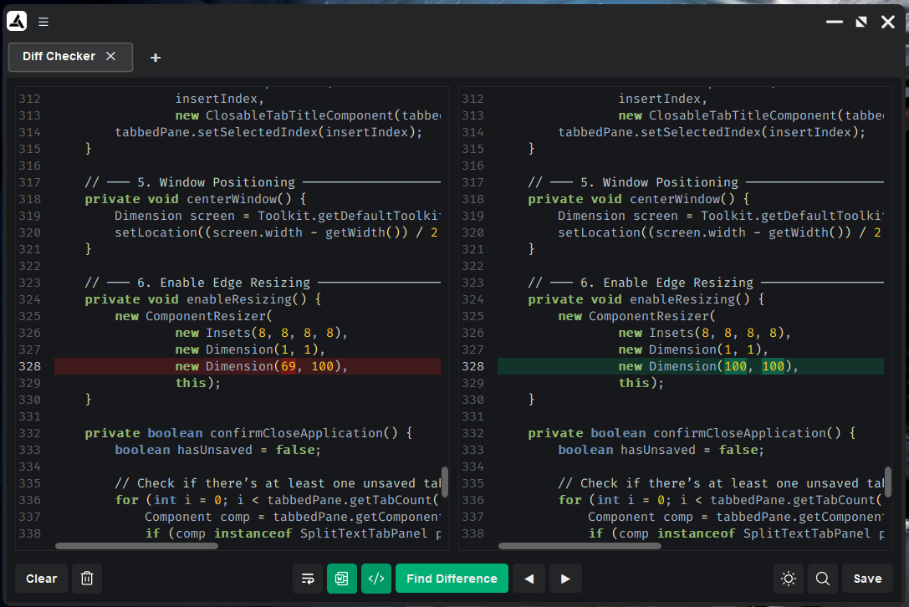

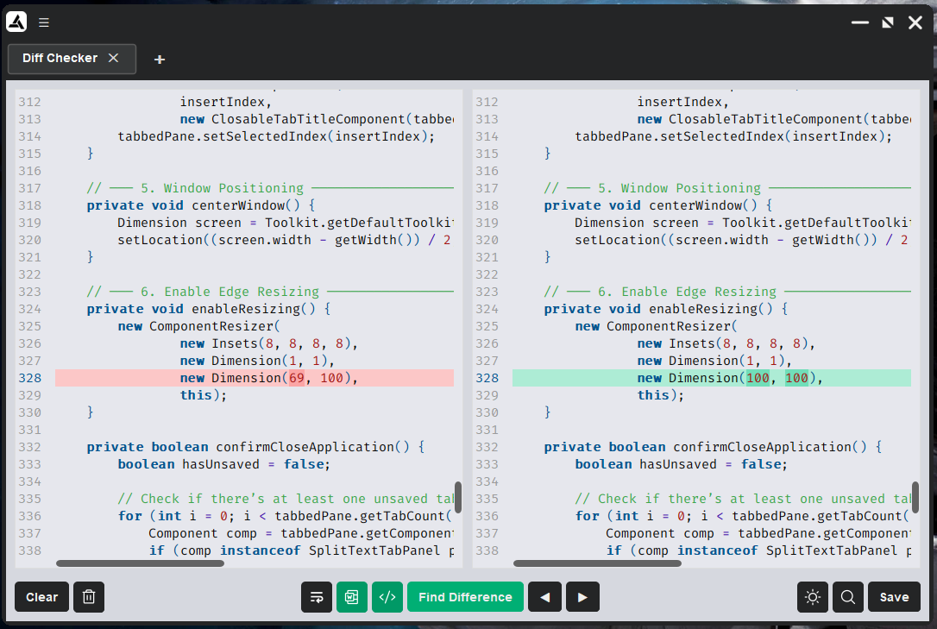

Instructions on how to use:

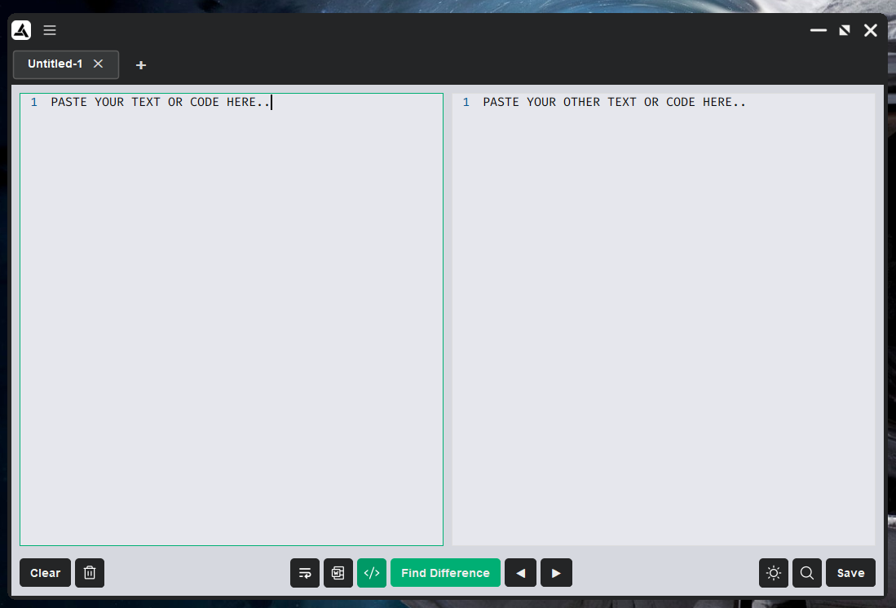
Figure 1 To start, paste your two differing texts individually on each text editors / code editors

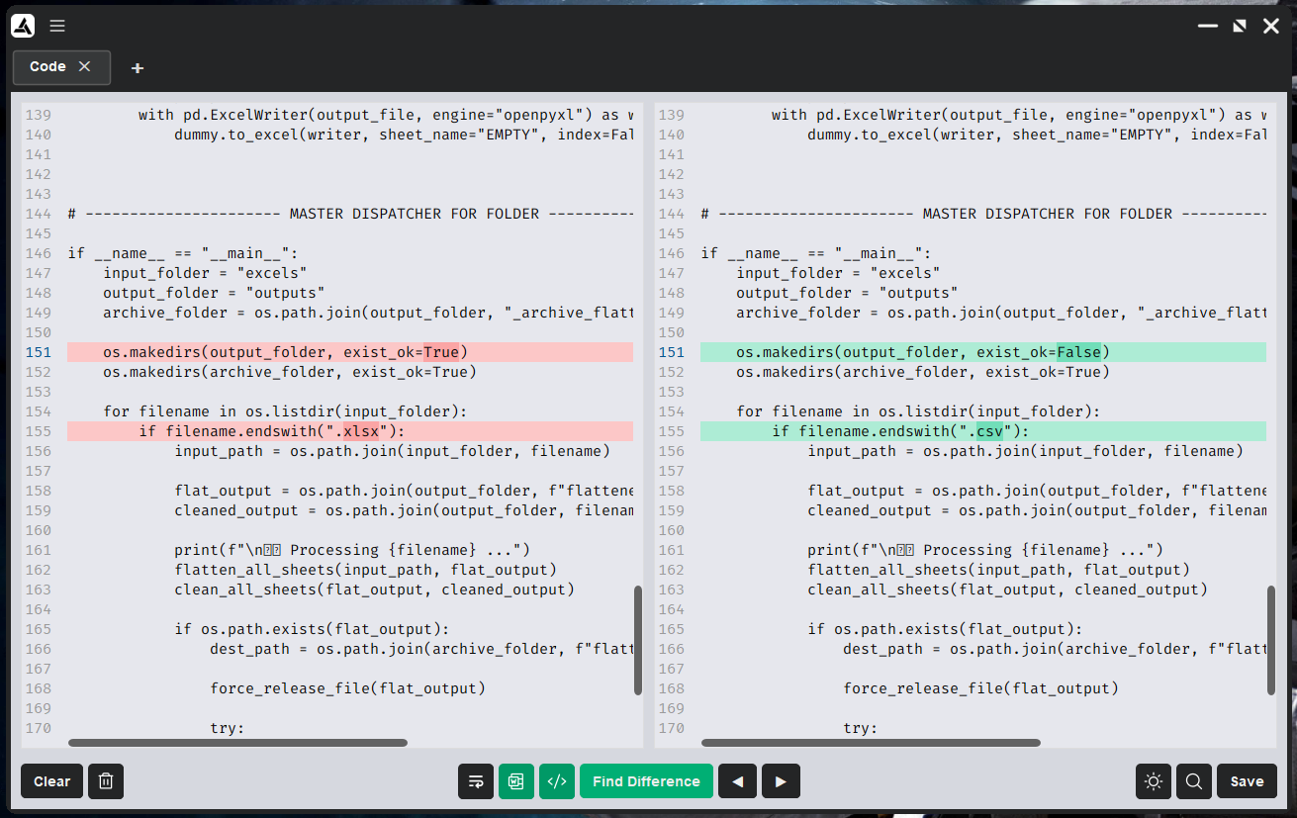
Figure 2 After pasting your two differing texts into the text editors, click the “Find Difference” button to highlight texts that are different from each other. You can also cycle through the next or previous other differences using the “Arrow” buttons

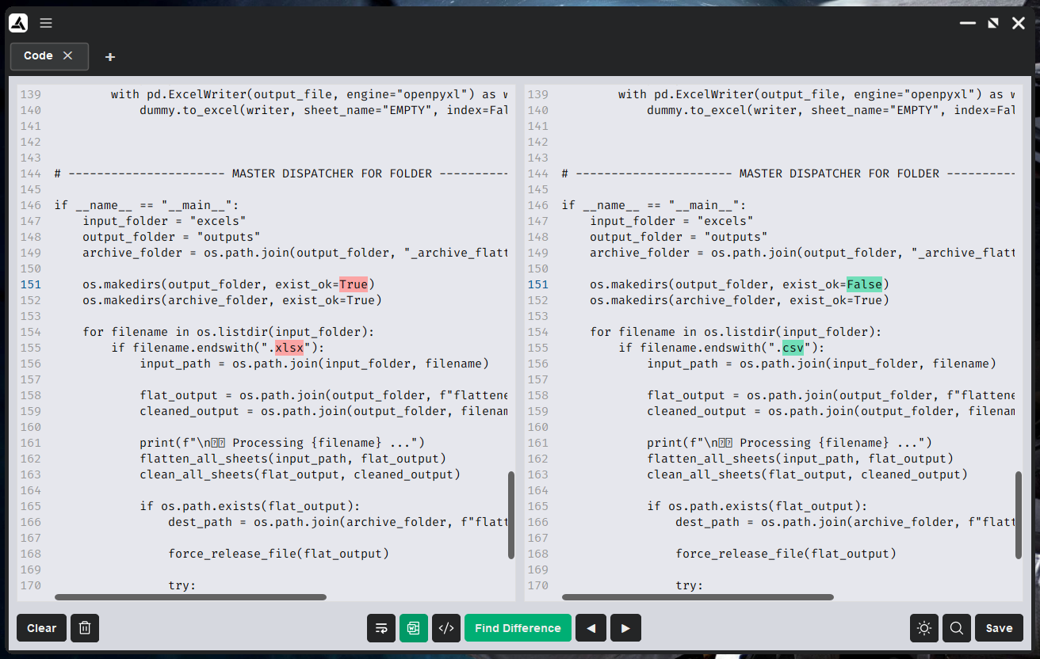
Figure 3 To easily see which words are different you can toggle off the line highlight by pressing the Toggle line highlight button denoted by these characters "</>"
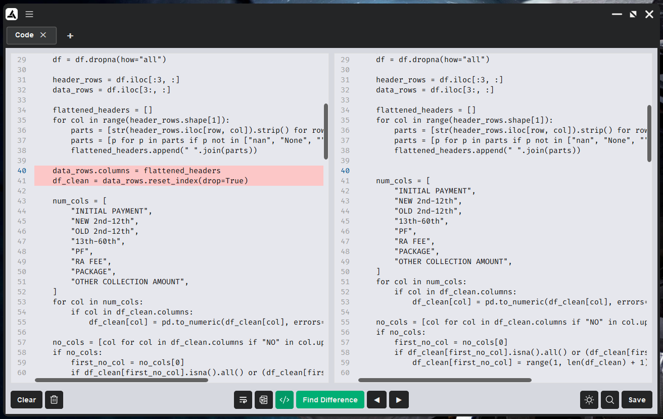
Figure 4 In some cases there are texts or codes that are completely absent from original text that you have pasted. You can easily spot those by toggling Line Highlight on.

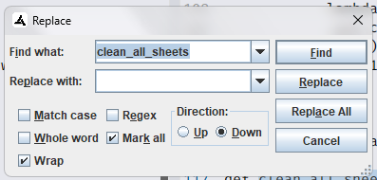
Figure 5 Sometimes, there are cases wherein you would need to find and replace some texts. You can easily do that by pressing the Magnifying glass button or by hitting Ctrl + F on your keyboard.

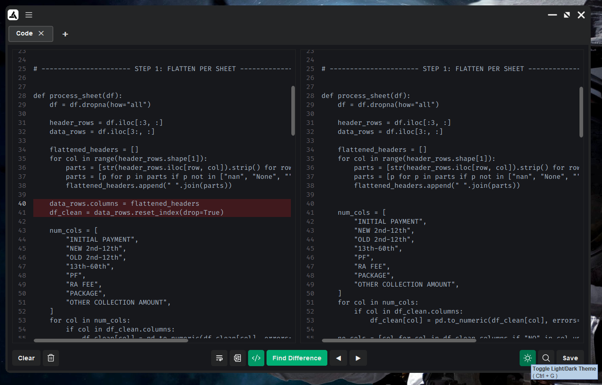
Figure 6 Sometimes, there are also cases wherein you want to not strain your eyes especially on long hours of coding. You can turn on Dark mode hitting Ctrl + G or clicking the sun button.
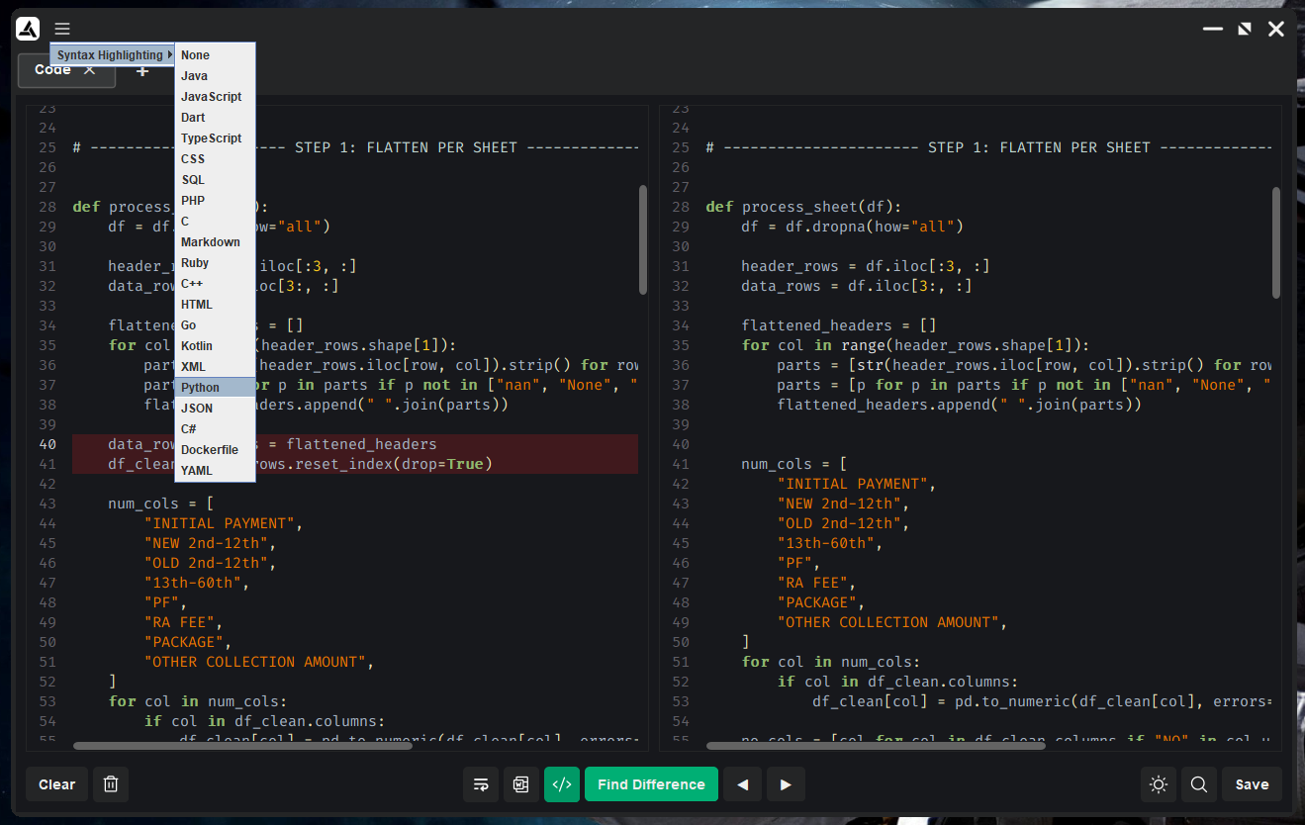
Figure 7 You can also turn on the Code Editor feature by turning on the Syntax highlighting via menu button up top on the title bar.

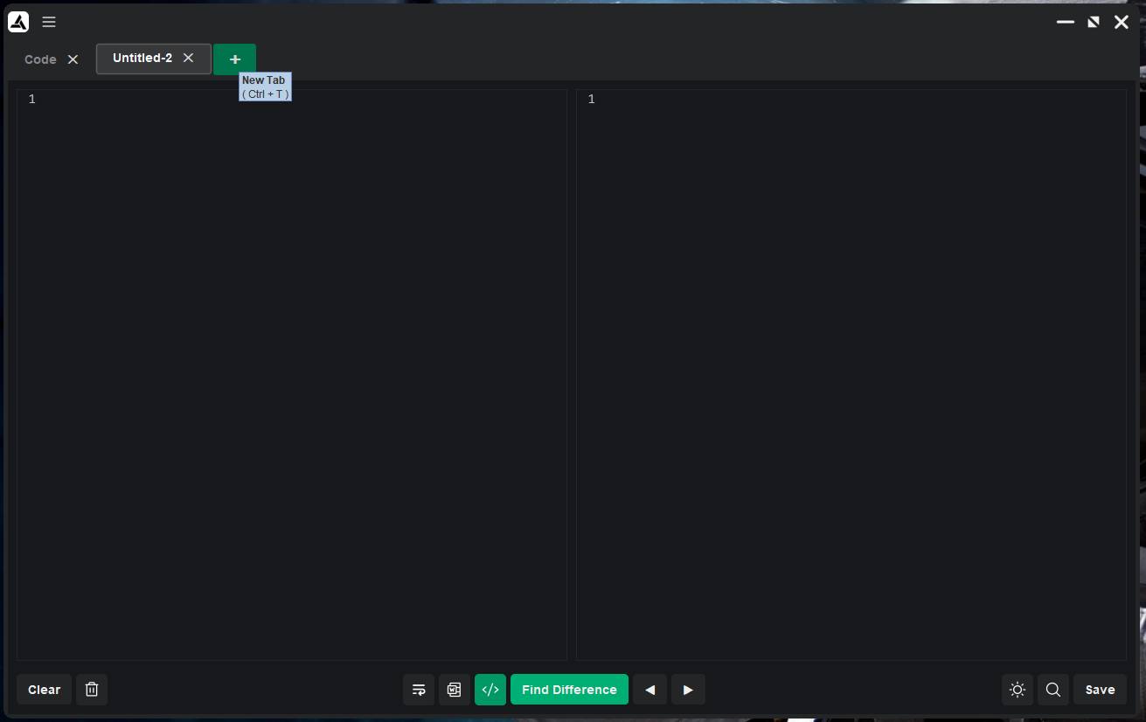
Figure 8 You can open a “New Tab” by pressing Ctrl + T or by click the Add New Tab “+” button
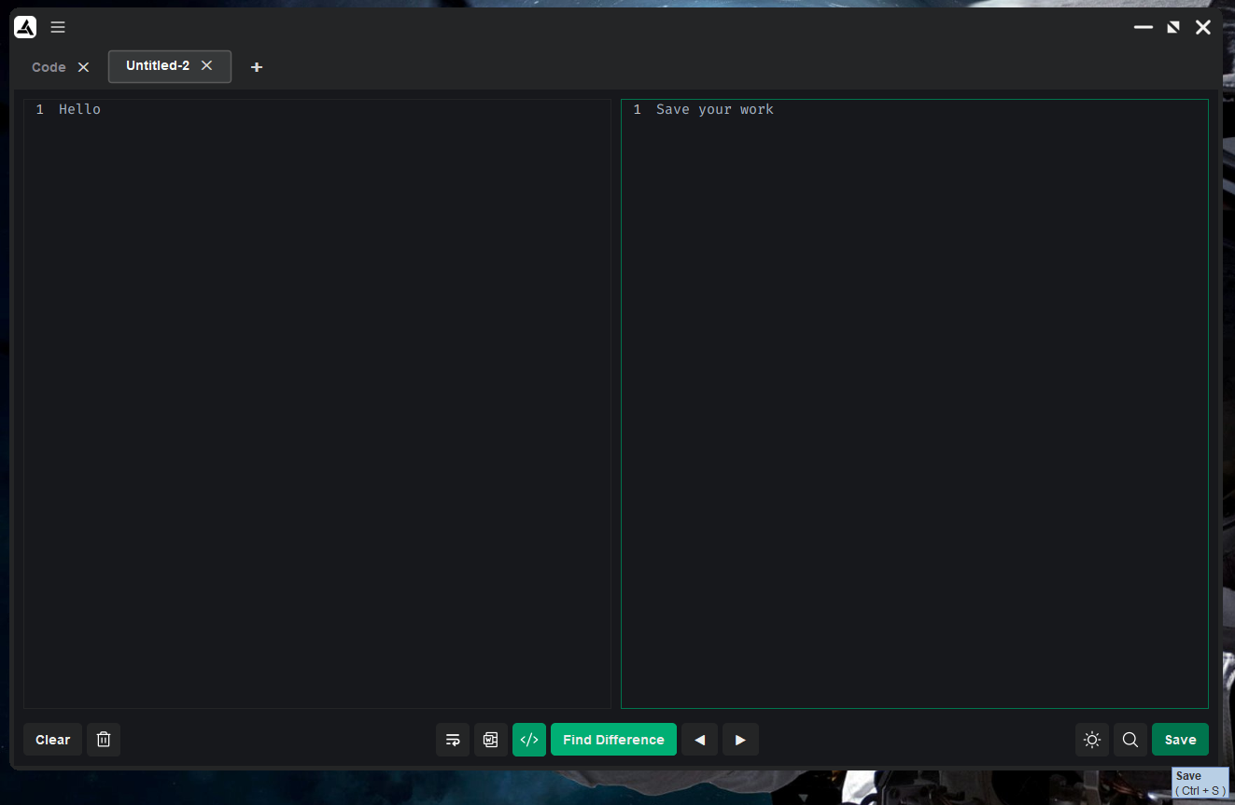
Figure 9 You can save your work into the SQLite database by either clicking the Save button or pressing Ctrl + S

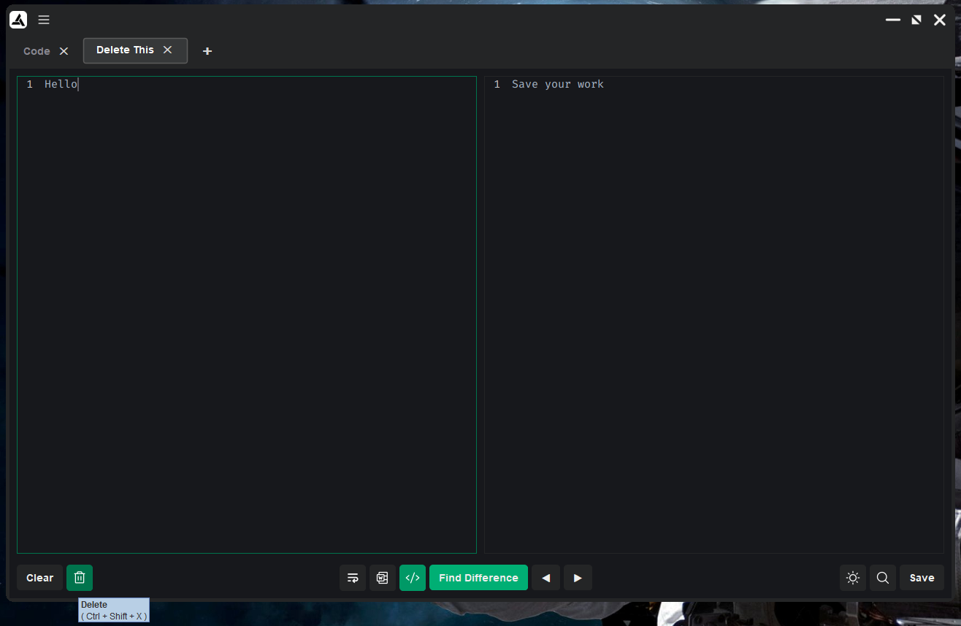
Figure 10 You can delete your work by pressing Ctrl + Shift + X or clicking the trash icon

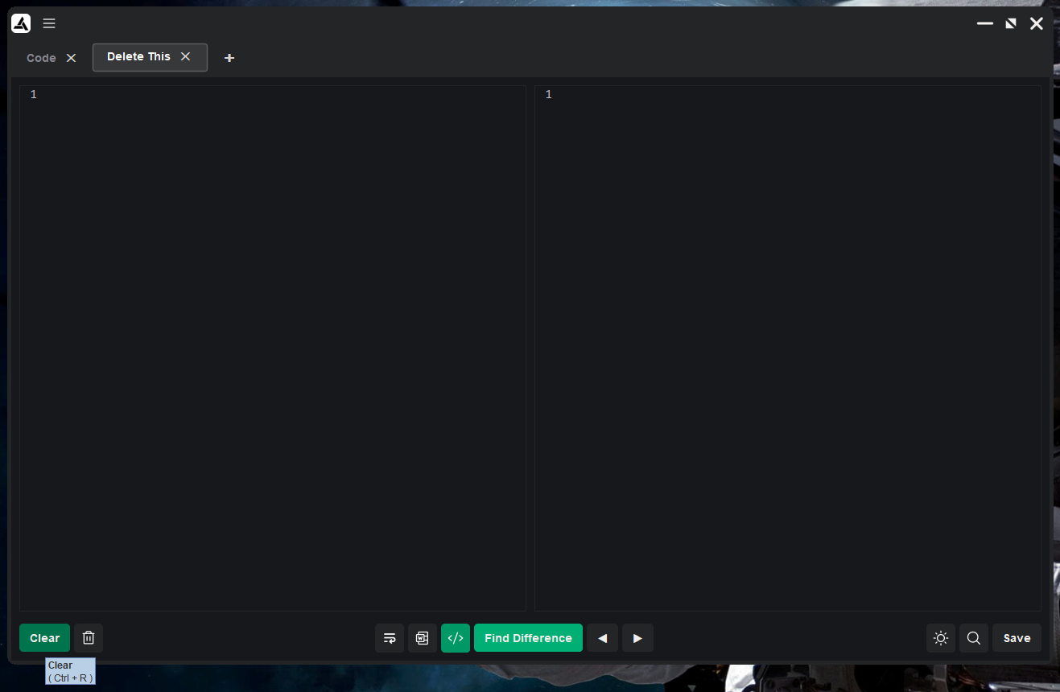
Figure 11 Finally, to clear everything on both of the editors at the same time you can press Ctrl + R or hit the Clear button

Keyboard Shortcuts

- Alt + Shift + Enter: Find difference between two texts
- Alt + E: Toggle line highlight
- Alt + W: Toggle word highlight
- Alt + Q: Toggle wrap
- Ctrl + G: Toggle light theme/dark theme
- Ctrl + S: Save
- Ctrl + F: Find/Replace
- Ctrl + Shift + X: Delete tab from database
- Ctrl + R: Clear texts from both Text Editors
- Ctrl + W: Close current tab

Sample Tooltips

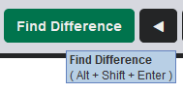

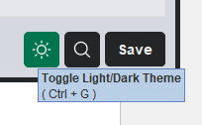

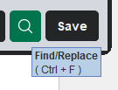

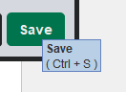

Download latest installer here:
https://github.com/rising-dancho/diffchecker_sqlite/releases

Installation instructions
- about the "Run anyway" screen, in order for me to remove that warning for this desktop app i would need to pay a trusted Certificate Authority for a "Code Signing Certificate" (around $70 – $500 PER YEAR) from Sectigo (Comodo), GoDaddy, SSL.com etc. in order for Windows to not flag me as an "Unknown Publisher."
- this is a free tool

Download the installer
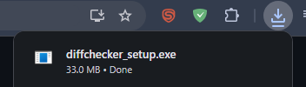
Click "More Info" > "Run anyway"
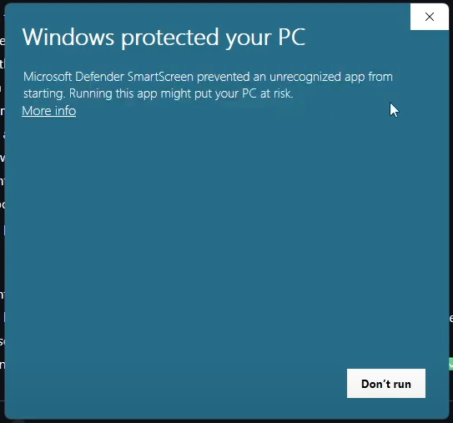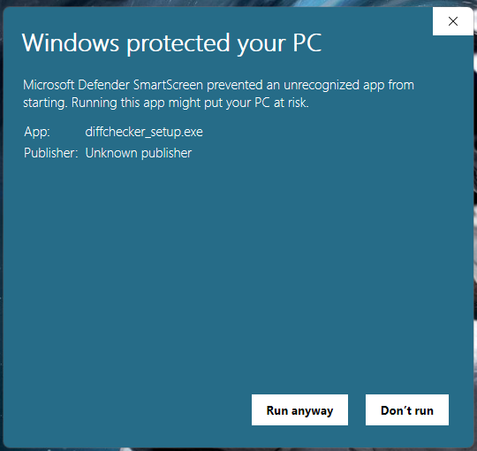
After that just proceed to your normal installation, hit "Next" until you see the "Finish" button
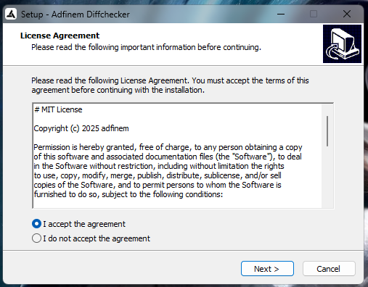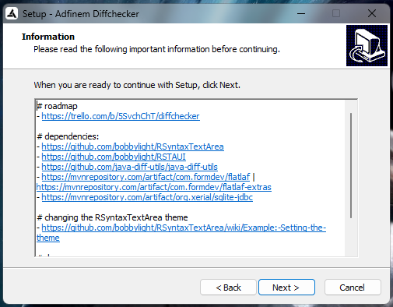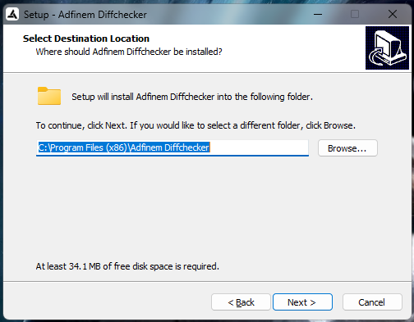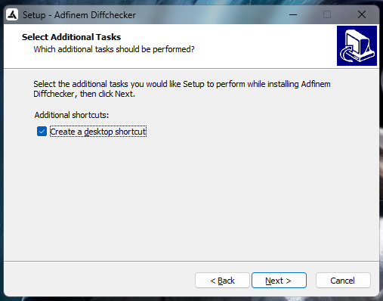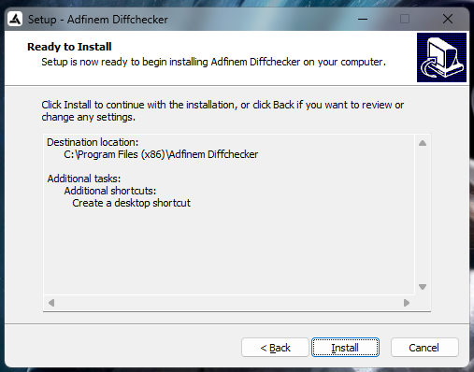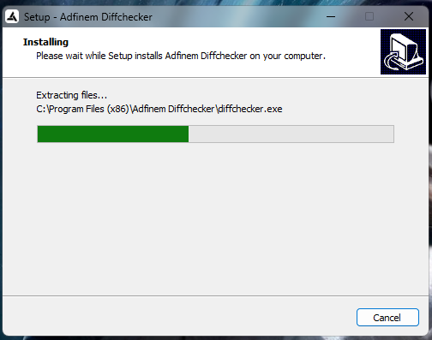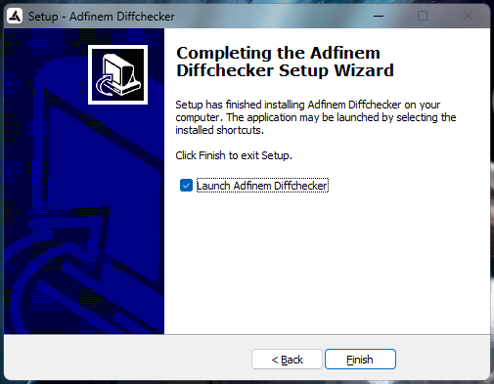

Download version 1.0 release:
https://github.com/rising-dancho/diffchecker_sqlite/releases/download/v1.0.0/diffchecker_setup.exe

Video Demo:
https://www.youtube.com/watch?v=f4yTybuBwkg

MEMBER’S SUMMARY OF A-SSIGNED TASK
Name (LN, FN, MI) | Picture: | Detailed Contributions/Assigned Tasks:
Member Name:  Perez Jr., Jose, A. |  | - Planning of interface and features  - Research on what algorithm to use for difference checking between two texts  - Project design and features implementation  - Documentation

REFERENCES

On real-world usage of Git diff and merge tools
Spinellis, D. (2021). Modern practices in version-controlled text comparison. IEEE Software, 38(2), 45–51.
https://doi.org/10.1109/MS.2020.3045813

On visual comparison tools and developer workflows
Han, S., Zhang, L., & Wang, X. (2021). A study on the effectiveness of visual differencing tools in code review. Journal of Software Engineering and Applications, 14(3), 125–138.
https://doi.org/10.4236/jsea.2021.143008

On text comparison for documents and collaboration
Kato, Y., & Oda, T. (2020). Improving document revision accuracy using automated diff tools. International Journal of Advanced Computer Science and Applications, 11(9), 586–593.
https://thesai.org/Downloads/Volume11No9/Paper_77-Improving_Document_Revision_Accuracy.pdf

On practical applications of online diff utilities
Diffchecker. (2024). About Diffchecker – Online text comparison tool.
https://www.diffchecker.com

On modern diff algorithms and optimization
Kim, H., & Lee, D. (2023). Optimizing line-based differencing for large-scale codebases. ACM Transactions on Software Engineering and Methodology, 32(4), 1–25.
https://doi.org/10.1145/3591234

On real-world usage of Git diff and merge tools
Spinellis, D. (2021). Modern practices in version-controlled text comparison. IEEE Software, 38(2), 45–51.
https://doi.org/10.1109/MS.2020.3045813

On version control, collaboration, and diff usage
Loeliger, J., & McCullough, M. (2022). Version control with Git (3rd ed.). O’Reilly Media.
https://www.oreilly.com/library/view/version-control-with/9781492091179/

