SOFTWARE EXAM v.6 [NODE JS]
Applicant: Jose A. Perez Jr.
WEBCAST TECHNOLOGIES, INC
Applying to the position of BACKEND DEVELOPER

- Make a Flowchart for the code/function below
let totalTxt = 0;
const mysql = require("mysql");
var connection = mysql.createConnection({
host : 'localhost',
user : 'dbuser',
password : 'secret',
database : 'my_db'
});

connection.connect();
let validateSender = "not allowed";

const rs = connection.query(`SELECT * FROM smscontacts WHERE msisdn = ${Number}`,
function (error, results, fields) {
if (error) throw error;
return results;
}
);

if(rs.length){
rs.forEach(row => {
if(row.group !== ""){
if(row.grouping.trim() === row.group){
if(row.txtallowed !== 256){
totalTxt = row.txtused + 1;
connection.query(`UPDATE smscontacts SET txtused = ${totalTxt} WHERE _msisdn = ${Number}`);
}
if(row.txtallowed <= row.txtused){
validateSender = "0";
} else {
validateSender = row.txtallowed - (row.txtused + 1);
}
} else {
validateSender = "unlimited";
}
} else if (row.grouping.trim().toUpperCase() === 'ADMIN'){
validateSender = "unlimited";
} else if (row.group.trim().toUpperCase() === 'ADMIN'){
validateSender = "unlimited";
}
sender = row.contact.trim();
});
}
connection.end();

ANSWER:
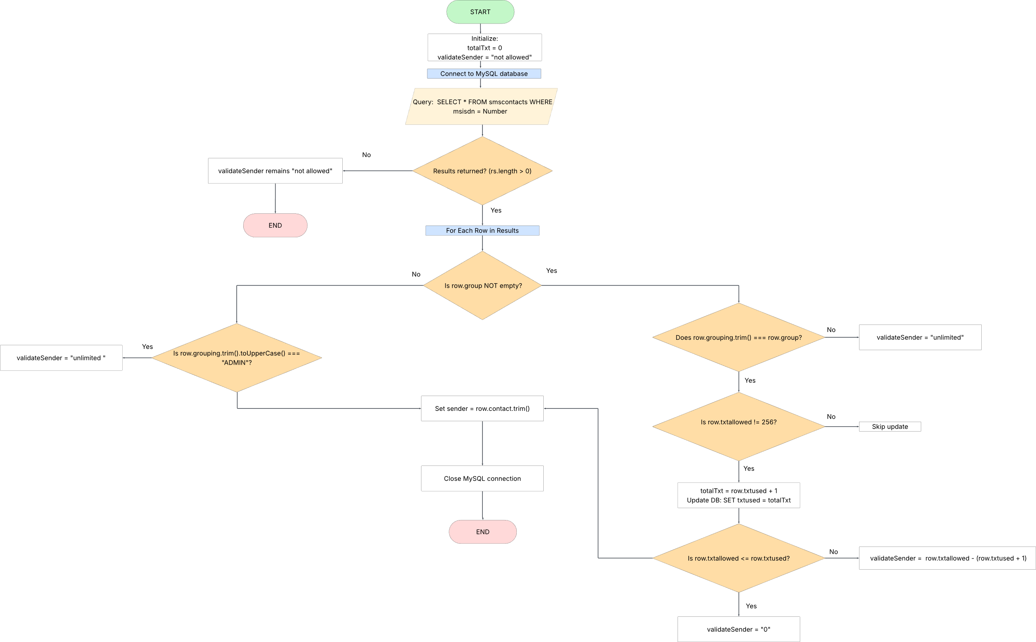
diagram link
- ES5 to ES6. Write ff. ES5 to ES6 standard
QUESTION a:
- function greet(name) {
return ‘hello’ + name;
}
ANSWER:
const greet = (name) => {
return `hello ${name}`;
};
QUESTION b:
- var obj1 = {a:1, b:2, c:3, d:4}
var a = obj1.a
var b = obj1.b
var c = obj1.c
var d = obj1.d
ANSWER:
const obj1 = {a: 1, b: 2, c: 3, d: 4};
const {a, b, c, d} = obj1;
QUESTION c:
- function isLesser (a, b, callback) {
var lesser = false
if (a < b) {
lesser = true
}
callback(lesser)
}
ANSWER:
const isLesser = (a, b, callback) => {
let lesser = false;
if (a < b) {
lesser = true;
}
callback(lesser);
};
QUESTION d:
- function isLesser(a, b, callback) {
var lesser = false;
if (a < b) {
lesser = true
}
callback(lesser)
}
ANSWER:
const isLesser = (a, b, callback) => {
let lesser = false;
if (a < b) {
lesser = true;
}
callback(lesser);
}
- Write a nodeJS function that has the following rules.
- Function name is addToList
- It accepts a parameter in Array type. Parameter name is newList
- It has a global variable named globalList of type Array
- The function will add the items from the newList to globalList if the item is not yet existing in the globalList
ANSWER:
// declare variable
let globalList = [];

function addToList(newList) {
if (!Array.isArray(newList)) {
throw new Error("Parameter must be an array");
}

newList.forEach(item => {
if (!globalList.includes(item)) {
globalList.push(item);
}
});
}
// call function
addToList([1, 2, 3]);
console.log(globalList);
OUTPUT:
$ node exam3.js
[1, 2, 3]

- Write a nodeJS script that has the following rules
- Has a global variable
- ADD – value is either true or false
- MULTIPLY – value is either true or false
- Has a function named compute
- This function is an asynchronous
- This function accepts an array of numbers
- If the global variable ADD is true, this function will call another function named addNumbers
- If the global variable MULTIPLY is true, this function will call another function named multiplyNumbers
- The multiplyNumbers function will only be called after the addNumbers process is done
- Has a function named addNumbers
- This function accepts an array of numbers
- It will log on the screen the sum of the numbers on the array list
- Has a function named multiplyNumbers
- This function accepts an array of numbers
- It will log on the screen the product of the numbers on the array list
ANSWER:
const ADD = true;
const MULTIPLY = true;

// compute function
async function compute(numbers) {
if (ADD) {
await addNumbers(numbers);
}

if (MULTIPLY) {
await multiplyNumbers(numbers);
}
}

// addNumbers function
function addNumbers(numbers) {
return new Promise((resolve) => {
const sum = numbers.reduce((acc, num) => acc + num, 0);
console.log("Sum:", sum);
resolve();
});
}

// multiplyNumbers function
function multiplyNumbers(numbers) {
return new Promise((resolve) => {
const product = numbers.reduce((acc, num) => acc * num, 1);
console.log("Product:", product);
resolve();
});
}

// call async function
compute([1, 2, 3, 4]);

OUTPUT:
$ node exam4.js
Sum: 10
Product: 24

