Analysis for Prefix Sum Code:

Number of threads – 32

Number of blocks – 1

Global Memory

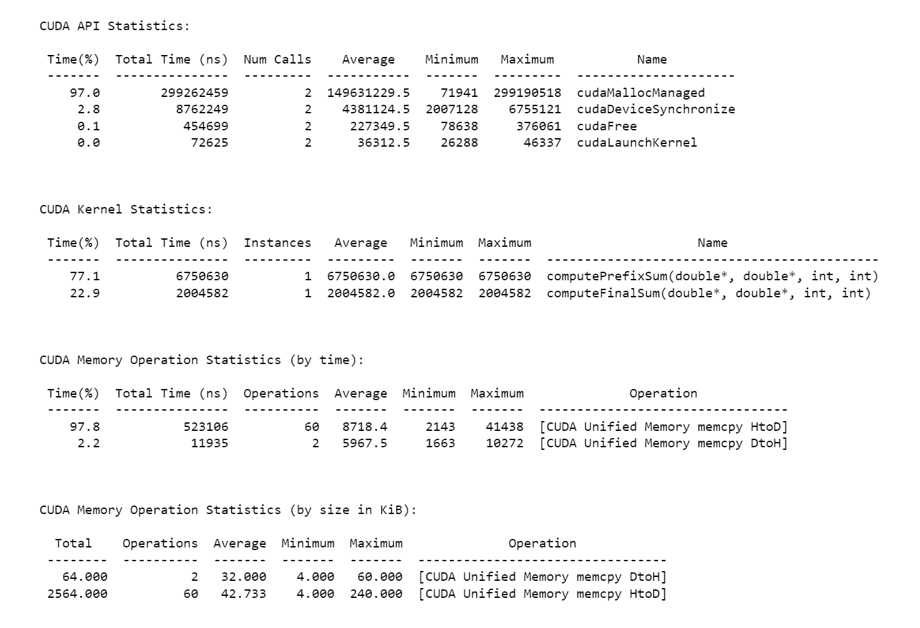

Time Taken: 8755212 ns

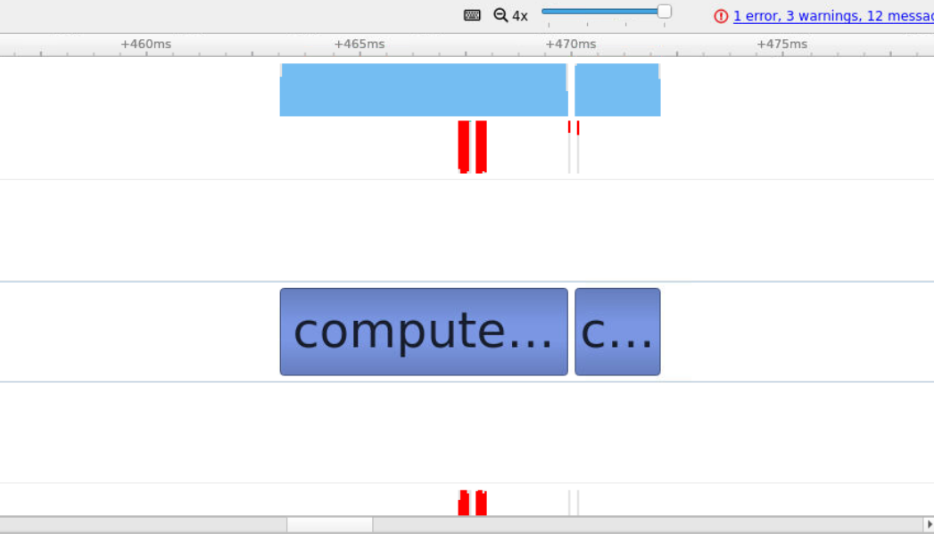

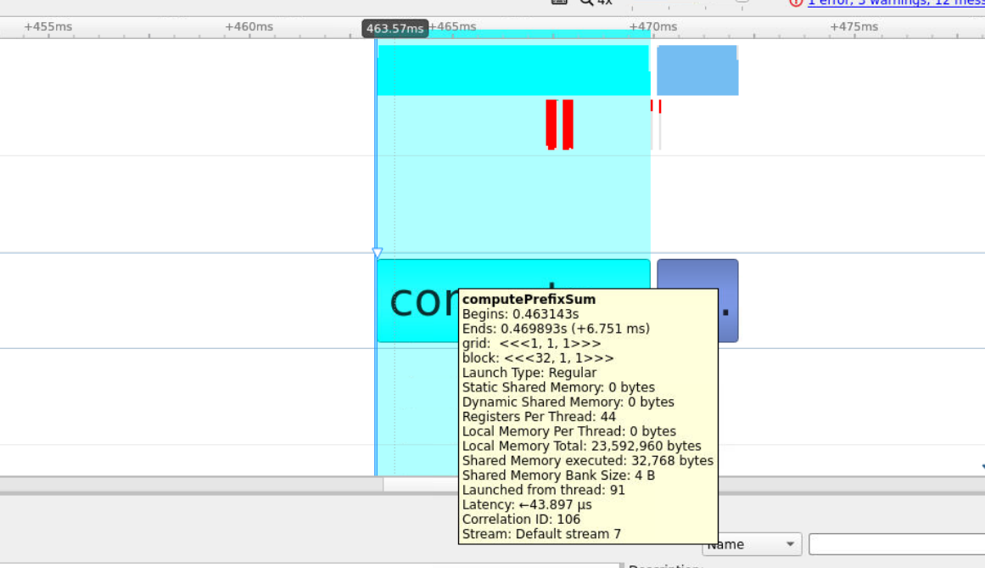

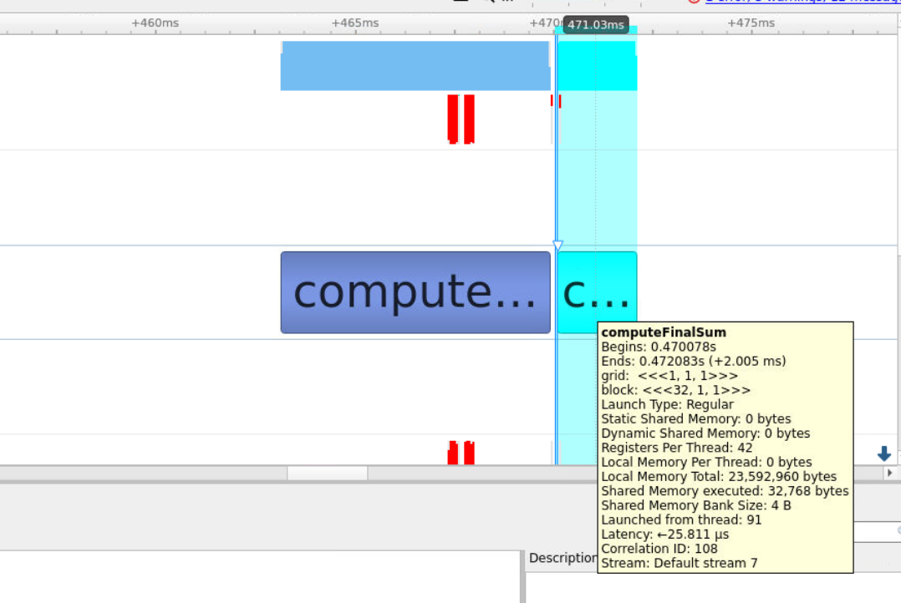

Shared Memory:

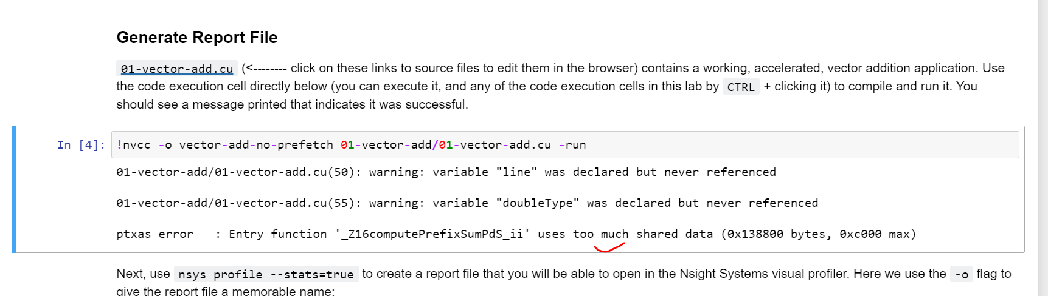

Won’t be able to use Shared Memory as it exceeds the GPU block memory

Now, let’s analyze with other combos of threads

We can check my taking any multiples of 32 or any even factors like – 2, 4, 8, 16

Number of threads – 16

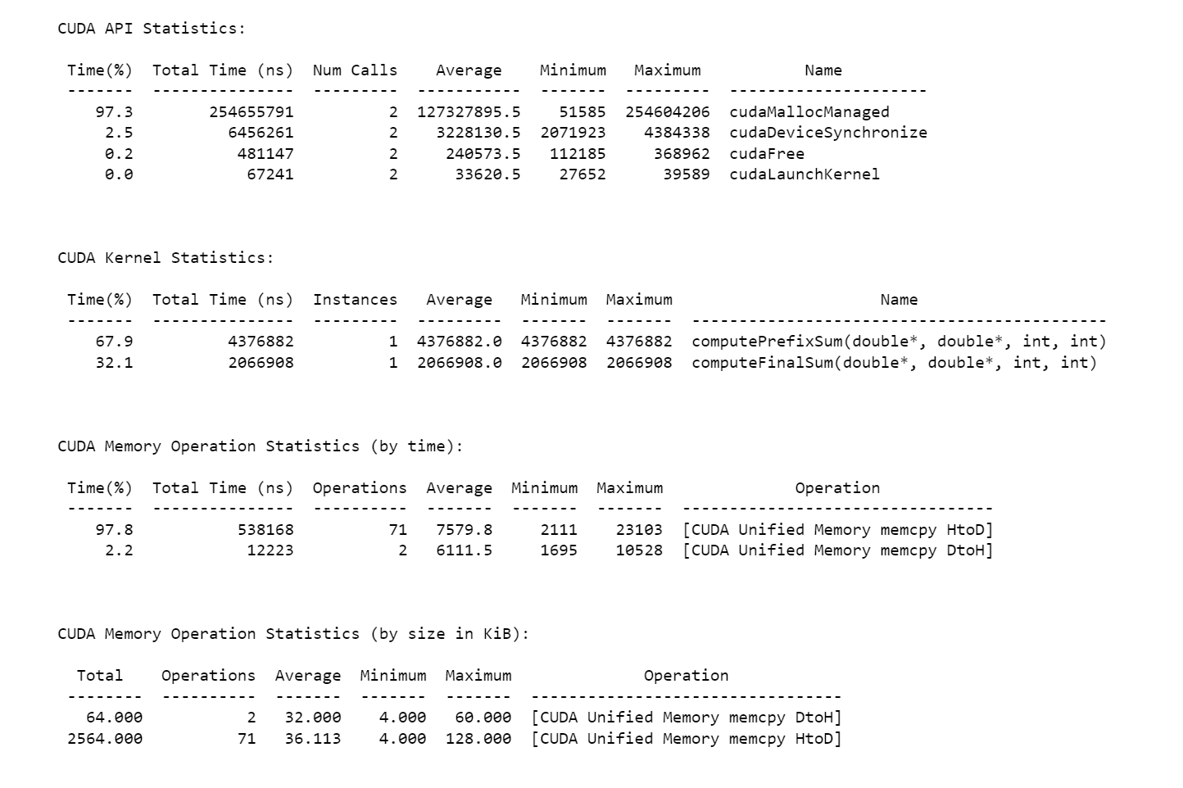

Time Taken: 6443790 ns

Number of Threads – 128

