

**Group Assignment of MAT-111**

**Submitted By:**

|  |  |
| --- | --- |
| **Name** | **ID** |
| MD. MEHEDI HASAN | 2102016 |
| DURJOY DAS | 2102017 |
| JANNATUL MIM | 2102018 |
| HRIDOY CHANDRA SARKER | 2102019 |
| MD. SADMAN KABIR BHUIYAN | 2102020 |

**Submitted to:**

|  |
| --- |
| MUHAMMAD MASUDUR RAHMAN  Associate Professor of Mathematics Department  Faculty of Computer Science And Engineering |

Successive Differentiation is the process of differentiating a given function successively times and the results of such differentiation are called successive derivatives. The higher order differential coefficients are of utmost importance in scientific and engineering applications.

Let f(x) be a differentiable function and let its successive derivative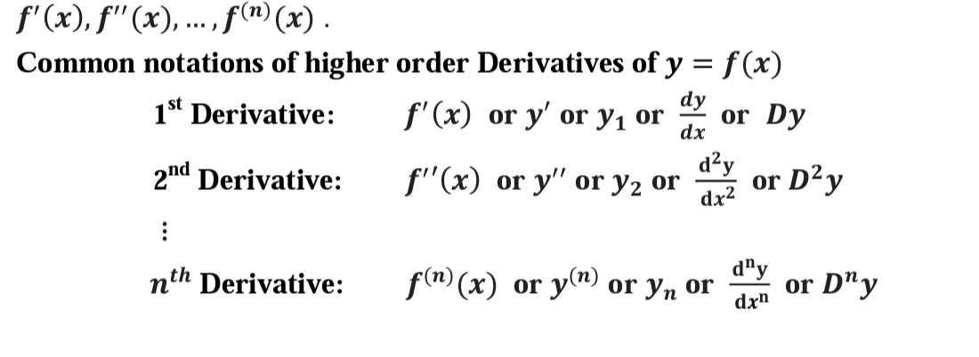

**Example 01.**

**If y=sin{2ln(x+3)}**

**Then solve (x + 3)2yn+2 +(2n+1)(x+3)yn+1 +(n2 +4)yn =0**

**Answer:**

(x+3)2 yn+2 + nc1. 2(x+3)yn+1 + nc₂ 2(1+0)yn+(x+3)yn+1 +

nc1(1+0)yn+ 4y = 0

Or. (x + 3)2 yn+2 +2n(x+3)yn+1 +(n(n-1)/2!)2yn+(x+3)y2+1+nyn

+ 4yn = 0

Or.(x +3)² yn+2 + (2n + 1)(x+3)yn+1 + (n²-n+n+4)yn= 0

Or. (x +3)² yn+2 + (2n + 1)(x+3)yn+1 +4yn=0 (solved)

**Example 02.**

**If y=cos{aln(x+b)}**

**Then solve (x + b)2 yn+2 +(2n+1)(x+b)yn+1 +(n2+a2 )yn =0**

**Answer:**

(x + b)2 yn+2 +nc1 . 2(x+b)yn+1 + nc2 . 2(1+0)yn+ (x + b) yn+1 + nC1(1+0)yn +a2 yn =0

Or.(x + b)2 yn+2 +2n(x+b)yn+1 + (n(n-1) /2!) 2yn +(x+b)yn+1 +

Nyn+a2yn=0

Or. (x + b)2 yn+2 +(2n+1)(x+b)yn+1 +(n2 -n+n+a2 )yn =0

Or. (x + b)2 yn+2 +(2n+1)(x+b)yn+1 +(n2+a2 )yn =0

**Example-03:**

**If y= $e^{\tan^{-1}x}$ then**

**i. $\left(1+x^{2}\right)y_{2}+\left(2x-1\right)y_{1}=0$**

**ii.(1+ $x^{2}) y_{n+2}+\left\{2\left(n+1\right)x-1\right\}y_{n+1}+n\left(n+1\right)y_{n}=0$**

**Solution:**

$$y=e^{\tan^{-1}x}$$

=> $logy=\tan^{-1}x$

=> $\frac{1}{y}y_{1}=\frac{1}{1+x^{2}}$

=> $\left(1+x^{2}\right)y_{1}=y$

=> $\left(1+x^{2}\right)y_{2}+2xy_{1}=y_{1}$

=> ($y_{2}\left(1+x^{2}\right)+y_{1}\left(2x-1\right)=0$

By Leibnitz’s theorem,

ii.

$$\left(1+x^{2}\right)y_{n+2}+nc_{1}y_{n+1}2x+nc_{2}y_{n}2+\left(2x-1\right)y_{n+1}+nc_{1}y_{n}2=0$$

=> $\left(1+x^{2}\right)y_{n+2}+ny_{n+1}2x+\frac{n\left(n-1\right)}{2}y_{n}2+\left(2x-1\right)y_{n+1}+ ny_{n}2=0$

=> $\left(1+x^{2}\right)y_{n+2}+\left(2xn+2x-1\right)y_{n+1}+\left(n^{2}-n+2n\right)y_{n}=0$

=> $(1+x^{2}) y_{n+2}+\left\{2\left(n+1\right)x-1\right\}y_{n+1}+n\left(n+1\right)y_{n}=0$

**Example-04:**

**If $y=\sin\left(m\sin^{-1}x\right) then$**

**i. $\left(1-x^{2}\right)y_{n+2}-\left(2n+1\right)xy_{n+1}+\left(m^{2}-n^{2}\right)y_{n}=0$**

**Solution: $y=\sin\left(m\sin^{-1}x\right)$**

$y_{1}=\cos\left(m\sin^{-1}x\right)\frac{m}{\sqrt{1-x^{2}}}$

$y_{1}\left(\sqrt{1-x^{2}}\right)=mcos\left(m\sin^{-1}x\right)$

$y_{2}\left(\sqrt{1-x^{2}}\right)+y_{1}\frac{-2x}{2\sqrt{1-x^{2}}}=-msin\left(m\sin^{-1}x\right)\frac{m}{\sqrt{1-x^{2}}}$

$\left(1-x^{2}\right)y_{2}-xy_{1}=-m^{2}y$

$\left(1-x^{2}\right)y_{2}-xy_{1}+m^{2}y=0$

By Leibnitz’s Theorem,

($1-x^{2})y_{n+2}+nc_{1}(-2x)y_{n+1}+nc_{2}(-2)y_{n}-(xy_{n+1}+nc_{1}y_{n})+m^{2}y_{n }=0$

$\left(1-x^{2}\right)y_{n+2}-2nxy_{n+1}-\frac{n\left(n-1\right)}{2!}2y_{n}-xy_{n+1}-ny_{n}+m^{2}y_{n}=0$

$\left(1-x^{2}\right)y_{n+2}-\left(2n+1\right)xy_{n+1}-\left(n^{2}-n+n-m^{2}\right)y_{n}=0$

$\left(1-x^{2}\right)y_{n+2}-\left(2n+1\right)xy_{n+1}+\left(m^{2}-n^{2}\right)y_{n}=0$

**Example 05**:

**If y= sin{2ln(x + 3)} then**

**i. (x + 3) 2 y2 + (x + 3) y1 + 4y = 0**

**ii.(x + 3)2yn+2 +(2n+1)(x+3)yn+1 +(n2 -n+n+4)yn =0**

**Solution:** (i)

y= sin{2ln(x + 3)}…..(1)

* y[1]= cos {2ln(x + 9)}
* (x + 3)y1 = 2cos{2ln(x + 3)}
* ( x+3) y2+(1+0 )y1= - 2sin{2ln(x + 3)}
* (x + 3)2 y2 +(x+3)y1= -4y ….from (1)
* (x + 3) 2 y2 + (x + 3) y1 + 4y = 0

**(ii) By Leibnitz’s Theorem**,

* (x + 3)2yn+2 +nC1.2(x+3)yn+1 +nC22(1+0)yn

+ (x + 3) yn+1 +nC1(1+0)yn +4yn=0

* (x + 3)2 yn+2 +2n(x+3)yn+1 + 2yn +(x+3)yn+1

+ nyn+ 4yn = 0

* (x + 3)2yn+2 +(2n+1)(x+3)yn+1 +(n2 -n+n+4)yn =

**Example 06:**

**If y=cos{aln( x + b )} then**

**i. (x + b)2 y2 + (x + b)y1 + a2y = 0**

**ii. (x + b)2 yn+2 +(2n+1)(x+b) yn+1 +(n2-n+n+a2 )yn=0**

**Answer: (i)**

y=cos{aln( x + b )}

y1 =-sin{aln(x+b)}

(x + b)y1= - asin[aln(x + b)]

(x+b)y2 + (1+0)y₁ = acos{(aln(x+b)}

(x + b)2y2 + (x + b)y1= -a2y

(x + b)2 y2 + (x + b)y1 + a2y = 0

(**ii) By Leibnitz’s Theorem**,

(x + b)2 yn+2 +nc12(x+b)yn+1 +nc2 (1+0)yn

+ (x + b) yn+1 +nc1 (1+0)yn +a2yn =0

(x + b)2 yn+2 + 2n(x+b)yn+1 + 2yn +(x+b)yn+1+nyn+a2yn = 0

(x + b)2 yn+2 +(2n+1)(x+b) yn+1 +(n2-n+n+a2 )yn=0. (solved)

**Example 07.**

**If y=, |x|<1**

**show that (1- $x^{2}$)yn+2 –(2n+3)xyn+1 –(n+1)2yn=0**

**ANSWER:**

by leibnitz’s theorem, we get

yn+2(1-x2)+n.yn+1(-2x)+nc2. yn(-2)-3(yn+1.x+n.yn.1)-yn=0

or, (1- $x^{2}$)yn+2 –x.yn+1(2n+3) -n(n-1)yn-3.n.yn-yn=0

or, (1- $x^{2}$)yn+2 –(2n+3)xyn+1-yn(n2+2n+1)=0

or, (1-)yn+2 –(2n+3)xyn+1 –(n+1)2yn=0 (Solved)

**Example 08.**

**if y=cos(msin-1x)**

**show that (1-)yn+2 –(2n+1)xyn+1+(m2-n2)yn=0**

**ANSWER:**

by leibnitz’s theorem, we get

yn+2(1-x2)+n.yn+1(-2x)+nc2. yn(-2)- x.yn+1- nyn(1)+m2yn=0

or, yn+2(1-x2)-2n. xyn+1-n(n-1)yn- xyn+1-nyn+ m2yn=0

or, (1-)yn+2 –(2n+1)xyn+1+(m2-n2)yn=0 (solved)

**Example 09.**

**If y= $e^{\cos^{-1}{x}}$**

**show that (1- $x^{2}$)yn+2 –(2n+1)xyn+1 –(n2+1)yn=0**

**ANSWER:**

by leibnitz’s theorem, we get

yn+2(1-x2)+n.yn+1(-2x)+nc2. yn(-2)- x.yn+1- nyn(1)-Yn=0

or, yn+2(1-x2)-2n. xyn+1-n(n-1)yn- xyn+1-nyn- yn=0

or, (1- $x^{2}$)yn+2 –(2n+1)xyn+1 –n2yn+ nyn-nyn- yn=0

or, (1-)yn+2 –(2n+1)xyn+1 –(n2+1)yn=0(Solved).

**Example 10.**

**If y=asin-1x +bcos-1x**

**show that (1-)yn+2 –(2n+1)xyn+1 –n2yn=0**

**ANSWER**:

by leibnitz’s theorem, we get

yn+2(1-x2)+n.yn+1(-2x)+nc2. yn(-2)- x.yn+1- nyn(1)=0

or, yn+2(1-x2)-2n. xyn+1-n(n-1)yn- xyn+1-nyn=0

or, (1-)yn+2 –(2n+1)xyn+1 –n2yn+ nyn-nyn=0

or, (1-)yn+2 –(2n+1)xyn+1 –n2yn=0(Solved)

------------The End------------

1.