I have replaced the 2d-2d part of the Hybrid-PnP from 8-points to eigensolver, which is more accurate according to the paper “Direct Optimization of Frame-to-Frame Rotation”. And I have run its code and generated the result shown in the following figure, which is almost similar to Fig. 4 of the paper.

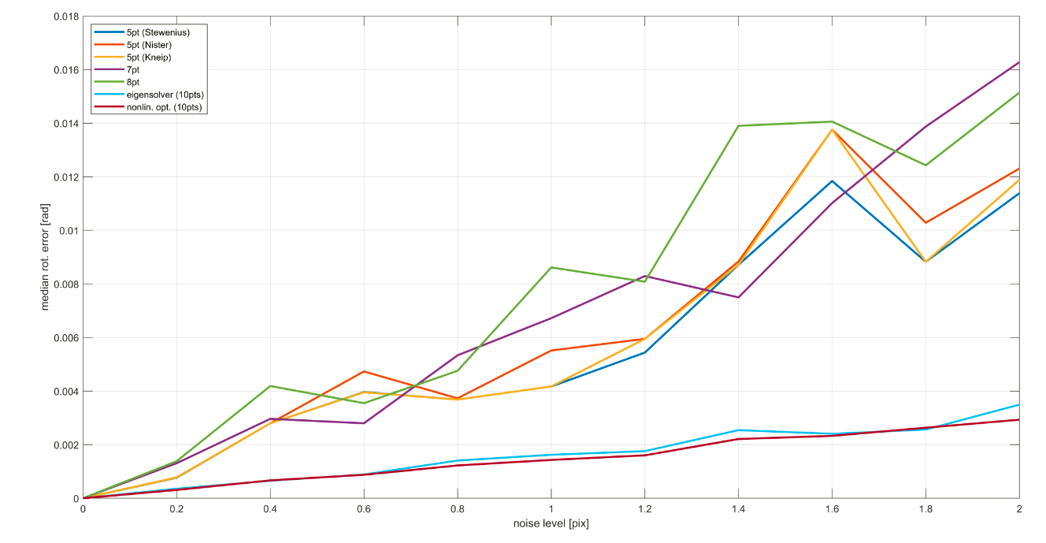

Then, I compare the new Hybrid-PnP (<https://github.com/rising-turtle/pnp_hybrid> ) with EPNP. First, with the same number of matched points (N), but with different image noise ($σ$), and it seems that the larger the image noise is, the worse the Hybrid-PnP is than that of EPnP. It is reasonable since large image noise will result in large rotation error for the 2D-2D part ( eigensolver), however, for small image noise, Hybrid-PnP can outperform EPNP by exploiting more 2D measurements.

The results are shown below, which shows: 1) when N is 30, Hybrid-PnP is better than EPNP if $σ<1.5$; 2) when N is 20, Hybrid-PnP is better than EPNP if $σ<1.$ 2; 3) when N is 20, Hybrid-PnP is better than EPNP if $σ<1.$ 0.

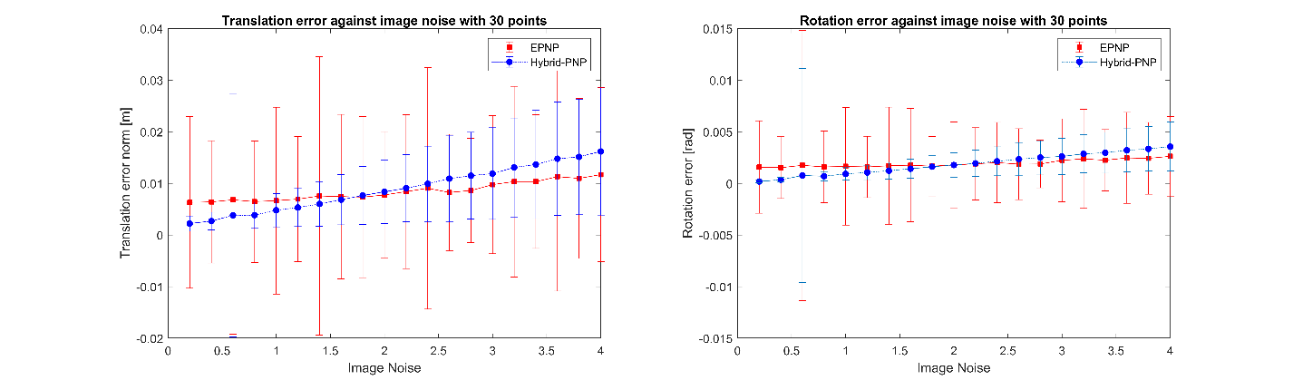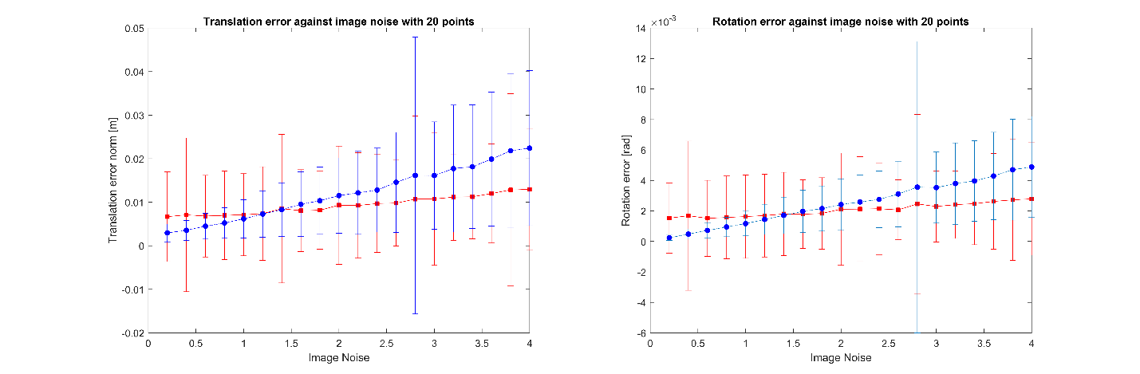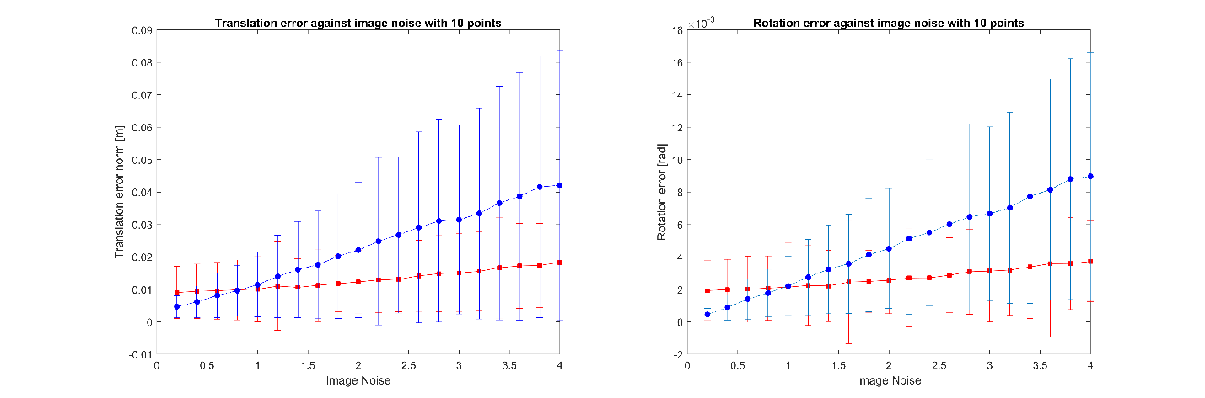

Second, with image noise ($σ$), I compare the accuracy against different number of 3D points (N). The results are shown below, which shows: 1) when $σ=0.5, 1.0, 1.5$, Hybrid-PnP is always better than EPNP 2) when $σ=2.0$, Hybrid-PnP is almost equal to EPNP.

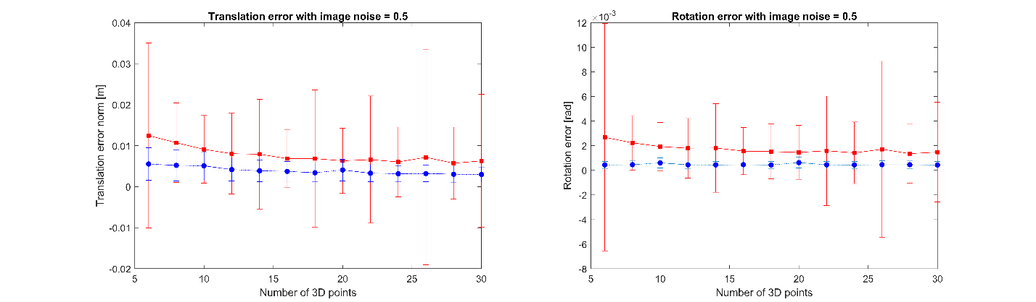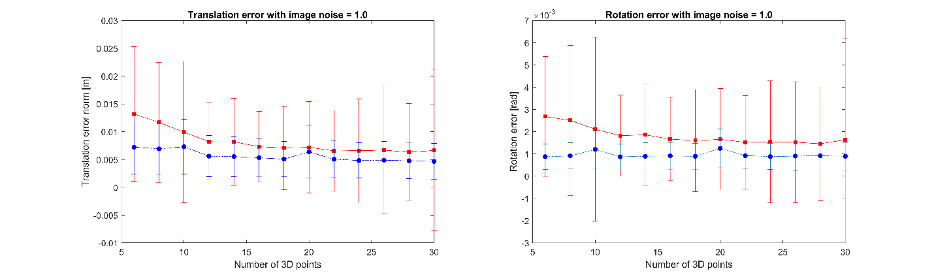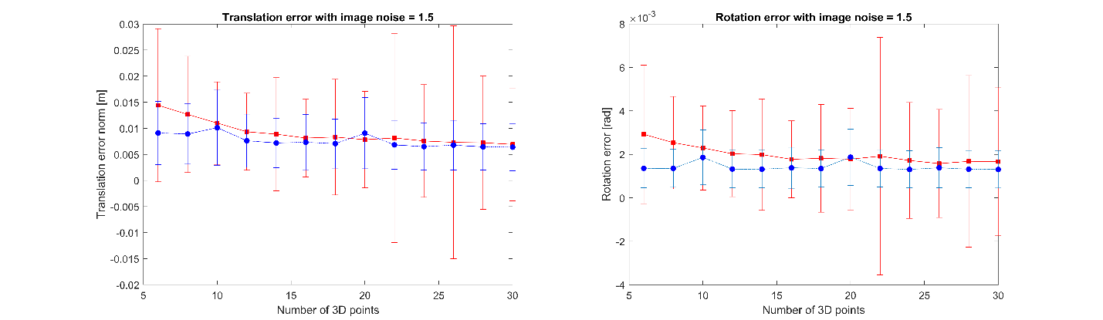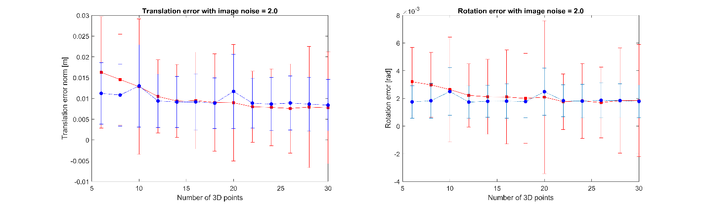

I also run one comparison using the iphone’s data, rot-pitch 3 degree, and the result is almost consistent with the simulation results.

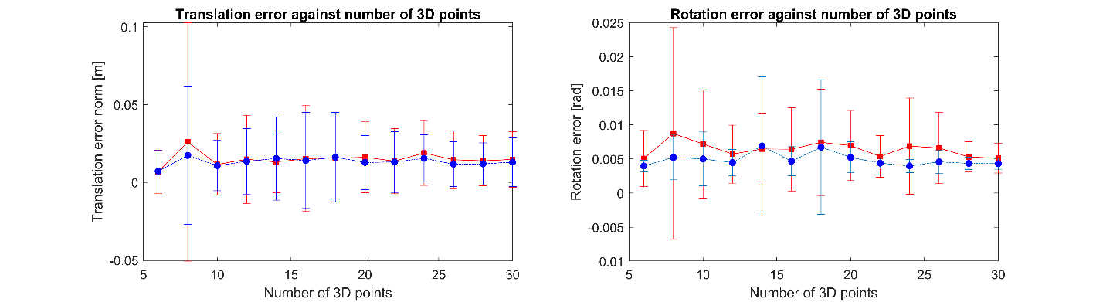

All these results have not involved any GN optimization, and I believe the results can be further improved with GN.