Cloud Computing Required Tools

For this course we’re going to need the following:

* CMake
* Boost
* Visual Studio 2005 or newer (duh…)

If you already have CMake and Boost installed, make sure you have the required versions listed below, otherwise please proceed to installing the latest ones. If you don’t have Visual Studio installed, the door is to your right side (if I remember correctly).

# **Installing CMake**

In order to install CMake, please navigate to the following link:

<https://cmake.org/download/>

There choose the suitable download for your platform. The required version in order to build our project is 3.11, so if you already have this (or a newer one obviously) then you are set. If you have an older version, please uninstall it before getting the new one.

If this is your first time using CMake, then make sure you follow the installer steps closely. You will be asked if you want to add CMake to your system PATH:

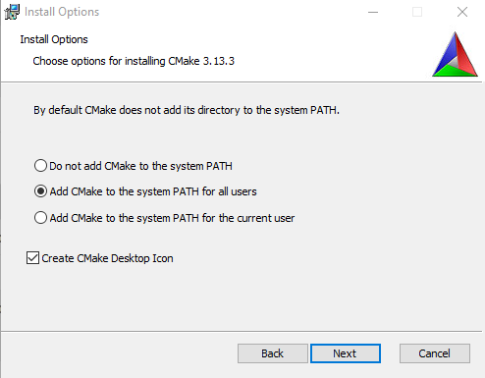

Check the second radio button. You can also check the first radio button, but if you do so, you will have to add CMake to the system path manually. Still, after the installation is finished, I recommend checking if the path has been added as we’ll have to add a new variable as well.

As for the installation location, it is prefferable that you leave it untouched but if you’re low on space you can choose a different one. After the installation is complete, we will check if CMake has been added to the system path. To do this, search for “Enviroment Variables” in Windows’ searchbar. Open this dialogue and click on **Enviroment Variables**.

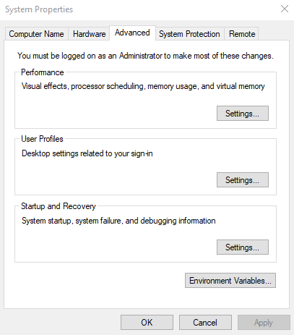

After that, find **Path** under System variables and click Edit. Make sure that at the end of the list, a path to the CMake **bin** folder has been added. If it’s not there, add it manually. We will also add a new variable called **CMAKE_ROOT**, that points to the installation folder, therefore the same path but without the **bin** folder (see the same example for Boost at the bottom). After everything is wrapped up, a reboot may be required.

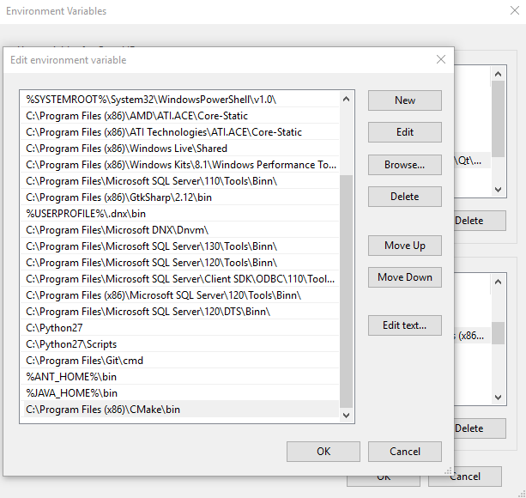

# **Installing Boost**

In order to install Boost, please navigate to the following link:

<https://www.boost.org/users/download/>

There, choose either the 7z or ZIP archieve for Windows. When done, extract it. It is recommended that you simply extract it directly under the **C:/** directory, NOT Program Files, e.g.: **C:/boost/boost_1_68_0/**. If you already have version 1.68 then you are set, if not, uninstall the older version first.

Before proceeding with the installation, we have to add a System variable for Boost. Navigate again to Enviroment Variables, but this time click on **New**, under System variables, and name it **BOOST_ROOT**. It should point to the folder where you just extracted the archieve. Same steps can be followed when adding the **CMAKE_ROOT** variable. For Boost we don’t need to touch the **Path** variable.

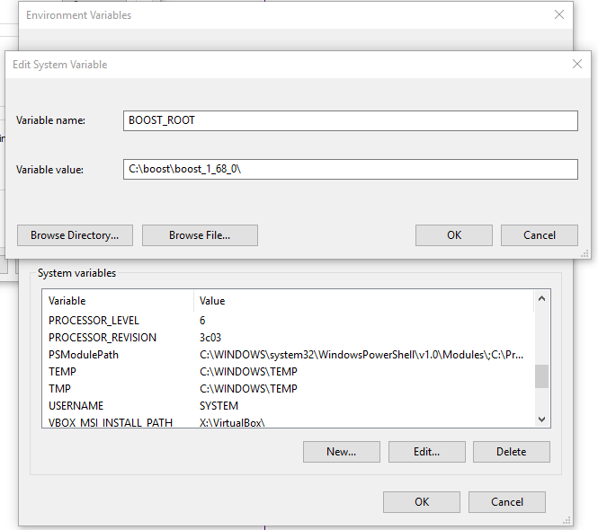

After you added the variable, navigate to the Boost folder and open up a Command Prompt there. Inside the CMD, type the following:

* bootstrap.sh
* b2 install

The first command will build the installer, the second one will build the libraries.

**IMPORTANT:** PLEASE notice that the second command might take even more than 30 – 40 minutes to execute, the installer is not stuck or broken. Don’t close the window during the process, it will close on its own when its done installing. After everything is wrapped up, a reboot might be required.

Now you should be ready to build the project. However, if you don't succeed, it's definitely not our fault.