**Name: Khushi Nitinkumar Patel**

**PRN: 2020BTECS00037**

**Batch: T5**

**Experiment 1: Introduction and Installation**

**Step 1:** Go to **browser** and search for **DEV C++** and click on the first link.

<https://sourceforge.net/projects/orwelldevcpp/>

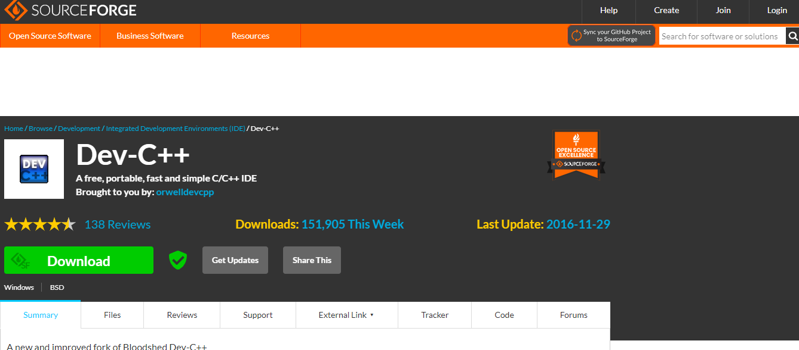

**Step 2:** Click on **Download.** Your download will begin in few seconds.

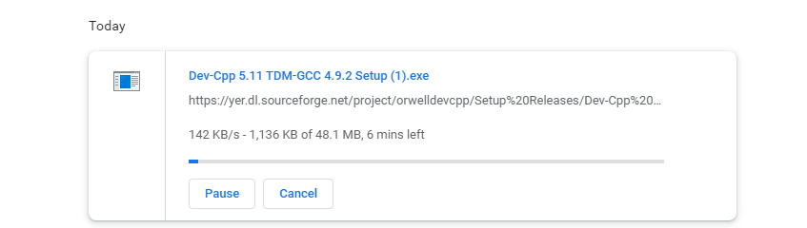

**Step 3:** Now, go to the **folder** where **DEV C++** is downloaded. Click on the file and the installation will begin.

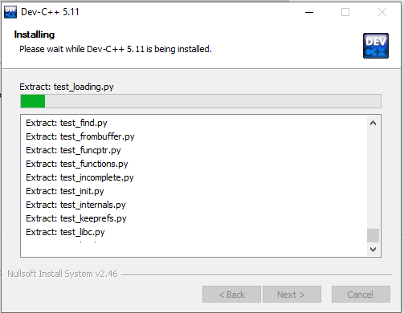

**Step 4:** Click on **Finish** and **DEV C++** is installed on your system and is ready to run.

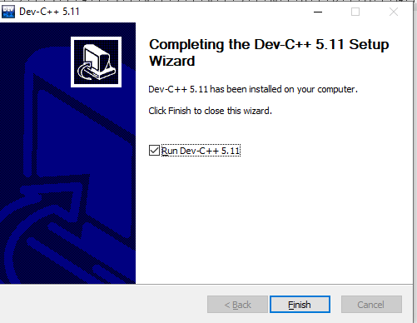

**Step 5:** Now to setup **graphics.h** in **DEV C++,** first go to this drive and download a zip file. <https://drive.google.com/file/d/16xZBvFXf7yFjxwTpuyevK1KPuLgUeZFh/view>

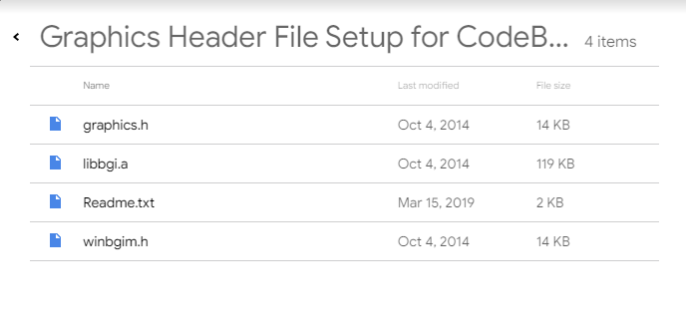

**Step 6:** Now select the **graphics.h** and **winbgim.h** files and copy it to the **include folder** of compiler installed within **DEV C++.**

Path: C:\Program Files (x86)\Dev-Cpp\MinGW64\include

**Step 7:** There is another file named **libbgi.a** in the zip file, copy the file and paste it into the lib folder of compiler installed within **DEV C++.**

Path: C:\Program Files (x86)\Dev-Cpp\MinGW64\lib

**Step 8:** Now, **open DEV C++**, and select the option highlighted below.

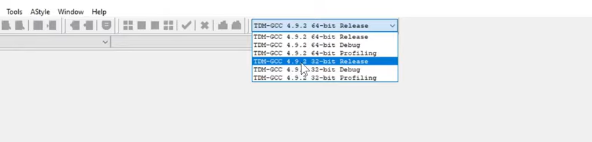

**Step 9:** Go to **tools -> compiler options** and make sure that the second option checkbox is checked.

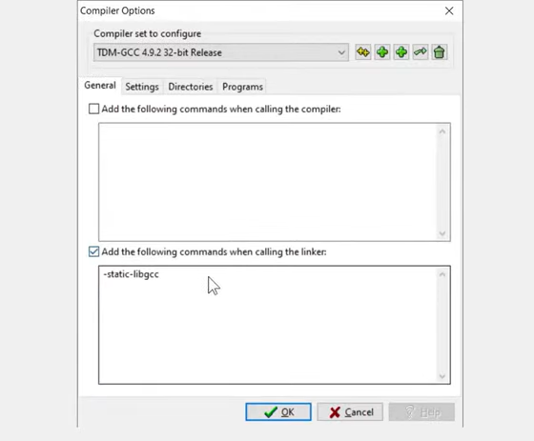

**Step 10:** In that box we need to write appropriate **Linker option**. Given below is the syntax. Now, click on **okay** button and **graphics.h** is successfully setup.

