**Name: Khushi Nitinkumar Patel**

**PRN: 2020BTECS00037**

**Batch: T5**

**Experiment 5: Implementation of 2D transformation**

**1.Translation**

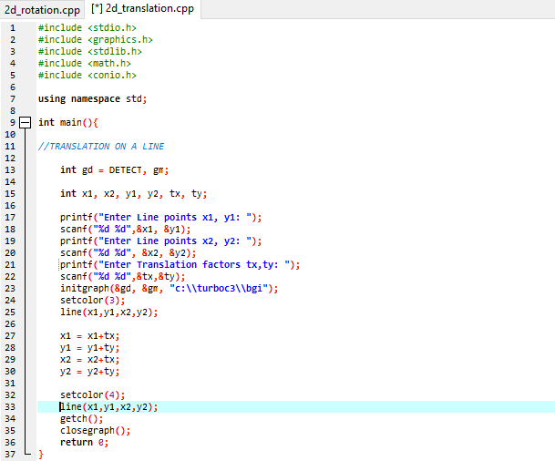

**OUTPUT:**

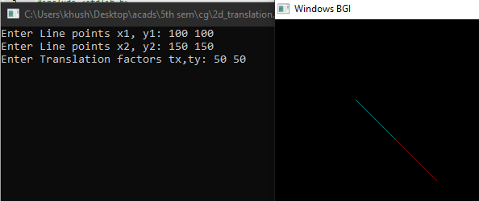

**2.Scaling**

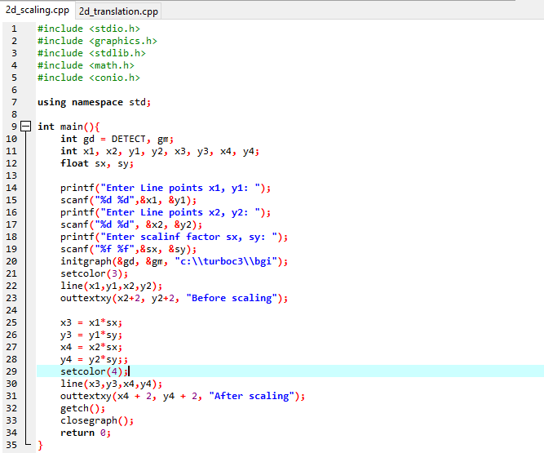

**OUTPUT:**

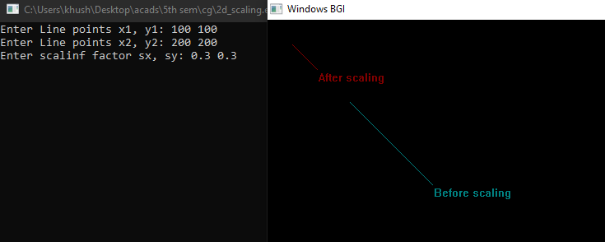

**3.Rotation**

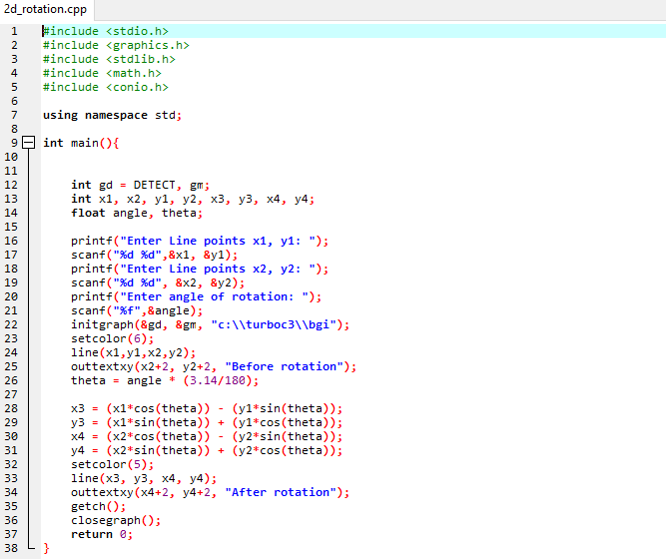

**OUTPUT:**

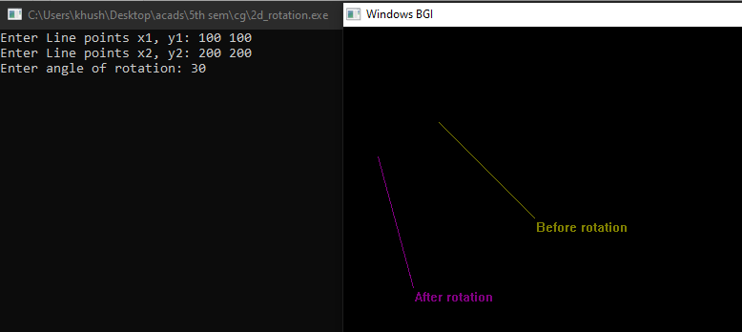

**4.Reflection**

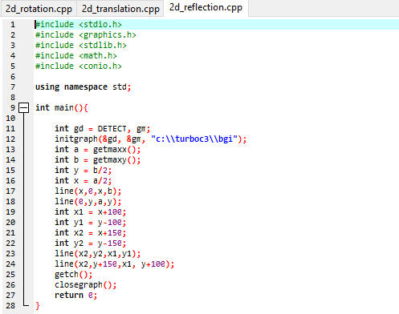

**OUTPUT:**

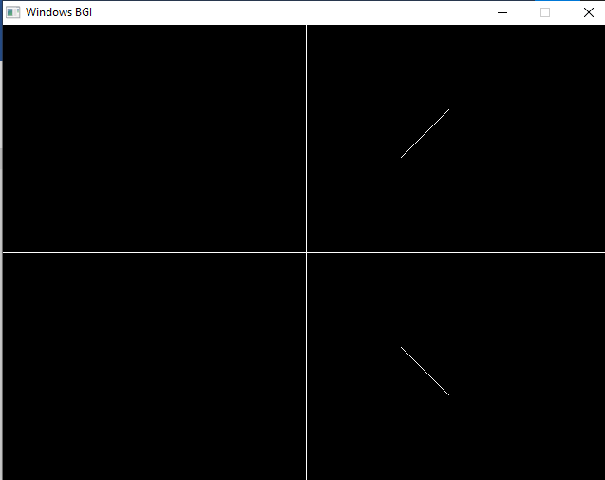

**5.Shearing**

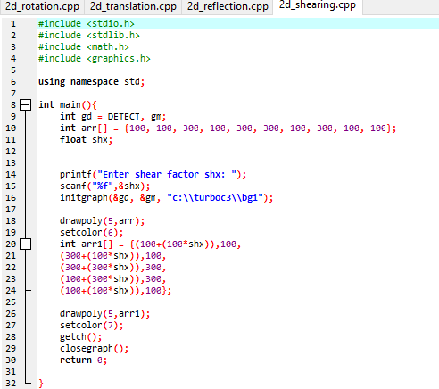

**OUTPUT:**

