**Name: Khushi Nitinkumar Patel**

**PRN: 2020BTECS00037**

**Batch: T5**

**Experiment 7: Implementation of real time object**

1. **CODE**:

#include <graphics.h>

#include <iostream>

#include <conio.h>

#include <math.h>

using namespace std;

void kite()

{

line(200, 200, 300, 100);

line(300, 100, 400, 200);

line(400, 200, 300, 300);

line(300, 100, 300, 300);

line(300,300,200,200);

arc(300, 300, 45, 135, 140);

setfillstyle(SOLID_FILL, RED);

floodfill(301, 105, WHITE);

setfillstyle(SOLID_FILL, RED);

floodfill(299, 105, WHITE);

setfillstyle(SOLID_FILL, 12);

floodfill(299, 275, WHITE);

setfillstyle(SOLID_FILL, 12);

floodfill(301, 275, WHITE);

line(300, 300, 250, 350);

line(250, 350, 350, 350);

line(300, 300, 350, 350);

setfillstyle(SOLID_FILL, 14);

floodfill(300, 310, WHITE);

}

int main()

{

int gd = DETECT, gm;

initgraph(&gd, &gm, "");

kite();

getch();

closegraph();

return 0;

}

**OUTPUT**:

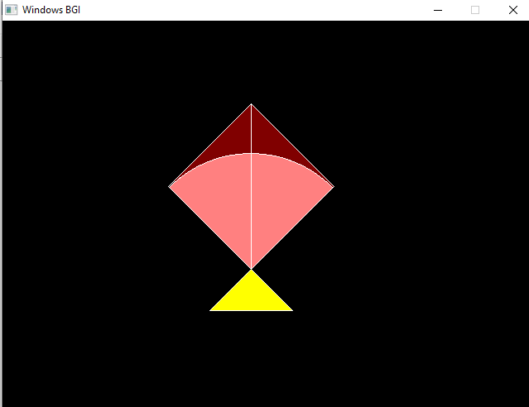

1. **CODE**:

#include<graphics.h>

int main()

{

int gd = DETECT, gm;

initgraph(&gd, &gm,NULL);

line(0,300,640,300);

setcolor(11);

circle(100,285,15);

circle(200,285,15);

circle(100,285,5);

circle(200,285,5);

line(65,285,85,285);

line(115,285,185,285);

line(215,285,235,285);

line(65,285,65,260);

line(235,285,235,260);

line(65,260,100,255);

line(235,260,200,255);

line(100,255,115,235);

line(200,255,185,235);

line(115,235,185,235);

line(106,255,118,238);

line(118,238,118,255);

line(106,255,118,255);

line(194,255,182,238);

line(182,238,182,255);

line(194,255,182,255);

line(121,238,121,255);

line(121,238,148,238);

line(121,255,148,255);

line(148,255,148,238);

line(179,238,179,255);

line(179,238,152,238);

line(179,255,152,255);

line(152,255,152,238);

setcolor(4);

//floodfill(150,200,4);

getch();

closegraph();

}

**OUTPUT**:

