**Name: Khushi Nitinkumar Patel**

**PRN: 2020BTECS00037**

**Batch: T5**

**Design and analysis of algorithm Lab**

**Week 4 Assignment**

**Part 2: Divide and conquer strategy**

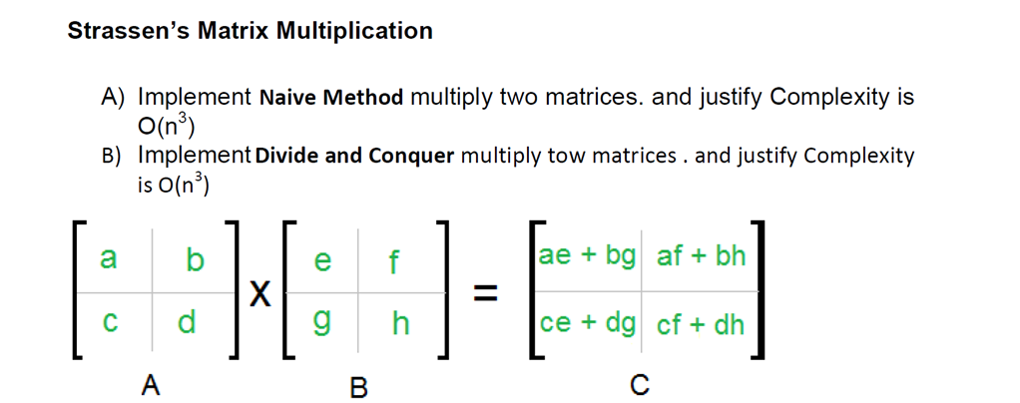

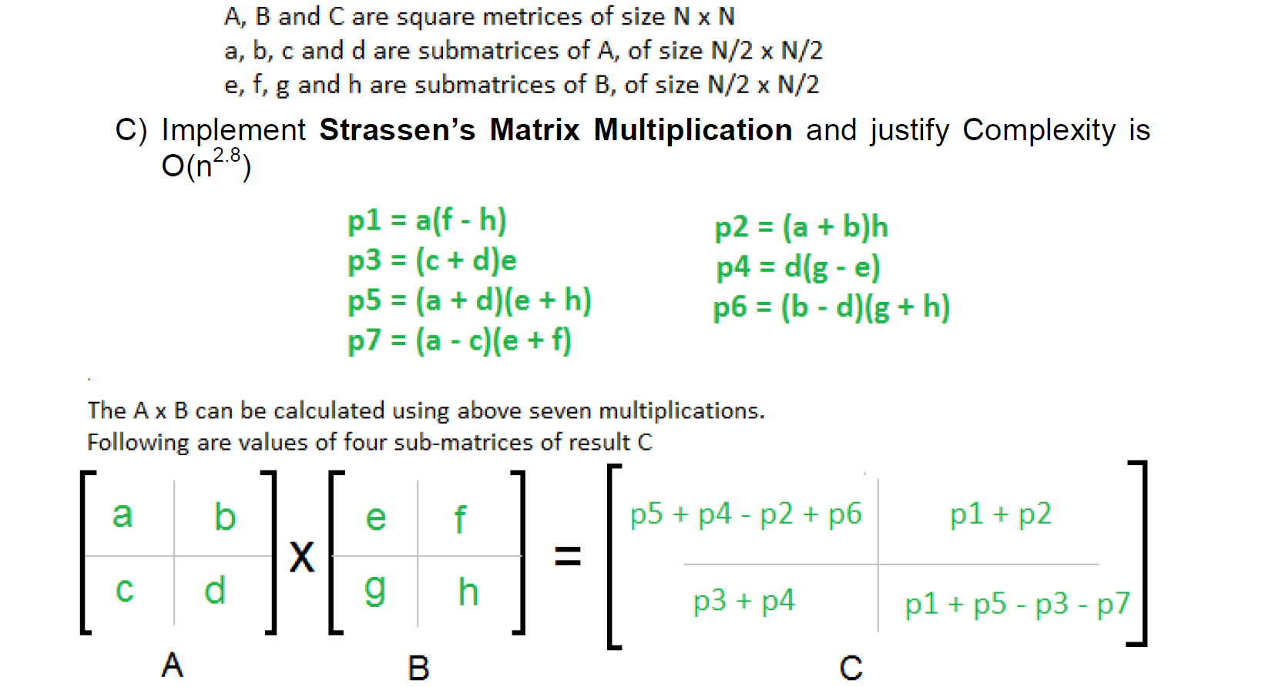

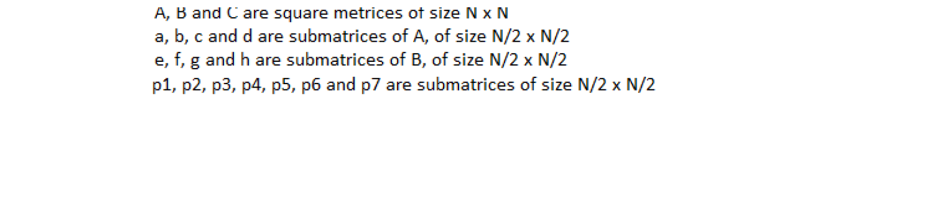

1. **Naive Method:**

Algorithm:

Algorithm matrix_multiply(a,b,c) // a and b are input matrices of size n x n and c is the output matrix of size n x n

for i = 0 to n-1 do

for j = 0 to n-1 do

for k = 0 to n-1 do

c[i][j]= c[i][j] + a[i][k]*[k][j]

end

end

end

**Code:**

#include<iostream>

using namespace std;

#include<vector>

void matrix_multiply(int a[][2],int b[][2],int c[][2])

{

    for(int i=0;i<2;i++)

    {

        for(int j=0;j<2;j++)

        {

            for(int k=0;k<2;k++)

            {

                c[i][j]+=a[i][k]*b[k][j];

            }

        }

    }

}

int main()

{

    int a[2][2]={{1,2},{3,2}},b[2][2]={{2,1},{4,5}},c[2][2]={0};

    matrix_multiply(a,b,c);

    for(int i=0;i<2;i++)

    {

        for(int j=0;j<2;j++)

        {

            cout<<c[i][j]<<" ";

        }

        cout<<endl;

    }

    return 0;

}

**Output:**

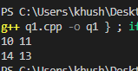

**Complexity Analysis:**

Time complexity: O(n3) where n is size of matrix

Space complexity: O(n2) As extra 2D array is used to store result

1. **Divide and Conquer Method:**

Algorithm:

Algorithm multiply_matrix(A, B, n) //A and B are input matrices and n is size of matrices

if(n<=2)

c11= (a11*b11) + (a12*b21)

c12= (a11*b12) + (a12*b22)

c21= (a21*b11) + (a22*b21)

c22= (a21*b12) + (a22*b22)

else

multiply_matrix(A11, B11, n/2) + (A12, B21, n/2)

multiply_matrix(A11, B12, n/2) + (A12, B22, n/2)

multiply_matrix(A21, B11, n/2) + (A22, B21, n/2)

multiply_matrix(A21, B12, n/2) + (A22, B22, n/2)

end

**Code:**

#include <iostream>

using namespace std;

#include<iomanip>

#include<vector>

void add_matrix(vector<vector<int>> A,vector<vector<int>> B,vector<vector<int>>& C,int split_index)

{

    for (auto i = 0; i < split_index; i++)

        for (auto j = 0; j < split_index; j++)

            C[i][j]= A[i][j] + B[i][j];

}

vector<vector<int>>multiply_matrix(vector<vector<int>> A,vector<vector<int>> B)

{

    int col_1 = A[0].size();

    int row_1 = A.size();

    int col_2 = B[0].size();

    int row_2 = B.size();

    if (col_1 != row_2) {

        cout << "\nError: The number of columns in Matrix "

                "A must be equal to the number of rows in "

                "Matrix B\n";

        return {};

    }

    vector<int> row(col_2, 0);

    vector<vector<int>> ans(row_1,row);

    if (col_1 == 1) ans[0][0]= A[0][0] * B[0][0];

    else

    {

        int split_index = col_1 / 2;

        vector<int> row_vector(split_index, 0);

        vector<vector<int>> ans_00(split_index,row_vector);

        vector<vector<int>> ans_01(split_index,row_vector);

        vector<vector<int>> ans_10(split_index,row_vector);

        vector<vector<int>> ans_11(split_index,row_vector);

        vector<vector<int>> a00(split_index, row_vector);

        vector<vector<int>> a01(split_index, row_vector);

        vector<vector<int>> a10(split_index, row_vector);

        vector<vector<int>> a11(split_index, row_vector);

        vector<vector<int>> b00(split_index, row_vector);

        vector<vector<int>> b01(split_index, row_vector);

        vector<vector<int>> b10(split_index, row_vector);

        vector<vector<int>> b11(split_index, row_vector);

        for (auto i = 0; i < split_index; i++)

            for (auto j = 0; j < split_index; j++) {

                a00[i][j] = A[i][j];

                a01[i][j] = A[i][j + split_index];

                a10[i][j] = A[split_index + i][j];

                a11[i][j] = A[i + split_index][j + split_index];

                b00[i][j] = B[i][j];

                b01[i][j] = B[i][j + split_index];

                b10[i][j] = B[split_index + i][j];

                b11[i][j] = B[i + split_index][j + split_index];

            }

        add_matrix(multiply_matrix(a00, b00),multiply_matrix(a01, b10),ans_00, split_index);

        add_matrix(multiply_matrix(a00, b01),multiply_matrix(a01, b11),ans_01, split_index);

        add_matrix(multiply_matrix(a10, b00),multiply_matrix(a11, b10),ans_10, split_index);

        add_matrix(multiply_matrix(a10, b01),multiply_matrix(a11, b11),ans_11, split_index);

        for (auto i = 0; i < split_index; i++)

            for (auto j = 0; j < split_index; j++) {

                ans[i][j]= ans_00[i][j];

                ans[i][j + split_index]= ans_01[i][j];

                ans[split_index + i][j]= ans_10[i][j];

                ans[i + split_index][j + split_index]= ans_11[i][j];

            }

        ans_00.clear();

        ans_01.clear();

        ans_10.clear();

        ans_11.clear();

        a00.clear();

        a01.clear();

        a10.clear();

        a11.clear();

        b00.clear();

        b01.clear();

        b10.clear();

        b11.clear();

    }

    return ans;

}

int main()

{

    vector<vector<int> > A = {{ 1, 1, 0, 1 },

                              { 2, 5, 2, 6 },

                              { 3, 3, 4, 3 },

                              { 2, 0, 1, 4 }};

    vector<vector<int> > B = {{ 0, 1, 1, 1 },

                              { 2, 6, 2, 3 },

                              { 3, 2, 3, 1 },

                              { 2, 1, 0, 2 }};

    vector<vector<int> > ans(multiply_matrix(A, B));

    cout<<"Multiplication :"<<endl;

    for(int i=0;i<4;i++)

    {

        for(int j=0;j<4;j++)

        {

            cout<<setw(4)<<ans[i][j];

        }

        cout<<endl;

    }

    return 0;

}

**Output:**

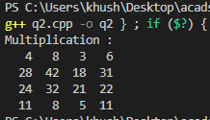

**Complexity Analysis:**

Time complexity: O(n3)

T(n) = 8T(n/2) + O(n2)

T(n)= O(n3) …using Master’s theorem

Space complexity: O(n2)

1. **Strassen’s Matrix Multiplication:**

Algorithm:

Calculate

P=(A11 + A22)*(B11+B22)

Q=(A21 + A22)* B11

R= A11*(B12 – B22)

S= A22*(B21 – B11)

T=(A11 + A12)*B22

U=(A21 - A11)*(B11 + B12)

V=(A12 – A22)*(B21 + B22)

Then,

C11= P + S – T + V

C12= R + T

C21= Q + S

C22= P + R – Q + U

**Code:**

#include<iostream>

using namespace std;

#include<iomanip>

#include<vector>

vector<vector<int>>add_matrix(vector<vector<int>> A,vector<vector<int>> B, int split_index,int multiplier = 1)

{

    for (auto i = 0; i < split_index; i++)

        for (auto j = 0; j < split_index; j++)

            A[i][j]= A[i][j]+ (multiplier * B[i][j]);

    return A;

}

vector<vector<int>>multiply_matrix(vector<vector<int>> A,vector<vector<int>> B)

{

    int col_1 = A[0].size();

    int row_1 = A.size();

    int col_2 = B[0].size();

    int row_2 = B.size();

    if (col_1 != row_2) {

        cout << "\nError: The number of columns in Matrix "

                "A must be equal to the number of rows in "

                "Matrix B\n";

        return {};

    }

    vector<int> result_matrix_row(col_2, 0);

    vector<vector<int> > ans(row_1,result_matrix_row);

    if (col_1 == 1)

        ans[0][0]= A[0][0] * B[0][0];

    else

    {

        int split_index = col_1 / 2;

        vector<int> row_vector(split_index, 0);

        vector<vector<int> > a00(split_index, row_vector);

        vector<vector<int> > a01(split_index, row_vector);

        vector<vector<int> > a10(split_index, row_vector);

        vector<vector<int> > a11(split_index, row_vector);

        vector<vector<int> > b00(split_index, row_vector);

        vector<vector<int> > b01(split_index, row_vector);

        vector<vector<int> > b10(split_index, row_vector);

        vector<vector<int> > b11(split_index, row_vector);

        for (auto i = 0; i < split_index; i++)

            for (auto j = 0; j < split_index; j++) {

                a00[i][j] = A[i][j];

                a01[i][j] = A[i][j + split_index];

                a10[i][j] = A[split_index + i][j];

                a11[i][j] = A[i + split_index][j + split_index];

                b00[i][j] = B[i][j];

                b01[i][j] = B[i][j + split_index];

                b10[i][j] = B[split_index + i][j];

                b11[i][j] = B[i + split_index][j + split_index];

            }

        vector<vector<int> > p(multiply_matrix(a00, add_matrix(b01, b11, split_index, -1)));

        vector<vector<int> > q(multiply_matrix(add_matrix(a00, a01, split_index), b11));

        vector<vector<int> > r(multiply_matrix(add_matrix(a10, a11, split_index), b00));

        vector<vector<int> > s(multiply_matrix(a11, add_matrix(b10, b00, split_index, -1)));

        vector<vector<int> > t(multiply_matrix(add_matrix(a00, a11, split_index),add_matrix(b00, b11, split_index)));

        vector<vector<int> > u(multiply_matrix(add_matrix(a01, a11, split_index, -1),add_matrix(b10, b11, split_index)));

        vector<vector<int> > v(multiply_matrix(add_matrix(a00, a10, split_index, -1),add_matrix(b00, b01, split_index)));

        vector<vector<int> > result_matrix_00(add_matrix(add_matrix(add_matrix(t, s, split_index), u,split_index),q, split_index, -1));

        vector<vector<int> > result_matrix_01(add_matrix(p, q, split_index));

        vector<vector<int> > result_matrix_10(add_matrix(r, s, split_index));

        vector<vector<int> > result_matrix_11(add_matrix(add_matrix(add_matrix(t, p, split_index), r,split_index, -1),v, split_index, -1));

        for (auto i = 0; i < split_index; i++)

            for (auto j = 0; j < split_index; j++) {

                ans[i][j]= result_matrix_00[i][j];

                ans[i][j + split_index]= result_matrix_01[i][j];

                ans[split_index + i][j]= result_matrix_10[i][j];

                ans[i + split_index][j + split_index]= result_matrix_11[i][j];

            }

        a00.clear();

        a01.clear();

        a10.clear();

        a11.clear();

        b00.clear();

        b01.clear();

        b10.clear();

        b11.clear();

        p.clear();

        q.clear();

        r.clear();

        s.clear();

        t.clear();

        u.clear();

        v.clear();

        result_matrix_00.clear();

        result_matrix_01.clear();

        result_matrix_10.clear();

        result_matrix_11.clear();

    }

    return ans;

}

int main()

{

    vector<vector<int> > A = {{ 1, 1, 0, 1 },

                              { 2, 5, 2, 6 },

                              { 3, 4, 4, 3 },

                              { 2, 0, 1, 4 }};

    vector<vector<int> > B = {{ 0, 1, 1, 1 },

                              { 2, 6, 2, 3 },

                              { 3, 2, 3, 1 },

                              { 2, 1, 0, 2 }};

    vector<vector<int> > ans(multiply_matrix(A, B));

    cout<<"Multiplication :"<<endl;

    for(int i=0;i<4;i++)

    {

        for(int j=0;j<4;j++)

        {

            cout<<setw(4)<<ans[i][j];

        }

        cout<<endl;

    }

    return 0;

}

**Output:**

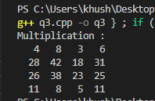

**Complexity Analysis:**

Time complexity: O(n2.81)

T(n) = 7T(n/2)+O(n2)

T(n)=O(nlog 7) …using Master’s theorem

Space complexity: O(n2)