43Handwritten Notes — AI Governance vs Corporate Governance
Transcription of all five images, preserving the original structure and numbering. I've tidied punctuation and formatting, marked uncertain readings as [unclear], and indicated crossed-out text where useful.

Page 1 — Talk outline, conclusions and goals
TALK: AI Governance vs Corporate Governance
Small note at top left:
Starve with horses? More humans More power Horses?

Conclusions
1. As the economy grows
- Industrial Revolution → Jobs
- Economy (early): agriculture, human labour
- Diagram: A small shaded circle representing agriculture/human work within a much larger circle representing the economy.
- Examples of work: machines, mules, steam, petrol, diesel, etc.
- Circular arrow: increasingly mechanised labour.
- Available human jobs.
- Second diagram: Much larger economy with human resources occupying a relatively small portion.
- What does this look like? → Things machines can't do: land!

Goals
- Sail / FDC3
- AI — where it's not over [unclear]
- Computing is still interesting despite code coming away [unclear]
- Governance as code with FINOS AI
- Risk-First

Talk Outline

1. Humans are the horses of the 21st century / No more jobs.
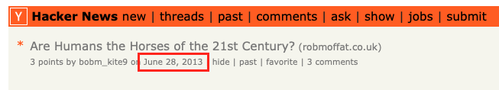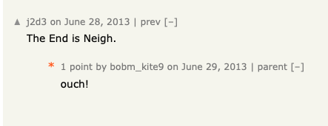

2. Is software engineering dead?
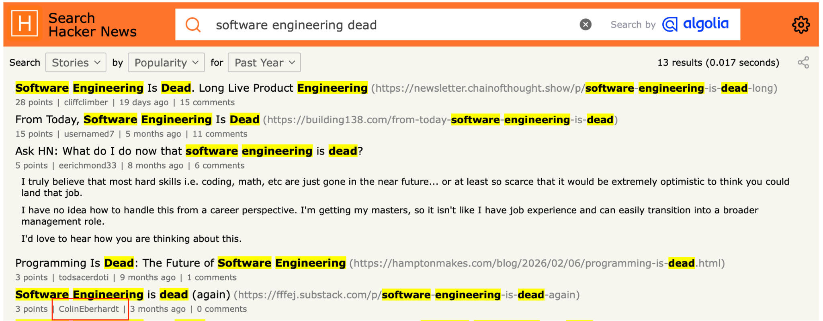

3. If we build it, everyone dies.
(Yudkowsky, argument)
(download book cover for this)

4. No more jobs.
https://www.independent.co.uk/news/uk/home-news/ai-jobs-work-unemployment-b3048696.html screenshot this

5. A simple formula:
I'd use Emerson and Pfeffer & Salancik together, introducing your model as:
$EffectiveAgency∝Intelligence×Resources×Access$
Conceptual model informed by Emerson (1962) and Pfeffer & Salancik (1978).
Then make the central point:
Intelligence tells you what to do. Resources and access determine what you can actually do.

6. Corporate governance vs AI governance.
→ Governance is Something our industry knows a lot about
AI governance is a new manifestation of an old problem: the principal–agent problem.
(define the problem)
- Intelligence ≠ Authority. Organisations already govern agents who may know more than their principals.
- Governance constrains power, not intelligence. Through delegated authority, separation of duties, approvals and accountability.
Cite: Jensen, M. C. & Meckling, W. H. (1976). Theory of the Firm: Managerial Behavior, Agency Costs and Ownership Structure. Journal of Financial Economics, 3(4), 305–360.

7. Three questions:
- Is corporate governance applicable to AI governance?
- What needs to change?
- Does governance even work anyway?

8. Governance As Brake
Governance is a brake
Governance does not have to be corrupt to fail.
But governance can constrain powerful or badly motivated actors when it possesses independent information, independence from the actor being monitored, credible escalation channels, sufficient technical and investigative capacity, and enforceable authority to impose costs or stop activity.
(Answering 3) — Governance is a brake. It can work. The principal–agent problem is always with us. And its possible to implement governance badly or suffer regulatory capture.

9. What does good governance look like (in finance)?
(boxes with icons for…)
- Clear accountability
- Delegated authority
- Segregation of duties
- Independent oversight
- Risk-based controls
- Transparency and auditability
- Continuous monitoring and enforcement

10. Moving Towards Governance as code
Some problems we need to get over to make governance appropriate for AI speeds (boxes)
- Siloed governance — Policies and controls locked away in spreadsheets, documents and disconnected systems.
- Manual bottlenecks — Slow, expensive reviews, approvals and audits.
- Inconsistent enforcement — Different teams interpret and implement policies differently.
- Governance drift — Policies and controls fall out of sync with actual systems.
- Point-in-time compliance — Periodic assessments miss emerging risks and changes.
- Poor traceability — Difficult to link risks, controls, decisions and evidence

10. Introduction to 10-Factor → key governance requirements.
Ten Factor Governance
- Govern Sensitive Activities
- Build a Governance Twin
- Governance is Version Controlled
- Govern the Factory and the Product Separately
- Context In, Decisions Out
- Evidence by Default
- Continuous Governance
- Govern Dependencies
- Governance Is Composable
- Governance Has Owners
Source: Ten Factor Governance — FINOS
Include image of website + URL

11. Introduction to CCC + Gemara. How Gemara helps with GaC (Governance as Code).
CCC (Common Cloud Controls) — FINOS standard defining reusable, technology-agnostic threats, controls and assessment requirements.
Gemara — OpenSSF model and schemas for expressing governance, risks, controls, policies and evidence as structured, machine-readable data.
Connecting the dots — Gemara links governance requirements to threats, controls, policies and assessments, enabling traceability and reuse.
Enabling Governance as Code — Version-controlled controls, automated validation, continuous assessment and evidence generation.

Two boxes, left and right include CCC,FINOS Gemara and OpenSSF logos here.

12. Governance-as-a-Service: Can we separate an AI application from its governance?
- Why would this help?
- How this enables splitting the intelligence + resources required.
- Prevents “marking your own homework” (separate departments in our line of work, in extremis, regulatory capture)
Can We Use 10-Factor for AI Governance?
- Govern sensitive activities — Focus on what AI agents can do, not just what they can say.
- Separate intelligence from authority — Agents can propose actions without automatically having permission to execute them.
- Independent governance — AI agents shouldn't mark their own homework; separate policy enforcement from decision-making.
- Context in, decisions out — Evaluate actions against policies, risks, identity and available evidence.
- Continuous governance — Enforce controls at runtime, not just during development or periodic reviews.
- Evidence by default — Record decisions, approvals and actions for accountability and audit.
Key message: 10-Factor gives us a foundation for governing autonomous AI using established software engineering and governance principles.

13. Overview of the demo components (1)
- FDC3 → Allows apps to talk to each other.
- FDC3 Sail → A sandbox for agents to play in.
- FluxNova → Allows us to construct workflows with third parties.

14.Overview of the demo components (2)
Apps: Portfolio, Risk, Market Data, Agent, Order Entry, Execution Service.
→ The FDC3 API / Sail.

15. Sail governance plugin
- Inspects what the agent does.
- Makes decisions on what is allowed.

14. But how does it make decisions?
Controls → Risks → Threats → Policy
→ Trace a single one or more to explain what happens.
- Use the example of preventing the AI from excecuting its own orders.
Run the demo: ( RECORD THIS.)
Show governance interrupting the agent doing something crazy. Get approval via FluxNova.

15. Recap of workshop:
- Poisoning attacks
- JEV for policy checking (AI checking AI - like departments in a bank), JEV is cheap - does governance need to be as clever as the thing being governed?
16. Conclusions

17. Governance needs to grow up
…and adopt software engineering procedures:
- Releases
- Code
- Version control, etc.
- So it can move at AI speeds.
→ 10-Factor shows how? And contains the whole example codebase

18. Governance (& Risk Management) are our best tool for managing AI risk in the future.
→ AIGF
→ Risk-First Software Development. Talk about the Lindy Effect
→ Everyone dies and we give AI unlimited power. But being more intelligent doesn't lead to that necessarily in the real world.
- Kings - not the smartest guys in the room, but have controls
- Einstein - was the smartest guy in the room, didn’t end up running austria.
- Quant traders working in banks - remunerated well but not in charge.

19. Governance used to be a lot harder to do!
ISO 42001.
Governance documentation
Etc.
Etc.
Now it’s easy with AI tools

20. Are humans the new horses?
- No.
- Comparative advantage.
- Things only humans can do.
- Do argument via Venn diagrams.

21. How to get involved.
- Join the Sail project (url for project, calendar.finos.org for wg)
- Join the FINOS AI Project (ai.finos.org)
- Contribute to 10-Factor or CCC (ccc.finos.org), tenfactorgovernance.org
- Gemara gemara.openssf.org

22. How do we make sure AI is governed?
Picture of mice arguing about who puts the bell on the cat.

