Software Architecture and Design

This document covers
Introduction

Introduction
Architecture represents the significant design decisions that shape a system, where significant is measure by cost of change
– Grady Booch.
A good architecture comes from understanding it more as a journey than a destination, more as an ongoing process of enquiry than as a frozen artifact
– Robert C Martin

Software architecture is the process of taking functional and non-functional requirements and using them to create a high-level conceptual architecture. The high-level conceptual architecture will define a set of coarse-grained components. The coarse-grained components are then decomposed into finer grained components. The architecture specifies how components are arranged and defines the interfaces, responsibilities, and interactions between these components. We can think of the architecture as the shape of the system.
Architecture versus Design
We might assert that software design is about organising classes withing modules and architecture is about organising modules. In practice the organisation of software elements from low level to high level is one discipline. For this reason in this document I will cover topics traditionally considered design.

Managing Dependencies
The goal of software architecture is to create a shape that minimises the effort required to develop, deploy, operate, and maintain the system. Ideally the effort involved in implementing a new feature should depend only on the complexity of that feature and not on the shape of the system. We want our components to have well-defined boundaries, well specified responsibilities, and well controlled dependencies.
Modules, Components and Services
It is hard to get a hard definition of the differences between a module and a component. I have read that a module logically groups together functions and classes without mandating any physical separation. Components on the other hand are the physical manifestation of modules. If the components are libraries, such as jars in Java or dll’s in .NET, then they can be linked together in a single address space and communicate via function call. Components can also be services running in their own address space and communicating using networks calls (SOAP, Rest etc.).
In this document from now on I will only refer to components irrespective of whether they are logically separate packages in a single executable, separate DLLs or deployable services.

The architecture must meet the needs of all specified use cases while at the same time satisfying non-functional requirements such as performance.

Policy and Detail
All components of a system can be roughly categorised as either policy or detail. Policy is the high-level business rules and detail is the supporting detail such as IO, databases and UI needed to support the policy.
We should architect the system such that the details are irrelevant to the policy and furthermore such that the detailed can be delayed as long as possible. The benefit of such a delay is that the longer we wait the more we know and the more likely we are to get details such as the database correct. We can even try plugging in different document and relational databases to see which works best.

Stable Dependencies and Stable Abstractions
Within a system some volatile components will be expected to change frequently. Consequently, we want to ensure such components are easy to change. Even a component that is well designed for change will itself become hard to change If we give it a load of incoming dependencies. In general, adding incoming dependencies (dependents) to a module makes it harder to change as any changes need to be coordinated with all such dependents.
If a module has many outgoing dependencies it is likely that it will have to change frequently in response to changes in those dependencies. We should ensure that such modules are easy to change. Conversely a module with no outgoing dependencies is said to be independent. There is no module that can force it to change.

Categorising Stability

Stable Component
Any changes to Stable Component is stable because any changes to it must be co-ordinated with all its dependents.
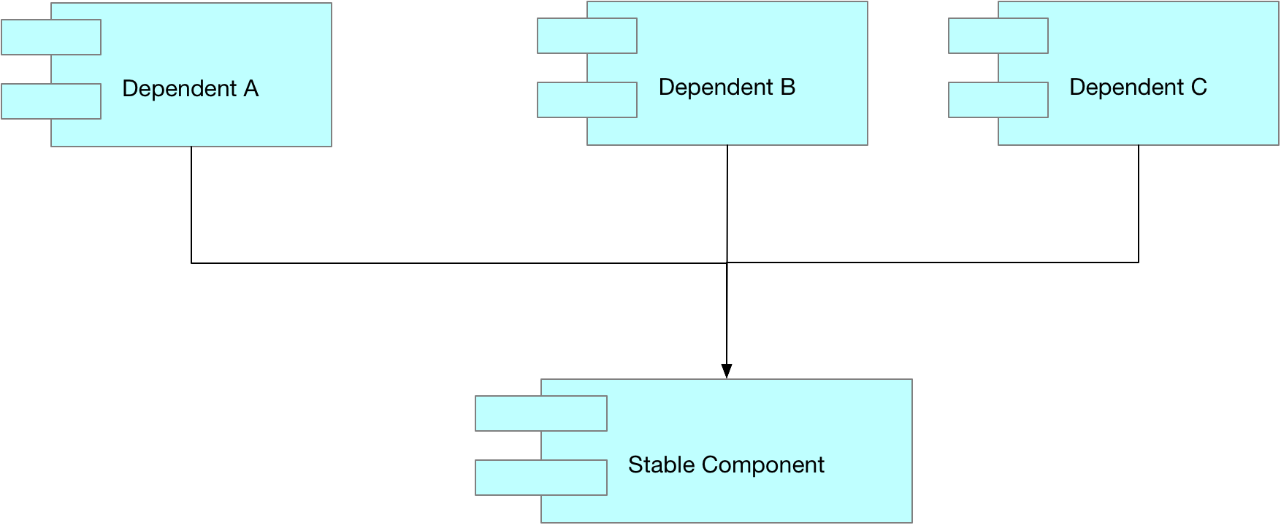

Irresponsible Component
An irresponsible component has no dependents (no incoming dependency arrows).

Unstable Component
The Unstable Component is unstable because any changes to any of its dependencies will force it to change. Any such components should be designed to be easy to change.
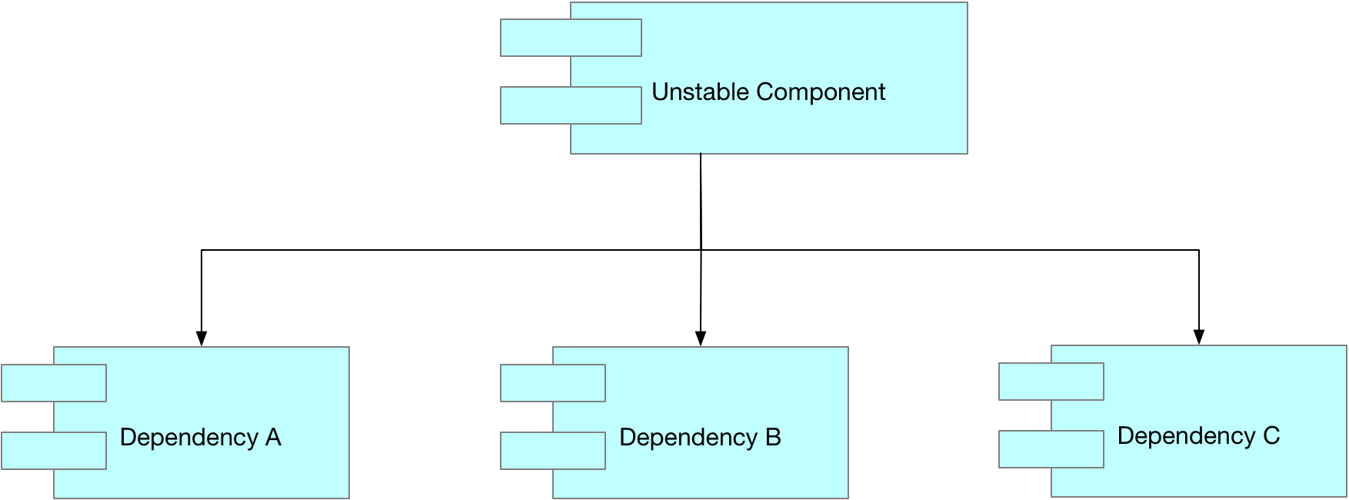

Independent Component
An independent component has no dependencies and so nothing can force it to change.

Arranging Dependencies
We want to arrange our components so the dependencies flow from the least stable components to the most stable. We would expect the components holding the high-level policy to be the most stable components in the system as they depend on nothing and most things depend on them.
Because the high-level policy modules are very stable this can lead to a system that is hard to extend. To mitigate this, we make very stable components abstract. Typically, the more stable a component the higher the percentage of its types will be interfaces and abstract classes. Abstractness flows in the direction of stability. This is DIP at the component level.
We can use plugins to create scalable and extensible architectures. The policy contains the core business logic. Plugins provide all the other non-business logic such as UI logic and persistence. The dependencies point from the plug-in components to to policy modules. This can be extended to more levels. Lower-level modules always depend on higher level modules. A module level is defined by how far it is from the IO.

Architectures
Type | Description
Clean Architecture
Domain Model | Layered architecture that uses presentation layer, application layer, domain layer and infrastructure layer.
Layered | Use Tiers instead of layers
CQRS | A Layered architecture with two columns; one for commands and one for queries. Each column can have its own architecture
Event Sourcing | Evolved from CQRS with focus on events rather than data
Monolithic | Enough said
Microservices | https://martinfowler.com/articles/microservices.html
Hexagonal
Service Oriented Architecture

Clean Architecture
Robert C Martin defines the clean architecture in his book of the same name. Each level is a concentric circle and all dependences inwards towards higher level modules

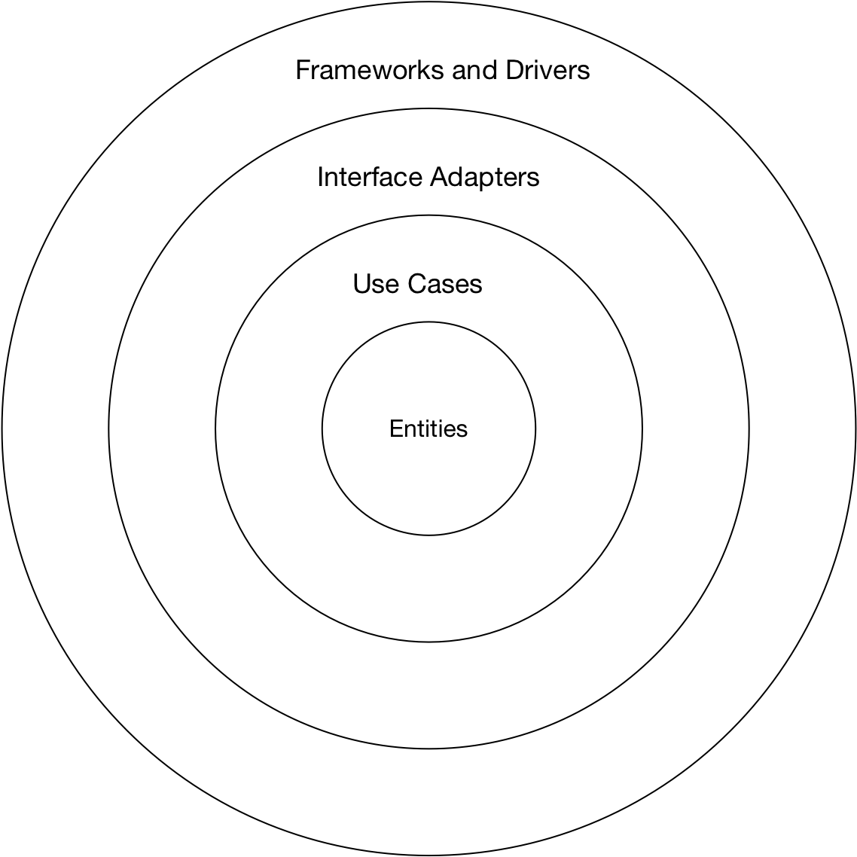
Within the business rules we have two different kinds of types. An entity has both data and behaviour and carries out critical business functionality. Entities are the highest-level modules in the business layer. Use cases use the entities and are one level lower. The entities are applicable to multiple applications whereas use cases only apply to one application. Use cases should accept simple request objects and produce simple response objects. These request/response objects should not depend on things like http requests. They should also not use the entities themselves.
The data that crosses the boundaries should be simple data structures, function arguments or data transfer objects. We should never pass things like entities or database rows.
 | Description
Entities | Enterprise level business concepts. Has data and behaviour
Use Cases | Application specific logic that orchestrates the entities.
Interface Adaptors | Convert data from the format of use cases and entities to the format needed by user interfaces, databases etc.

The main function is the lowest and dirties part of the system. It depends on everything and sets up all dependency injection. Main is of course itself a plug-in. If we consider a simple scenario where we merge the Entities and use cases and add persistence and UI we see something like this
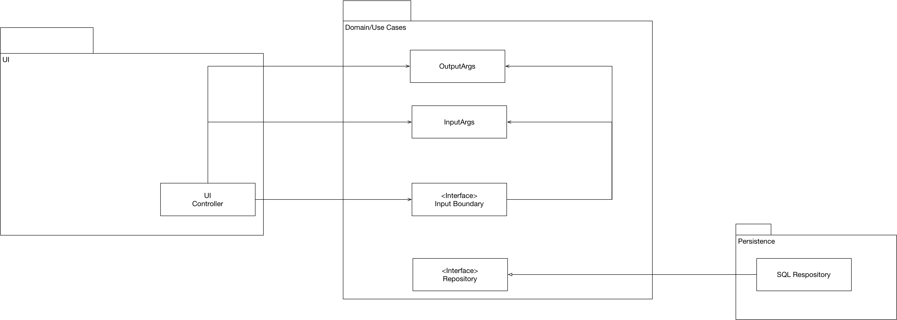

Domain Model
The domain model is a layered architecture where the layers are presentation, application, domain, and infrastructure. The domain layer consists of entities and value objects and their state and behaviour. Entities have identity whereas value objects do not. In order to make a more manageable design entities can be grouped together into aggregates.

Domain Layer
A domain layer focusses on behaviour rather than data. It consists of entities, their behaviours, and the relationships between them. Each Entity represents important entity in the domain. In addition to Entities, we have Value Objects and Services. Services are classes utilise multiple entities and are known as Entity Services. The objects in the domain layer are grouped into modules where each module is a .NET namespace.
- One bounded context maps to one domain model
- One bounded context can consist of multiple modules
- One domain model can consist of multiple modules
- Each module is a .NET namespace.

Entity
An Entity has identity. Two objects with the same attributes are not necessarily the same. Objects that need and Id are entities in the domain layer.

Value Object
In contrast to an entity, a value object is just data grouped together.

Aggregates
Where entities are often being used together, we can treat them as being logically grouped together into an aggregate. An aggregate has a root. Consider an order and its order items. The order items have identity, but most clients won’t need direct access to them. The order becomes the root of an aggregate. Entities should only below in one aggregate. Value objects can be in multiple different aggregates
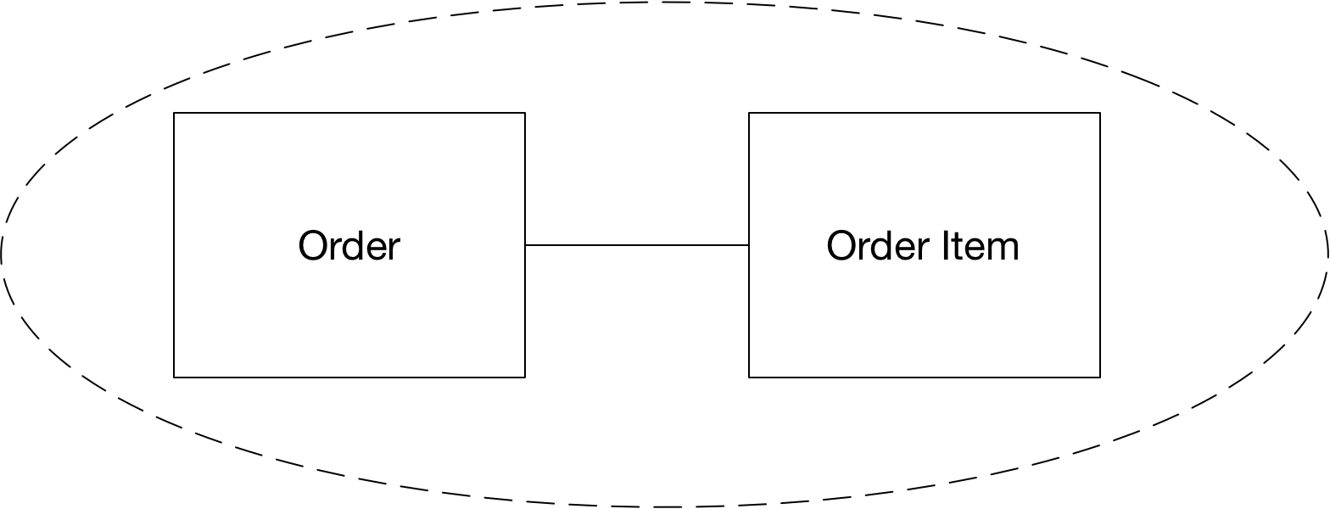
An aggregates root entity can reference its own child entities or the root entities of other aggregates. A child entity can only access root entities of other aggregates. The root of the aggregate is visible to other objects in the model. Aggregate child entities have identity and life but cannot be directly referenced outside the aggregate. If a root provides reference to child items the receiver should treat them as transient.

Services
Implement logic that utilise multiple entities and aggregates to carry out a business action. The actions of domain services are defined in the requirements. A repository is a domain service

Repositories
There should be one repository per aggregate root.

Domain model classes should not have direct knowledge of how to persist and load objects from the persistence store.
POCO means Plain Old CLR Object. Persistence is not a domain model responsibility. The domain model will define a repository interface and the infrastructure layer will implement it. The infrastructure level implementation can be injected in using Inversion of Control.

Layered Architecture
In a layered architecture layers determine the division of components into logical groups.
Layers Versus Tiers
Tiers describe the physical location of components on networks and servers. Layers say nothing about where components are deployed

The architect should consider whether layers exist purely to provide logical separation or to also provide physical separation. Reasons to use physical separation are shared business logic, scalability, or security. The components within each layer can be further decomposed into sub layers.
A modern layered architecture can look as follows
Modern Layered Architecture
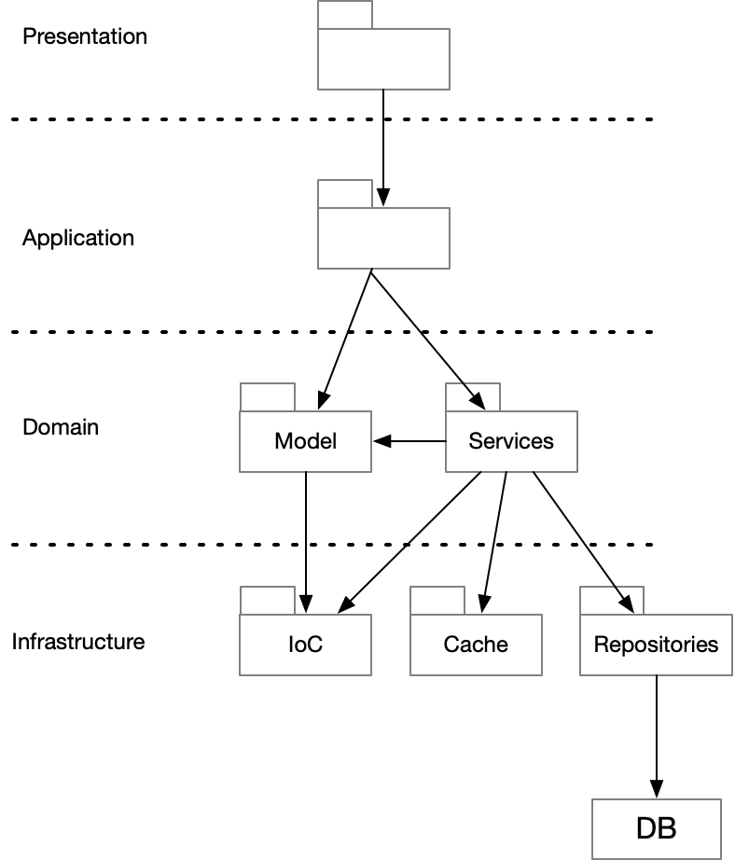

Presentation layer
Anything that populates the presentation layer is known as the view model. The input model consists of actions originating in the UI that cause back end actions.

Application layer
Helps to separate presentation and domain. Takes care of use cases by executing and coordinating work done in lower layers of the stack.

Domain layer
All the business logic. An Entity should provide data and behaviour. In addition to entities the domain model provides domain services. Domain services operate on multiple entities to achieve some task.

Infrastructure layer
Data access, IoC containers, logging, caching

Interface Between Layers
Layers can be closed or open. If a layer is closed it cannot be bypassed. The layer above it must go through it.
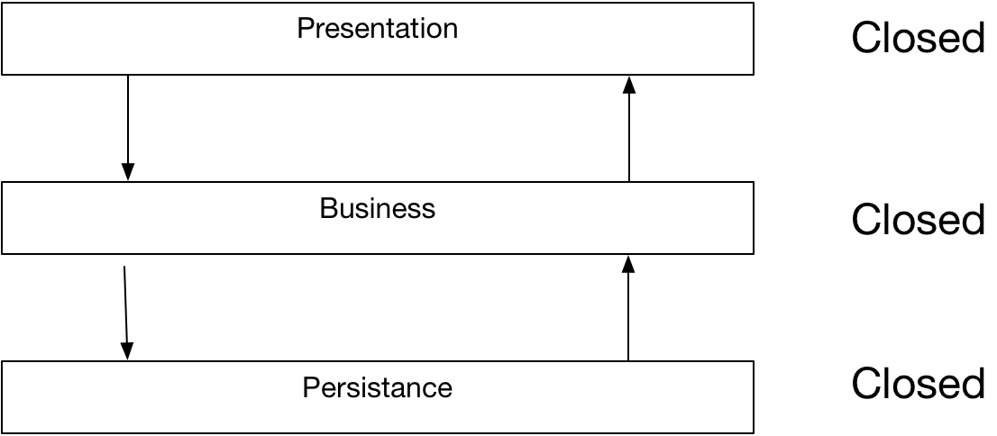
If a layer is marked as open, then a layer above it can bypass that layer.
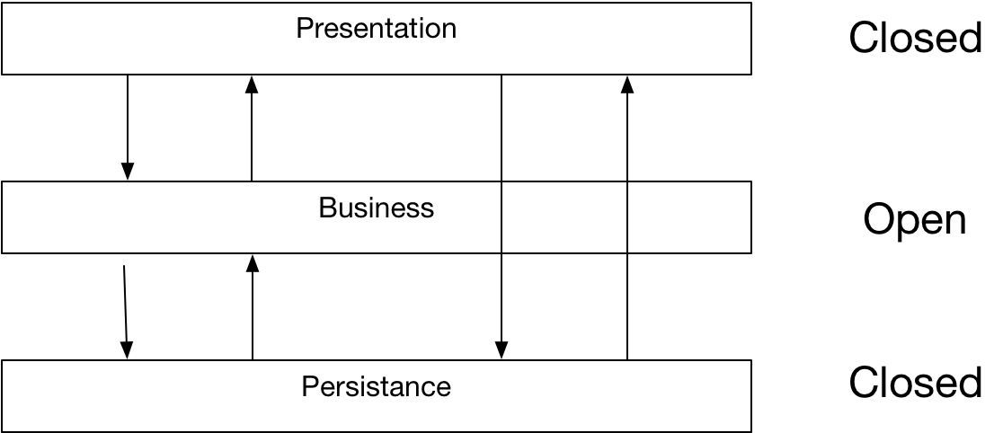

Layers Of Isolation
If all the layers are closed and we have well defined contracts between the layers we reduce coupling. In additions we can replace any layer without impacting the other layers. If we change the interface to any layer, we only impact the layer immediately above. The trade-off is that crossing layers is expensive, especially when deployed on tiers. Skipping layers can increase performance. The benefits of increased scalability, maintainability, extensibility, and flexibility often outweighs the performance costs.
If we mark a layer or multiple layers as open, we increase coupling which can lead to a more brittle architecture.

Sinkhole Anti-pattern

Agile Design
Agile design is a process, not an event. It’s the continuous application of principles, patterns, and practices to improve the structure and readability of the software. It is the dedication to keep the design of the system as simple, clean, and expressive as possible at all times. – Robert C Martin

Metrics

Coupling
If one package is tightly coupled to other packages it makes reuse harder. It also leads to unstable and brittle code bases where changing one part breaks other parts.

Cohesion
Cohesion measures how related the various parts of a module or class are to each other.
Attempting to divide a cohesive module would only lead to increased coupling
- Larry Constantine

S.O.L.I.D.

Single Responsibility Principle
A single class should have only one responsibility. If a class has multiple responsibilities, then changes to one responsibility can break the logic of the other responsibilities thus increasing brittleness. In cases where a module exposes a class that provides multiple responsibilities, clients of that module may be forced to recompile and redeploy when a responsibility on which they have no logical dependency changes.
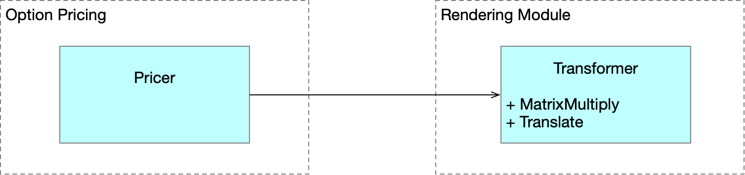
We can fix this as follows
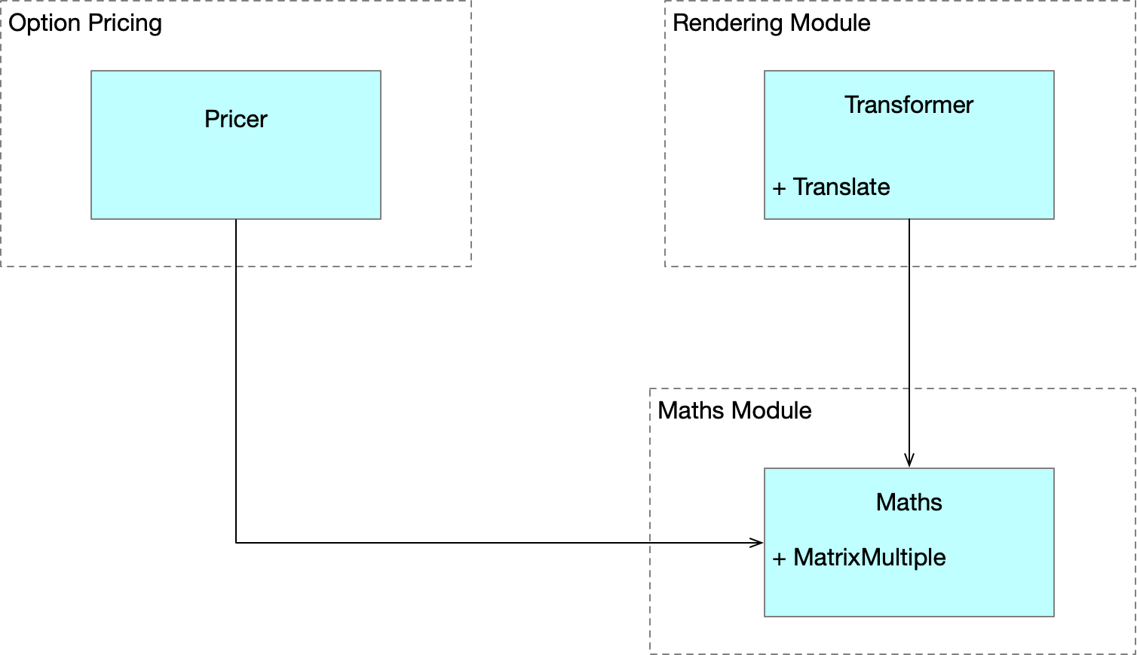

Classic violation
Mixing business rules and persistence is a classic example of breaking the Single Responsibility Principle. Patterns such as Façade, Proxy and DAO patterns can be used in such situations

Open Closed Principle
“The Open/Closed principle is at the heart of object-oriented design. Conformance to this principle is what yields the greatest benefits claimed for object-oriented technology: flexibility, reusability, and maintainability. – Robert C Martin
Types should be open for extension and closed for modification. Consider the following simple type hierarchy and a piece of client code which breaks the Open/Closed Principle
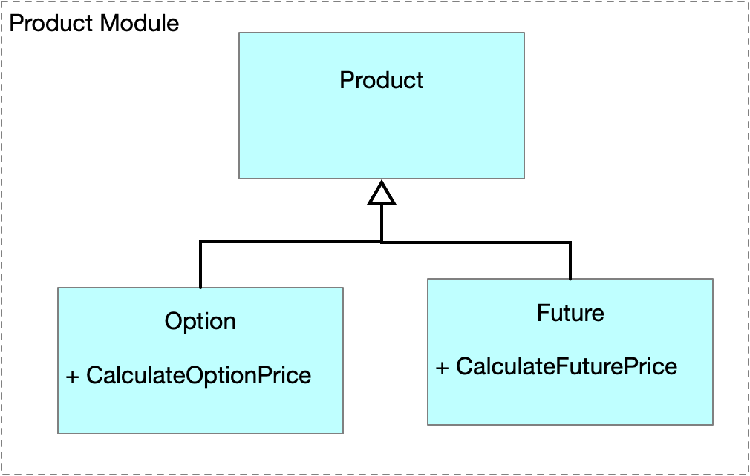
double PriceProducts(IEnumerable<Product> products)
{
double total = 0.0;

foreach (var product in products)
{
if (product is Option)
total += ((Option)product).PriceOption();
if (product is VarSwap)
total += ((VarSwap)product).PriceVarswap();
}

return total;
}

The use of abstractions and polymorphism enable us to modify our hierarchy and PriceProducts method to obey the open closed principle.
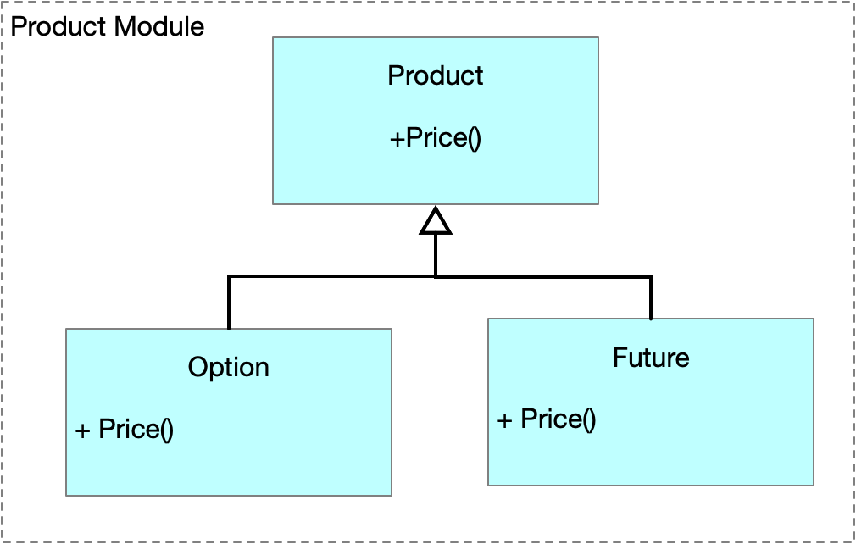
double PriceProducts(IEnumerable<Product> products)
{
double total = 0.0;

foreach (var product in products)
total += product.Price();

return total;

The primary enablers of the open closed principle are abstraction and polymorphism.

Limitations
It is impossible to design software that is open to extension in all contexts.

Liskov Substitution Principle
Replacing objects of a base-class with object of a subclass should not impact the correctness of the program. This is not just a question of type. An overridden method must have pre-conditions no more restrictive than the base class method and post-conditions no less restrictive than the base class method. This leads to an important point. The validity is determined by the clients of the design. Since are coded against the base-class that is all they know. A subclass cannot expect that clients obey preconditions more restrictive than those specified in the base class method. Similarly, a subclass cannot expect the clients to accept results that are less restricted than the results of the base class method.
The LISKOV Substitution principle is a key facilitator of the Open/Closed principle because it enables code that is expressed in terms of a base class to be extended without modification.

Interface Segregation Principle
Interfaces should form a cohesive whole. If one class of client uses some methods of an interface and a different class of client uses other methods it would be better to split the interface into two smaller interfaces. The basic idea is that we do not make clients depend on interface methods that they never use,

Dependency Inversion Principle
In historic structured design methodologies high level modules depend on lower-level modules and policy depends on detail. The DI Principle says this is wrong as it leads to a situation where it is difficult to use the high-level policy in different contexts of use. Consider the following diagram. Because dependencies are transitive the high-level policy module is dependent on both the medium level module and the low-level module. Notice dependencies always flow in the direction of arrows.
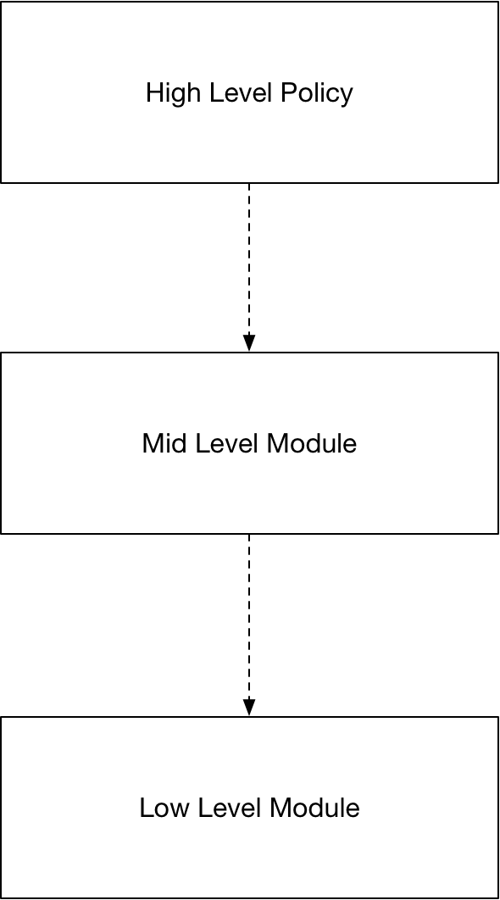
The DI Principle states that the high-level policy that specifies business rules should be independent of low-level implementation details. We can restructure our illustrative example as follows. Notice the directions of the arrows. Higher level modules never have dependencies on lower level modules.
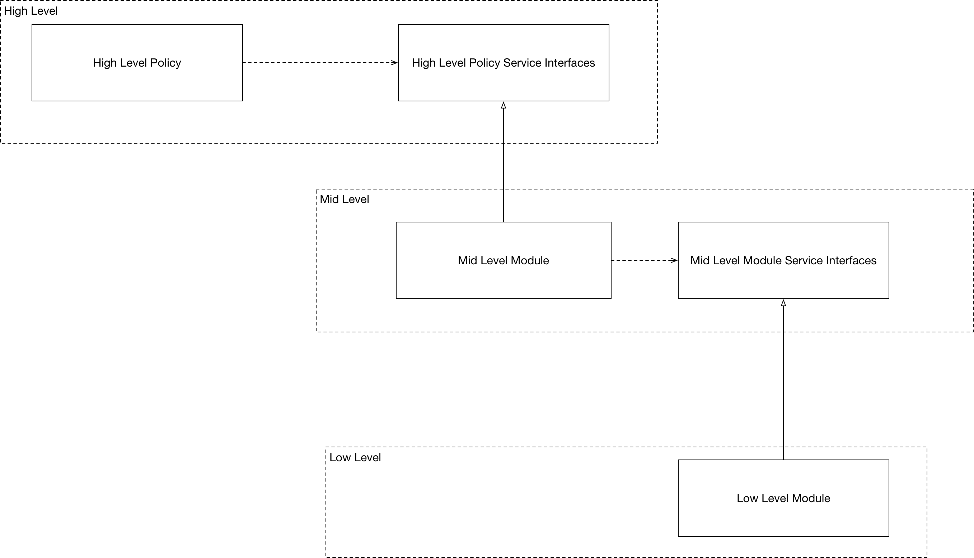

Code Smells

Rigid
Rigid code is hard to change often because a small change in one part of the codebase leads to large number of cascading changes in other seemingly unrelated parts.

Fragile
Fragile code is easy to break. A single change in one part of the codebase breaks other seemingly unrelated parts.

Immobile
If software has functionality that would be useful to use elsewhere but we don’t do so because it is so hard to separate out the logic we say it is immobile.

Viscous
Viscosity makes it hard to change the software in a way that preserves the design leading developers to make hacks instead. Viscosity can be caused by the environment or by the code itself.

Needlessly Complex

Needlessly Repetitive
Can be fixed by factoring out appropriate abstractions.

Opaque
Code is written in a convoluted and hard to understand form.

Questions -Agile Design
What is SOLID?
 | Column Header
Single Responsibility | A class should have one responsibility
Open Closed Principle | Open for extension, closed for modification
Liskov Substitution Principle | Replacing objects with sub-type instances should not break the code
Interface Segregation | Multiple specific interfaces are better than one large one
Dependency Inversion | One should depend on abstractions, not concrete types

Why is SRP important?
If a class has multiple responsibilities, then changes to one responsibility can break the logic of the other responsibilities thus increasing brittleness.

Creating an Architecture
To produce an architectural solution, the software architect considers
Inputs To The Architectural Process
- Use cases – how the application will be used
- Functional and non-functional requirements
- Technology requirements
- How the application will be deployed and managed
The architect must decide on the most appropriate application type, architectural style(s), technologies, and deployment methods. Each draft should be tested against scenarios known constraints, and quality attributes.
 | Description
1. Goal | A goal might be to create a prototype or a complex systems architecture
2. Key Scenarios and Use Cases | These will be used to evaluate candidate architecture
3. Application Type | Are we building a thick client, web application etc.
4. Deployment Constraints. | Corporate policy might restrict the protocols or network topology on which the application will be deployed. Attributes such as security and reliability will also impact the deployment
5. Architectural Styles | Come up with architectural styles such as message bus, SOA etc.
6. Decide on technologies | The choice of technology will be influenced by the application type, deployment constraints and architectural styles.
7. Whiteboard the architecture | If you can’t it is sure you don’t understand it
8. Quality attributes | Consider Usability, performance, reliability, security
9. Cross-cutting concerns | Authentication and authorization, caching, configuration, Logging

Architectural Patterns

Transaction Script
Each user request originating in the presentation layer is processed by a single procedure known as a transaction script. Typically, a transaction script executes as a single database transaction.
TS is suited to simple use cases. Ideally the logic is unlikely to change much. Might be used for a web portal onto an existing back end.
In more complex cases can lead to code duplication without careful refactoring.

