Mathematical Cheat Sheet

Factorizing Polynomials

1. Common Factors Extraction of highest common factors

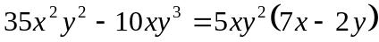

2. Grouping Four termed expressions can sometimes be factorized into two binomial expressions

3. Factorisation of quadratic expression 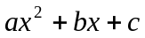

  - If c is positive, select factors of ac whose sum equals |b|, both factors have the same sign as b
  - If c is negative, select factor of ac whose difference equals |b|. The numerically larger takes the sign of b
  - Write factors as f1 and f2
  - Re-write as 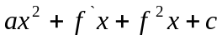
  - Factorize by grouping

4. Standard factors of quadratic polynomials
- 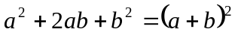
- 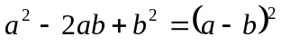
- 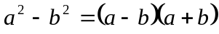

5. Test for simple factors

A quadratic polynomial can be written as the product of two simple factor if 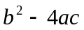is a perfect square

6. Solving quadratic equations with no simple factors

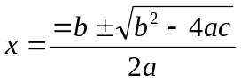

6. Remainder/Factor theorem
If a polynomial f(x) is divided by (x-a) the quotient g(x) is a polynomial of degree one less than f(x) and a remainder R still do be divided by x-a

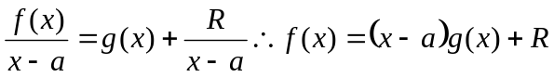

If x = a 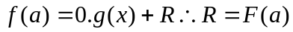 furthermore if f(x) is a polynomial and substituting x=a gives a remainder of zero then x-a is a facor

7. Solving higher order polynomials

We can solve higher order polynomials by using the remainder theorem to find simple factors, dividing through until we get a quadratic which we can factorize using the formula

Partial Fractions

1. Simple case

An equation of the form 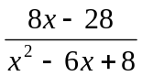can be written as partial fractions 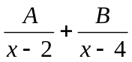
We then solve the identity

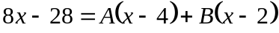

2.

If the degree of the numerator is more than the degree of the denominator we must divided out to get a polynomial with remainder which has numerator less than denominator. This remainder can then be broken into partial fractions as above

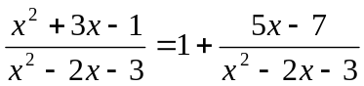 which we can now break down into partial fractions as above

3. Irreducible quadratic factor in the denominator

Gives rise to a partial fraction of the form 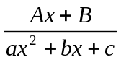

4. Repeated factors in the denominator

Gives rise to the partial factor of the form
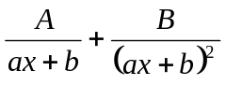or for a cubic repeat 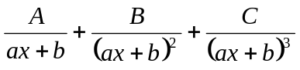

Trigonometric Identities
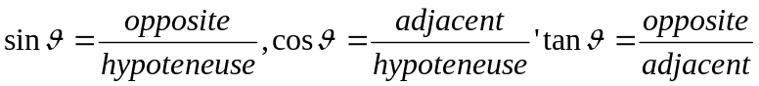

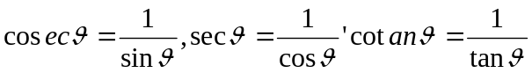

Special Triangles (i) Isosceles

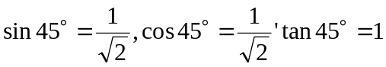
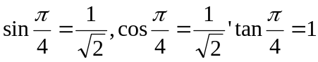

Special Triangles (ii) Half-equilateral

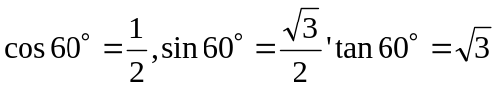
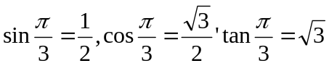

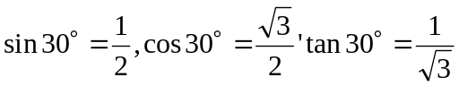
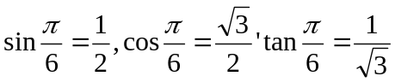

Fundamental Trigonometric Relationships

Fundamental Trigonometric identities
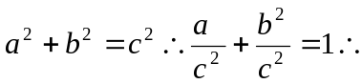
Identity 1
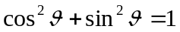

Dividing both sides by 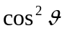we get 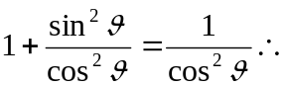
Identity 2
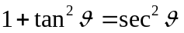

Dividing both sides of the fundamental identity by 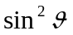we get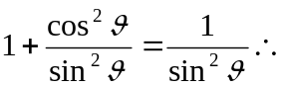
Identity 3
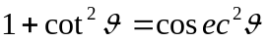

Differentiation

Differentiation
- The expression is called the derivative of y with respect to x
- The derivative of a straight line 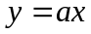 is given by 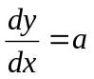
- The derivative of a curve 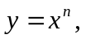is given by 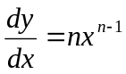
- Alternate notation 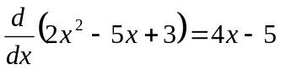
- 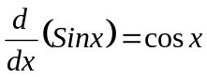
- 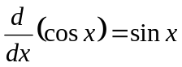
- 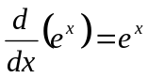
- Second derivative 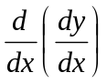is written as 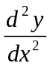

- Product of Functions
  - Let 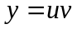, where u and v are functions of x
  - 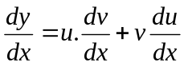
- Quotient of Functions
  - Let 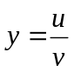 where u and v are functions of x
  - 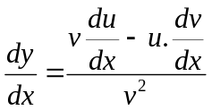
- Function of Functions and the chain rule
  - Let 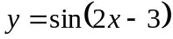 then y is a function of the angle 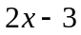which is itself a function of x
  - Therefore y is a function of ( a function of x )
  - If 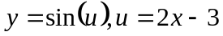
  - 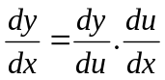

Integration
- 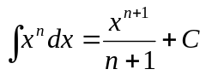
- The area under the curve 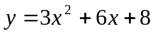 between 1 and 3 is given by
  - 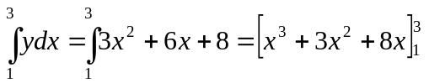
Partial Differentiation
- Consider the expression for the volume of a cylinder 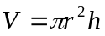
- We can calculate the partial derivative of V with respect to h
  - Differentiate the expression keeping all symbols except V and h constant
  - 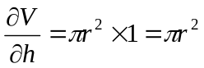
- We can calculate the partial derivative of V with respect to r
  - Differentiate the expression keeping all symbols except V and r constant
  - 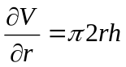

- Definitions
  - If 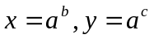 then 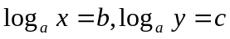
  - E.g. 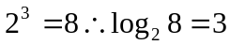, 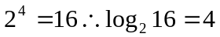
- The log of a product equals the sum of the logs
  - 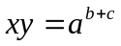 hence 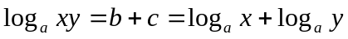 that is
  - 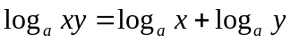
  - 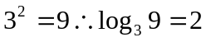, 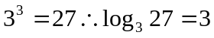
  - E.g.
- The log of a quotient equals the difference of the logs
  - If then
  - 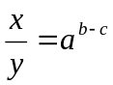 hence 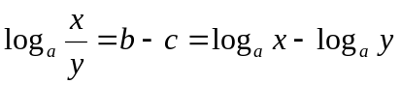 that is
  - 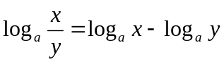
- The log of a number raised to a power is the product of the power and the log of the number
  - 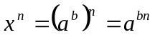 therefore
  - 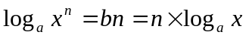 so
  - 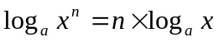
  - E.g. 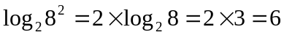
- The logarithm of 1 to any base is zero from the laws of powers
  - 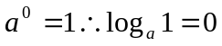
  - 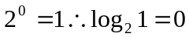
- 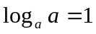
  - 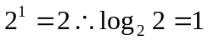
- 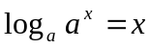
  - 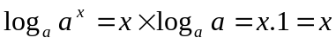
  - E.g. 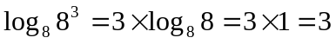
- 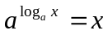
  - 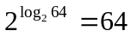
- 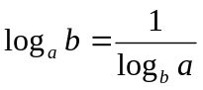
  - 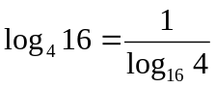

Converting between bases
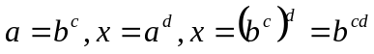
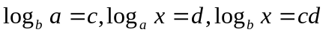
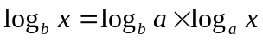

In English we convert logarithm of x from base a to b as follows
- Take logarithm of x using old base a
- Take the logarithm of the old base to the new base
- Multiple the two together

So for example to convert 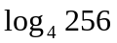to base 2 as follows
- 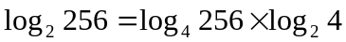

Calculus

Differentiation

Definitions:
- The gradient of the curve at some point P is equal to the gradient of the tangent to the curve at P
- The expression is called the derivative of y with respect to x
- The process of finding the derivative is called differentiation

Differentiation:
- The derivative of a straight line is given by
- The derivative of a curve is given by
- To differentiate a polynomial we differentiate each term in turn

Alternate Notation:
- If 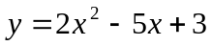then 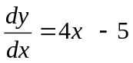
- We can write this using the following alternate notation
Second Derivatives (and higher order derivatives)

- We can differentiate a derivative to obtain the second derivative
- is written as
- We can find higher powers in the same way

Products of Functions:
- Let , where u and v are functions of x

Quotient of Functions:
- Let where u and v are functions of x
Function of Functions and the chain rule
- Let then y is a function of the angle which is itself a function of x
- Therefore y is a function of ( a function of x )
- If

Integration

Definitions:
- Integration is the reverse process to differentiation.
- When we differentiate, we start with an expression and proceed to find its derivative.
- When we integrate we start with the derivative and find the expression from which it has been derived
  - 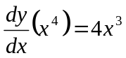Therefore, the integral of 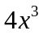with respect to x is
  - 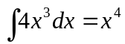
- When we integrate we lose the constant from the original which we denote C
  - +C

Standard Integrals:

Rules:
- To integrate a polynomial we integrate each term one by one with individual constants of integration consolidated into a single symbol C

Area under the curve
- We calculate the area under the curve by calculating the definite integral
  - The area under the curve between 1 and 3 is given by
  - Equals 66 square units

Partial Differentiation

- Consider the expression for the volume of a cylinder
- V depends on two quantities, the values or r and h
- We can calculate the partial derivative of V with respect to h
  - Differentiate the expression keeping all symbols except V and h constant
- We can calculate the partial derivative of V with respect to r
  - Differentiate the expression keeping all symbols except V and r constant

