Derivation of BS PDF
Assume our stock price follows a Wiener process given by 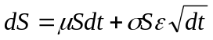then changes in a function of S and t will be given by an Ito process

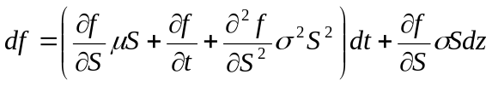

We could consider this the process for a call option struck on S at time t. Furthermore we can set up a portfolio of a short call and long 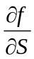stocks. The change in this portfolio will then be given by

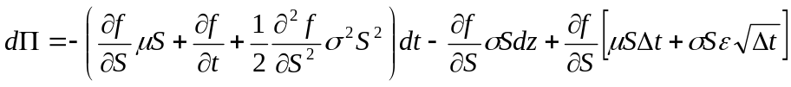
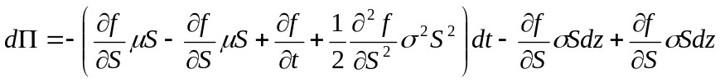

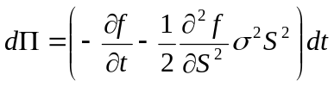
We have now eliminated all randomness from our process. It must hence grow at the risk-free rate

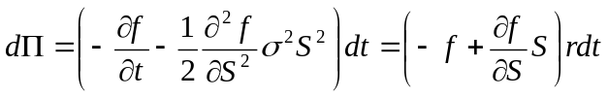

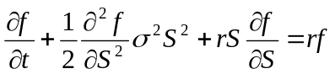

Risk-Neutral proof of call price
We have shown above that a portfolio of a short call and long delta stocks is riskless over infinitesimal intervals. This means that the portfolio must grow at the risk-free rate.

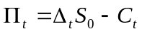

And that its expected value at time T is given as

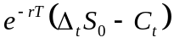
But we can also use the boundary values of and C to calculate the expected value of 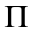. If the option expires in the money the delta will be one and the portfolio will be worth 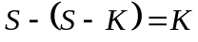On the other hand if the stock expired out of the money the delta will be zero and the portfolio will be worth zero so the portfolio expected value at expiry is then 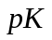where p is the probability of the option expiring in the money. If we equate this value with the above we obtain.

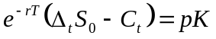

But we can calculate the probability of expiring in the money from the properties of the Wiener browning motion model of the stock price evolution – see appendix A.

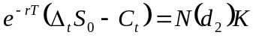

Re-arranging we get

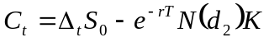

But we now need to derive 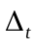

First we note that it can be shown that

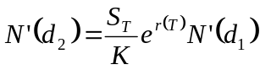

So we take our original expression

And differentiate with respect to S

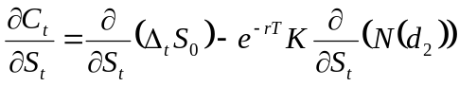

By definition

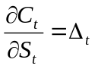

So we get

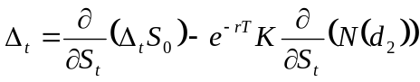

Expanding the first term on the rhs using the product rule

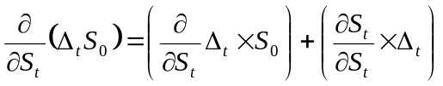

Note that
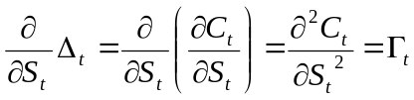

So now we have

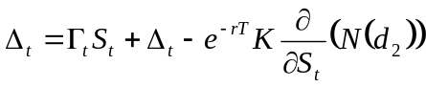

Now we expand the third term using the chain rule

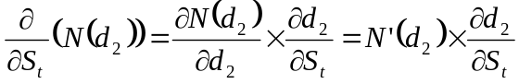

But we know that

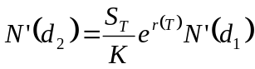

So we rewrite the third term

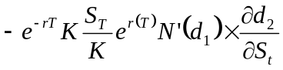

So we need to calculate

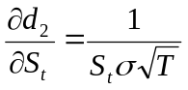

Substituting in

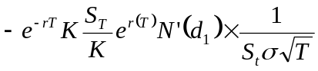
Cancelling
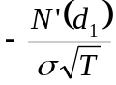

Putting the whole thing together

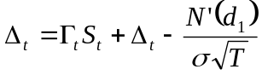

Re arranging

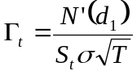

We can integrate this with respect to S noting first that

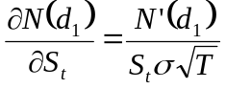

So by definition

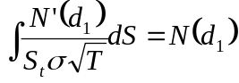

And of course

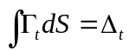

So we get

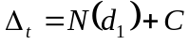

And to meet the boundary conditions C must of course be zero

So we have now proved in a non-rigorous manner the BS formula for European call on non-dividend paying stock

Show that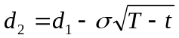
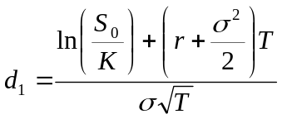
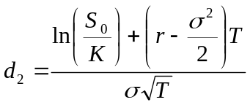

We start by separating out the terms on the numerator

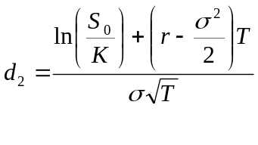
To get

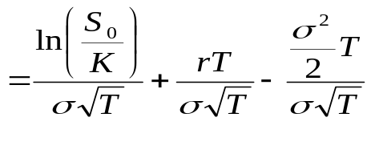

Now note that

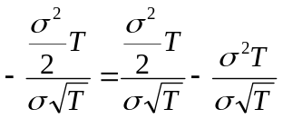

To get

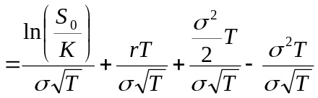

And finally

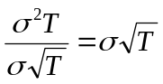

Show that

Show that if the equation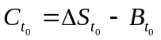then a hedging portfolio of 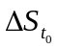stocks and 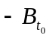bond is self-financing

First we note that if is the correct value of a European call we can replicate is by entering into a hedging portfolio of stocks and bond and then continually rebalance it so that at all times we hold 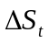stocks and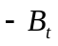bonds.

The cost of this hedging strategy is equal to the initial setup costs 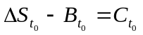plus any rebalancing costs. We can say 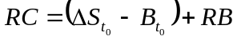

But if the formula is correct the value 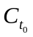must be equal to the NPV of all future cash-flows then there cannot be any other cash flows not accounted for by 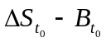

Since there are no costs other that the initial setup costs we can see that the hedging portfolio must be self-financing.

From the BS formula for European Call along with Put-Call parity to derive the price of a European put

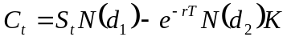

And put-call parity is of course

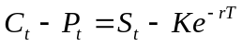

Substituting for C we get

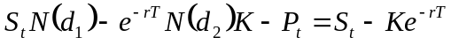

Re-arranging to get P on the LHS

Bringing terms in S and K together and factorising

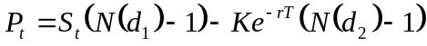

Therefore

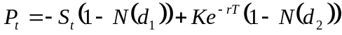

Now we note that

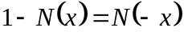

To write the put price as

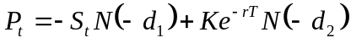

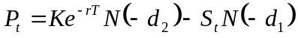

From the BS formula for European Call derive the call delta and then put delta

Therefore

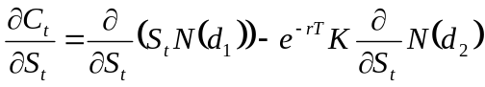

First we know that

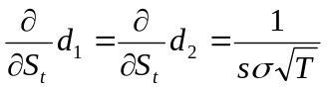

And by the chain rule we know that

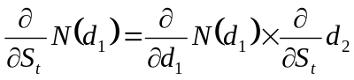and 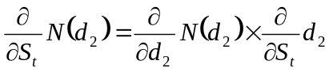

We also know that by the product rule

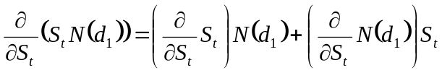

Putting this all together

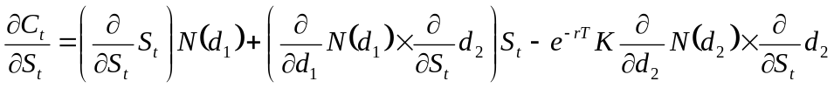

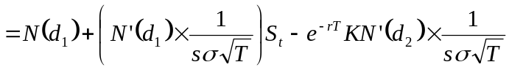

Finally we use the result that

To get

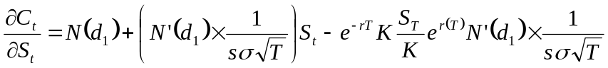

Cancelling

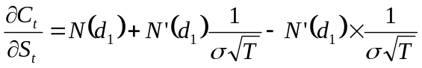

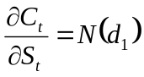

And of course we can use put-call parity to show that

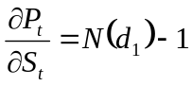

Now use the put/call delta to derive the gamma

Hence

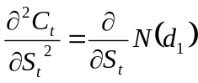

So by the product rule

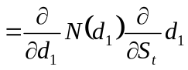

So we have

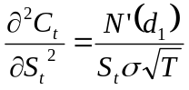

And of course since

Then of course put gamma is just the same

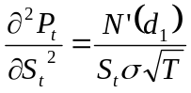

From the BS formula for European Call derive the call rho

First we note that

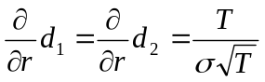

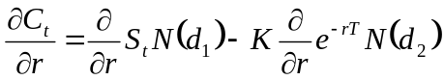

Consider the first term

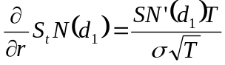

Now the second term

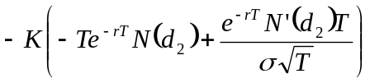

And note that

So we get

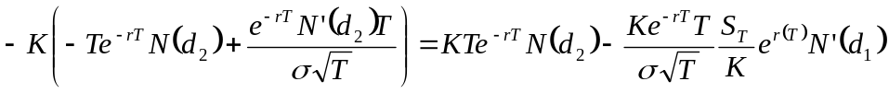

Cancelling terms and adding back in the original first term
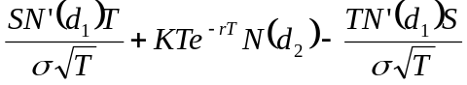

Hence

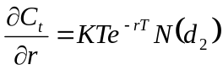

From the BS formula for European Call derive the call vega

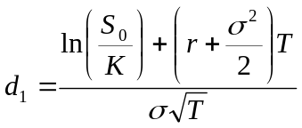

So we get

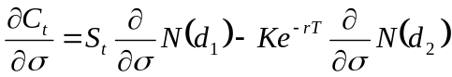

Applying the chain rule to each term

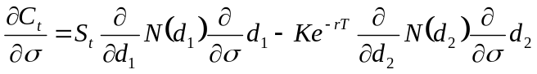

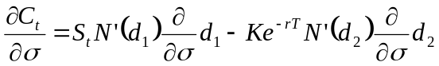

But we know that

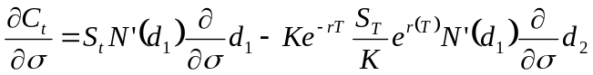

Cancelling

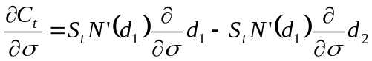

Now we note that

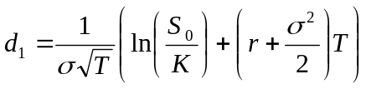

So by the product rule

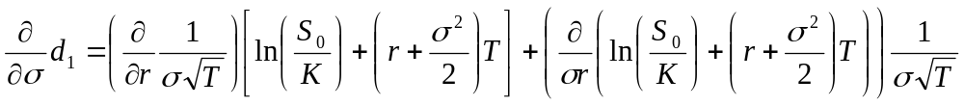

Taking each term in turn

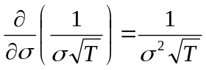

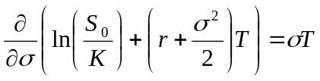

Putting it together

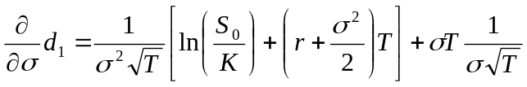

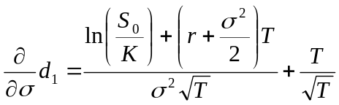

And similarly

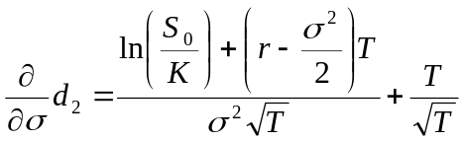

Now we put these back into our original

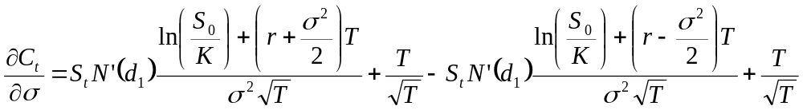

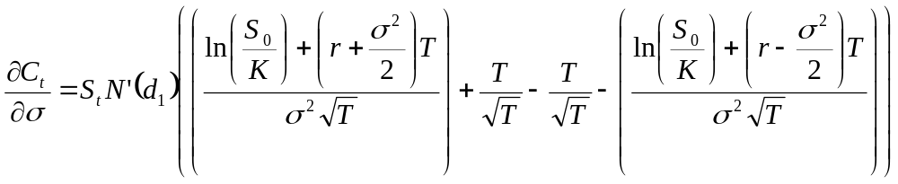

Cancelling all the terms we get

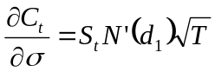

The Vega of a European put is the same as the Vega of a European call.

Why is the vega of a European put equal to Vega of a European call?

From the BS formula for European Call derive the call Theta

So we start the differentiation with respect to time

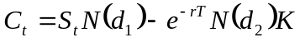

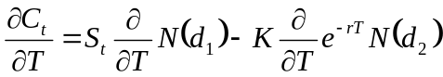

Applying the chain rule and the product rule

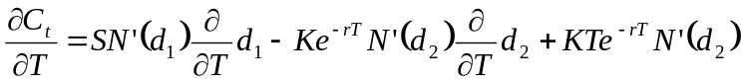

Extend the Black-Scholes equation for a put and a call to deal with the situation where the underlying stock pays Lumpy Dividends

If we define D as the NPV of all dividends from value time until the option expiry given by

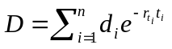

Then we calculate

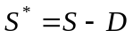

And
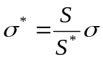

The value of the call/put is then just the value of the call and put using the original Black-Scholes formula using 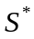as the spot level and 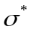as the volatility

Extend the Black-Scholes equation for a put and a call to deal with the situation where the underlying stock pays a Continuous dividend yield

The value of the call and put is just the value of the call and put using the original Black-Scholes formula and substituting 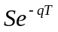for every occurrence of S. where q is the continuous dividend yield from value time until expiry of the option.
Appendix A – Probability of a stock exceeding a given level

Initial derivation
How would we go about calculating the probability that a given stock with price 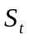at time t will exceed some level K at time T if the instantaneous rate of return is r and the annual volatility is? In other words, we need to know the probability that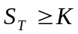. In order for the terminal stock price to be greater than K then we need

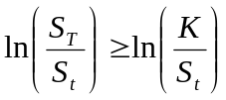

The first point of note is that if the stock price process follows a Brownian motion then the returns over some time interval 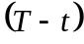 will be normally distributed with mean 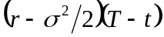and standard deviation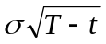. Furthermore, from the properties of the normal distribution we know that the random variable

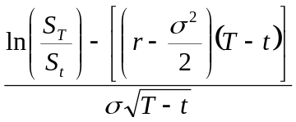

will be normally distributed having mean zero and standard deviation one. We re-write our original inequality in terms of the new distribution.

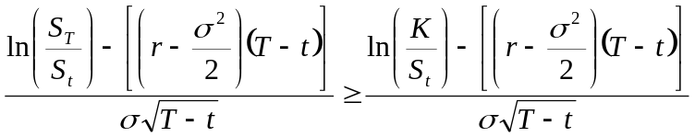

The left hand side of this inequality is a normally distributed random variable having mean zero and standard deviation of one. In order to use the standard cumulative normal distribution we require an inequality with a less than sign. We multiply both sides by negative one.
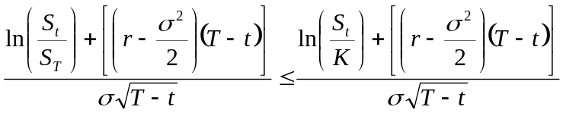

Re-arrangement
We can re-arrange the right hand side of our inequality as follows.

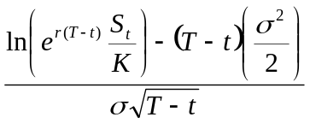

We simply note that

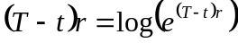

And

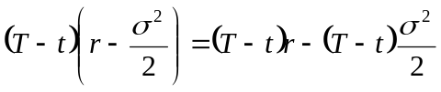

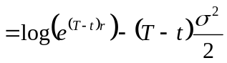
So re-writing the original write hand side, we get

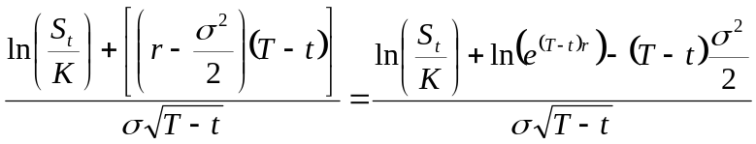

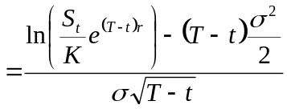

Interpretation
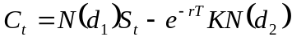
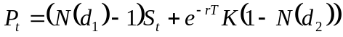

Call
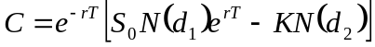

The two terms inside the square brackets can be interpreted as the

- Expected value of the stock price if it exceeds the strike
- The probability the strike will be paid multiplied by the strike

We consider each in turn. Consider the probability that the strike is paid. We know the continuously compounded return is a normally distributed random variable having mean 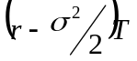 and standard deviation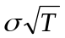. In order for the strike to be paid

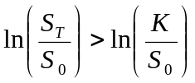

We need to covert our normally distributed random variable to a random variable with a mean of zero and a standard deviation of one. We note that if a random variable with having mean and standard deviation then the random variable

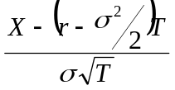is normally distributed with mean zero and standard deviation one. We convert our original inequality so we get

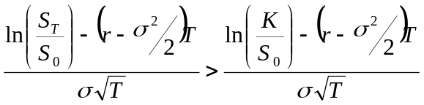

The left hand side is now a normally distributed random variably with mean zero and standard deviation of one. In order to use the cumulative normal function however we need a less than or equal to inequality. We multiply the right hand side by minus one.

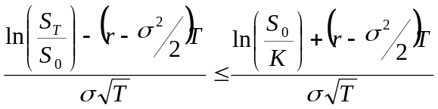

We now have now derived 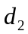.

Put

We know that the cumulative normal distribution has the property 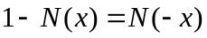 and that 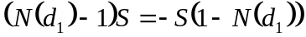

In the same way as the call example, we can interpret the two terms inside the brackets as follows. The first term is the expected value of the stock price if the value is below the strike multiplied by negative one to indicate this is what we pay. The second term is the strike price multiplied by the probability of the terminal stock level finishing below the strike strike.

