Putting it together: scaling and shifting
We now know that if we have a process with mean zero and variance one we can scale and shift it to a process with mean and variance 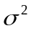by adding and multiplying by 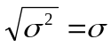. Our new random variable 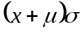is now distributed with mean and variance

Even more useful is the fact that if we know that a random variable is distributed with mean and variance then we also know that the random variable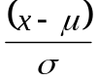 is distributed with mean zero and variance one

Increasing the number of steps
From our previous sections we can see that if we sum n identical independent random variables with mean zero and unit variance we obtain a new random variable

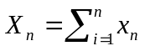

With mean zero and variance. But what happens as we increase the number of steps? In the limit as 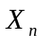is normally distributed with mean 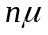and variance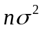.

Using the standard normal distribution
The standard normal distribution with mean zero and standard deviation has been studied extensively and its properties are well known. So if we have a random variable which we know is normally distributed with mean and variance then we can represent it via a scale and shift of the standard normal distribution 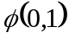as follows

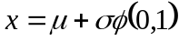

Stochastic time series

Overview
We know from the previous section that the sum of n identical, independently distributed random variables with mean and finite non-zero variances  is a random variable with mean and variance.

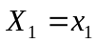 Mean and standard deviation
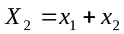 Mean 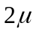and standard deviation 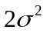
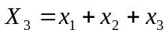 Mean 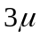and standard deviation 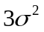
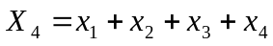 Mean 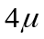and standard deviation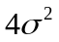
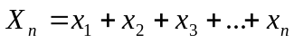 Mean and standard deviation

What if we were to replace the subscript n with the subscript t as follows?

Mean and standard deviation
Mean and standard deviation
Mean and standard deviation
Mean and standard deviation
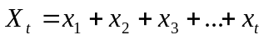 Mean 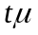and standard deviation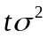

We can view 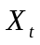as a random variable which describes the displacement of a particle that starts at the origin and is displaced the distance at time t.

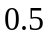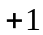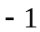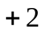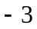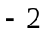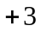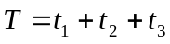
Two sample paths through the above distribution

Once again note that it is the variance that scales linearly. The total variance in this example is three so each individual part has variance one.

A stock price process

Zero interest rates
Consider a stock price that starts at some level 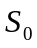.On each tick one of two equally probable outcomes can occur; either the stock moves up by one dollar or it moves down by one dollar. Over three ticks we could model our stock using the process in the previous section with one small modification; we adjust the mean to be the current stock level.

We have created a simple stochastic process to model the change in value of our stock over time. We know from the introductory sections that if over one unit of time our stochastic process has variance and mean zero then over a period of time T it will have variance 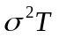

We also know that if we break down a stochastic process with variance into n equal steps represented by the random variables then at each step we will need the variance of to equal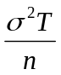. The change in our asset price can then be modelled as 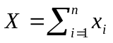

In the limit as n tends to infinity the steps in our stochastic process become finer and finer but the total variance remains atAlso our process converges to a Gaussian variable of mean zero and variance and hence 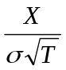is normally distributed with mean zero and variance one.

We can hence represent the change in our stock price over the time T as the stochastic process

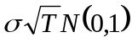

And we can represent the terminal value of our stock price over the time T as the stochastic process

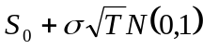

A more realistic stock price process
In the previous section we created a very simplistic stock price model where at each point in time a stock would move up or down by some equal amount and mean value of the stock price process at the end of the period was the same as its value at the beginning. We now consider a more realistic stock price model

The Markov property
The value of given 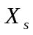is that determined by 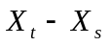and so the behaviour of is totally unaffected by the values of 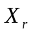for r less than s. This is known as the Markov property.

Normal distribution notation
Normal distribution with mean zero and variance of one
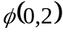 Normal distribution with mean zero and variance of two
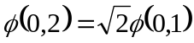
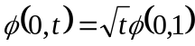

If a process has a variance of per unit of time then we get

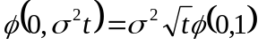

Brownian Motion
We say that a stochastic process 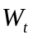 is a Brownian motion if it has the following properties.

- 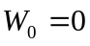
- For every s less than t, 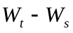is normally distributed with variance 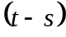.

From these properties it follows that

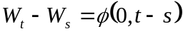.

In the limit as tends to zero we get

.

We can then represent a process with non unit variance as

Stochastic differential equation
We extend this notion to define a family X of random variables that satisfy the stochastic differential equation.

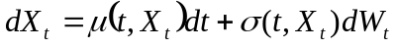

Dropping the parameters of the drift and volatility we get a general stochastic differential equation for a variable with a constant growth or drift rate plus some noise.

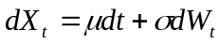

Ito Calculus

Taylor series expansion of function of two variables
Given a normal function of two variables 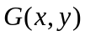 the Taylor series expansion gives us

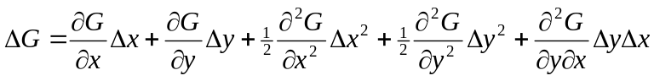

In the limit as 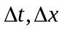tend to zero we can drop the second order terms and obtain

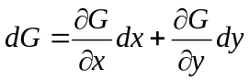

Extending Taylor series expansion to Ito
Now consider the situation where a variable x follows the Ito process

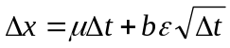

Furthermore if G is a function of x and t then we can write

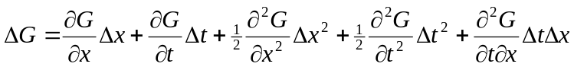

In this case we cannot exclude the 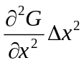term for the following reason

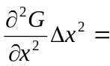

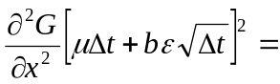

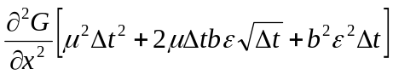

Inside the square brackets, we obtain a first order term so we need to include this to get

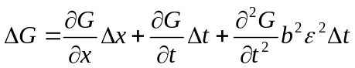

However, it can be shown that in the limit as change in t tends to zero then 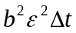tends to 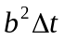. We now obtain

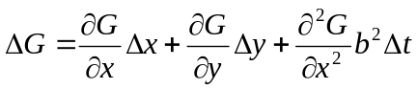

Substituting in we obtain

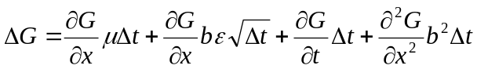

Re-arranging we get

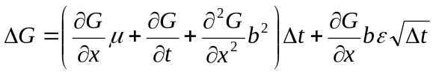

In the limit as the change in t tends to zero we obtain

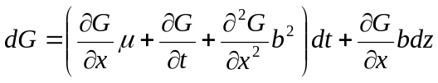

Deriving the lognormal process for stock prices from Ito
If we believe that the change in stock prices over a small interval of time can be modelled by the following stochastic differential equation

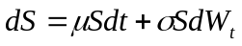

Then we can use Ito to show that the distribution of prices at some later time T is lognormal. We consider the function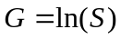. Ito tells us that

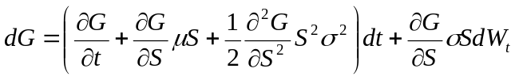

We know from ordinary calculus that if then 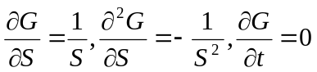

Plugging these into our stochastic differential equation we obtain

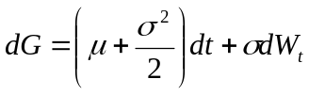

So we have shown that the change in the logarithm of the stock prices is a Wiener process with mean 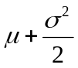and standard deviation. This is the same as saying the continuously compounded return is a Wiener process with mean and standard deviation.

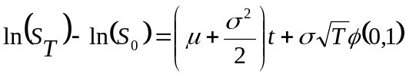

From this we can see that the logarithm of the terminal stock price is normally distributed with mean 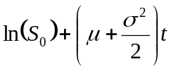and variance 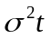

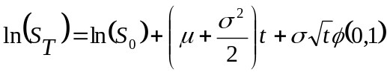

One well known result from statistics is that if the logarithm of variable is normally distributed then the variable itself will be lognormal.

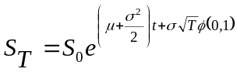

Appendix A – A short introduction to differential equations
If we have the differential equation 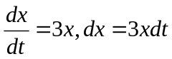how do we back out a solution. A little intuition can show that 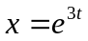is a solution since

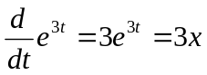

Is it the only solution though? It is not because any equation of the form

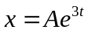

Where A is any constant is also a solution. We now solve the same equation but change the variable names.

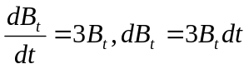
Once again we have the same solution

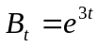

because

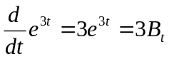

We can also very easily change the original differential equation to

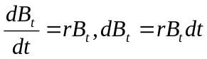

the solution becomes

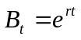since 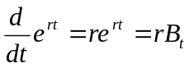

Since any equation of the form 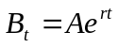is a solution we choose the initial condition to be the value of B at the start which we denote 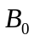and the solution to our differential equation becomes

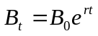

Appendix B – Probability of a stock exceeding a given level

Initial derivation
How would we go about calculating the probability that a given stock with price 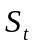at time t will exceed some level K at time T if the instantaneous rate of return is r and the annual volatility is? In other words, we need to know the probability that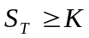. In order for the terminal stock price to be greater than K then we need

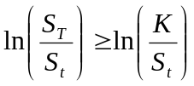

The first point of note is that if the stock price process follows a Brownian motion then the returns over some time interval 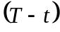 will be normally distributed with mean 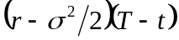and standard deviation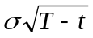. Furthermore, from the properties of the normal distribution we know that the random variable

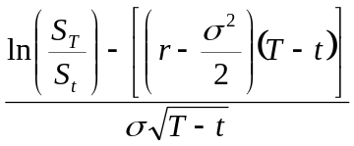

will be normally distributed having mean zero and standard deviation one. We re-write our original inequality in terms of the new distribution.

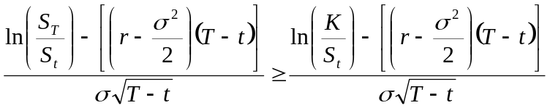

The left hand side of this inequality is a normally distributed random variable having mean zero and standard deviation of one. In order to use the standard cumulative normal distribution we require an inequality with a less than sign. We multiply both sides by negative one.
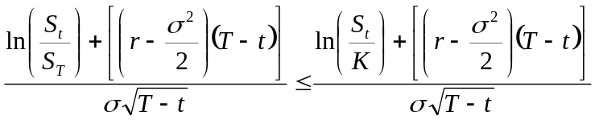

Re-arrangement
We can re-arrange the right hand side of our inequality as follows.

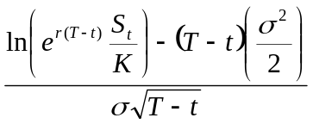

We simply note that

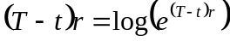

And

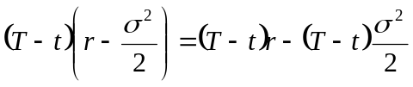

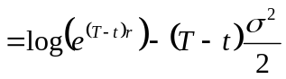
So re-writing the original write hand side, we get

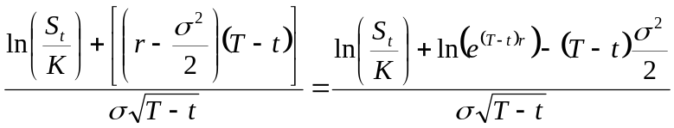

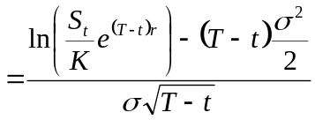

Deriving the Black-Scholes differential equation
Assume our stock price follows a Wiener process given by 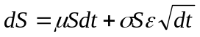then changes in a function of S and t will be given by an Ito process

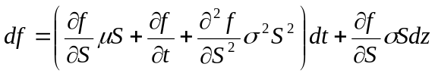

We could consider this the process for a call option struck on S at time t. Furthermore we can set up a portfolio of a short call and long 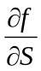stocks. The change in this portfolio will then be given by

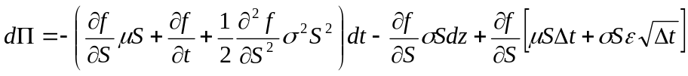
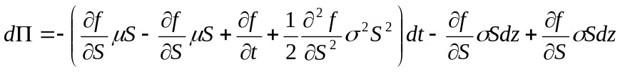

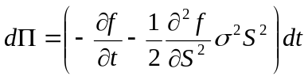
We have now eliminated all randomness from our process. It must hence grow at the risk-free rate

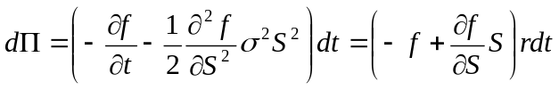

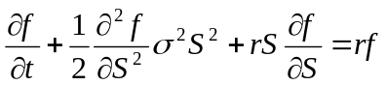

Might need stuff

Transforming to standard normal distribution
One standard property of the mean of a distribution is that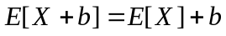. If a random variable has mean

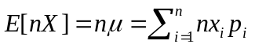

Then 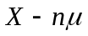is a random variable with mean zero

Finally we can scale our variable to have a standard deviation of one by performing

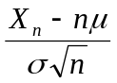

Again for a proof of this scaling find a proper mathematician

