Logical Trees

UI Structure

Nodes with more than one child

Source code



Lopgical tree

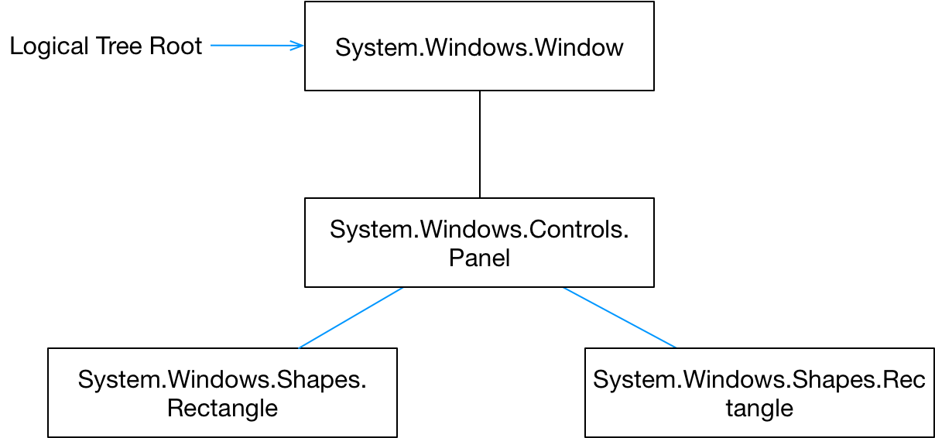

Questions

Compare and contrast the logic and visual trees

The logical tree is typically defined by the XAML. A node in the logical tree is often a FrameworkElement or Control. Each node in the logical tree can map to many nodes in the visual tree. For example a single ListBox in the logical tree is composed of many visual elements such as scrollbars, borders etc

ContentControls have a single child. How can we add more than one child to such an object?

By using a Panel