Vector Graphics

Rendering Shapes

Vector graphic are used to render lines, paths and shapes to screen. The building blocks of vector graphics in WPF are Segments which are strung together end to end to form PathFigures. Multiple PathFigures can be combined to form a PathGeometry.

`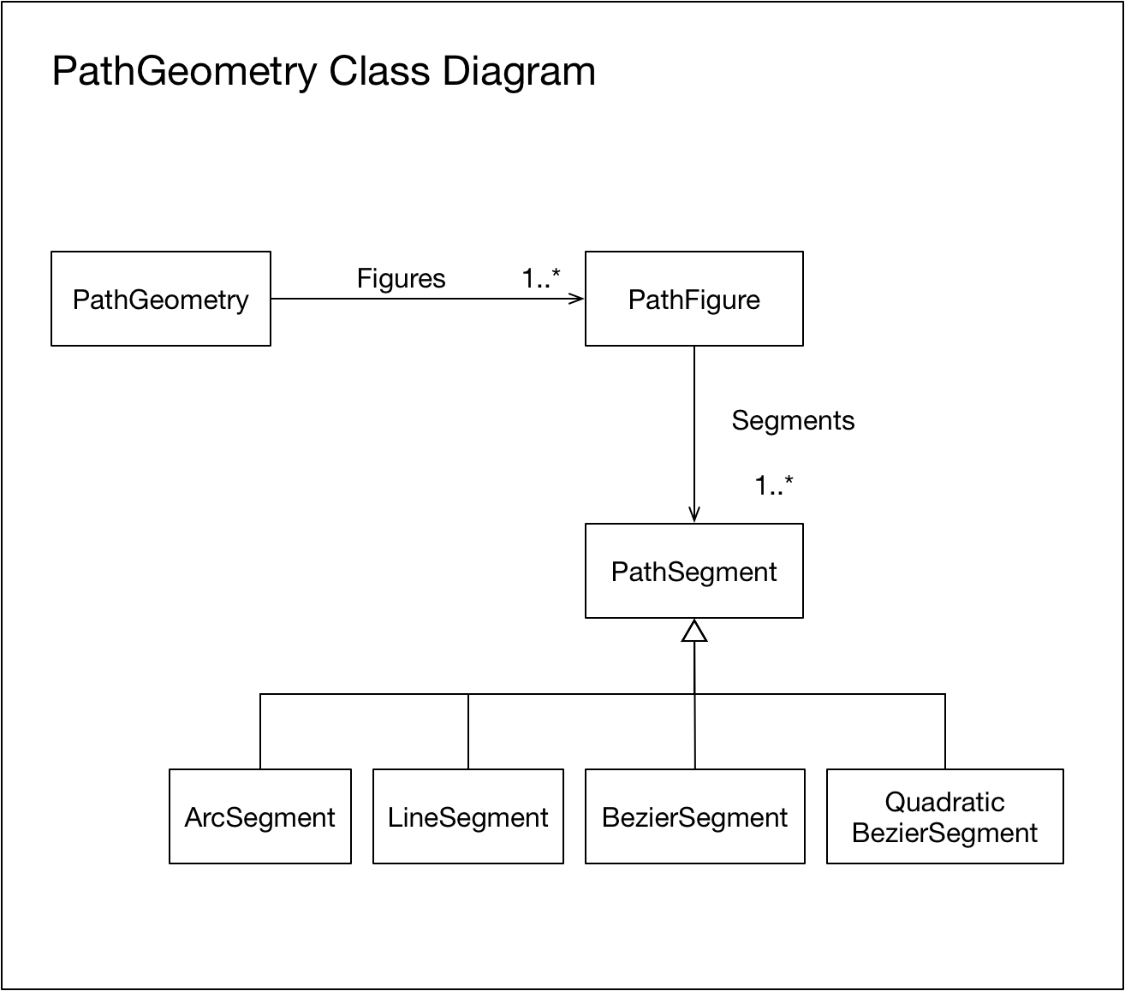

We now show how to construct shapes using lines, arc and Bezier segments. Each Path element has the following basic settings

# Scalar Segment Types

## Line Segments





## Arc Segments



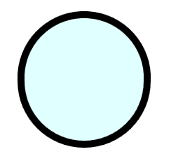

## Bezier Curve (Cubic)



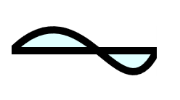

## Bezier Curve (Quadratic)



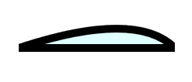

All the above sections use a standard piece of XAML styling in order to set the width and font

## Arc Segments

Arc segments can be a little tricky to use so we look at them in a little bit more detail. The following arcs are for an ellipse with x-radius 200, y-radius 150 that connects the points (400,100) and (400,300).

1. Large arc in the clockwise direction
2. Large arc in the counter clockwise direction
3. Small arc in the clockwise direction
4. Small arc in the counter clockwise direction

