Functions

A function maps elements in a set X to elements in a set Y.

$$f:X→Y$$

The set X is called the domain and the set Y is called the codomain. Evert element in X must be mapped to an element in Y although different values in X can map to the same value in Y. If $x∈X$ then the unique element $y∈Y$ that x maps to is called the value of x under f or $f\left(x\right)$ The set X is called the domain and the set Y is called the codomain. Any specific value of x must map to only one value in Y, however multiple values of X can map to the same value in Y. There may be values in the codomain which are not values of Y.

### Floor/Ceiling

$\left\lfloor x\right\rfloor =$ The greatest integer less than or equal to x

$\left\lceil x\right\rceil$ The smallest integer greater than or equal to x

Figure 1Floor/Ceiling

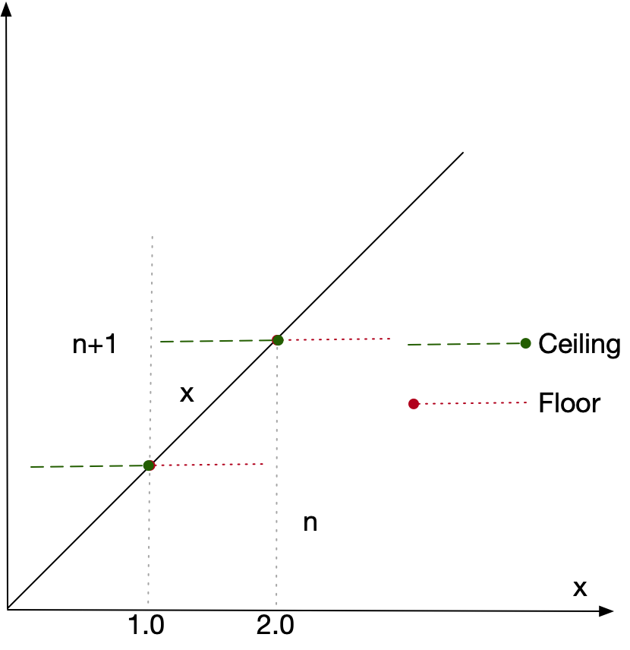

Notice how

$\left\lfloor 1.0\right\rfloor =\left\lceil 1.0\right\rceil =1$

$\left\lfloor 1.0000001\right\rfloor =1$

$\left\lceil 1.0000001\right\rceil =2$

$\left\lfloor 1.9999999\right\rfloor =1$

$\left\lceil 1.9999999\right\rceil =2$

#### Basic Properties

##### Property 1

$$\left\lceil x\right\rceil =x↔x∈N↔\left\lfloor x\right\rfloor =x$$

The ceiling and floor of x are only equal to x if x is an integer.

##### Property 2

$$\left\lceil \frac{x}{2}\right\rceil +\left\lfloor \frac{x}{2}\right\rfloor =x$$

##### Property 3

$$x-1<\left\lfloor x\right\rfloor ≤x≤\left\lceil x\right\rceil <x+1$$

##### Property 4

$$\left\lfloor -x\right\rfloor =-\left\lceil x\right\rceil$$

##### Property 5

If n is an integer and x a real

$$\left\lfloor x+n\right\rfloor =\left\lfloor x\right\rfloor +n$$

$$\left\lceil x+n\right\rceil =\left\lceil x\right\rceil +n$$

$$x<n→\left\lfloor x\right\rfloor <n$$

$$n<x→n<\left\lceil x\right\rceil$$

#### Fractional Part

The floor gives the integer part of a real and subtracting the floor from the real gives the fractional part

$$\left\{x\right\}=x-\left\lfloor x\right\rfloor$$

We can use this notation to calculate possible values of $\left\lfloor x+y\right\rfloor$

##### Property 5 $\left\lfloor x+y\right\rfloor$

Letting

$$x=\left\lfloor x\right\rfloor +\left\{x\right\}$$

$$y=\left\lfloor y\right\rfloor +\left\{y\right\}$$

Then

$$\left\lfloor x+y\right\rfloor =\left\lfloor x\right\rfloor +\left\lfloor y\right\rfloor +\left\lfloor \left\{x\right\}+\left\{y\right\}\right\rfloor$$

Since $0≤\left\{x\right\}+\left\{y\right\}<2.0$ sometimes

$$\left\lfloor x+y\right\rfloor =\left\lfloor x\right\rfloor +\left\lfloor y\right\rfloor$$

And sometimes

$\left\lfloor x+y\right\rfloor =\left\lfloor x\right\rfloor +\left\lfloor y\right\rfloor$ +1

#### Basic Rules

##### Rule a) $\left\lfloor x\right\rfloor =n ↔ n≤x<n+1$

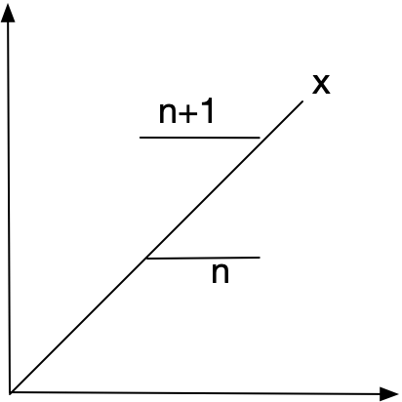

$$Rule b) \left\lfloor x\right\rfloor =n ↔ x-1<n≤x$$

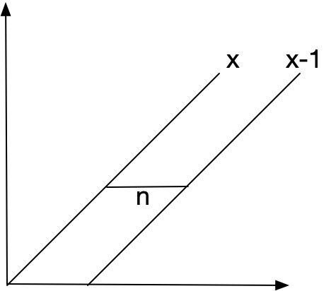

$$\left\lceil x\right\rceil =n ↔ n-1<x≤n$$

$$\left\lceil x\right\rceil =n ↔ x≤n<x+1$$