Reactive Extentions

This document covers

Introduction

## Introduction

The Reactive Extensions API defines a framework for managing and co-ordinating asynchronous streams of data events. Because the elements of the stream are delivered as and when they are ready, Rx is ideal for modelling infinite streams of data. The Rx framework provides a set of operators for filtering, combining and transforming data streams.

Unlike LINQ which is a pull-based API, Reactive Extensions for .NET works with push-based sources. The core interface to an event source is IObservable<T> and the RX operators work on instances of this type in the same way LINQ operators work on instances of IEnumerable<T>

Listing 1 IObserver<T> and IObservable<T>

public interface IObserver<in T>

{

void OnNext(T value);

void OnError(T value);

void OnCompleted();

}

public interface IObservable<out T>

{

IDisposable Subscribe(IObserver<T> observer);

}

### A Simple IObservable<T> Implementation

Listing 2 SimpleObservable<T>

public class SimpleObservable<T> : IObservable<T>

{

➊ public IDisposable Subscribe(IObserver<T> observer)

{

Console.WriteLine($"Subscribe”);

_observers.Add(observer);

return new ActionDisposable(() =>

{

Console.WriteLine($"Dispose”);

_observers.Remove(observer);

});

}

➋ public void Publish(T val)

{

foreach (var observer in _observers)

{

observer.OnNext(val);

}

}

private readonly List<IObserver<T>>

_observers = new List<IObserver<T>>();

}

When clients invoke Subscribe ➊ we add the given IObserver to our list. We also define a Publish ➋ method (not part of IObservable<T>) which iterates the list and invokes OnNext on each subscribed observer. We use a special implementation of IDisposable that takes an Action in its constructor and invokes this action when its Dispose method is invoked.

### Basic Lifecycle

// (1) Create an instance of an Observable

SimpleObservable<int> observable = new SimpleObservable<int>();

// (2) Create an instance of an IObserver

IObserver<int> observer = new SimpleObserver<int>();

// (3) Subscribe the observer to the observable

IDisposable disposable = observable.Subscribe(observer);

// (4) Observerable delivers some events

observable.Publish(1);

observable.Publish(2);

// (5) After disposal the Observer no longer delivers

// events to the disposed observer

disposable.Dispose();

observable.Publish(3);

### Delegate Based Observers

We rarely ever explicitly implement IObserver<T> because the Reactive Framework combines a delegate-based implementation of IObserver with extension methods that enable us to subscribe for updates using delegates and lambdas. If the framework didn’t already do it for us we could do this ourselves as follows.

Listing 3 Delegate Based Observer

public class DelegateBasedObserver<T> : IObserver<T>

{

public DelegateBasedObserver(Action<T> nextAction)

{

_nextAction = nextAction;

}

public DelegateBasedObserver(Action<T> nextAction,

Action completedAction) : this(nextAction)

{

_completedAction = completedAction;

}

public DelegateBasedObserver(Action<T> nextAction,

Action<Exception> exceptAction, Action completedAction) :

this(nextAction, completedAction)

{

_exceptAction = exceptAction;

}

public void OnNext(T value)

{

_nextAction?.Invoke(value);

}

public void OnError(Exception error)

{

_exceptAction?.Invoke(error);

}

public void OnCompleted()

{

_completedAction?.Invoke();

}

private readonly Action<T> _nextAction;

private readonly Action _completedAction;

private readonly Action<Exception> _exceptAction;

}

Now we need to write a static extension method that takes an instance of IObservable<T> and an Action. The extension method then creates an instance of our DelegateBasedObserver type and subscribes it to updates from the observable.

Listing 4 Subscribe Extension Method

public static class MyObservable

{

public static IDisposable Subscribe<T>(this IObservable<T> obs,

Action<T> action)

{

return obs.Subscribe(new DelegateBasedObserver<T>(action));

}

}

We can then subscribe for notification by passing in a delegate as follows

Listing 5 Subscribing using delegates

SimpleObservable<int> observable = new SimpleObservable<int>();

observable.Subscribe( i => Console.WriteLine(i));

observable.Publish(5);

## Scheduling

### Default Scheduling

// 1. Create the observable

var observable = new SimpleObservable<int>();

// 2. Create the observer

IObserver<int> observer = new SimpleObserver<int>();

// 3. Register the observer with the observable

var disposable = observable.Subscribe(observer);

// 4. Publish a value

observable.Publish(1);

// 5. Dispose the observer

disposable.Dispose();

### Schedulers

The core interface we must implement if we want to define a reactive scheduler is IScheduler. The following code shows how to specify the scheduler on which OnNext methods are invoked. We can create our own very simple Scheduler in

Listing 6 Custom Scheduler. We can then instruct our code to observe or subscribe on this custom scheduler.

Listing 6 Custom Scheduler



### Explicit Subscription

Listing 7 Explicit Subscription scheduling

// 1. Log out the calling thread

"ExplicitMultiThreadedSubsciption".Log();

Console.WriteLine("Current Thread {0}", Thread.CurrentThread.ManagedThreadId);

// 2. Create a scheduler with its own thread

IScheduler scheduler = new SingleThreadedScheduler("KennyScheduler");

// 3. Create the observable

var observable = new SimpleObservable<int>();

// 4. Create the observer

IObserver<int> observer = new SimpleObserver<int>();

// 5. Register the observer with the observable

var disposable = observable.SubscribeOn(scheduler).Subscribe(observer);

// Make sure the publish does not happen before the subscription as

// subscription is running on a separate thread

Thread.Sleep(100);

// 6. Publish a value

observable.Publish(1);

// 7. Dispose the observer

disposable.Dispose();

Listing 8 Output

ExplicitMultiThreadedSubsciption - Thread Main Query Thread 11

Current Thread 11

Subscribe on Thread "KennyScheduler:17"

OnNext(1) thread Main Query Thread:11

Dispose on Thread KennyScheduler:17

### Explicit Observation

Listing 9 Explicit Observation

// 1. Log out the calling thread

"ExplicitMultiThreadedObservation".Log();

// 2. Create a scheduler with its own thread and a

// wait handle to prevent premature completion

IScheduler scheduler = new SingleThreadedScheduler("KennysScheduler");

AutoResetEvent handle = new AutoResetEvent(false);

// 3. Create observable tell it we want to observer

// on our explicit scheduler

var observable = new SimpleObservable<int>();

var disposable = observable

.ObserveOn(scheduler)

.Subscribe(i => i.ToString().Log(), () => handle.Set());

// 4. Publish 2 messages and then complete

observable.Publish(1);

observable.Publish(2);

observable.Complete();

handle.WaitOne();

disposable.Dispose();

Listing 10 Output

ExplicitMultiThreadedObservation - Thread Main Query Thread 10  
Subscribe on Thread "Main Query Thread:10"  
1 - Thread KennysScheduler 11  
2 - Thread KennysScheduler 11  
Dispose on Thread KennysScheduler:11

## Implementing Observable

Although the IObservable<T> looks simple, a full compliant implementation is actually rather tricky. It has to handle disposals and work correctly in multithreaded scenarios introduced by different schedulers. Consider the following implementations of IObservable and IObserver

Listing 11 Implementing IObservable



We then write code to subscribe an instance of MyObserver to MyObservable. Finally, we publish a value from MyObservable, dispose the observer and publish another value through the MyObservable.



As we might expect disposing the observable has no effect as our MyObservable returns an empty disposable from its Subscribe method. It has no logic to do the unsubscription.

The output from our code becomes

1

2

This highlights the first implicit behaviour we need to support when creating RX sources, namely unsubscribing observers when they are disposed.

### Observable.Create

We can fix the code from the previous section such that it stops delivering events to IObserver instances that have been unsubscribed by using the static Observable.Create method.



Now the output from running this code is what we want. The first publish causes the observer to write 1 to the console but the second publish after the dispose call is suppressed.

1

What happens here is that when we call Observable.Create it creates an instance of a framework type called AnonymousObservable which stores a reference to the factory method we pass into it.

Listing 12 AnonymousObservable

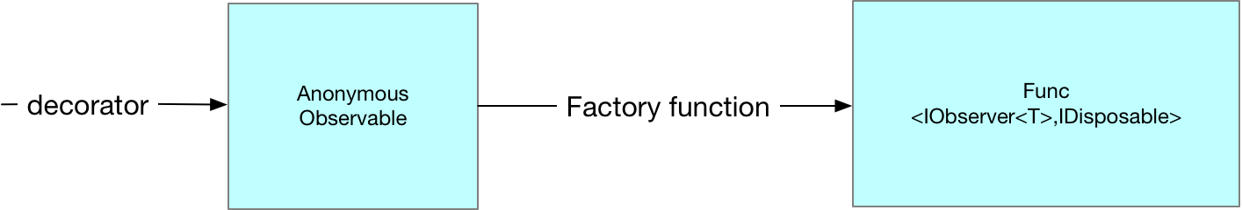

Then when we call Subscribe on our observable and pass in our MyObserver instance we are actually calling Subscribe on the AnonymousObservable instance. This is turn creates an instance of a type called AutoDetachObserver which it gives to the factory method we passed into Observable.Create. The AutoDetachObserver holds a reference to our actual MyObserver creating an extra layer of indirection.

Listing 13 AutoDetachObserver

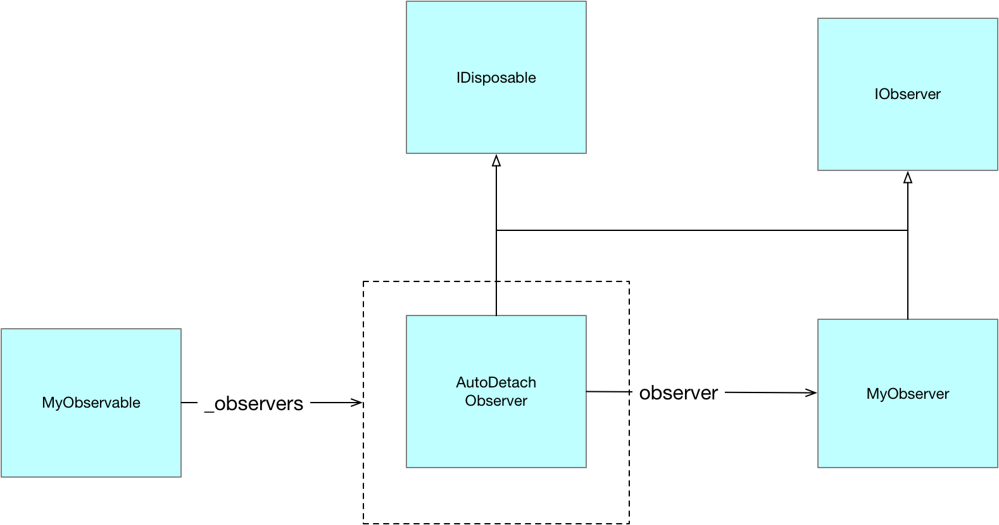

Notice how the AutoDetachObserver implement IDisposable. It is the AutoDetachObserver which is returned to the client when it invokes subscribe on the instance of Anonymous Observer. This enables the AutoDetachObserver to stop delivering updates to the MyObserver after dispose has been invoked on it.

Observable.Create is the prefered means of creating observable sequences as internally it has been carefully coded to ensure correct order of subscriptions and notification in multi threaded scenarios

## Hot and Cold Observables

Rx makes the distinction between hot and cold observables. A cold observable only ever produces values at the point an observer subscribes and each subscriber is given its own set of data. A subscriber can never miss out on data by subscribing late. A hot observable on the other hand is always producing data irrespective of whether any observers are subscribed. With a hot observable a subscriber can miss out on earlier values if it subscribes late. We consider cold and hot observables in turn.

### Cold Observable

The basic characteristic of a cold observable is that nothing is done until a subscription is made and each subscription gets different values

Listing 14 Basic Cold Observable

// We use a factory method together with Observable.Create to create

// an IObservable which delivers completely different values to each

// Subscription. This is the basic property of a ColdObservable.

// Nothing is delivered util a subscription is made and each

// subscription gets a different value.

int x = 0;

// Define a factory method that when invoked directly calls OnNext

IDisposable FactMeth(IObserver<int> observer)

{

observer.OnNext(x++);

return Disposable.Empty;

}

// Use Observable.Create to turn our factory method into an IObservable

var observable = Observable.Create((Func<IObserver<int>, IDisposable>)FactMeth);

// Perform two different subscriptions. Each IOBserver

// get different values to the nature of a cold observable

observable.Subscribe(i => Console.WriteLine($"A {i}"));

observable.Subscribe(i => Console.WriteLine($"B {i}"));

Listing 15 Basic Cold Observable Output

A 0  
B 1

### Connectable Observable

Listing 16 Connectable Observable

// As per the previous sample we use a factory method together

// with Observable.Create to create an IObservable which delivers

// completely different values from each subscription. The key

// difference is that we wrap this Observable

// with a ConnectableObservable

// using the Publish extension method. This extra layer allows us to

// share the values published from the originating Observable as the

// Connectable wrapper performs the multiplexing

int x = 0;

// Define a factory method that when invoked directly calls OnNext

IDisposable FactMethod(IObserver<int> observer)

{

observer.OnNext(x++);

return Disposable.Empty;

}

// Use the Observable.Create to turn our factory method into an IObservable

IObservable<int> observable = Observable.Create((Func<IObserver<int>, IDisposable>)FactMethod);

// Wrap the source Observable in a Connectable observable

IConnectableObservable<int> connectableObservable = observable.Publish();

// Even though we subscribe twice the connectable observable

// will make sure

// there is only one underlying Observable

// with the ConnectableObservable

// providing multi-plexing

connectableObservable.Subscribe(i => Console.WriteLine($"A {i}"));

connectableObservable.Subscribe(i => Console.WriteLine($"B {i}"));

// The subscription is now carried out and multiplexed out to the

// registered observers

connectableObservable.Connect();

Listing 17 Connectable Observale Output

A 0  
B 0

### Hot Observable

Listing 18 Hot Observable

// In this example we wrap our observable in a ConnectableObservable

// and connect it before we make any subscriptions. By doing this we are

// creating what is known as a Hot Observable. This Observable is still

// publishing values even though it has no subscriptions.

SimpleObservable<int> sourceObservable = new SimpleObservable<int>();

IConnectableObservable<int> hotObservable = sourceObservable

.Do(i => Console.WriteLine("Source({0}) thread {1}", i, Thread.CurrentThread.ManagedThreadId))

.Publish();

// Connecting to the IConnectableObservable causes it to subscribe on

// the sourceObservable thereby setting up a hot observable which will

// publish out even when the connectableObservable has no observers

IDisposable disposable = hotObservable.Connect();

// Tis logged via the Do call even though we have no observer on

// the connectableObservable

sourceObservable.Publish(1);

// now we subscribe on the connectableObservable

hotObservable.Subscribe(i => Console.WriteLine("OnNext({0}) thread {1}", i, Thread.CurrentThread.ManagedThreadId));

// this is now delivered to the IObserver

sourceObservable.Publish(2);

// Disposing of the connectableObservable turns off the publishing

disposable.Dispose();

sourceObservable.Publish(3);

// we can now reconnect to the same IConnectableObservable and once again

// messages are delivered

disposable = hotObservable.Connect();

sourceObservable.Publish(4);

Listing 19 Hot Observable Output

Subscribe on Thread "Main Query Thread:12"

Source(1) thread 12

Source(2) thread 12

OnNext(2) thread 12

Dispose on Thread Main Query Thread:12

Subscribe on Thread "Main Query Thread:12"

Source(4) thread 12

OnNext(4) thread 12

## Creating Sequences

Sequences can be created in three ways

* Factory methods
* Functional unfolds
* Transitioning from other entities (delegates, tasks, events)

### Factory Methods

#### Observable.Create

IObservable<int> s =

Observable.Create<int>(observer =>

{

observer.OnNext(1);

observer.OnNext(2);

observer.OnNext(3);

observer.OnCompleted();

return Disposable.Empty;

});

s.Subscribe(i =>

WriteLine($"OnNext({i})"),

() => WriteLine("OnCompleted"));

#### Observable.Empty

Returns an empty stream which simply invokes OnCompleted to end the sequence

IObservable<int> s =

Observable.Empty<int>();

s.Subscribe(i => WriteLine($"OnNext({i})"),

() => WriteLine("OnCompleted"));

#### Observable.Return<T>

Returns a stream consisting of a single value.

Observable.Return(1)

.Subscribe(WriteLine, () => WriteLine("OnCompleted"));

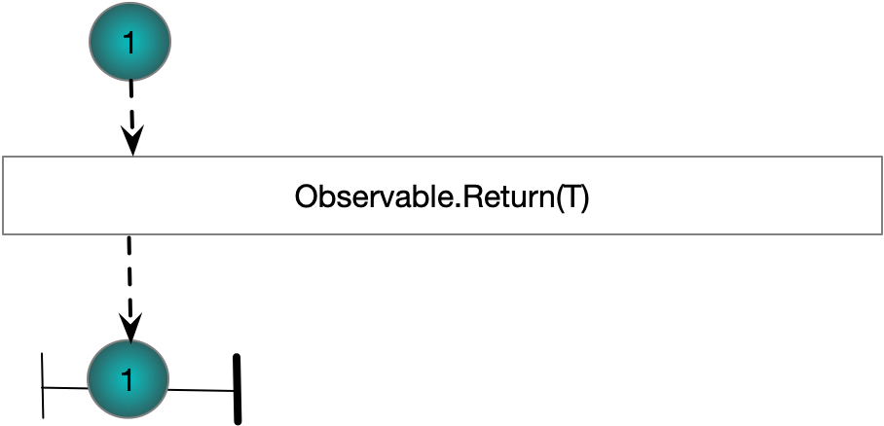

#### Observable. Throw

Returns a stream which calls OnError and then returns

IObservable<int> s =

Observable.Throw<int>(new Exception("An exception"));

s.Subscribe(i => WriteLine($"OnNext({i})"),

exception => WriteLine("OnException"),

() => WriteLine("OnCompleted"));

### Functional Unfolds

An unfold can be used to produce a possibly infinite sequence. Generate is the root Rx unfold method. The other unfold methods such as Range, Interval and Timer could be produced using Generate.

#### Observable.Generate

Supports the creation of more complex sequences of event.

IObservable<int> s =

Observable.Generate(0, i => i < 5, i => i + 1, i => i);

s.Subscribe(i => WriteLine($"OnNext({i})"),

exception => WriteLine("OnException"),

() => WriteLine("OnCompleted"));

#### Observable.Range(int,int)

Returns an observable over a sequence of consecutive integers

Observable.Range(1,3)

.Subscribe(WriteLine, () => WriteLine("OnCompleted"));

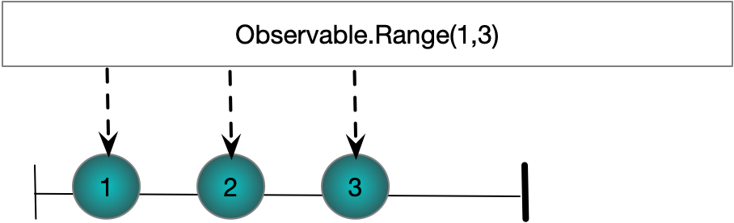

#### Observable.Interval(Timespan)

Produces incrementally increasing integers. The gap between elements is defined by the given Timespan

Observable

.Interval(TimeSpan.FromSeconds(0.25))

.Take(4)

.ObserveOn(Scheduler.Default)

.Subscribe(l => WriteLine($"{l}"),

() => tcs.SetResult(null));

#### Observable.Timer(TimeSpan)

Takes a timespan and creates a stream of one value. The single value is delivered after the specified TimeSpan has elapsed

TaskCompletionSource<string> tcs = new TaskCompletionSource<string>();

Observable

.Timer(TimeSpan.FromSeconds(1))

.ObserveOn(Scheduler.Default)

.Subscribe(l => WriteLine($"{l}"),() => tcs.SetResult(null));

#### Observable.Timer(TimeSpan,TimeSpan)

Takes two TimeSpan objects. The first determines how much time should be allowed to elapse before the first element is delivered. The second TimeSpan determines the interval between subsequent events.

TaskCompletionSource<string> tcs = new TaskCompletionSource<string>();

Observable

.Timer(TimeSpan.FromSeconds(2),TimeSpan.FromSeconds(0.1))

.Take(4)

.ObserveOn(Scheduler.Default)

.Subscribe(l => WriteLine($"{l}"),() => tcs.SetResult(null));

### Transitioning from Other APIs

We can use the methods of Rx to create Observables form other .NET types.

#### Observable.Start(Action)

Creates a single value observable from an Action delegate

Action a = () => { };

Observable

.Start(a)

.Subscribe(unit => WriteLine($"OnNext({unit})"),

() => WriteLine("OnCompleted"));

#### Observable.Start(Func<T>)

Creates a single value observable from a Func<T>. The value is the value returned by the Func<T>

Action a = () => { };

Observable

.Start(a)

.Subscribe(unit => WriteLine($"OnNext({unit})"),

() => WriteLine("OnCompleted"));

#### Observable.FromEventPattern

Creates Observables from standard .NET events

IObservable<EventPattern<EventArgs>> obs

= Observable

.FromEventPattern<EventArgs>(h => MyEvent += h, h => MyEvent -= h);

obs.Subscribe(x => WriteLine(x.EventArgs));

MyEvent?.Invoke(this,new EventArgs());

#### Task.ToObservable

Creates Observables from standard tasks

TaskCompletionSource<string> tcs = new TaskCompletionSource<string>();

tcs.SetResult("Value");

tcs

.Task

.ToObservable()

.Subscribe(x => WriteLine($"OnNext({x})"), () => WriteLine("OnCompleted"));

WriteLine("Subscribed to already completed task\n");

Task

.Run(() => "Value")

.ToObservable()

.Subscribe(x => WriteLine($"OnNext({x})"), () => WriteLine("OnCompleted"));

WriteLine("Subscribed to running task");

#### IEnumerable<T>.ToObservable

Enumerable

.Range(0,3)

.ToObservable()

.Subscribe(x => WriteLine($"OnNext({x})"), () => WriteLine("OnCompleted"));

## Composing Sequences

Sequences can be combined using three classes of compositors

1. Sequential composition
2. Concurrent compositions
3. Pairwise composition

### Sequential Composition

#### Observable.Concat(IObservable<TSource>)

Observable

.Range(0, 2)

.Concat(Observable.Range(5, 2))

.Subscribe(WriteLine);

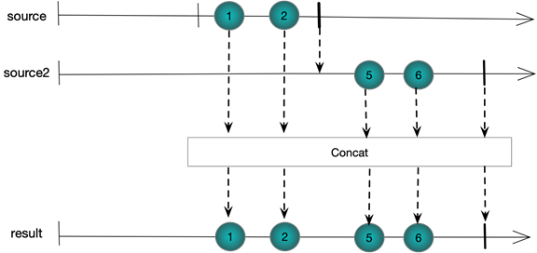

#### Observable.Repeat(int reps)

Observable

.Range(0, 2)

.Repeat(2)

.Subscribe(WriteLine, () => WriteLine("OnCompleted\n"));

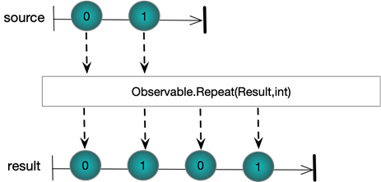

#### Observable.StartsWith

Observable

.Range(10, 2)

.StartWith(8, 9)

.Subscribe(WriteLine);

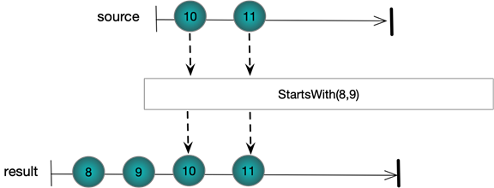

### Concurrent Composition

#### Observable.AMB

Subject<string> a = new Subject<string>();

Subject<string> b = new Subject<string>();

Observable.Amb(a,b)

.Subscribe(WriteLine);

a.OnNext("a");

b.OnNext("1");

a.OnNext("b");

b.OnNext("2");

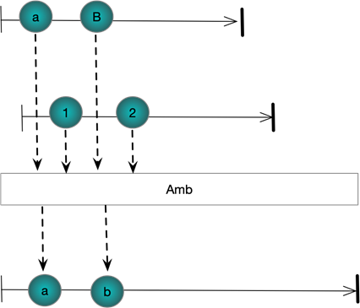

#### Observable.Merge

Subject<string> a = new Subject<string>();

Subject<string> b = new Subject<string>();

Observable.Merge(a, b)

.Subscribe(WriteLine);

a.OnNext("a");

b.OnNext("1");

a.OnNext("b");

b.OnNext("2");

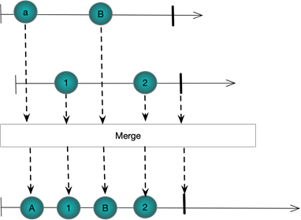

#### Observable.Switch

Works on a stream of streams. When the first stream starts publishing, its events are published into the result stream until the second stream starts publishing. At which point the first stream is unsubscribed

Subject<string> a = new Subject<string>();

Subject<string> b = new Subject<string>();

Subject<Subject<string>> master = new Subject<Subject<string>>();

master.Switch()

.Subscribe(WriteLine);

master.OnNext(a);

a.OnNext("a");

a.OnNext("b");

master.OnNext(b);

b.OnNext("1");

b.OnNext("2");

a.OnNext("c");

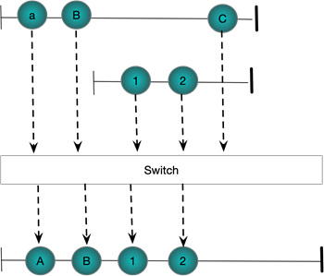

### Pariwise Composition

#### Observable.CombineLatest

Combines the latest value from two streams as each stream produces new values. Requires that each stream has at least one value before anything is published to the result

Subject<string> a = new Subject<string>();

Subject<string> b = new Subject<string>();

Observable.CombineLatest(a,b,(s, s1) => $"({s},{s1})")

.Subscribe(WriteLine);

a.OnNext("a");

a.OnNext("b");

b.OnNext("1");

b.OnNext("2");

a.OnNext("c");

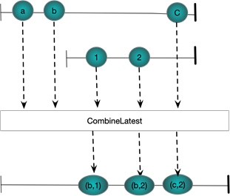

#### Observable.Zip

Pairs together values from two streams.

Subject<string> a = new Subject<string>();

Subject<string> b = new Subject<string>();

Observable.Zip(a,b,(s, s1) => $"({s},{s1})")

.Subscribe(WriteLine);

a.OnNext("a");

a.OnNext("b");

b.OnNext("1");

b.OnNext("2");

a.OnNext("c");

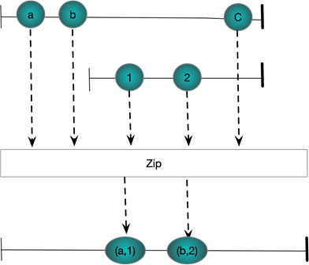

#### And/Then/When

Pairs together values from ,multiple streams.

IObservable<int> a = Observable.Range(1, 3);

IObservable<int> b = Observable.Range(1, 3).Select(x => x * 2);

IObservable<int> c = Observable.Range(1, 3).Select(x => x * 3);

Observable

.When(a

.And(b)

.And(c)

.Then((x, y, z) => (x, y, z)))

.Subscribe(x => WriteLine(x));

// Verbose form to show what is happening

Pattern<int, int> pattern1 = a.And(b);

Pattern<int, int, int> pattern2 = pattern1.And(c);

Plan<(int, int, int)> then = pattern2.Then((i, i1, i2) => (i, i1, i2));

IObservable<(int, int, int)> observable = Observable.When(then);

observable.Subscribe(x => WriteLine(x));

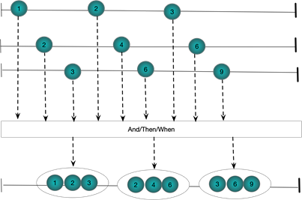

## Time Shifting

### Buffering

The various overloads of Buffer enable one to group together elements from an input stream. The resulting groups are called buffers. The basic idea then is to take a stream IObservable<T> and produce a stream IObservable<IList<T>>. Buffers can be perfectly contiguous with every source element existing in one and only one result buffer; skipping with some source elements being completely left out of the result bugffers or overlapping where some source elements make it into more than once destination buffer.

Buffering Behaviour

* Perfectly contiguous
* Overlapping
* Skipping

Buffers can be defined by source element count, time interval or via open and close signals.

Buffer Definition

* Source element count
* time interval
* opening and closing signals

#### Buffer(int count)

Supports perfectly contiguous buffers in the result stream

Observable

.Range(0, 5)

.Buffer(2)

.Subscribe(ints => WriteLine(string.Join(",", ints)));

The following figure shows graphically what is happening. Each buffer contains at most count items. Notice the final buffer has less than two items because the source stream completes

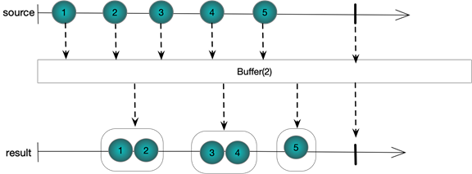

#### Buffer(int count,int skip)

By taking two integer arguments this overload of Buffer supports non-contiguous result buffers. Skip defines the number of elements between each buffer opening and count defines the maximum number of elements in each buffer. If skip is more than count then we miss out some source elements from the destination. If skip is less than count then we have overlapping buffers with some elements making it into more than one buffer. Of course if skip is equal to count we have the exact same behaviour as Buffer(int count), that is to say perfectly contiguous buffers. Let us look at each case in turn

##### Skipping Elements

We set the count to 2 and the skip to 3. A new buffer is started every three elements and hold at most 2 elements.

Observable.Range(1, 5)

.Buffer(2, 3)

.Subscribe(ints => WriteLine(string.Join(",", ints)));

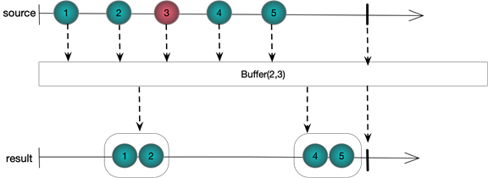

##### Overlapping Elements

We set the count to 3 and the skip to 2. A new buffer is started every two elements and hold at most three elements. The last element from each buffer is also duplicated as the first element in the next buffer

Observable.Range(1, 5)

.Buffer(3, 2)

.Subscribe(ints => WriteLine(string.Join(",", ints)));

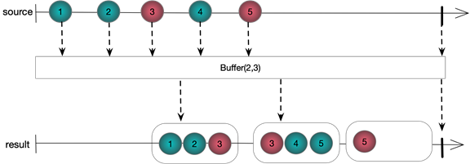

#### Buffer(Timespan timeSpan)

Partitions each element of a source stream into contiguous buffers in the result stream. The buffers in the result stream are defined by the timing of events in the source stream.

EventWaitHandle ewh = new AutoResetEvent(false);

Observable

.Interval(TimeSpan.FromSeconds(0.3))

.Take(6)

.Buffer(TimeSpan.FromSeconds(1.0))

.Subscribe(ints => WriteLine(string.Join(",", ints)),()=>ewh.Set());

ewh.WaitOne();

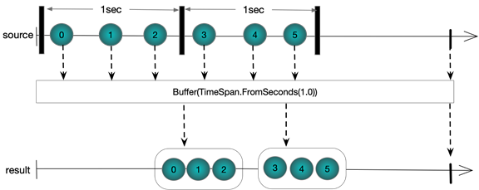*\*Output\**

#### Buffer(Timespan timeSpan, TimeSpan timeshift)

As with using Buffer(int,int) this overloads support overlapping and skipping elements by specifying two TimeSpans. We consider each in turn

##### Overlapping Elements

EventWaitHandle ewh = new AutoResetEvent(false);

Observable

.Interval(TimeSpan.FromSeconds(0.3))

.Take(6)

.Buffer(TimeSpan.FromSeconds(1.0), TimeSpan.FromSeconds(0.4))

.Subscribe(ints => WriteLine(string.Join(",", ints)), () => ewh.Set());

ewh.WaitOne();

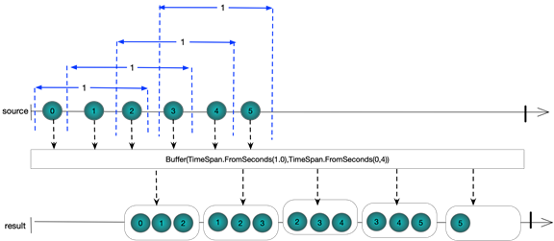

##### Skipping Elements

EventWaitHandle ewh = new AutoResetEvent(false);

Observable

.Interval(TimeSpan.FromSeconds(0.3))

.Take(6)

.Buffer(TimeSpan.FromSeconds(0.4), TimeSpan.FromSeconds(1.0))

.Subscribe(ints => WriteLine(string.Join(",", ints)), () => ewh.Set());

ewh.WaitOne();

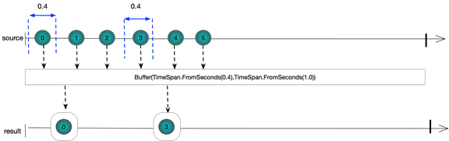

#### Buffer(Func<IObservable<TClosingSelector>> closingSelector)

This form uses a separate observable sequence that produces values in order to flush buffers. Each time a element is published by this observable the current buffer is flushed through

EventWaitHandle latch = new AutoResetEvent(false);

var obs = Observable

.Interval(TimeSpan.FromSeconds(0.3))

.Take(10);

var closing = Observable

.Interval(TimeSpan.FromSeconds(1.0))

.Take(2);

obs

.Buffer(closing)

.Subscribe(ints => WriteLine(string.Join(",", ints)),()=>latch.Set());

latch.WaitOne();

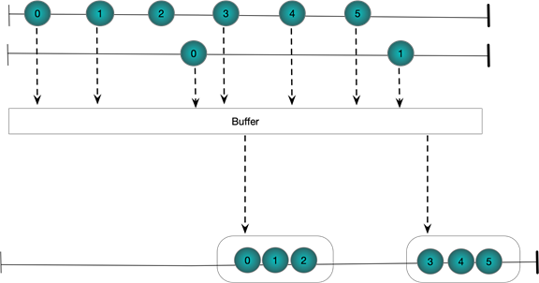

#### Buffer(Iobservable<TBufferOpening> bufferOpenings, Func<TBufferOpening, IObservable<TbufferOpening>> bufferClosingSelector)

The bufferOpenings selector is used to publish events which determine when buffers are opened. The bufferClosingSelector takes the value from the buffer opening event and uses it to generate the buffer closing event.

EventWaitHandle latch = new AutoResetEvent(false);

var obs = Observable

.Interval(TimeSpan.FromSeconds(0.3))

.Take(10);

var opening = Observable

.Interval(TimeSpan.FromSeconds(0.7))

Take(2);

var closing = Observable

.Timer(TimeSpan.FromSeconds(0.5))

.Take(2);

obs

.Buffer(opening, i => closing)

.Subscribe(ints => WriteLine($"({string.Join(",", ints)})"), () => latch.Set());

latch.WaitOne();

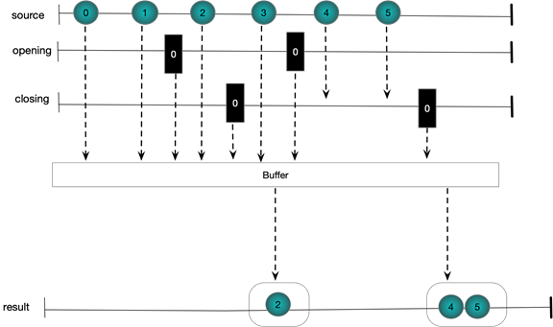

#### Buffer(Timespan timeSpan, int count)

Sometimes it is useful to be able to buffer by both count and timeframe. A buffer is closed and a new one started when either the maximum buffer size is reached or the timespan elapses. This means the buffer does not get too big and also data never gets stale

EventWaitHandle latch = new AutoResetEvent(false);

Observable

.Interval(TimeSpan.FromSeconds(0.1))

.Take(5)

.Concat(Observable.Interval(TimeSpan.FromSeconds(0.5)).Take(4))

.Buffer(TimeSpan.FromSeconds(1.0),5)

.Subscribe(ints => WriteLine($"({string.Join(",", ints)})"), () => latch.Set());

latch.WaitOne();

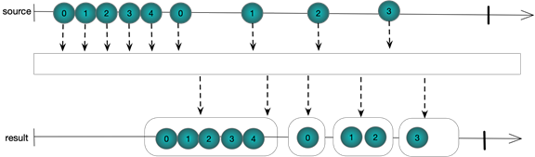

### Delay

#### Delay (Timespan)

Simply delays a sequence by a specified TimeSpan. The times between elements remain the same.

DateTime now = DateTime.Now;

EventWaitHandle latch = new AutoResetEvent(false);

var source = Observable.Interval(TimeSpan.FromSeconds(0.5)).Take(4);

var delays = source.Delay(TimeSpan.FromSeconds(1.0));

source.Subscribe(l => WriteLine($"Original {l} {(DateTime.Now - now).TotalSeconds}"));

delays.Subscribe(l => WriteLine($"Delayed {l} {(DateTime.Now - now).TotalSeconds}"),()=>latch.Set());

latch.WaitOne();

Original 0 0.5671419

Original 1 1.0641751

Original 2 1.5644976

Delayed 0 1.6014948

Original 3 2.0791571

Delayed 1 2.0985018

Delayed 2 2.6119969

Delayed 3 3.1114934

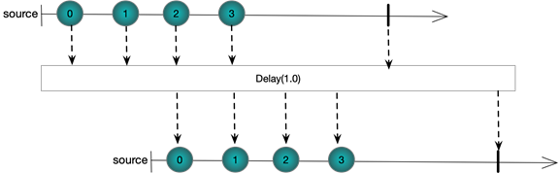

### Sample

#### Sample (Timespan)

Returns the last element emitted by a source sequence in a buffer interval specified by a TimeSpan

DateTime now = DateTime.Now;

EventWaitHandle waitHandle = new AutoResetEvent(false);

Observable

.Interval(TimeSpan.FromSeconds(0.3))

.Take(10)

.Sample(TimeSpan.FromSeconds(1.0))

.Subscribe(l => Console.WriteLine($"Delayed {l} {(DateTime.Now - now).TotalSeconds}"), () => waitHandle.Set());

waitHandle.WaitOne();

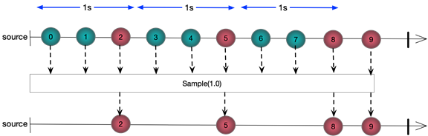

Delayed 2 1.1075141

Delayed 5 2.1179985

Delayed 8 3.1327291

Delayed 9 4.1504981

##### More Examples

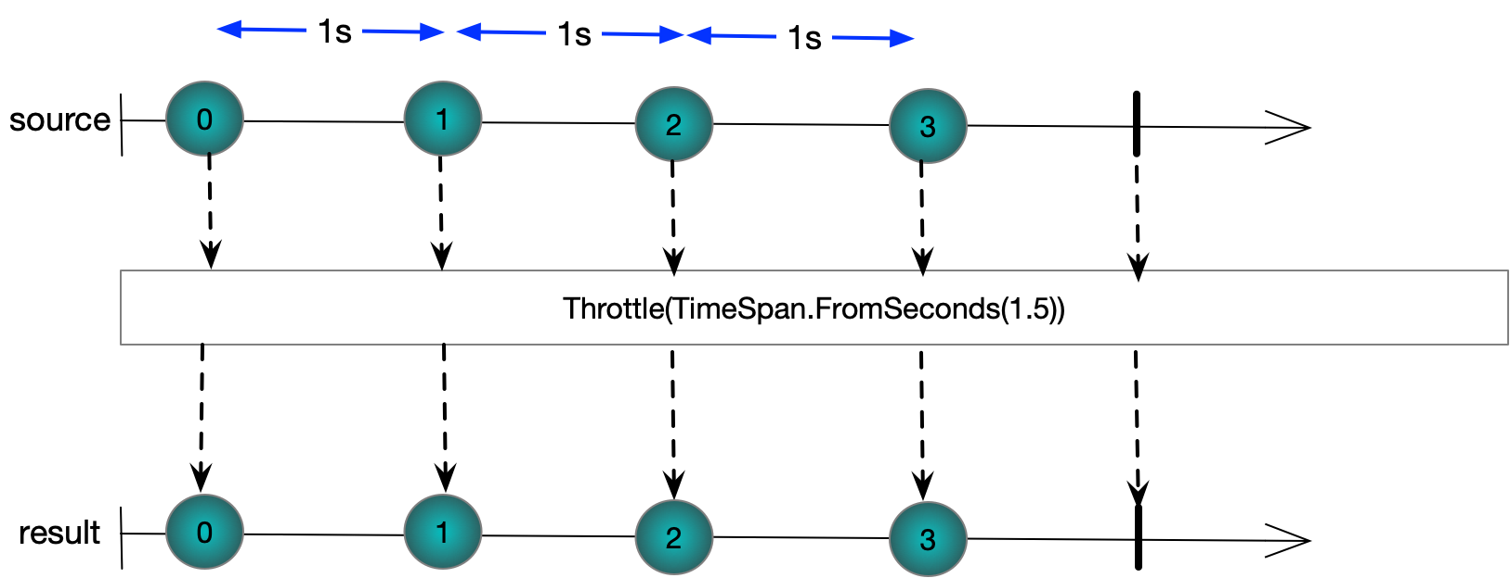

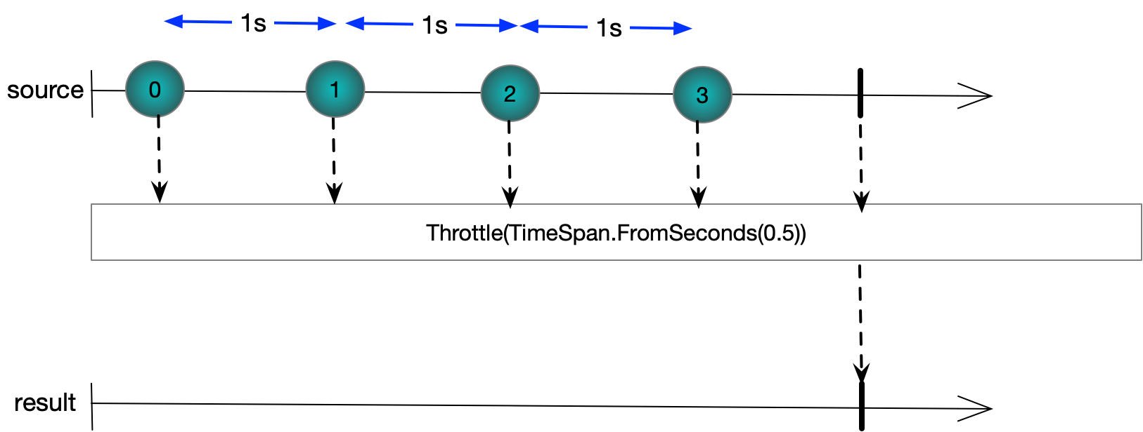

## Aggregating

#### Scan(TAccumulate,Func<TAccumulate, TSource, TAccumulate>)

An accumulator which produces a sequence of accumulated values

Observable.Range(1, 3)

.Scan(0,(cum, i1) => cum+i1)

.Subscribe(WriteLine, () => WriteLine("OnCompleted\n"));

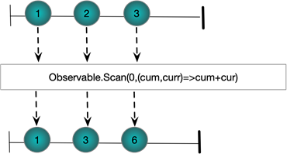

## Transforming Streams

#### SelectMany

SelectMany seems to work by taking an observable sequence and using each value from that sequence to generate another sequence. The generated sequences are then merged (flattened) together

Subject<int>[] subs = new Subject<int>[]

{

new Subject<int>(),

new Subject<int>()

};

Observable

.Range(0, 2)

.SelectMany(i => subs[i])

.Subscribe(WriteLine);

subs[0].OnNext(1);

subs[1].OnNext(2);

subs[0].OnNext(3);

subs[1].OnNext(4);

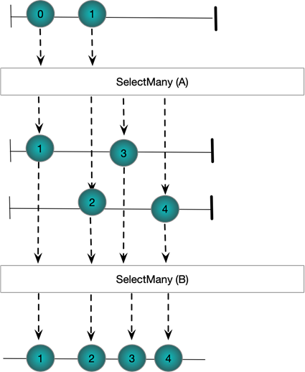

Questions

Introduction

What is RX?

API for asynchronous streams of events.

Provides a set of operators that filter, combine and transform those streams.

Compare Rx to LINQ?

LINQ is a pull-based API

Rx works with push-based sources of date

IObservable<T> is Rx equivalent of IEnumerable<T>

What are the core interfaces of RX?

IObservable<T> and IObserver<T>

Why is it unlikely we will ever explicitly implement IObserver<T>?

Because the Rx library provides a set of extension methods that take actions and internally create instances of a special IObserver<T> implementation that invokes the provided delegates when the IObservable<T> calls OnNext, OnError and OnCompleted

What is the single method of IObservable<T>

IDisposable Subscribe(IObserver<T>)

What are the three method of IObserver<T>

Void OnNext(T)

Void OnError(Exception)

Void OnCompleted()

What is the implicit contract a stream should obey?

1. An Observable delivers 0..N items via OnNext followed by either OnError or OnCompleted
2. Rx calls cannot interleave form a single source. The source must wait for any methods it invokes to complete before invoking the net one

What are the two ways a sequence can be terminated?

By calling OnCompleted or OnError

What are the advantages of Rx versus events?

1. Rx sources are first class objects and can be passed as arguments to methods and stored in fields and properties
2. An event sources items are delivered in a well-defined order in the presence of multiple threads
3. Well defined mechanism for delivering errors
4. Well defined mechanism for notifying the end of the sequence

What are the difficulties of implementing IObservable<T>

A source needs to play nicely with RX Schedulers and multi-threaded scenarios.

What is the preferred way of creating observables?

Using Observable.Create

What does observable.Create do?

We pass it a factory method and it creates a returns an instance of AnonymousObservable

When we invoke subscribe on AnonymousObservable it creates an AutoDetachObserver that decorates our observer

Tbis autodetachobserver is then passed to our factory method.

AutoDetachObserver does not process items once disposed

What are the advantages of using Observable.Create to create sources?

Deals with stopping sending messages to disposed subscribers so you don’t have to.

How does one define a reactive scheduler?

Implement IScheduler

Hot and cold

Describe cold observables?

Cold observables only produce values at the point an observer subscribes

Each subscriber given own set of data

Subscriber can never miss data by subscribing late

Describe hot observables?

Always producing data irrespective of whether observers are subscribed

Observer can miss out on earlier values

Given a single cold observable how can we ensure all observers get the same values?

Using Observable.Publish to create a IConnectableObservable

Multiple observers can subscribe on the connectable observable

Once connect is called on connectable observable the subscription is carried out on original observable and multiplexed out to all observers

How can we create a hot observable from a cold observable?

Create connectable observable and connect to it before subscribing any observers

Values are then being produced before a subscriber get them

Operators

What are the factory methods?

Observable.Create – daddy method can be used to create the others

Observable.Empty – return empty stream and OnCompleted

Observable.Return – single value and OnCompleted

Observable.Throw – simply returns OnError

What are the functional unfolds methods?

Observable.Generate – root unfold method can produce the others. Take seed and accumulator function

Observable.Range – sequence of consecutive integers

Observable.Interval – produce incrementally increasing integers, gap between specified by interval

Observable.Timespan – delivers single value after given timespan

Observable.Timer

What are the transition methods?

Observable.Start(Action)

Observable.FromEventPattern

Task.ToObservable

IEnumerable<T>.ToObservable

What are the composition operators?

Concat – sequential composition

Repeat

StartsWith – prepends

Merge

Switch – publish first stream to result until second stream starts publishing

CombineLatest

Zip – pairs together values

And/Then/When – pair together values from multiple streams

Write a delegate based implementation of IObserver<T> as mentioned in the previous section



Write an extension method that uses the created IObserver<T> to enable one to subscribe using action delegates. You need only deal with OnNext actions and not OnError and OnCompleted



in decorators which block messages to disposed subscriptions

Sequence Composition

Sequence Creation

What are 3 kind of method for creating sequences?

Factory methods

Functional unfolds

Transitioning from events, delegates and tasks

What is the preferred means of creating observables and why?

Observable.Create because it is designed to ensure correct ordering of subscriptions and notifications in multi-threaded scenarios.

What are the five factory methods

Observervable.Create

Observable.Empty

Observable.Throw

Observable.Return

Observable.Never

Which of these methods can be used to create the other four?

Observable.Create

Write code that produces the single value “hello world”

Observable.Return("Hello World")

Write code that produces the integers from one to ten?

Observable.Range(1,10)

What are the advantages of Observable.Create

Lazily evaluated when a client subscribes

What are 4 basic functional unfold methods provided?

Observable.Generate

Observable.Range

Observable.Interval

Observable.Timer

Hot and Cold Observables

Compare and contrast hot and cold observables?

1. Hot sources produce values even when there are no observers
2. Mouse events, keyboard presses and stock ticks would typical examples of hot observables
3. Each subscriber to a cold source gets separate values