WPF Framework Overview

WPF From 10,000 Feet

This article provides a high-level overview of the WPF framework. The topics introduced in this document will be expanded upon in more detailed documents.

1. WPF executables – Windows and UI Threads
2. XAML
3. Resources
4. Logical and Visual Trees (Templating)
5. Styles and Triggers
6. Dependency Properties
7. DataBinding and the DataContext
8. Controls s

## Dependencies and Building

The WPF framework is spread over three Dll’s

* PresentationCore.dll
* PresentationFramework.dll
* WindowsBase.dll

For most .NET project we also need to include System.xam.dll A simple bare bones WPF MainClass.cs is as follows.

Listing 1Basic MainClass



Questions – Dependencies and Building

What 3 Libraries constitute the .NET Framework?

PresentationCore.dll

PresentationFramework

WindowsBase

What other library do most .NET applications use?

System.XAML

## The Window

The first point is that a WPF application needs to contain at least one window. It is after all a user interface application. The window in a WPF application is just a Win32 window. The OS doesn’t know the difference between a window with Win32 content and a window with WPF content.

We can create any number of windows. By default, as each window is closed the other windows remain running. If we want to create a modeless dialog which closes when its parent closes, we need to set the child windows Owner property to be the parent window.

Questions – The Window

What does every WPF application need?

At least one Window as it is a user interface application

What is the window in a WPF application?

It is just a Win32 window

The OS doesn’t know the difference between a Win32 window with WPF content and one with basic Win32 content

## Threading Model

A Win32 window must run inside a thread whose COM apartment state is ApartmentState.STA We achieve this by marking the entry method Main with the following attribute.



To make our new STAThread a UI Thread it needs to have an associated message loop. The message loop is setup by calling Dispatcher.Run. The message loop sits inside a loop, pulling messages from a message queue and dispatching them. Any window’s input messages such as keystrokes and mouse presses are pushed onto the message queue by the operating system. It is then the message loop’s job to pull these from the queue, process them and dispatch them such that handlers can respond to them. The following line of code makes the thread it is executing on a UI thread,



Any WPF object whose type extends DispatcherObjecthas what is known as thread affinity. It must be created on a UI thread and once created it has affinity with that UI thread. It can only be safely accessed from the user interface thread that created it.

If any thread other than the user interface thread wants to interact with elements created by the user interface thread in a thread safe fashion, they must do so via that elements Dispatcher. The DispatcherObject type defines a Dispatcher which can be used for this purpose. Almost all WPF types extend the type DispatcherObjectand as such have access to the dispatcher associated with the thread which created them.

Questions – The Threading Model

What restrictions are places on the thread a Win32 window runs?

Its COM apartment state must be set to STA for Single Threaded Affinity

What else is needed to make a thread a UI thread?

It must be associated with a message loop and a dispatcher

What does the message loop do?

The OS pushed messages such as keystrokes and mouse clicks onto the message queue

The message loop sits inside a loop pulling messages from the queue and dispatching them

Handlers can then handle them

How does one setup the message loop?

System.Windows.Threading.Dispatcher.Run();

Which objects in WPF have thread affinity?

Any object that inherits from DispatcherObject

What restrictions are places on DispatcherObjects?

They must be created on a UI thread

They can only be safely accessed from the UI thread that created them

How can background threads interact with DispatcherObjects?

By asking them for their Dispatcher and then using BeginInvoke

## The Application

Although not mandatory, most WPF executables will make use of an instance of the type Application .

One application per app domain

WPF ensures there is only Application per app domain. If we try to instantiate a second Application

Questions – The Application

Is it mandatory for all WPF executable to have an instance of Application?

No

What restrictions are there on Applications?

Only once instance of Application per app domain

## XAML

It is possible to build WPF user interfaces using just procedural code. In practice, WPF user interfaces tend to be built using XAML. The details of XAML are beyond this basic introduction however the following listing gives a flavour of a very basic user interface consisting of a window and a button.

Listing 2Simple XAML



For more information on XAML see [Xaml - Detail](https://d.docs.live.net/e9ce91852086ca9f/2.%20Notes/dotnet/applied/wpf/xaml/Xaml.docx)

# The logical tree

A WPF Application XAML is used to build up a tree of elements known as the logical tree. The logical tree is fundamental to understanding many of the features of WPF. Consider the following piece of XAML

<Window x:Class="LogicalTree.MainWindow"

xmlns="http://schemas.microsoft.com/winfx/2006/xaml/presentation"

xmlns:x="http://schemas.microsoft.com/winfx/2006/xaml"

xmlns:d="http://schemas.microsoft.com/expression/blend/2008"

xmlns:mc="http://schemas.openxmlformats.org/markup-compatibility/2006"

mc:Ignorable="d"

Title="MainWindow" SizeToContent="WidthAndHeight">

<StackPanel Orientation="Horizontal">

<Rectangle Width="100" Height="100" Fill="LightBlue"></Rectangle>

<Rectangle Width="100" Height="100" Fill="White"></Rectangle>

<Rectangle Width="100" Height="100" Fill="LightBlue"></Rectangle>

</StackPanel>

</Window>

This piece of XAML corresponds to the following logical tree and rendering

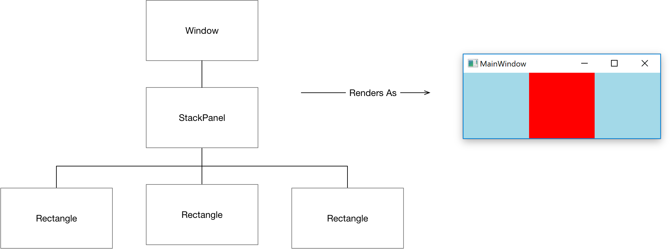

# Resource Mechanism

Resource Dictionaries provide a standard mechanism for packaging and accessing resources in WPF. We extend the simple piece of XML from the previous section to show how resources work. The resources property is defined on FrameworkElement

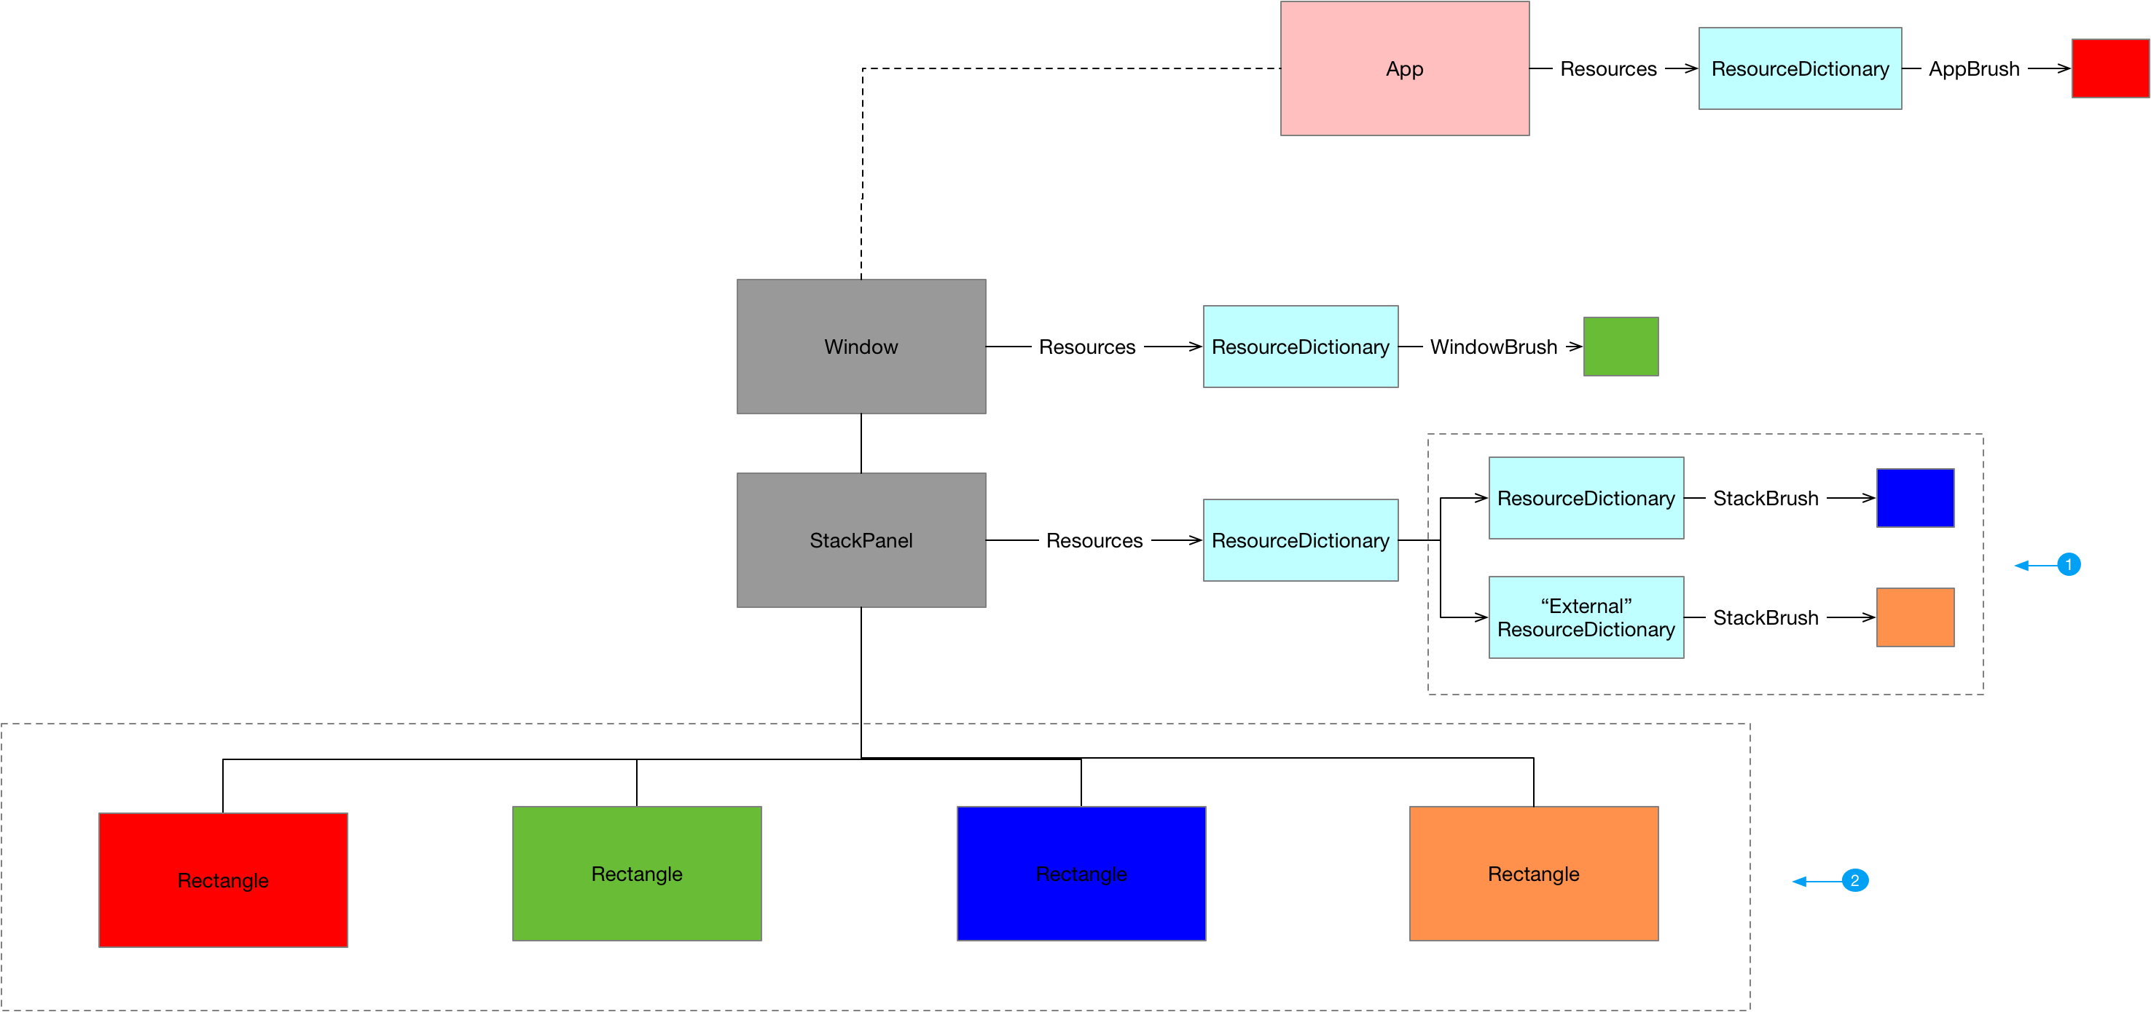

1. Resource dictionaries can be merged
2. Framework Elements can access resources from the resources collections of parents in the logical tree (and resources defined in the application itself )

Resources can be accessed as either static or dynamic resources

Below we share the source code for this example

Listing 3ExternalResourceDict.xaml



Listing 4App.xaml



Listing 5MainWindow.xaml



For more information on the resource mechanism see [Resource - Detail](https://d.docs.live.net/e9ce91852086ca9f/2.%20Notes/dotnet/applied/wpf/resources/Resources.docx)

# Mapping Logical tree to Visual Tree

The visual tree is an expansion of the logical tree into core visual components. A very simple UI may consist of just a single node logical tree holding the Window itself. This window is however made up of multiple visual objects that render it. Consider a basic window as follows.

Single logical to multi-node visual

Source code



Mapping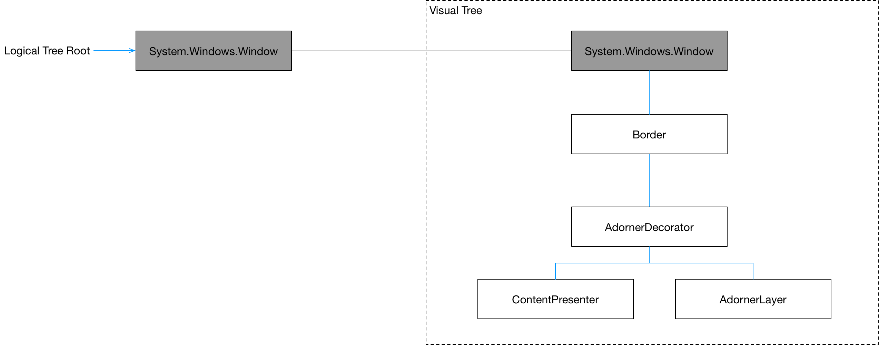

# Controls

The killer feature of WPF controls is that the procedural behaviour code is completely separated from its visual tree. Every Control has a Template dependency property of type ControlTemplate. A control template enables the consumer of a control to replace its visual tree with a completely new and arbitrarily complex tree of visuals while keeping the core behaviour of the control intact. Whenever a Control is instantiated its ControlTemplate is used to generate a tree of visuals that will be used in rendering. The template acts as a blueprint that tells WPF how to create the visual elements needed to render the Control. The content of a ControlTemplate is of type VisualTree.

All FrameworkElements in a control template have a relationship back to the control being templated. This relationship is know as the templated parent and is represented by the property

Creating the ControlTemplate

Listing 6Creating a ControlTemplate



The ControlTemplate is not the same thing at the actually rendered visuals in the visual tree. It is a blueprint which tells WPF how to create the VisualTree as shown in the diagram below

Figure 1Creating a ControlTemplate

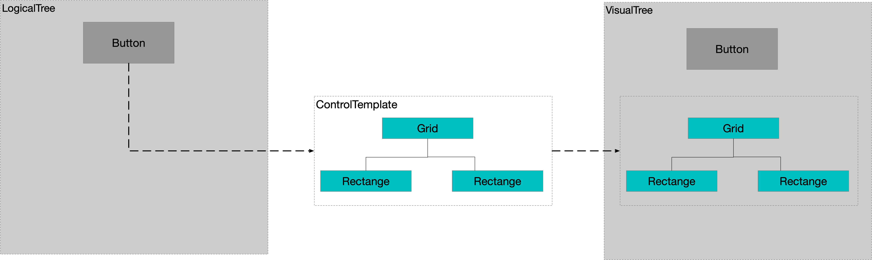

For more information on Controls see the following document

[Controls - Detail](https://d.docs.live.net/e9ce91852086ca9f/2.%20Notes/dotnet/applied/wpf/controls)

# Dependency Properties

Dependency Properties are arguably the most important abstraction in the whole of WPF. There are not many parts of the framework that would work without dependency properties. For example the following technologies all use depency properties

1. Data Binding
2. Property value inheritance / Sparse storage
3. Styles – only dependency properties can be styled
4. Property Triggers

For more information on dependency properties see [DependencyProperties - Detail](https://d.docs.live.net/e9ce91852086ca9f/2.%20Notes/dotnet/applied/wpf/dependencyproperties/DependencyProperties.docx)

# Data Binding

A Binding keeps source and target properties in sync. The target property must be a dependency property and hence the target object must be a dependency object. The source property can be any .net property, however if we want the target to respond to changes in the source then the source object’s type should implement INotifyPropertyChanged

Figure 2Binding Object

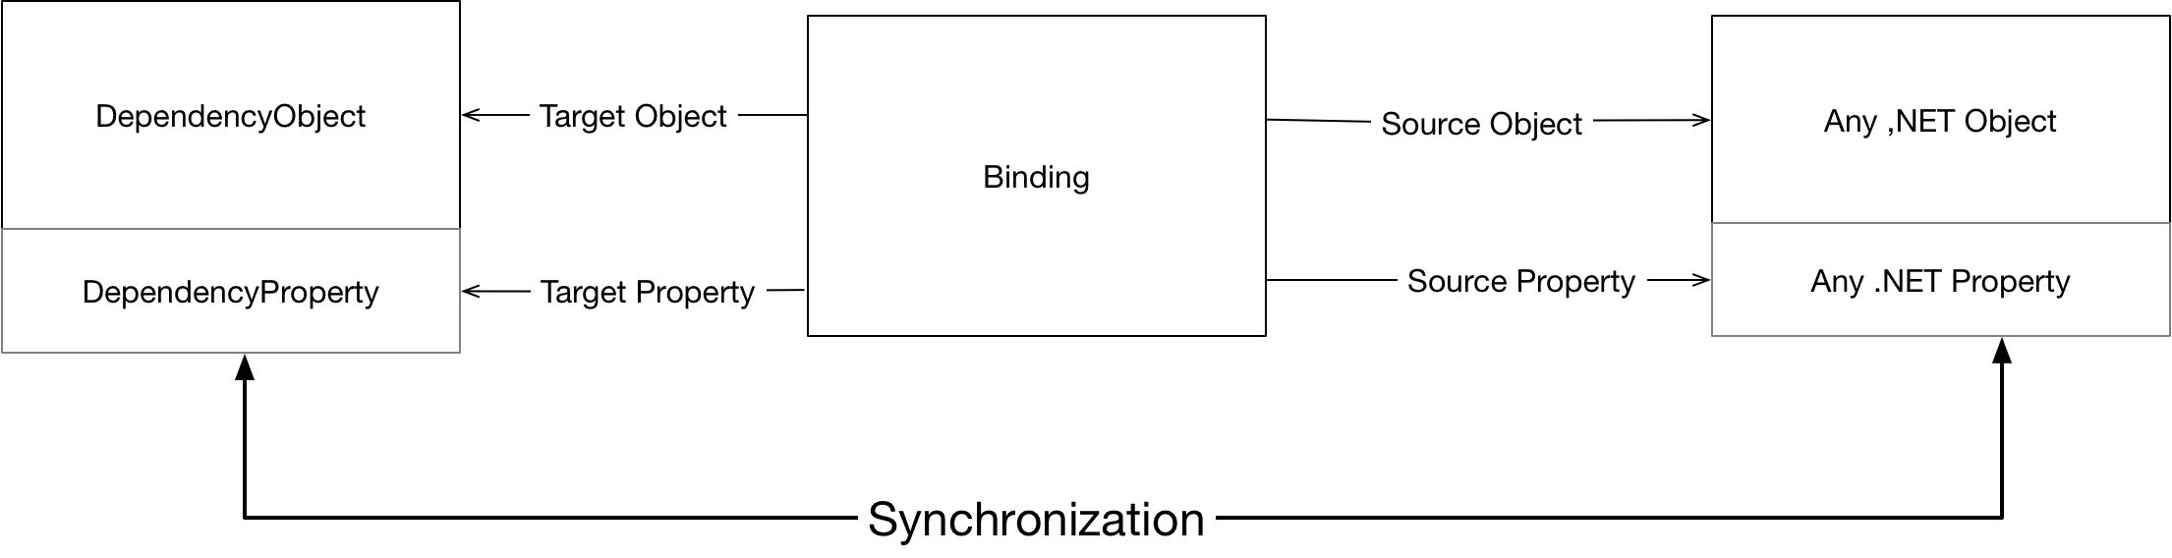

Binding

|  |  |
| --- | --- |
| ➊ Target Object | Must be a DependencyObject |
| ➋ Target Property | Must be DependencyProperty |
| ➌ Source Object | Any .NET object but must implement INotifyPropertyChanged if we want change propagation |
| ➍ Source Property | Any .NET property but again must raise INotifyPropertyChanged if we want change notification. Must also be a property and not just a field. |

For more information on data binding see [DataBinding - Detail](https://d.docs.live.net/e9ce91852086ca9f/2.%20Notes/dotnet/applied/wpf/dependencyproperties/DependencyProperties.docx)

# Styles and Triggers

A style is a collection of DependencyProperty setters that can be applied to multiple objects typically with the goal of providing a consistent appearance. Typically, styles are stored and accessed from ResourceDictionaries. Consider the following piece of XAML



For more information on style and triggers see [Styles - Detail](https://d.docs.live.net/e9ce91852086ca9f/2.%20Notes/dotnet/applied/wpf/styles/Styles.docx)

# Layout

**Layout is the process whereby each FrameworkElement is sized, positioned and rendered onto the screen. A parent Panel allocates a rectangular subset of its total available space to each child. The size and location of this rectangle defines a layout slot or bounding box onto which the child can be rendered. As a panel’s children can also be panels, layout is implemented as a two-pass traversal of the element tree. In the first pass, known as measure, parents ask their children how much space they would like.**

**Inputs into process**

* **Available screen space**
* **Size of constraints**
* **Layout specific properties (margin and padding)**
* **Logic and behaviour of the parent panel**

Layout occurs when an application starts and every time a window is resized.

**For more information on layout see** [Layout - Detail](https://d.docs.live.net/e9ce91852086ca9f/2.%20Notes/dotnet/applied/wpf/layout/Layout.docx)

# Rendering

From a high level, any UI technology is about processing user input from the mouse or keyboard and rendering the resultant state to the screen. Rendering in WPF is supported via the abstract base clas Visual. Visual is a lightweight implementation that supports

* Specifying and rendering drawing content
* Hit Testing
* Bounding box calculations
* Transformations
* Clipping

For more detail on low level renderinf see [Rendering - detail](https://d.docs.live.net/e9ce91852086ca9f/2.%20Notes/dotnet/applied/wpf/rendering/Rendering2.docx)

# Vector Graphics

Vector graphic are used to render lines, paths and shapes to screen. The building blocks of vector graphics in WPF are Segments which are strung together end to end to form PathFigures. Multiple PathFigures can be combined to form a PathGeometry

For more information on vector graphics see

[Vector Graphics - Detail](https://d.docs.live.net/e9ce91852086ca9f/2.%20Notes/dotnet/applied/wpf/vectorgraphics)

# List Controls

# Input – Commands and Events

## **Command Binding**

Each UIElement has a collection of CommandBinding objects. Each CommandBinding indicates that this UIElement can handle the binding’s associated command.

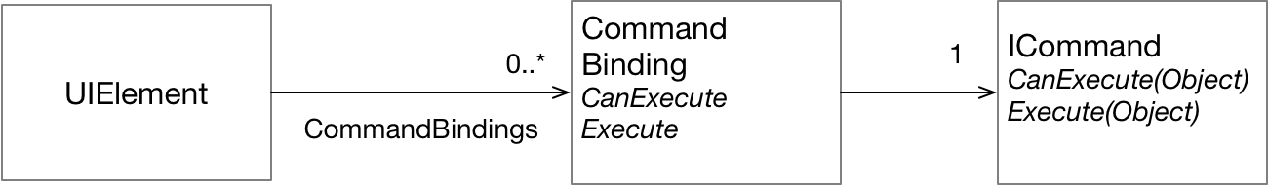

## RoutedCommand

RoutedCommand is the WPF implementation of ICommand. The execute method on a RoutedCommand does not directly contain the logic to carry out the command. Instead a RoutedCommand’s Execute method raises an Execute event. The event is a RoutedEvent that bubbles/tunnels the element tree looking for a CommandBinding that knows how to handle that event. If it finds one it is a delegate attached to the CommandBinding that carries out the logic

